Ben Franklin: The World Stage
Diplomacy and the American Revolution
From: Footprints of Freedom: Bowers Museum, 2011
History Standards: 8.1
Students understand the major events preceding the founding of the nation and relate their significance to the development of American constitutional democracy.
11.1
Students analyze the significant events in the founding of the nation and its attempts to realize the philosophy of government described in the Declaration of Independence.
CCSS Standards: Reading, Grade 6-8
1. Cite specific textual evidence to support analysis of primary and secondary sources.
2. Determine the central ideas or information of a primary or secondary source; provide an accurate summary of the source distinct from prior knowledge or opinions.
4. Determine the meaning of words and phrases as they are used in a text, including vocabulary specific to domains related to history/social studies.
7. Integrate visual information (e.g., in charts, graphs, photographs, videos, or maps) with other information in print and digital texts.

Reading, Grade 11-12
1. Cite specific textual evidence to support analysis of primary and secondary sources, connecting insights gained from specific details to an understanding of the text as a whole.
2. Determine the central ideas or information of a primary or secondary source; provide an accurate summary that makes clear the relationships among the key details and ideas.
4. Determine the meaning of words and phrases as they are used in a text, including analyzing how an author uses and refines the meaning of a key term over the course of a text (e.g., how Madison defines faction in Federalist No. 10).
7. Integrate and evaluate multiple sources of information presented in diverse formats and media (e.g., visually, quantitatively, as well as in words) in order to address a question or solve a problem.

Writing, Grade 6-8
2. Write informative/explanatory texts, including the narration of historical events, scientific procedures/ experiments, or technical processes.
4. Produce clear and coherent writing in which the development, organization, and style are appropriate to task, purpose, and audience.
9. Draw evidence from informational texts to support analysis reflection, and research.

Writing, Grade 11-12
2. Write informative/explanatory texts, including the narration of historical events, scientific procedures/ experiments, or technical processes.
4. Produce clear and coherent writing in which the development, organization, and style are appropriate to task, purpose, and audience.
9. Draw evidence from informational texts to support analysis, reflection, and research.

Guiding Question:
What is a diplomat?
Why was diplomacy important for the success of the Americans in the Revolutionary war?
How did Franklin’s diplomacy fit into the historical context of the American Revolution?
Overview of Lesson:
Lesson Objectives:
- Students will understand the role of Ben Franklin’s diplomacy in the American Revolution
- Students will learn and understand the concept of historical context by comparing events in the Americas with events in France during the Revolutionary period
- Students will interpret time lines

Procedure
- Opening exercise: Explain to students that this lesson will allow them to understand the American Revolution from both a national and international perspective. Write the words “historical context of the American Revolution” on the board and explain to students that they will expand their learning of this concept. You may define historical context for students as, “the situation, events, or information that are related to a historical event that help you better understand it.” Review the important moments of the American Revolution and/or events leading up to the Revolution covered in class so far. Record these ideas on the board by organizing each idea into categories titled local, national, and international or around the world. Most likely, student answers will fit into the local (Boston Massacre) or national (Declaration of Independence) category, but may contain some information in the international category (Stamp Act). The teacher should draw a timeline on the board from 1774 to 1782. The teacher can then transfer events from the brainstorming session to the timeline.

- Developing the central concept: If Benjamin Franklin has not been mentioned in the brainstorm prompt students to consider what they know about this founding father and list it on the board. Explain to students that Ben Franklin participated in an important component of the American Revolution, not as a military leader or Congressional representative, but as a diplomat, a person who represented their nation in a foreign country. The teacher should explain:
  - America needed money for supplies, arms, and war materials
  - America needed to borrow money to buy these supplies
  - France, the traditional enemy of Britain, was the most logical ally from which to request aid
  - Franklin was the ideal person to serve as a diplomat because he had an international reputation as a scientist, politician, philosopher, and he had experience working in Europe. In fact, Franklin was well known throughout the colonies as well as Britain and France as a highly-regarded intellectual.
  - Franklin’s goal was to get France to back the Americans with aid and by entering into the war against the British
- Source Analysis: Break students into groups and ask that the students read each of the sources and answer questions. Each group should have a time keeper, a recorder to answer the questions on a separate sheet of paper, an organizer to gather answers from the group, and a reporter to share out the group’s information. Teachers may have to work through the Group 4 documents as whole class.
- Ask groups to share out by describing their documents, answering the questions, and writing an important date from their documents on the timeline.
- The teacher should revisit the “historical context of the American Revolution” brainstorm and ask students place the events from their sources into the international context.

Sources:
Benjamin Franklin Tercentenary, http://www.benfranklin300.org/index.php

“The American Revolution, 1763-1783” in the Library or Congress
http://www.loc.gov/teachers/classroommaterials/presentationsandactivities/presentations/timeline/amrev/index.html

Ben Franklin in The Revolutionary Diplomatic Correspondence of the United States, Volume 2
By United States. Dept. of State, John Bassett Moore.

Group 1 Sources: Famous Americans

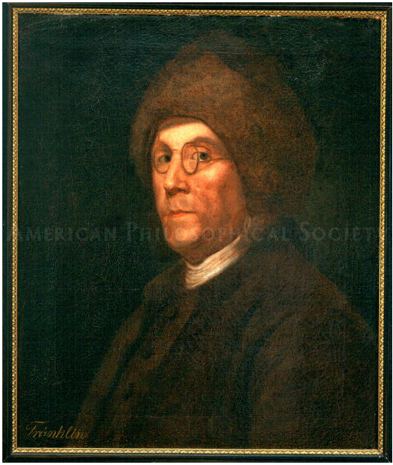  Source A: Benjamin Franklin in fur cap, after Charles Nicolas Cochin, ca.1777-1780. American Philosophical Society | 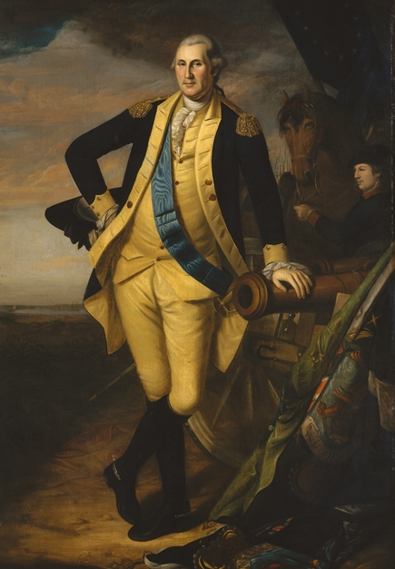  Source B: George Washington, during the American Revolution, Charles Willson Peale in 1780. Metropolitan Museum of Art

Source C: Bowl with portrait of Benjamin Franklin, after 1775 made in England by Josiah Wedgewood, Collection, State Museum of Pennsylvania, Pennsylvania Historical & Museum Commission (Harrisburg, Pa.). This bowl is an example of the many items such as candy boxes, jewelry, and handkerchiefs that were sold to the French when Franklin arrived on their shores.
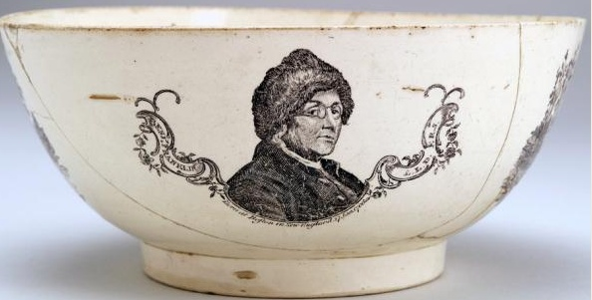

1. Are these sources primary or secondary? How do you know?

- Examine the images of Franklin and Washington. What is similar and different about the way they are dressed and presented?
Similar / Different

- How is Benjamin Franklin pictured in both of the sources? What is unusual about his clothing and hairstyle?

- When Franklin arrived in Paris in December 1776, he became a symbol of America. How do these images of Franklin in a fur cap look “American?” Why would a fur cap be seen as “American?”

- Why would people in France be interested in buying a bowl or other household items with an image of Ben Franklin? Does this compare to anything you own in your own home?

Group 2 Sources: A Nation in Need

Source A:
From Ben Franklin Tercentenary, “World Stage” http://www.benfranklin300.org/timeline/index.html

With the start of the Revolutionary War, Americans faced the major challenge of fighting Britain—until now, their main provider of military goods. Congress sent Franklin a detailed, 38-page list of supplies to get in France. It specified items essential to outfitting and sustaining the American troops, ranging from arms of all sorts to bolts of cloth for uniforms, cooking pots, fifes and drums, and goods for Indian allies—all of which then had to be smuggled across the Atlantic, often via the Caribbean. | military goods—weapons or other things used to fight a war, such as guns and cannon  outfitting—to provide someone with a set of clothes or materials for a specific purpose  arms—weapons

Source B:
[In early 1777] the ports of France were opened to American ships for the selling of American goods and the buying of French. Arrangements were made for the purchase of five thousand hogsheads [barrels] of American tobacco by French merchants.
From The First American: The Life and Times of Benjamin Franklin by H.W. Brands, 2000. page 531.

- Are these sources primary or secondary? How do you know?

- What supplies did America need to fight the war?

- Why did American not have the supplies it needed to fight the war?

- Where did America get supplies for the war? What did it sell to buy these supplies?

- Why were Americans concerned with trade? How did the war change trade and consumption in the America?

Group 3 Sources: A Turning Point: The Victory of the Battle of Saratoga October-November 1777

Source A:
Benjamin Franklin writing in March 1777 of his hope that France would soon enter into the war on the American side.

“The French…fleet is nearly ready, and will be much superior to the English… When all are ready for it, a small matter may suddenly bring it on; and it is the universal opinion that peace cannot last another year.” | fleet-navy or group of ships  matter-event  universal opinion-the opinion of most people

Ben Franklin in The Revolutionary Diplomatic Correspondence of the United States, Volume 2
By United States. Dept. of State, John Bassett Moore, page 289.

Source B:
George Washington to General Horatio Gates, October 30, 1777
Washington writing to congratulate him on winning the Battle of Saratoga, a major turning point in the war.
Sir: By this Opportunity, I do myself the pleasure to congratulate you on the signal success of the Army under your command, in compelling Genl. Burgoyne and his whole force, to surrender themselves prisoners of War. An Event that does the highest honor to the American Arms, and which, I hope, will be attended with the most extensive and happy consequences. At the same time, I cannot but regret, that a matter of such magnitude and so interesting to our General Operations, should have reached me by report only, or thro' the Channel of Letters, not bearing that authenticity, which the importance of it required, and which it would have received by a line under your signature, stating the simple fact. | opportunity-chance  compelling-forcing  surrender-to officially give up fighting after losing  prisoner of war-an enemy soldier kept as a prisoner

George Washington Papers, in Library of Congress

- Are these sources primary or secondary? How do you know?

- According to Source A, why did Franklin believe France would go to war soon? What advantages will France’s entry into the war bring to the American side?

- Who was General Burgoyne and what happened to him at the Battle of Saratoga?

- Why do you think the Battle of Saratoga was so important for Franklin, Washington, and America?
Group 4: The French Treaty of Amity

In 1778 the Treaty of Amity (amity means friendship between countries) produced an alliance, or partnership, between the United States and France, in which each nation agreed to support one another in the event of British attack. The Treaty officially brought France into the American Revolutionary War against the British, giving assistance to the Americans to win their fight for independence.

Source A:

TREATY OF ALLIANCE, EVENTUAL AND DEFENSIVE
Library of Congress
http://www.loc.gov/teachers/classroommaterials/presentationsandactivities/presentations/timeline/amrev/turning/french.html
The most christian king, and the United States of North America, to wit, New Hampshire, Massachusetts Bay, Rhode Island, Connecticut, New York, New Jersey, Pennsylvania, Delaware, Maryland, Virginia, North Carolina, South Carolina and Georgia, having this day concluded a treaty of amity and commerce, for the reciprocal advantage of their subjects and citizens, have thought it necessary to take into consideration the means of strengthening those engagements, and of rendering them useful to the safety and tranquillty of the two parties; particularly in case Great Britain, in resentment of that connexion and of the good correspondence which is the object of the said treaty, should break the peace with France, either by direct hostilities, or by hindering her commerce and navigation... and the peace subsisting between the two crowns. And his majesty and the said United States, having resolved, in that case, to join their counsels and efforts against the enterprises of their common enemy…  Done at Paris, this 6th day of February, one thousand seven hundred and seventy-eight.  C. A. Gerard  B. Franklin  Silas Deane  Arthur Lee | amity-friendship  commerce-trade, or economic exchange  reciprocal-complement, between two sides  engagements-a promise or pledge between two nations  tranquility-peace  direct hostilities-military attack  hindering-blocking or stopping
Source B:
The French Alliance May 1778 agreed upon by the Continental Congress

The Continental Congress agreed to the treaties.

Resolved, that… the diplomats representing these States at the court of France, are directed to present the thanks of this Congress to the French King, for his generosity and friendship to the United States, and to promise the French King, on the part of this Congress, it is wished that the friendship between France and these United States may be long lasting.

Continental Congress, May 4 1778, Library of Congress

- Are these sources primary or secondary? How do you know?

- What did France promise to America in the Treaty of Alliance?

- What was France concerned Britain would do? How does France explain they will defend themselves against Britain?

- Who signed the treaty on behalf of the Americans?

- Did the Continental Congress agree to the treaty with France?

- After reading reply of the Continental Congress, do you think the Americans were pleased to have France agree to an alliance? Give examples from Source B.

