 | Silk Road Lesson

China Lesson: What was the Silk Road?
From: Nicole Gilbertson

History Standards:
6.6.7: Cite the significance of the trans-Eurasian "silk roads" in the period of the Han Dynasty and Roman Empire and their locations.

CCSS Standards: Reading, Grade 6-8
- Determine the central ideas or information of a primary or secondary source; provide an accurate summary of the source distinct from prior knowledge or opinions.
7. Integrate visual information (e.g., in charts, graphs, photographs, videos, or maps) with other information in print and digital texts.

Guiding Question:
- Where was the Silk Road?
- Who traveled the Silk Road?
- What was traded on the Silk Road?

Lesson Objective: Students engage in the lesson below to consider who traded across the Silk Road and the goods that traveled across Asia.

The Silk Road

The Silk Road was a series of routes that crossed Eurasia linking peoples from throughout the continent through trade of goods, ideas, and religions. You may want to visit the American Museum of Natural History’s Interactive Silk Road Journey to get a preview of the Silk Road:

http://www.amnh.org/exhibitions/silkroad/journey.php

Part 1: Sedentary Civilizations and Nomadic Peoples on the Silk Road
For this portion of the lesson you will use the Silk Road map.

The Silk Road stretched across Eurasia (the landmass of Europe and Asia) from the Mediterranean to Japan. This trade network began in the Han Chinese capital of Xi’an. Find Xi’an on the map. The Han emperors were interested in extending the boundaries of their kingdom and learning about the surrounding territories. In 138 B.C.E. the emperor sent a diplomat, Zhang Qian to establish contact with the Xiongnu peoples living in Mongolia. Find Mongolia on the map.
Below is a description of Zhang Qian’s travels describing the Xiongnu people, a nomadic people.
Read the text below and answer the questions.

They live among the northern barbarians, moving to follow their flocks. They primarily raise horses, oxen, and sheep, but also keep unusual animals like camels, asses, mules, and wild horses. They move about in search of water and grass, having no cities, permanent dwellings, or agriculture. They have no written language, so make oral agreements. Little boys are able to ride sheep and shoot birds and mice with bows and arrows. When they are somewhat older they shoot foxes and rabbits for food. Thus all the men can shoot and serve as cavalry.  Sima Qian’s history of China (ca.145-90 BCE) in Chinese Civilization: A Sourcebook edited by Patrica Buckley Ebrey. | barbarians—a person who does not live in a civilization (often a negative term)  flocks—groups of one kind of animal (like sheep)  oral—verbal, or communicated by speaking  cavalry—soldier on horseback

- What do the Xiongnu people do to survive? Do you know any other groups that had a similar nomadic lifestyle?
- The Xiongnu are nomadic people, meaning that they do not live in permanent settlements and instead move around the steppes in order to feed their animals on the grassland. How does this compare and contrast to the Han Chinese civilization?
- Why might Zhang Qian consider the Xiongnu barbarians?

The Xiongnu and other nomadic groups traveled the Silk Roads and often traded with settled, or sedentary, civilizations like the Han. The Xiongnu were able to produce goods they needed to survive from their animals. See the artifact below from the Secrets of the Silk Road exhibit and answer the questions.

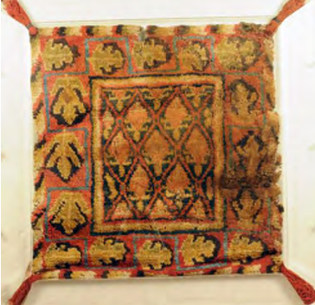 | Citation: Woolen Saddle Blanket with Leaves Pattern, 2nd Century BC-AD 2nd Century Excavated from Tomb No. 2, Horse Pit, Sampul, Lop Xinjiang Uygur Autonomous Region Museum Collection  This blanket would have been placed under a saddle and was found in a grave buried with a horse.  4. How do you think this was made? Where does wool come from? Would the nomadic people have to trade to obtain wool or could they make this without trading for it?

Part 2: The Deserts of the Silk Road

For this portion of the lesson you will use the Silk Road map. Find Turfan on the map.
5. What surrounds this area?

This desert has extreme temperatures because there is no ocean to keep the temperatures stable. Instead, this desert area has long, cold winters (up to eight months of the year) and short hot summers. Travelers have found the region very difficult to cross. A famous traveler, Marco Polo, commented about this area, the Tarim Basin, stating,

“This plain…extends fully twelve days journey. In all these twelve days there is no habitation or shelter, but travelers must take their provisions with them. No birds fly here because of the height and the cold. And I assure you that because of this great cold, fire is not so bright here nor of the same colour as elsewhere, and food does not cook well.”  Marco Polo (ca.1254-1324) in The Silk Road: Two Thousand Years in the Heart of Asia by Frances Wood | plain—a flat area of land  habitation—settlement or living areas of people  provisions—supplies

6. What stands out for you about Marco Polo’s description of the desert area of the Tarim Basin?
7. Why would this area be difficult to travel across?

Turfan and the Tarim Basin is area is a desert and people live around oases. Oases are underground springs that have water from melted snowfall of mountain ranges. People live around an oasis in the middle of the desert, like living on an island in the middle of the ocean. These oasis towns were important stops for travelers on the Silk Road. Traders on the Silk Road traveled the road to buy and sell goods from oasis to oasis. Often they were away from their homes for many years. For example, Zhang Qian traveled for twelve years on the Silk Road. These traders often sold luxury goods, or things that were unusual, expensive, and ways for people to display wealth.
8. Can you think of some luxury goods that people buy and sell today?

Part 3: Trading Luxury Goods on the Silk Road

Luxury goods are important aspects of long distance trade. If a trader, or merchant, wanted to make a bigger profit, or more money, from his trade, then he will sell goods that are easy to transport and that he can sell for a high price. For this reason, luxury goods were an important part of the Silk Road trade.

Today and in the past gold is a luxury good that people buy, sell, and display as examples of wealth. Gold was found in graves in the Tarim Basin in the area of Turfan. Gold was used as a medium of exchange in the form of coins and also as decorative items.

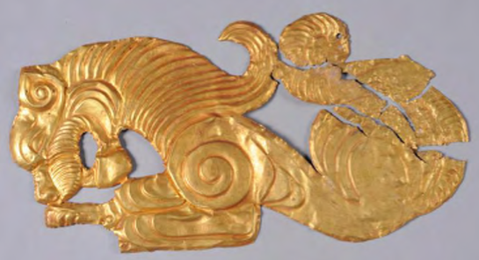 | Gold Plaque with Lion Design,  5th-3rd Century BCE  8. What is this object? What do you think it was used for? Why would someone want to display this object?

The Silk Road was so named in the 1800s by a German explorer. Long before it was named the Silk Road, long distance trade flourished across Eurasia. While few people traveled the entire distance of the route, trade goods did travel from continent to continent. One of these luxury goods was silk.
9. What do you already know about silk? How is it made?

Silk production begins with the silkworm. These silkworms eat a special type of food, mulberry leaves, and need to be kept in places that have a warm and constant temperature (about 75 degrees). Only then, do the worms spin silk cocoons. Once they have spun the cocoons, people boil them to kill the worms, and use the cocoons to form silk thread. This silk thread is then woven into silk fabric. Silk thread and fabric was (and still is) an important luxury good. For several hundred years the secret of silk production was only known in the Chinese empire, but this knowledge as well as silk textiles, such as clothing and goods for the home, were exchanged across the Silk Road. Study the two items and answer the questions below.

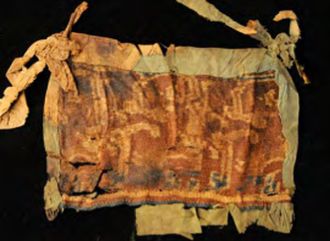 | Silk Mask, 1st-2nd Century  The mask has animal designs and words embroidered that state, “May you have long life and many sons and grandsons.” The mask was found in a grave and tied around the head of the person.  10. What do you notice about this mask? Why do you think that words and animals decorate the mask?  11. After reading the message embroidered on the mask, what do you think was important to the person buried with the mask?

12. What does the mask tell us about the person who owned it?

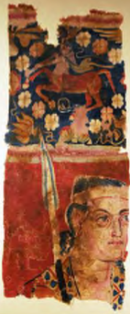 | Wall Hanging with Warrior and Centaur Design, 2nd Century BC-AD 2nd Century  On the top portion is an image of a centaur playing a musical instrument. A centaur is a figure from mythology that is half human and half horse.  The bottom portion pictures a warrior carrying a spear.  13. What parts of this wall hanging stand out to you? Have you seen images like these before? If so, what civilization that you have studied produced images like these?  14. What would this hanging have been used for? What does it tell us about the person who owned it?

This wall hanging has imagery that looks like many of the decorations and artistic representations of the Classical Mediterranean civilizations.

For this portion of the lesson you will use the Silk Road map. Find the Mediterranean Sea on the map.
15. What civilization ruled this area in the year 200 C.E.?
16. Where was its capital? Find this on the map.
17. What types of things were produced and traded in the Mediterranean around the year 200?

The Silk Road linked the Mediterranean civilizations in the West and the Chinese empire in the East. Although few people traveled the entire distance of the Silk Road, many goods, people, and ideas traveled across Eurasia.

Conclusion: The Silk Road

After studying the primary sources and answering the questions you are prepared to answer the questions that guided this lesson:
- Where was the Silk Road?
- Who traveled the Silk Road?
- What was traded on the Silk Road?
Answer these questions in a paragraph using one to two sentences to answer each question.

What questions do you have about the Silk Road and what more do you want to know about the Silk Road?

