Lesson Question: Who started the Russian Revolution?

Grounding Source:

John M. Thompson, Russia and the Soviet Union: A Historical Introduction from the Kievan State to the Present, Westview Press: 2009. Sixth Edtion, pp. 215-216.

Everyone was glad it was warmer. During street demonstrations of the past two days, people had shivered and nearly frozen, but despite the bitter cold, they had continued their protests against the shortage of bread and the war. Now, by midmorning on Saturday March 10, 1917, the thermometer had climbed to 20 degrees Fahrenheit, and the crowds of strikers, unemployed workers, students, and housewives were again on the streets, heading for the center of Petrograd, the Russian capital. The demonstrators’ mood on the previous two days had been amiable, almost jolly, as if they were on holiday. On Saturday, however, more clashes with the police occurred as more and more workers left work to join the protest marches. By noon, three hundred thousand people, or about one-fifth of the city’s totally pollution were milling about. Some, besides demanding bread, shouted, “Down with the tsar,” and a few even called out a truly revolutionary slogan, “Down with tsarism!”

…[On] the main street of the city, a revolutionary orator was haranguing a large crowd when mounted police arrived to break up the demonstration. The speaker urged the throng not to move on as ordered. The detachment commander then raised his pistol and took aim. Before he could fire, a Cossack, a member of the capital’s security forces, rode forward and cut the commander down with his saber. Although Cossacks and army troops had previously behaved with tolerance toward the demonstrators, this was the first time that anybody from the government’s side actively supported the protesters. The next day, soldiers from the Pavlovskii guards regiment attacked a police unit, and that night members of the Volynskii regiment, who, under orders, had fired on unarmed demonstrators in the morning, vowed not to do so again. The next morning, when their commanding officer again ordered them out against the crowds, the soldiers mutinied and killed him.

These incidents marked the turning point in the revolution that overthrew the stardom.

John M. Thompson has taught Russian history for almost 20 years. He was a distinguished visiting professor at the U.S. Air Force Academy and the Air War College.

Source 1:

“Breakdown of Discipline on the Front”

M. V. Alekseev, General Alekseev to War Minister Guchkov. April 16, 1917

The situation in the army grows worse every day: information coming in from all sides indicates that the army is systematically falling apart.
(1) Desertions continue unabated: in the armies of the Northern and Western fronts between April 1 and 7, 7,688 soldiers are reported as deserters … a number manifestly and considerably underestimated …
(2) Discipline declines with each passing day; those guilty of violating military duty are completely indifferent to possible criminal punishments, convinced of the extreme unlikelihood of enforcement.
(3) The authority of officers and commanders has collapsed and cannot be restored by present methods. Owing to undeserved humiliations and assaults, the de facto removal of their authority over subordinates, and the surrender of such control to soldiers’ committees … the morale of the officer corps has sunk to a new low.
(4) A pacifist mood has developed in the ranks. Among the soldier mass, not only is the idea of offensive operations rejected, but even preparations for such, on which basis major violations of discipline have occurred …
(5) Defeatist literature and propaganda has built itself a firm nest in the army. This propaganda comes from two sides -from the enemy and from the rear … and obviously stems from the same source.

Found at http://soviethistory.msu.edu/1917-2/revolution-in-the-army/revolution-in-the-army-texts/breakdown-of-discipline-on-the-front/

Source 2:

Long live the Council of Workmen's and Soldiers' Deputees! 1917, Library of Congress, http://hdl.loc.gov/loc.pnp/cph.3a32370

Photograph shows a crowd of mostly women and children with banner on a street in Saint Petersburg.
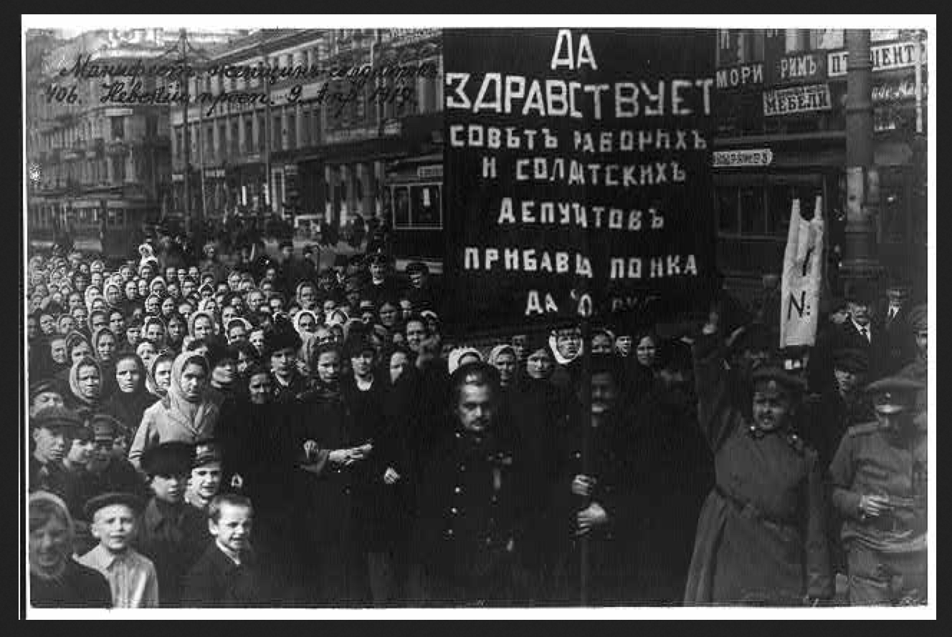

Source 3:
Temma Kaplan, “Women and the Communal Strikes in the Crisis of 1917 to 1922” in R.Bridenthal & C. Koonz, Becoming Visible: Women in European History, 1998.

In February 1917, after three years of war during which over two million Russian soldiers died, the Russian government failed to supply food and fuel to its civilian population. Because of this failure, the women in Petrograd launched a communal strike that in its final stages culminated in the overthrow of the Tsarist autocracy, against which there had been revolutionary activity for decades…The upheaval began with a communal strike in 1917, however, removed the Tsar and resulted in the creation of the Provisional Government, which was meant to lay the foundations of the liberal system in Russia…Acting in advance of the unionized working class, women precipitated the fall of the Tsar in February 1917 with demands for bread…
Most of the female 55 percent labor force of Petrograd in 1917 worked unskilled positions, especially in the textile industries. After eleven or twelve hour shifts, the women returned home to wash, mend, take care of children and get food. They joined their mothers, sisters, and daughters in bread lines…
Russian women used the occasion of International Women’s Day (March 8 in the West but February 23 on the Julian calendar, observed in Russia) to call a meeting for “Bread and Peace,” which provoked a communal strike.
Temma Kaplan is a Distinguished Professor of History at Rutgers University. She specializes on women’s and gender history in Spain, Latin America, South Africa, and the US.

Source 4:
Aleksei Radakov: The Autocratic System (1917)
From the top: We reign; we pray for you; we judge you; we guard you; we feed you; AND YOU WORK!
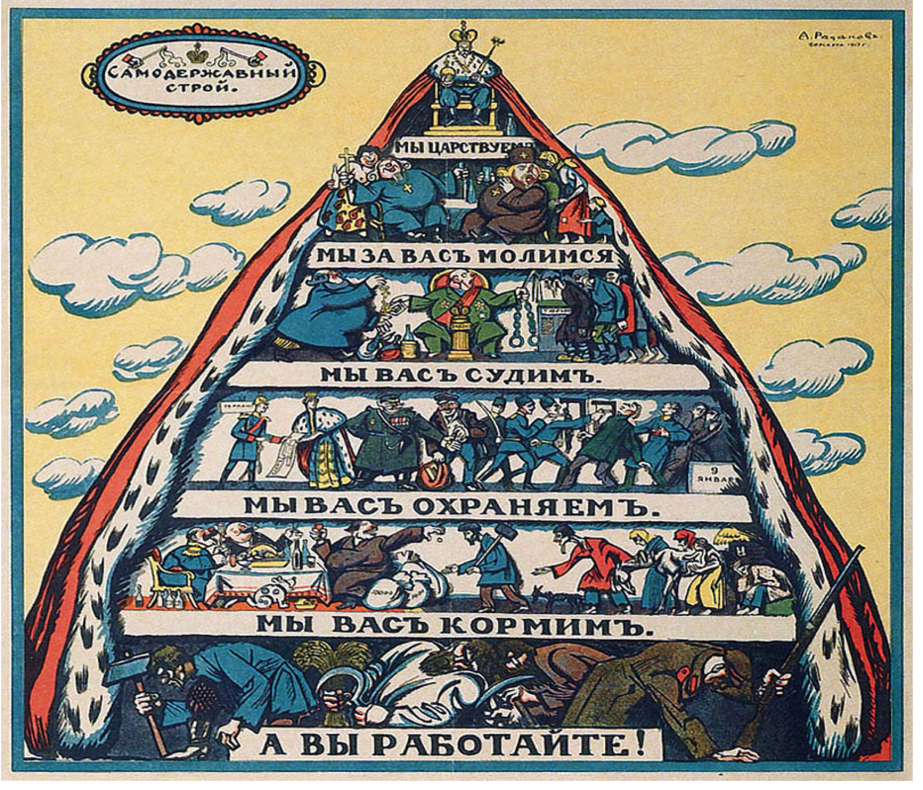

Source 5:

“Formation of the Soviet of Workers’ Deputies”

Provisional Executive Committee of the Soviet of Workers’ Deputies, Proclamations. March 12, 1917

The Soviet of Workers’ Deputies resolved to address the following proclamations to the inhabitants:
I. CITIZENS: The representatives of the workers, soldiers, and inhabitants of Petrograd, meeting in the State Duma, announce that the first session of their representatives will take place at seven o’clock tonight in the building of the State Duma. All those troops that have joined the side of the people should immediately elect their representatives, one for each company. Factory workers should elect one deputy for each one thousand. Factories with less than one thousand workers should elect one deputy each. The Provisional Executive Committee of the Soviet of Workers’ Deputies
II. CITIZENS: The soldiers who have joined the side of the people have been in the streets since morning without food. The Soviet of Deputies, workers, soldiers, and inhabitants are making every effort to feed the soldiers. But it is hard to organize the food supply at once. The Soviet appeals to you, citizens, to feed the soldiers as best you can.

Found at http://soviethistory.msu.edu/1917-2/formation-of-the-soviets/formation-of-the-soviets-texts/formation-of-the-soviet-of-workers-deputies/

