Tiananmen Uprising
Post-war World
From: Kate Merkel-Hess

History Standards: 10.10
Students analyze instances of nation-building in the contemporary world in at least two of the following regions or countries: the Middle East, Africa, Mexico and other parts of Latin America, and China.

CCSS Standards:
CCSS RH 6. Compare the point of view of two or more authors for how they treat the same or similar topics, including which details they include and emphasize in their respective accounts.

Guiding Question: How did the Chinese state remain authoritarian despite public advocacy for reform?

Overview of Lesson:
- View the iconic footage of Tiananmen Square: https://www.youtube.com/watch?v=YeFzeNAHEhU
Ask students what they know about this moment and what they think it might be about.
2. The class engages in HOT Lesson, Tiananmen Uprising, located below

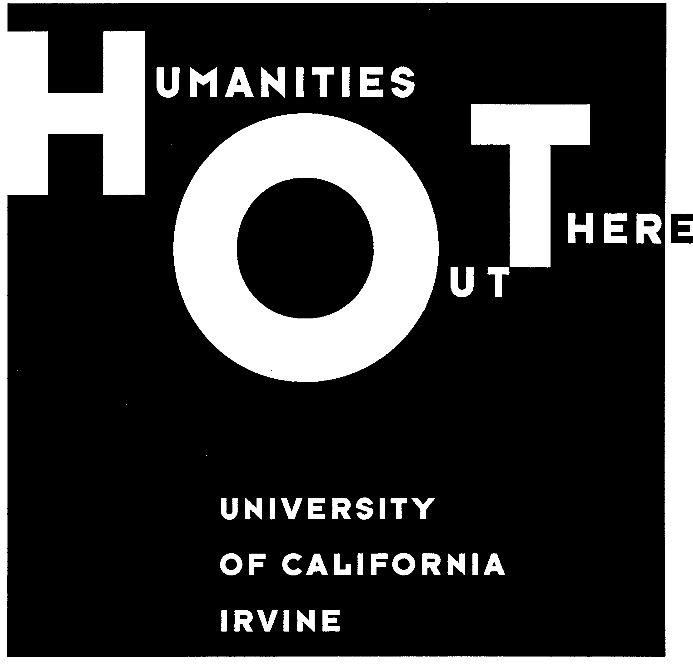
Name________________________

The 1989 Tiananmen Uprising

Part One: The 1989 Tiananmen Uprising
New Words
rationing: to distribute equally

summit: a meeting between high-level officials

hunger strike: the refusal to eat food—to the point of death—in order to protest something
In the late 1970s political leader Deng Xiaoping began to implement a series of economic reforms. By the late 1980s, those economic changes had begun to have both positive and negative impacts. People living in rural areas had more freedom to pursue side-line employments and buy and sell their own land. Chinese people had greater freedom in choosing their own jobs.

However, for many people the economic reforms meant less economic security. Unlike their parents, who received government-appointed jobs after graduation, high school and college students in the late 1980s were not guaranteed employment. Moreover, grain production fell as many peasants moved to the cities, even while the population continued to grow. As a result, prices rose rapidly and the government had to start rationing basic goods like sugar and eggs.
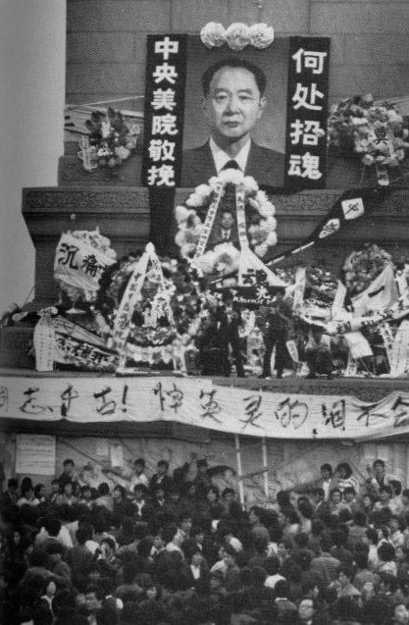
Hu Yaobang’s funeral was the catalyst for the 1989 protests.

In April 1989, political leader Hu Yaobang died. Once a high-ranking official in the Communist Party, Hu was blamed for mishandling student democratic protests in 1986 and was forced to resign his post as secretary-general of the Communist Party in 1987.

The deaths and funerals of well-known leaders are dangerous political moments in China. People gather to mourn the leader, using the funeral as an opportunity to express their dissatisfaction with those in power. This is what happened in April 1989. Thousands of students began to gather daily at Tiananmen Square—the huge square in front of Beijing’s Forbidden City—to mourn Hu and to call for an end to corruption. After political leaders refused to meet with the students, they began to boycott their classes.

The rallies in Tiananmen Square grew larger, and the students began to demand democratic reforms. On May 4—an important date because a massive student demonstration was held on that day in Beijing in 1919—over 100,000 people marched in the streets to support the students.
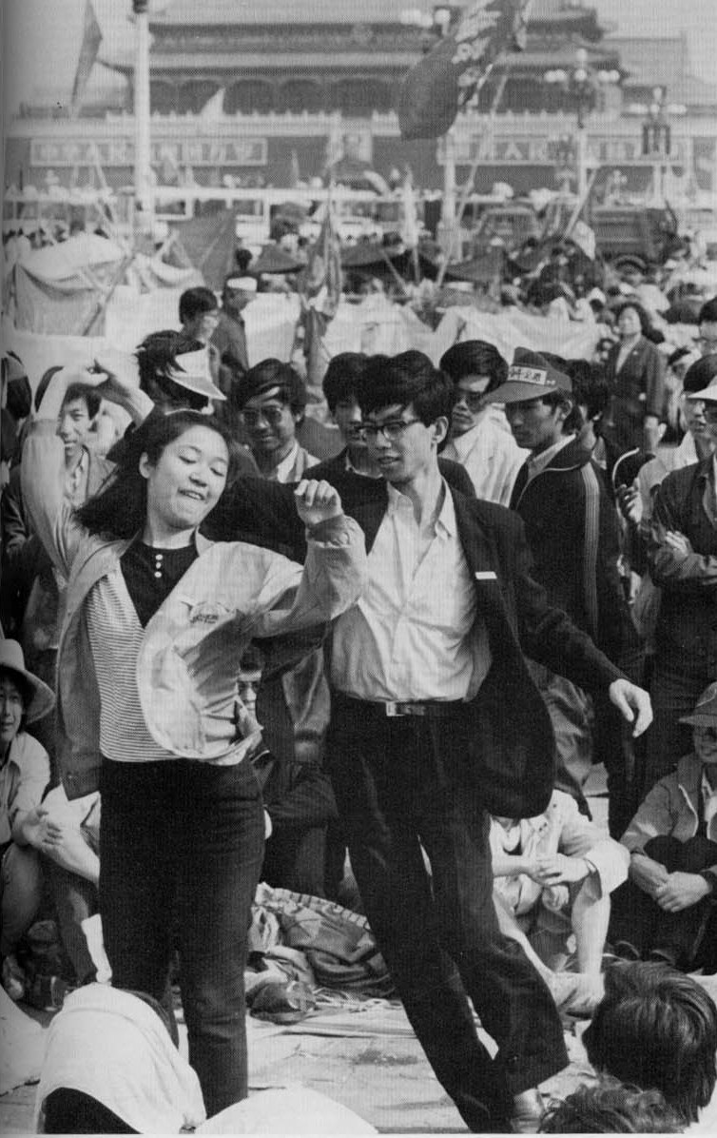
Spirits remained high in Tiananmen Square.
Up to this point, little international attention had been paid to the demonstrations. But in mid-May, Mikhail Gorbachev, the secretary-general of the Soviet Communist Party, visited Beijing. As journalists from all over the world arrived in China to cover the historic summit between Gorbachev and Deng Xiaoping, they discovered that a revolution was underway on the streets of Beijing. To draw even more attention to their protests, and in an effort to put pressure on the government, thousands of students began a hunger strike and camped out in Tiananmen Square.
The sympathies of people all over China seemed to lie with the students. Teachers, laborers, and other residents of Beijing aided the students by providing water and medical care to the hunger strikers. Students in other cities began their own protests, and thousands of students from around China began to take trains into Beijing to join the Tiananmen protestors.

The leaders of the Communist Party were uncertain how to respond. It appears that there was an argument between those who wanted to work with the students and meet some of their demands, and others who wanted to crush the protests. The latter group won out. In late May, the government tried to send in soldiers to clear the square, but Beijing residents blocked the roads with barricades, surrounded military trucks with crowds of people and refused to let them move, and pleaded with the soldiers not to turn their guns on the students.

Late on the evening of June 3, however, the army moved in with tanks, smashing the barricades and crushing those who got in their way. Gunfire rang out along the avenues that led into the square, and residents and students who had gathered to block the military’s progress were shot indiscriminately. Eventually, the troops moved into Tiananmen Square, and arrested those protestors who remained there. Certainly hundreds and perhaps thousands of civilians were killed, as well as some soldiers, who were killed by angry crowds.

Many of the student and labor leaders were arrested and imprisoned, and some were executed. A few, however, managed to escape China and live today in the United States and Taiwan.
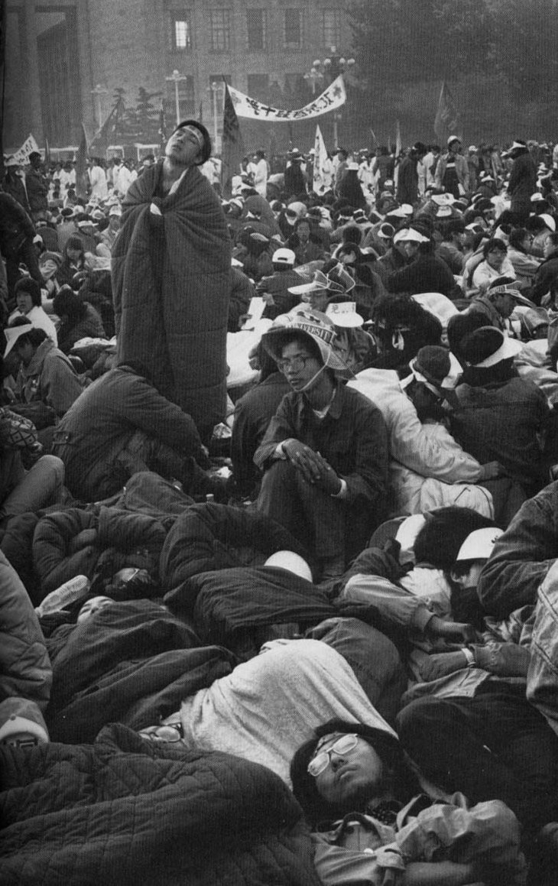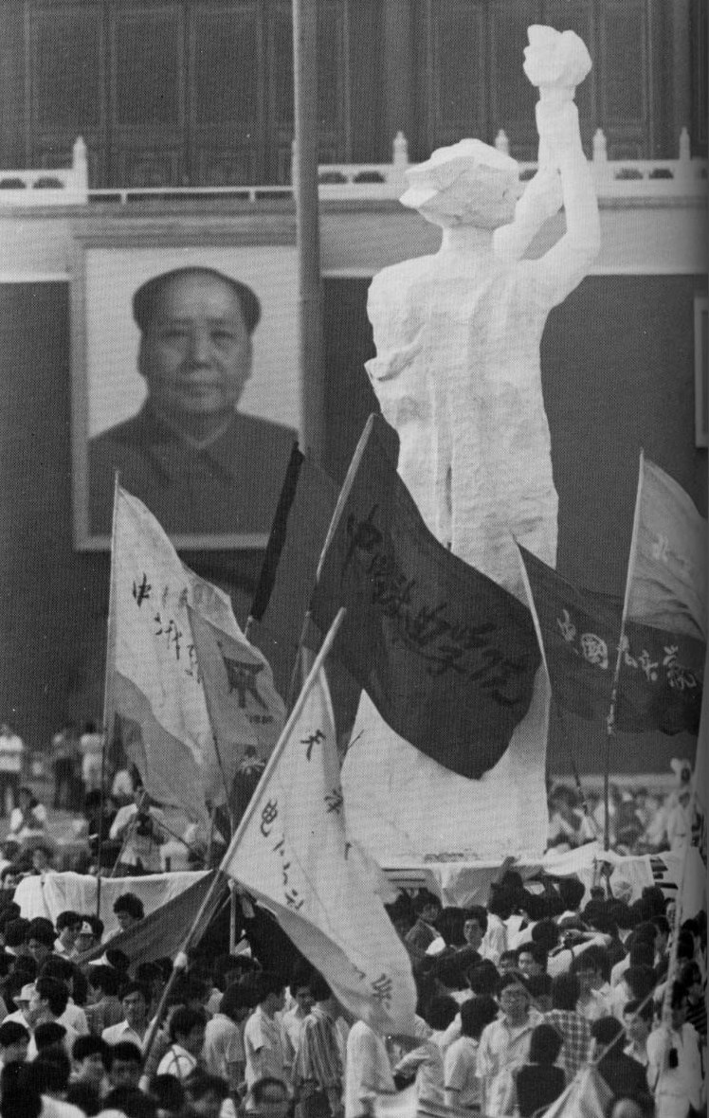

Top left: Hunger strikers in Tiananmen Square; Top right: Art students created a “Goddess of Democracy and Freedom”; Bottom left: People were crushed as tanks moved through Beijing on June 3 and 4. Bottom right: An anonymous man confronts a column of tanks on June 4.
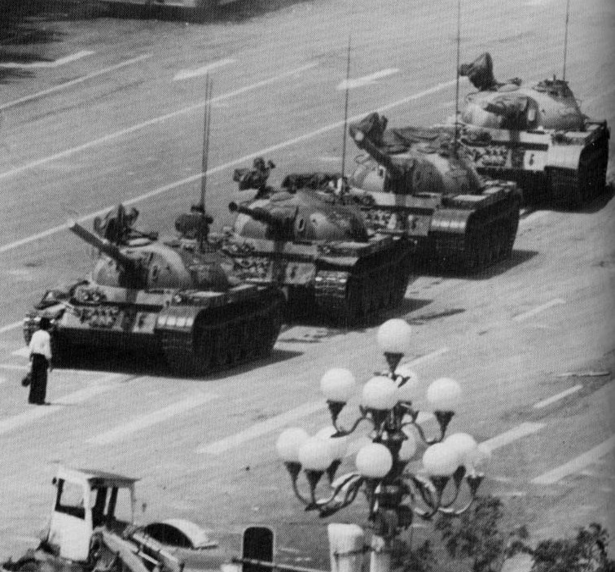

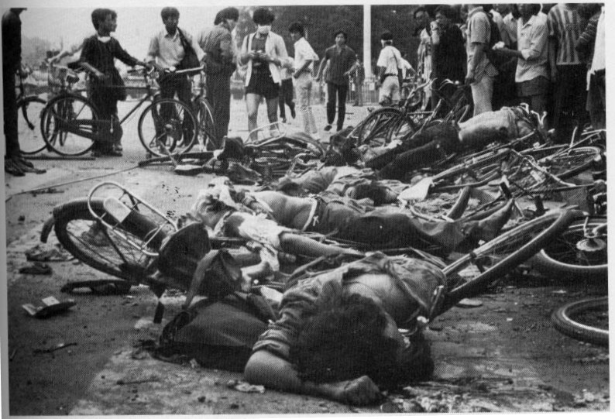
- Have you ever participated in a political protest or march? If you have, share your experiences with your group. How did you feel—were you scared, confidant, excited, angry? Were you concerned that you might be arrested for your actions or your behavior?

- The Chinese protestors lived in a political environment very different from your own. Complete the chart below to contrast the Chinese and US political systems.

political system

economic system

the right to protest?

the right to criticize the government?

United States

__________________________

__________________________

__________________________

__________________________

People’s Republic of China

__________________________

__________________________

__________________________

__________________________
Part Two: Voices of the Tiananmen Protests
New Words
ulterior: further, extra

handbills: fliers, handouts

deprecate: belittle, say bad things about

dissension: disagreement, discord
Please read the following excerpts and answer the accompanying questions.

This is an excerpt from the national Communist newspaper, the People’s Daily. On April 26, 1989, it published an editorial regarding the student protests:

“…During the mourning period, abnormal situations emerged. A tiny handful of people took this opportunity to fabricate rumors and openly attack Party and government leaders; they poisoned and bewitched the masses…
“In its consideration for the deep grief of the vast masses, the Party and the government adopted a tolerant and restrained attitude toward some of the inappropriate words and deeds of those young students who acted in moments of emotional distress…
“But after the mourning service, a tiny handful of people with ulterior motives continued to take advantage of the grief of the students to fabricate all sorts of rumors, poison people’s mind, and used posters and handbills to slander, deprecate, and attack the Party and the government leaders. They openly violated the constitution and encouraged opposition to the leadership of the Communist Party and the socialist system…
“All these facts indicate that this tiny handful of people are not really engaged in mourning Comrade Hu Yaobang. Their goal is not to promote the process of socialist democracy in China nor are they simply complaining because they are dissatisfied…Their goal is to sow dissension in people’s minds, to disrupt the entire nation, and to ruin an orderly and united political situation. This is planned conspiracy.”

- Why do you think the editorial emphasizes that only a small number of people (a “tiny handful”) were involved in the protests?

- It was particularly upsetting to the students that they had been accused of “planned conspiracy.” Why do you think that was so upsetting?

This second excerpt is from a declaration made by the hunger strikers in May 1989:

“Our nation has come to a critical juncture: inflation is sky-rocketing, government corruption is rampant, power is in the hands of few high-ranking officials, bureaucrats are corrupt, a large number of patriots have fled into exile, and social order grows daily more chaotic. Fellow-countrymen, all fellow-countrymen of conscience, at this crucial moment for the survival of the nation, please hear our voice:
New Words
juncture: moment, point in time

rampant: widespread

exile: forced absence from one’s homeland

conscience: a sense of justice
“The country is our country!
“The people are our people!
“The government is our government!
“If we do not dare to cry out, who will?
“If we do not dare to act, who will?
“Even though our shoulders are soft and tender, even though death is too heavy a burden, we are going, we must go, history demands this of us…
“We use the willingness to die to fight for life.
“But we are still children! We are still children! Mother China, please cast a serious eye on your children…Can you fail to be moved as death approaches us?”

  - Why do you think the students declare that “the country is our country” and “the people are our people”?

  - Why would the students say they are “still children”?

Part Three: Big Character Posters

In 1978, when Deng Xiaoping initiated China’s economic reforms, he called on the Chinese people to achieve the “Four Modernizations” in industry, agriculture, science and technology, and national defense. In response, one Chinese writer named Wei Jingsheng demanded a “Fifth Modernization”: Democracy.
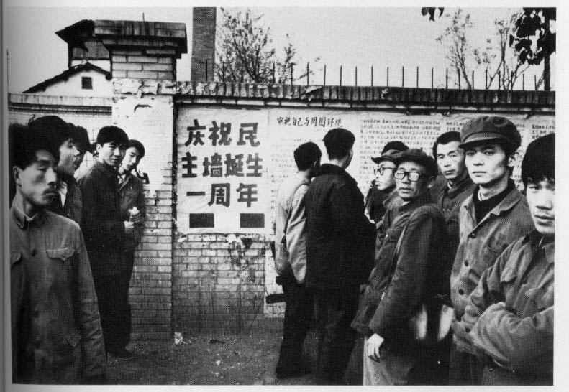
Wei Jingsheng was the most famous of a group of writers, most of them anonymous, who posted writings along a wall west of the Forbidden City in Beijing. Because many of the postings criticized the government and called for political change, it came to be known as “Democracy Wall.” The Chinese government cracked down on the posters, and Wei Jingsheng was eventually jailed. Today, he lives in the United States.

The postings at “Democracy Wall” were called “big character posters.” Big character posters were also used during the Tiananmen protests. Some were long essays, but many were short, just like the signs that protestors carry here in the United States. Here is an excerpt from Wei Jingsheng’s posting:

“The Fifth Modernization…
“What is true democracy? It means the right of the people to choose their own representatives [who will] work according to their will and in their interests. Only this can be called democracy.”

Many posters attacked government leaders, like this one that criticizes Mao Zedong:

“Chairman’s tomb and Emperor’s palace
Face each other across the square,
One great leader in his wisdom
Made our countless futures bare,
Each and every marble staircase
Covers heaps of bones beneath
From the eaves of such fine buildings
Fresh red blood drops everywhere.”

Today you are going to make your own “big character posters” to post on a class “Democracy Wall.” With your group, discuss what you would like to write about. Will you criticize the government or praise it? You can write about a specific issue, or talk about freedom and democracy more generally. If you have time, you may make multiple posters.
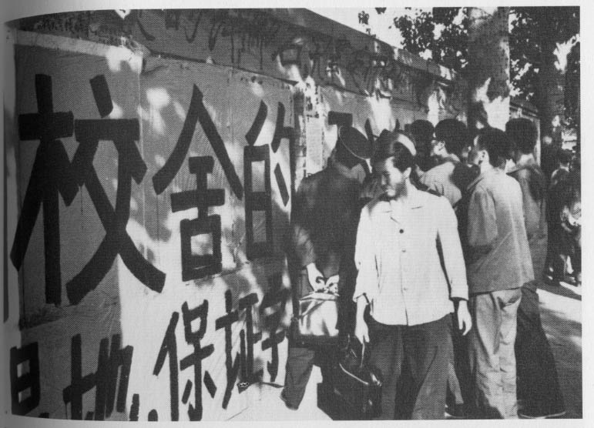

All photos in this lesson are from Jonathan D. Spence. The Search for Modern China. New York: W. W. Norton and Company, 1990.
Excerpted from The Search for Modern China: A Documentary Collection, ed. by Pei-kai Cheng and Michael Lestz with Jonathan Spence. New York: W. W. Norton and Company, 1999. pp. 488-489
Ibid. pp. 493.
Jonathan D. Spence. The Search for Modern China. New York: W. W. Norton and Company, 1990. p. 662.
Ibid. p. 661.

