Lesson Question: What were the effects of
Arabic trade on West Africa?

Grounding Source:

“The Influence of Islam on West Africa” in History Alive: The Medieval World and Beyond, pgs. 155, 158
During the seventh century, Islam spread quickly through the Middle East and North Africa. In the eight century, trans-Saharan trade brought Muslim merchants and traders to West Africa. Over the next few hundred years, Islam spread among West Africans…Both Mali and Songhai eventually accepted Islam. The new faith left a lasting mark on the culture of West Africa.
West Africans often blended Islamic culture with their own traditions. For example, West Africans who became Muslims began praying to God in Arabic. They built mosques as places of workshop. Yet they also continued to pray to the spirits of their ancestors, as they had done for centuries…
As Islam spread in West Africa, people adopted new religious practices and ethical values. African Muslims learned Islam’s Five Pillars of Faith. They prayed in Arabic, fasted, worshiped in mosques, went on pilgrimages, and gave alms. They were taught to regard all Muslims as part of a single community.
West Africans also began to celebrate Muslim religious festivals. The festival of Eid al-Fitr marks the end of the holy month of Ramadan.

How did Islam spread to West Africa?

What aspects of Islam did the West Africans adopt?

How does this source allow us to answer the lesson question?

Source 1:

Source 1: Al-Bakri, “The Book of Routes and Realms”
Al-Bakri lived in the eleventh century and died in 1094. He lived his entire life in Spain and never visited Mali. He collected his information from other Arab historians who had traveled to West Africa. The kings of Ghana were not Muslims. These excerpts come from al-Bakri’s Book of Routes and Realms, written in 1068.

The city of Ghana consists of two towns. . . . One of these towns, which is inhabited by Muslims, is large and has twelve mosques, in one of which they assemble for the Friday prayer. There are salaried imams and muezzins, as well as jurists and scholars…  The king's interpreters, the official in charge of his treasury and the majority of his ministers are Muslims. When the people who follow the same religion as the king approach him they fall on their knees and sprinkle dust on their heads, for this is their way of greeting him. As for the Muslims, they greet him only by clapping their hands. . .  On every donkey-load of salt when it is brought into the country their king levies one golden dinar, and two dinars when it is sent out. The nuggets [of gold] found in all the mines of his country are reserved for the king, and only this gold dust is left for the people. | salaried—a regular income  interpreters—people who provide an oral translation between speakers who speak different languages.

Found in the History Blueprint: Medieval World, “Mali,” p.25

How did trade affect the way the towns were organized in Ghana?

What benefits does the trade bring the king?

How does this source allow us to answer the lesson question?

Source 2:
“New Ideas about Government and Law” in History Alive: The Medieval World and Beyond, pgs. 159

Muslims in the Middle East and North African developed Islamic forms of government and law. Muslim rulers in West Africa adopted some of these ideas.  One important change concerned the line of succession, or inheritance of the right to rule. In West Africa, succession to the throne had been matrilineal. That is, the right to rule was traced through a woman rather than a man…In Ghana the son of the king’s sister inherited the throne. After the arrival of Islam, succession became patrilineal. Under this system, the right to rule passed from father to son.  A second change affected the structure of government. Muslims believed in a highly centralized government. After West African kings converted to Islam, they started to exercise more control of local rulers. Rulers also adopted titles used in Muslim lands. Often the head of a region was now called the sultan or the amir or emir. Amir and emir are shortened forms of Amial- Muminin. This Arabic expression means “Commander of the Faithful.” | succession—the rules about who will become the next ruler  matrilineal—from the line of the mother

What aspects of Islam did the West Africans adopt?

How does this source allow us to answer the lesson question?

Source 3:
“Conversion to Islam,” in Across the Centuries, p. 116

Among the first of the converts to Islam were the Mandinke people from the Southern Sahara, who served as middlemen in trade between Arab caravans and Wangara gold miners. The Mandinke formed small trade companies that made contact with many different people. They spread Islamic ideas throughout West Africa.

Many West Africans converted to Islam because it stressed belief in the “brotherhood of all believers.” This sense of brotherhood encouraged trust and peaceful trade between people of different nationalities. Muslim traders often extended credit to each other simply because they practiced the same faith.

What encouraged people to adopt Islam?

How does this source allow us to answer the lesson question?

Source 4:
Tahir Shah, “The Islamic Legacy of Timbuktu,” Aramco World, November/December 1995 found at https://www.saudiaramcoworld.com/issue/199506/the.islamic.legacy.of.timbuktu.htm

Located in today's Mali, some 12 kilometers (eight miles) north of the Niger flood-plain along the southern edge of the Sahara, Timbuktu today is little more than a sleepy, sweltering stop on the adventure-tourism trail. Most visitors fly in and out in a single afternoon; the city's days as a caravanserai and desert entrepôt (trading center) are long past…
Set on the Islamic world's southwestern edge, Timbuktu was the product of an eclectic mixture of West African and Arab influences that found in Islam a common denominator... Its peoples … lived side by side, in peace, bound together by their belief in God, their acceptance of the Qur'an, and their familiarity with Arabic.
… The difficulty of the journey to or from Timbuktu induced pilgrims and traders alike, once they got there, to spend months, even years, in the city before moving on. In time, local belief held that, by studying the Qur'an or donating generously to Timbuktu's Islamic schools, one would be assured safe passage through the surrounding desert…
Built literally of the desert itself, the adobe mosques of Timbuktu became famous throughout the Islamic world. They towered high above the sandy streets and afforded the city an impressive skyline.
Tahir Shah lives in London and is the author of Beyond the Devil's Teeth: Journeys in Gondwanaland, published by Octagon Press, as well as five other books.
Map from Florida Geographic Alliance found at http://www.learnnc.org/lp/multimedia/8814
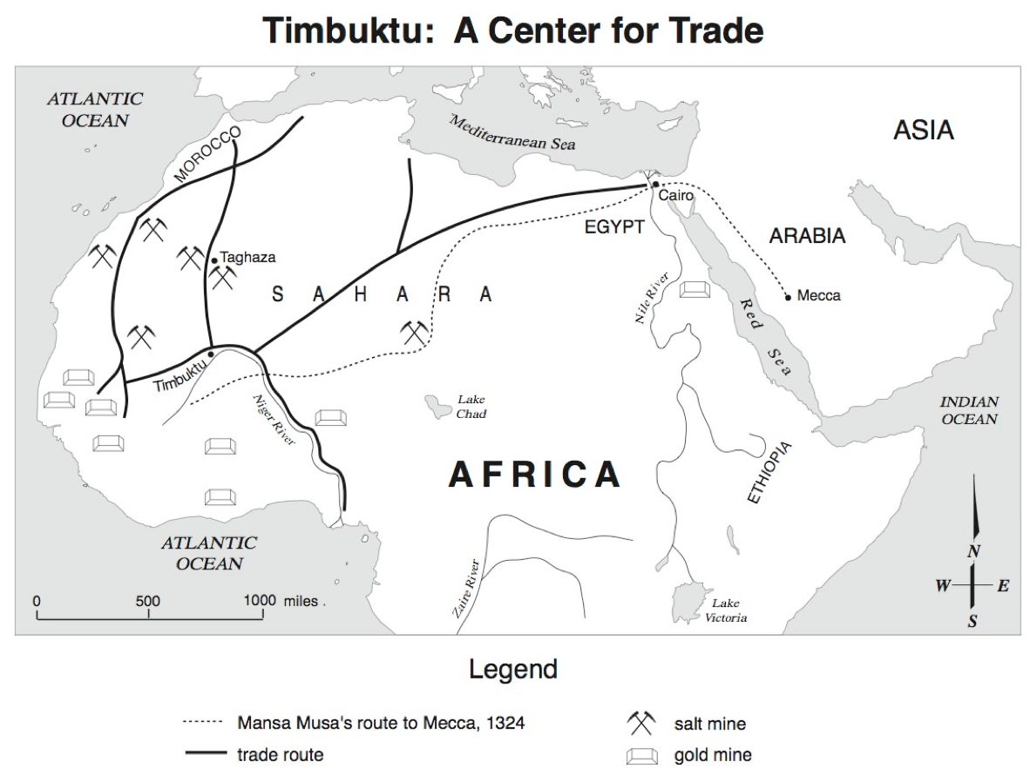 | How did trade make Timbuktu an important city?  Why did people stay in Timbuktu? What did they do when they stayed in the city?  How does this source allow us to answer the lesson question?

Source 5:
Great Mosque of Djenne
The Great Mosque of Djenne is located in Mali and is built of adobe. A mosque has stood on this ground since approximately the 13th century, but this one was built in 1907.

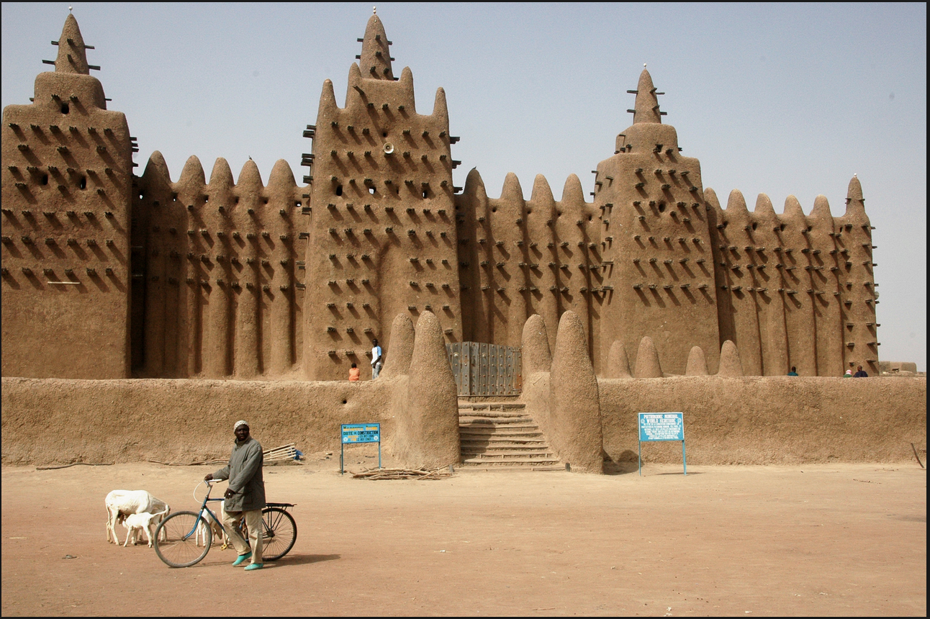
Photo take by Ruud Zwart and found at https://en.wikipedia.org/wiki/Great_Mosque_of_Djenn%C3%A9#/media/File:Djenne_great_mud_mosque.jpg

What aspects of Islam did the West Africans adopt?

How does this source allow us to answer the lesson question?

Lesson Conclusion:

Students should develop a thesis statement that responds to the prompt:
What were the effects of
Arabic trade on West Africa?

In addition to the thesis, list 4 pieces of evidence from the sources to support the thesis:

1.

2.

3.

4.

