SOURCE 1:

Source: Zhi Dun, Chinese scholar, author, and confidant of Chinese aristocrats and high officials during a period when China was embroiled in warfare and instability, circa 350 CE.

Whosoever in China, in this era of sensual pleasures, serves the Buddha and correctly observes the commandments [four noble truths and eightfold path], who recites Buddhist scriptures, and who furthermore makes a vow to be reborn without ever abandoning his sincere intention, will at the end of his life, when his soul passes away, be miraculously transported thither. He will behold the Buddha and be enlightened in Spirit, and then he will enter Nirvana.

SOURCE 2:

Source: Tang Emperor Wu, Edict on Buddhism, 845 CE

We have heard that the Buddha was never spoken before the Han Dynasty; from then on the religion of idols gradually came to prominence. So in this later age Buddhism has transmitted its strange ways and has spread like a vine until it has poisoned the customs of our nation. Buddhism has spread to all nine provinces of China; each day finds its monks and followers growing more numerous and its temples more luxurious. Buddhism wears out the people’s strength, steals their wealth, causes people to abandon their lords and parents for the company of teachers, and separates man and wife with its monastic decrees. In destroying law and injuring humankind indeed nothing surpasses the doctrine of Buddhism!

Now if even one man fails to work the fields, someone must go hungry; if one woman does not tend her silkworms, someone will go cold. At present there are an uncountable number of monks and nuns in the empire, all of them waiting for the farmers to feed them and the silkworms to clothe them while the Buddhist public temples and private chapels have reached boundless numbers, sufficient to outshine even the imperial palace itself!

Having thoroughly examined all earlier reports and consulted public opinion on all sides, there no longer remains the slightest doubt in our mind that this evil should be removed.

SOURCE 3:

Source: Zong Mi, a leading Buddhist scholar, favored by the Tang Imperial household in an essay entitled, “On the nature of Man,” late 800’s CE.

Confucius, Laozi, and the Buddha were perfect sages. They established their teachings according to the demands of the age and the needs of the various beings. While they differ in their approaches, they all encourage the perfection of good deeds, punishment of wicked ones, and reward for good ones; all three teachings lead to the creation of an orderly society and for this they must be observed with respect.

SOURCE 4:

The Longmen caves and cliff sculptures of Buddhist divinities were created in phases over the centuries, with the oldest dating back to the late 5th century (Northern Wei Dynasty 386 - 534 CE), and the most recent completed in the 10th century (Tang Dynasty 618 - 907 CE). The grottoes are situated on both sides of the Yi River, and include some 2,300 caves and niches, over 100,000 Buddhist images, and more than 2,800 inscriptions, all commissioned by various imperial dynasties, top-ranking officers, powerful families, religious leaders, merchants, and even common people (who could only afford the smaller niches).

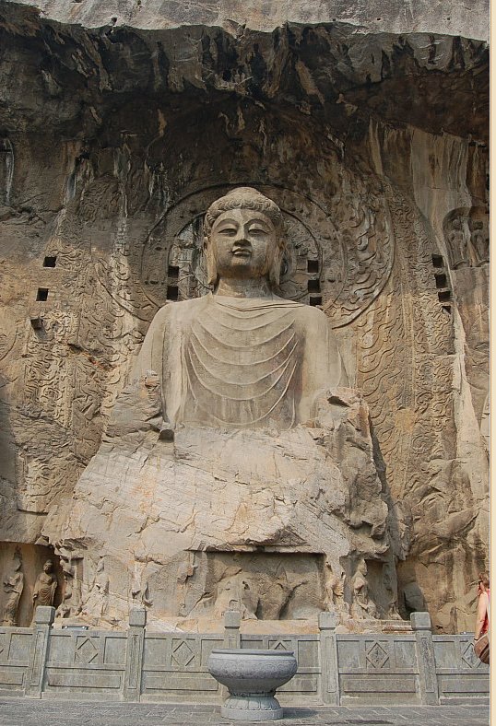
Fengxian Temple
Ancestor Worshipping Temple
Carving began in 672, completed circa 672-675 CE.
Central Image = Vairocana Buddha
Seated atop lotus; 17 meters in height; limestone.
Commissioned by Empress Wu Zetian, and
reportedly made to resemble her facial features.

