**World History – Imperialism**

**Primary Source Collection**

**California History Standard**

10.4 Students analyze patterns of global change in the era of New Imperialism in at least two of the following regions or countries: Africa, Southeast Asia, China, India, Latin America, and the Philippines.

10.4. Describe the rise of industrial economies and their link to imperialism and colonial­ ism (e.g., the role played by national security and strategic advantage; moral issues raised by the search for national hegemony, Social Darwinism, and the missionary impulse; material issues such as land, resources, and technology).

10.4.3 Explain imperialism from the perspective of the colonizers and the colonized and the varied immediate and long-term responses by the people under colonial rule.

**Common Core State Standard**

Key Ideas and Details

1. Cite specific textual evidence to support analysis of primary and secondary sources, attending to such features as the date and origin of the information.

2. Determine the central ideas or information of a primary or secondary source; provide an accurate summary of how key events or ideas develop over the course of the text.

3. Analyze in detail a series of events described in a text; determine whether earlier events caused later ones or simply preceded them.

Craft and Structure

4. Determine the meaning of words and phrases as they are used in a text, including vocabulary describing political, social, or economic aspects of history/social studies.

6. Compare the point of view of two or more authors for how they treat the same or similar topics, including which details they include and emphasize in their respective accounts

Integration of Knowledge and Ideas

9. Compare and contrast treatments of the same topic in several primary and secondary sources.

**Guiding Questions**

Argumentative: Was imperialism beneficial to developing nations?

Informative: What are the patterns of imperialism?

**Primary Source Documents**

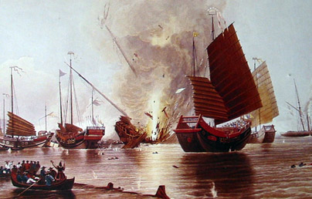

**The British iron steamship HMS Nemesis (far right) destroying Chinese war junks in the Opium War, 1841.**

“Destroying Chinese War Junks,”

painting by E. Duncan, 1843,

National Maritime Museum, London

**From the Internet Modern History Sourcebook**

**Excerpts from British Missionary Letters:**

**Urging the Annexation of The South Sea Islands, 1883**

**Letter Published by John G. Paton, New Hebrides Mission:**

For the following reasons we think the British government ought now to take possession of the New Hebrides group of the South Sea islands, of the Solomon group, and of all the intervening chain of islands from Fiji to New Guinea:

1. Because she has already taken possession of Fiji in the east, and we hope it will soon be known authoritatively that she has taken possession of New Guinea at the northwest, adjoining her Australian possessions, and the islands between complete this chain of islands lying along the Australian coast.

2. The sympathy of the New Hebrides natives are all with Great Britain, hence they long for British protection, while they fear and hate the French, who appear eager to annex the group, because they have seen the way the French have treated the native races in New Caledonia, the Loyalty Islands, and other South Sea islands.

3. Until within the past few months almost all the Europeans on the New Hebrides were British subjects, who long for British protection.

4. All the men and all the money used in civilizing and Christianizing the New Hebrides have been British. Now fourteen missionaries and the Dayspring mission ship, and about 150 native evangelists and teachers are employed in the above work on this group, in which over #6000 yearly of British and British-colonial money is expended; and certainly it would be unwise to let any other power now take possession and reap the fruits of all this British outlay.

5. Because the New Hebrides are already a British dependency in this sense---all its imports are from Sydney and Melbourne and British colonies, and all its exports are also to British colonies.

6. The islands on this group are generally very rich in soil and in tropical products so that if a possession of Great Britain, and if the labor traffic stopped so as to retain what remains of the native populations on them, they would soon, and for ages to come, become rich sources of tropical wealth to these colonies, as sugar cane is extensively cultivated on them by every native of the group, even in his heathen state. . .

7. Because if any other nation takes possession of them, their excellent and spacious harbors, as on Efate, so well-supplied with the best fresh water, and their near-proximity to Great Britain's Australasian colonies, would in time of war make them dangerous to British interests and commerce in the South Seas and her colonies.

8. The thirteen islands of this group on which life and property are now comparatively safe, the 8000 professed Christians on the group, and all the churches formed from among them are, by God's blessing, the fruits of the labors of British missionaries, who, at great toil, expense, and loss of life have translated, got printed, and taught the natives to read the Bible in part or in whole in nine different languages of this group, while 70,000 at least are longing and ready for the gospel…and we fear all this good work would be lost if the New Hebrides fall into other than British hands.

For the above reasons, and others that might be given, we sincerely hope and pray that you will do all possible to get Victoria and the other colonial governments to help and unite in urging Great Britain at once to take possession of the New Hebrides group. Whether looked at in the interests of humanity, or of Christianity, or commercially, or politically, sure it is most desirable that they should at once be British possessions.

From: Accounts and Papers 1883, (London: HMSO, 1883), Vol. XLVII, pp. 29-30.

**From the Internet Modern History Sourcebook**

**Wilfred Scawen Blunt:**

**Excerpts from Britain's Imperial Destiny, 1896-1899**

9th Jan. 1896. The German Emperor has telegraphed his congratulations to Kruger [the Boer leader], and this seems to have produced great anger in England. We have now managed in the last six months to quarrel violently with China, Turkey, Belgium, Ashanti, France, Venezuela, America, and Germany. This is a record performance, and if it does not break up the British Empire nothing will. For myself I am glad of it all, for the British Empire is the greatest engine of evil for the weak races now existing in the world---not that we are worse than the French or Italians or Americans--indeed, we are less actively destructive---but we do it over a far wider area and more successfully. I should be delighted to see England stripped of her whole foreign possessions. We are better off and more respected in Queen Elizabeth's time, the "spacious days," when we had not a stick of territory outside the British Islands, than now, and infinitely more respectable. The gangrene of colonial rowdyism is infecting us, and the habit of repressing liberty in weak nations is endangering our own. I should be glad to see the end....

17th Oct. 1898. Arrived at Saighton. I have had it out with George [Wyndham, parliamentary under-secretary in the War Office] about Fashoda. He states the English case with brutal frankness. "The day of talking," he says, "about legality in Africa is over, all the international law there is there consists of interest and understandings. It is generally agreed by all the powers that the end of African operations is to 'civilize' it in the interests of Europe, and that to gain that end all means are good. The only difference between England and France is which of them is to do it in which particular districts. England intends to do it on the Nile, and it makes no difference what the precise legal position is…We don't care whether the Nile is called English or Egyptian or what it is called, but we mean to have it and we don't mean the French to have it…It is not worth while drawing distinctions of right and wrong in the matter, it is a matter entirely of interest."…

22nd Dec., 1900. The old century is very nearly out, and leaves the world in a pretty pass, and the British Empire is playing the devil in it as never an empire before on so large a scale. We may live to see its fall. All the nations of Europe are making the same hell upon earth in China, massacring and pillaging and raping in the captured cities as outrageously as in the Middle Ages. The Emperor of Germany gives the word for slaughter and the Pope looks on and approves. In South Africa our troops are burning farms under Kitchener's command, and the Queen and the two houses of Parliament, and the bench of bishops thank God publicly and vote money for the work. The Americans are spending fifty millions a year on slaughtering the Filipinos; the King of the Belgians has invested his whole fortune on the Congo, where he is brutalizing the Negroes to fill his pockets. The French and Italians for the moment are playing a less prominent part in the slaughter, but their inactivity grieves them. The whole white race is reveling openly in violence, as though it had never pretended to be Christian. God's equal curse be on them all! So ends the famous nineteenth century into which we were so proud to have been born....

31st Dec., 1900. I bid good-bye to the old century, may it rest in peace as it has lived in war. Of the new century I prophesy nothing except that it will see the decline of the British Empire. Other worse empires will rise perhaps in its place, but I shall not live to see the day. It all seems a very little matter here in Egypt, with the pyramids watching us as they watched Joseph, when, as a young man four thousand years ago, perhaps in this very garden, he walked and gazed at the sunset behind them, wondering about the future just as I did this evening. And so, poor wicked nineteenth century, farewell!

From: W. S. Blunt, My Diaries: 1888-1914, 2 Vols., (New York: Alfred A. Knopf, 1921), I.212-213, 298-299, 325, 375-380.

**From the Internet Modern History Sourcebook**

**Rudyard Kipling, The White Man's Burden, 1899**

Take up the White Man's burden--

Send forth the best ye breed--

Go bind your sons to exile

To serve your captives' need;

To wait in heavy harness,

On fluttered folk and wild--

Your new-caught, sullen peoples,

Half-devil and half-child.

Take up the White Man's burden--

In patience to abide,

To veil the threat of terror

And check the show of pride;

By open speech and simple,

An hundred times made plain

To seek another's profit,

And work another's gain.

Take up the White Man's burden--

The savage wars of peace--

Fill full the mouth of Famine

And bid the sickness cease;

And when your goal is nearest

The end for others sought,

Watch sloth and heathen Folly

Bring all your hopes to nought.

Take up the White Man's burden--

No tawdry rule of kings,

But toil of serf and sweeper--

The tale of common things.

The ports ye shall not enter,

The roads ye shall not tread,

Go mark them with your living,

And mark them with your dead.

Take up the White Man's burden--

And reap his old reward:

The blame of those ye better,

The hate of those ye guard--

The cry of hosts ye humour

(Ah, slowly!) toward the light:--

"Why brought he us from bondage,

Our loved Egyptian night?"

Take up the White Man's burden--

Ye dare not stoop to less--

Nor call too loud on Freedom

To cloke your weariness;

By all ye cry or whisper,

By all ye leave or do,

The silent, sullen peoples

Shall weigh your gods and you.

Take up the White Man's burden--

Have done with childish days--

The lightly proferred laurel,

The easy, ungrudged praise.

Comes now, to search your manhood

Through all the thankless years

Cold, edged with dear-bought wisdom,

The judgment of your peers!

**From the Internet Modern History Sourcebook**

**Dadabhai Naoroji:**

**Excerpts from The Benefits of British Rule, 1871**

**The Benefits of British Rule for India:**

In the Cause of Humanity: Abolition of suttee and infanticide. Destruction of Dacoits, Thugs, Pindarees, and other such pests of Indian society. Allowing remarriage of Hindu widows, and charitable aid in time of famine. Glorious work all this, of which any nation may well be proud, and such as has not fallen to the lot of any people in the history of mankind.

In the Cause of Civilization: Education, both male and female. Though yet only partial, an inestimable blessing as far as it has gone, and leading gradually to the destruction of superstition, and many moral and social evils. Resuscitation of India's own noble literature, modified and refined by the enlightenment of the West.

Politically: Peace and order. Freedom of speech and liberty of the press. Higher political knowledge and aspirations. Improvement of government in the native states. Security of life and property. Freedom from oppression caused by the caprice or greed of despotic rulers, and from devastation by war. Equal justice between man and man (sometimes vitiated by partiality to Europeans). Services of highly educated administrators, who have achieved the above-mentioned results.

Materially: Loans for railways and irrigation. Development of a few valuable products, such as indigo, tea, coffee, silk, etc. Increase of exports. Telegraphs.

Generally: A slowly growing desire of late to treat India equitably, and as a country held in trust. Good intentions. No nation on the face of the earth has ever had the opportunity of achieving such a glorious work as this. I hope in the credit side of the account I have done no injustice, and if I have omitted any item which anyone may think of importance, I shall have the greatest pleasure in inserting it. I appreciate, and so do my countrymen, what England has done for India, and I know that it is only in British hands that her regeneration can be accomplished. Now for the debit side.

**The Detriments of British Rule:**

In the Cause of Humanity: Nothing. Everything, therefore, is in your favor under this heading.

In the Cause of Civilization: As I have said already, there has been a failure to do as much as might have been done, but I put nothing to the debit. Much has been done, though.

Politically: Repeated breach of pledges to give the natives a fair and reasonable share in the higher administration of their own country, which has much shaken confidence in the good faith of the British word. Political aspirations and the legitimate claim to have a reasonable voice in the legislation and the imposition and disbursement of taxes, met to a very slight degree, thus treating the natives of India not as British subjects, in whom representation is a birthright. Consequent on the above, an utter disregard of the feelings and views of the natives. The great moral evil of the drain of wisdom and practical administration, leaving none to guide the rising generation.

Financially: All attention is engrossed in devising new modes of taxation, without any adequate effort to increase the means of the people to pay; and the consequent vexation and oppressiveness of the taxes imposed, imperial and local. Inequitable financial relations between England and India…

Materially: The political drain, up to this time, from India to England, of above ,500,000,000, at the lowest computation, in principal alone, which with interest would be some thousands of millions… The consequent continuous impoverishment and exhaustion of the country, except so far as it has been very partially relieved and replenished by the railway and irrigation loans, and the windfall of the consequences of the American war, since 1850. Even with this relief, the material condition of India is such that the great mass of the poor have hardly tuppence a day and a few rags, or a scanty subsistence. The famines that were in their power to prevent, if they had done their duty, as a good and intelligent government. The policy adopted during the last fifteen years of building railways, irrigation works, etc., is hopeful, has already resulted in much good to your credit, and if persevered in, gratitude and contentment will follow. An increase of exports without adequate compensation; loss of manufacturing industry and skill. Here I end the debit side.

**Summary:** To sum up the whole, the British rule has been: morally, a great blessing; politically, peace and order on one hand, blunders on the other; materially, impoverishment, relieved as far as the railway and other loans go. The natives call the British system "Sakar ki Churi," the knife of sugar. That is to say, there is no oppression, it is all smooth and sweet, but it is the knife, notwithstanding. I mention this that you should know these feelings. Our great misfortune is that you do not know our wants. When you will know our real wishes, I have not the least doubt that you would do justice. The genius and spirit of the British people is fair play and justice.

From: Dadabhai Naoroji, Essays, Speeches, Addresses and Writings, (Bombay: Caxton Printing Works, 1887), pp. 131-136.

From HOT Lesson, Grade 10, African Imperialism



Inoculation against plague, Bombay 1897 – 1914. From <http://www.iias.nl/iiasn/25/regions/25SA1.html>.

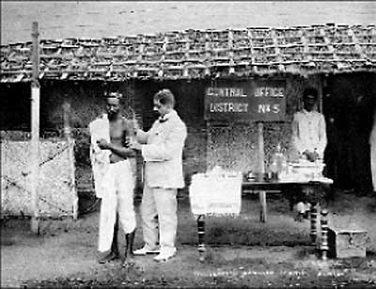

|  |  |
| --- | --- |
| |  | | --- | | An early Indian railway station, c. 1854. From: <http://www.columbia.edu/itc/mealac/pritchett/00routesdata/1800_1899/dailylife_drawings/ilnviews/railwaystation.jpg>. | |

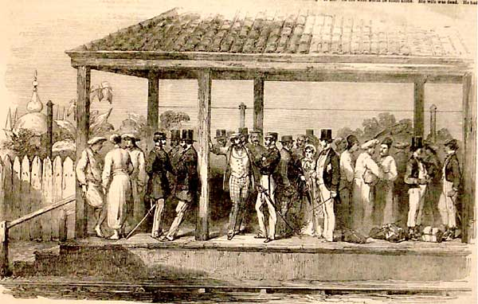

**From the Internet Modern History Sourcebook**

**F. Hassaurek:**

**Excerpts from How to Conduct a Latin-American Revolution, 1865**

…A political adversary is considered an outlaw, who may with impunity be treated in the most arbitrary and cruel manner by those in power. His haciendas are laid waste by soldiers quartered on them; his cattle and horses are at the mercy of a reckless Government. The greatest sufferers, however, are the owners of beasts of burden, whether they take part in political affairs or not. Their horses and mules are taken whenever they are needed for the transportation of military stores. They are used generally without compensation to the owner, who may congratulate himself id they are at last restored to him. Their galled backs and emaciated bodies are the pay he gets, all constitutional and legal provisions to the contrary notwithstanding. Those who own mules or donkeys which they hire out to travelers, or on which they bring their vegetables to market, keep away from cities in times of war or civil commotion, for fear of being robbed of their means of subsistence. Their beasts they send to the fastnesses of the mountains until the danger is over. Thus the city markets will be but scantily supplied, merchants cannot ship their goods, travelers find no means of transportation, and the whole country suffers and decays because Government will not respect individual rights and private property.

When the country is threatened with war, foreign invasion, or revolution, or when a violent change of government has taken place, the houses of foreign ministers, consuls, and other foreigners are eagerly resorted to by all classes of the population. Not only will ladies and gentlemen take refuge there, but such houses will be depositories for all sorts of valuables---goods, trunks, and boxes, belonging to merchants, mechanics, private citizens, and even the Government. During the war with New Granada, in 1862, when it was feared that General Arboleda, after his victory at Tulcan, would march to Quito and occupy the town, the Government made arrangements to deposit the silver bars belonging to the mint in the house of one of the foreign ministers. The houses of foreigners are respected, not only because the Governments to which they belong are expected to shield them with a strong arm, but also because even the victorious or ruling party are interested in maintaining the sacredness or asylums to which, perhaps tomorrow, it may be their turn to resort as the vanquished. In Ecuador, foreigners alone enjoy the rights and privileges which the constitution, on paper, guarantees to the citizen. The persons of foreigners are secure; their servants are not taken away from them; their beasts are never interfered with; their property is respected; and if they have a diplomatic representative in the country, they are favored in a thousand different ways. They are the only class of persons who can carry on business in safety. Of course, they will suffer from bad times, when the country is desolated by revolutions or civil war, but they have little to fear from the Government and party leaders; and while forced contributions of money or goods will be exacted from the native capitalists; while their servants and laborers, horses and cattle, will be taken away from them; the person, property, laborers, and servants of a foreigner will be secure. No wonder, therefore, that every extensive landowner, every wealthy merchant in the country, wants to make himself a foreigner. I was almost continually troubled by persons who wanted to know how to make themselves North American citizens. Everybody, almost, who has anything to lose is anxious to abjure his nationality, and place himself under the protection of a foreign flag.

From: Eva March Tappan, ed., Canada, South America, Central America, Mexico and the West Indies, Vol. XI in The World's Story: A History of the World in Story, Song, and Art, (Boston: Houghton Mifflin, 1914), pp. 330-335.

**From the Internet Modern History Sourcebook**

**Alexander Von Humboldt:**

**Excerpts from Problems And Progress in Mexico, c. 1800**

*Alexander von Humboldt was a German scientists who left a detailed description of his visits to the Spanish Empire around 1800. The laws of Spain prevented entry to all non-Spanish Europeans to the Spanish Empire. Humboldt's comments as an outsider are then, especially valuable.*

Mexico is the country of inequality. No where does there exist such a fearful difference in the distribution of fortune, civilization, cultivation of the soil, and population. The interior of the country contains four cities, which are not more than one or two days' journey distant from one another, and possess a population of 35,000, 67,000, 70,000, and 135,000. The central table-land from la Puebla to Mexico, and from thence to Salamanca and Zelaya, is covered with villages and hamlets like the most cultivated part of Lombardy. To the east and west of this narrow strip succeed tracts of uncultivated ground, on which cannot be found ten or twelve persons to the square league. The capital and several other cities have scientific establishments, which will bear a comparison with those of Europe. The architecture of the public and private edifices, the elegance of the furniture, the equipages, the luxury and dress of the women, the tone of society, all announce a refinement to which the nakedness, ignorance, and vulgarity of the lower people form the most striking contrast. This immense inequality of fortune does not only exist among the cast of whites (Europeans or Creoles), it is even discoverable among the Indians.

The Mexican Indians, when we consider them en masse, offer a picture of extreme misery. Banished into the most barren districts, and indolent from nature, and more still from their political situation, the natives live only from ,hand to mouth. We should seek almost in vain among them for individuals who enjoy anything like a certain mediocrity of fortune. Instead, however, of a comfortable independency, we find a few families whose fortune appears so much the more colossal, as we least expect it among the lowest class of the people. In the intendancies of Oaxaca and Valladolid, in the valley of Toluca, and especially in the environs of the great city of la Puebla de los Angeles, we find several Indians, who under an appearance of poverty conceal considerable wealth. When I visited the small city of Cholula, an old Indian woman was buried there, who left to her children plantations of maguey (agave) worth more than 360,000 francs. These plantations are the vineyards and sole wealth of the country. However, there are no caciques at Cholula; and the Indians there are all tributary, and distinguished for their great sobriety, and their gentle and peaceable manners. The manners of the Cholulans exhibit a singular contrast to those of their neighbors of Tlascala, of whom a great number pretend to be the descendants of the highest titled nobility, and who increase their poverty by a litigious disposition and a restless and turbulent turn of mind. Among the most wealthy Indian families at Cholula are the Axcotlan, the Sarmientos and the Romeros; at Guaxocingo, the Sochipiltecatl; and especially the Tecuanouegues in the village de los Reyes. Each of these families possesses a capital of from 800,000 to 1,000,000 of livres. They enjoy, as we have already stated, great consideration among the tributary Indians; but they generally go barefooted, and covered with a Mexican tunic of coarse texture and a brown colour, approaching to black, in the same way as the very lowest of the Indians are usually dressed…

If the legislation of Queen Isabella and the Emperor Charles V appears to favour the Indians with regard to imposts, it has deprived them, on the other hand, of the most important rights enjoyed by the other citizens. In an age when it was formally discussed if the Indians were rational beings, it was conceived granting them a benefit to treat them like minors, to put them under the perpetual tutory of the whites, and to declare null every act signed by a native of the copper-coloured race, and every obligation which he contracted beyond the value of 15 francs…

Source:

from Alexander von Humboldt, Political Essay on the Kingdom of New Spain, trans. John Black (London: Longman, Hurst, Rees, Orme, and Brown, 1811), vol. 1, pp. 134-217, passim.

**From the Internet Modern History Sourcebook**

**Excerpts from The People of Canton: Against the English, 1842**

*[Tappan Introduction]: From a paper that was agreed to at a great public meeting in Canton.*

Behold that vile English nation! Its ruler is at one time a woman, then a man, and then perhaps a woman again; its people are at one time like vultures, and then they are like wild beasts, with dispositions more fierce and furious than the tiger or wolf, and natures more greedy than anacondas or swine. These people having long steadily devoured all the western barbarians, and like demons of the night, they now suddenly exalt themselves here.

During the reigns of the emperors Kien-lung and Kia-king these English barbarians humbly besought an entrance and permission to deliver tribute and presents; they afterwards presumptuously asked to have Chu-san; but our sovereigns, clearly perceiving their traitorous designs, gave them a determined refusal. From that time, linking themselves with traitorous Chinese traders, they have carried on a large trade and poisoned our brave people with opium.

Verily, the English barbarians murder all of us that they can. They are dogs, whose desires can never be satisfied. Therefore we need not inquire whether the peace they have now made be real or pretended. Let us all rise, arm, unite, and go against them.

We do here bind ourselves to vengeance, and express these our sincere intentions in order to exhibit our high principles and patriotism. The gods from on high now look down upon us; let us not lose our just and firm resolution.

From: Eva March Tappan, ed., China, Japan, and the Islands of the Pacific, Vol. I of The World's Story: A History of the World in Story, Song, and Art, (Boston: Houghton Mifflin, 1914), p. 197.

**From the Internet Modern History Sourcebook**

**Kaiser Wilhelm II and German Interests in China**

*[An uprising of the Society of Righteous Harmonious Fists--the Boxer Rebellion--was a desperate effort by native Chinese forces to stave off foreign influence and the dismemberment of their country by the Great Powers. In June 1900, 140,000 Boxers occupied Peking, laying siege to the foreigners and attacking Chinese converts to Christianity. An international expeditionary force raised the siege in August, but not before several Europeans, including the German envoy and several missionaries, had been murdered. The Boxer Rebellion occasioned heated nationalistic rhetoric all over Europe. Although Kaiser Wilhelm II outdid all others in his posturings, behind the rhetoric, there stood concrete economic interests that had to be protected if Germany were to achieve its "place in the sun."*

*Upon confirmation of the news that the German envoy to Peking had been murdered, a military force was assembled in Bremerhaven for a punitive expedition. Wilhelm and his wife happened to be present at the embarkation, when the Kaiser made this impromptu speech to the soldiers on July 2, 1900. Source: Ernst Johann (ed.), Reden des Kaisers: Ansprachen, Predigten und Trinksprüche Wilhelms II (Munich, 1966), pp. 86-88. Translated by Richard S. Levy.]*

Into the midst of the deepest peace--alas, not surprising to me--the torch of war has been hurled. A crime unprecedented in its brazenness, horrifying in its cruelty, has struck my trusted representative and carried him off. The ambassadors of the other powers are in danger of their lives and along with them your comrades who were dispatched for their protection. Perhaps, they have today fought their last battle. The German flag has been insulted, and the German Empire held up to scorn. This demands an exemplary punishment and revenge.

With fearful speed the conditions have become extremely serious. Since I have summoned you to arms, [the situation has become] still more serious. What I had hoped to restore with the help of the marines will now require the united contingents of troops from all the civilized nations. Today the chief of the cruiser squadron has implored me to consider sending an [entire] division.

You will oppose an enemy no less resolute in the face of death than yourselves. Trained by European officers, the Chinese have learned the use of European weapons. Thank God your comrades in the marines and in my navy, with whom you will join, have asserted and maintained the old German repute in combat; they have defended themselves with glory and victory and eased your task.

Thus I send you now to avenge injustice, and I shall not rest until the German flag, united with those of the other powers, waves victoriously over the Chinese, planted on the walls of Peking, and dictating peace to the Chinese.

Maintain a good comradeship with all the troops whom you will join with there. Russians, Englishmen, Frenchmen, and whoever else--they all fight for one cause, for civilization.

Yet we also bear in mind something higher, our religion, and the defense and protection of our brothers overseas, some of whom have stood up for their Savior with their life.

Think also of our military honor, of those who have fought for you, and depart with the old motto of the flag of Brandenburg: "Trust God, defend yourself bravely. In that lies all your honor! For whoever ventures on God with a full heart will never be routed."

The flags that wave above you here go into fire for the first time. Bring them back to me pure, unblemished, and without stain!

My thanks and my concern, my prayers and my solicitude will not leave you. With these I accompany you.

**From Internet Modern History Sourcebook**

**Thomas Babington Macaulay (1800-1859):**

**Excerpts from On Empire and Education**

*The speech on the India bill of 1833 and expresses his view of the achievements and goals of the British Empire in the East. Between 1834 and 1838 he lived in Calcutta and served on the British "Supreme Council for India".*

I feel that, for the good of India itself, the admission of natives to high office must be effected by slow degrees. But that, when the fulness of time is come, when the interest of India requires the change, we ought to refuse to make that change lest we should endanger our own power, this is a doctrine of which I cannot think without indignation. Governments, like men, may buy existence too dear…. The mere extent of empire is not necessarily an advantage. To many governments it has been cumbersome; to some it has been fatal. It will be allowed by every statesman of our time that the prosperity of a community is made up of the prosperity of those who compose the community, and that it is the most childish ambition to covet dominion which adds to no man's comfort or security. To the great trading nation, to the great manufacturing nation, no progress which any portion of the human race can make in knowledge, in taste for the conveniences of life, or in the wealth by which those conveniences are produced, can be matter of indifference. It is scarcely possible to calculate the benefits which we might derive from the diffusion of European civilisation among the vast population of the East. It would be, on the most selfish view of the case, far better for us that the people of India were well governed and independent of us, than ill governed and subject to us; that they were ruled by their own kings, but wearing our broadcloth, and working with our cutlery, than that they were performing their salams to English collectors and English magistrates, but were too ignorant to value, or too poor to buy, English manufactures. To trade with civilised men is infinitely more profitable than to govern savages. That would, indeed, be a doting wisdom, which, in order that India might remain a dependency, would make it an useless and costly dependency, which would keep a hundred millions of men from being our customers in order that they might continue to be our slaves.

Are we to keep the people of India ignorant in order that we may keep them submissive? Or do we think that we can give them knowledge without awakening ambition? Or do we mean to awaken ambition and to provide it with no legitimate vent? Who will answer any of these questions in the affirmative? Yet one of them must be answered in the affirmative, by every person who maintains that we ought permanently to exclude the natives from high office. 1 have no fears. The path of duty is plain before us: and it is also the path of wisdom, of national prosperity, of national honor.

From Thomas Babington Macaulay, "Speech in Parliament on the Government of India Bill, 10 July 1833," Macaulay, Prose and Poetry, selected by G.M. Young (Cambridge, MA: Harvard University Press, 1957), pp. 716-18

**From the Internet Modern History Sourcebook**

**Moshweshewe: Excerpts from Letter to Sir George Grey, 1858**

**[The establishment of Basutoland]**

… Unfortunately it was not with the English Government that my first intercourse with the whites commenced. People who had come from the Colony first presented themselves to us, they called themselves Boers. I thought all white men were honest. Some of these Boers asked permission to live upon our borders. I was led to believe they would live with me as my own people lived, that is, looking to me as to a father and a friend.

…The Boers then began to talk of their right to places I had then lent to them. Sir P. Maitland told me those people were subjects of the Queen, and should be kept under proper control; he did not tell me that he recognized any right they had to land within my country, but as it was difficult to take them away, it was proposed that all desiring to be under the British rule should live in that part near the meeting of the Orange and Caledon rivers.

Then came Sir Harry Smith, and he told me not to deprive any chief of their lands or their rights, he would see justice done to all, but in order to do so, he would make the Queen's Laws extend over every white man. He said the Whites and Blacks were to live together in peace. I could not understand what he would do. I thought it would be something very just, and that he was to keep the Boers in my land under proper control, and that I should hear no more of their claiming the places they lived on as their exclusive property. But instead of this, I now heard that the Boers consider all those farms as their own, and were buying and selling them one to the other, and driving out by one means or another my own people.

…I was at that time in trouble, for Sikonyela and the Korannas were tormenting me and my people by stealing and killing; they said openly the Major gave them orders to do so, and I have proof he did so. One day he sent me a map and said, sign that, and I will tell those people (Mantatis and Korannas) to leave off fighting: if you do not sign the map, I cannot help you in any way. I thought the Major was doing very improperly and unjustly. I was told to appeal to the Queen to put an end to this injustice. I did not wish to grieve Her Majesty by causing a war with her people. I was told if I did not sign the map, it would be the beginning of a great war. I signed, but soon after I sent my cry to the Queen. I begged Her to investigate my case and remove "the line," as it was called, by which my land was ruined. I thought justice would soon be done, and Warden put to rights.

I tried my utmost to satisfy them and avert war. I punished thieves, and sent my son Nehemiah and others to watch the part of the country near the Boers, and thus check stealing. In this he was successful, thieving did cease. We were at peace for a time. In the commencement of the present year my people living near farmers received orders to remove from their places. This again caused the fire to burn, still we tried to keep all quiet, but the Boers went further and further day by day in troubling the Basutos and threatening war. The President (Boshof) spoke of Warden's line, this was as though he had really fired upon us with his guns. Still I tried to avert war.

It was not possible, it was commenced by the Boers in massacring my people of Beersheba, and ruining that station, against the people of which there was not a shadow of a complaint ever brought forward. Poor people, they thought their honesty and love for Christianity would be a shield for them, and that the white people would attack in the first place, if they attacked at all, those who they said were thieves. I ordered my people then all to retreat towards my residence, and let the fury of the Boers be spent upon an empty land; unfortunately some skirmishes took place, some Boers were killed, some of my people also. We need not wonder at this, such is war! But I will speak of many Basutos who were taken prisoners by the Whites and then killed, most cruelly. If you require me to bring forward these cases, I will do so. I will however speak of the horrible doings of the Boers at Morija, they there burnt down the Missionary's house, carried off much goods belonging to the Mission, and pillaged and shamefully defiled the Church Buildings.

I had given orders that no farms should be burnt, and my orders were obeyed till my people saw village after village burnt off, and the corn destroyed, they then carried destruction among the enemy's homes. On coming to my mountain, the Boers found I was prepared to check their progress, and they consequently retired. My intention was then to have followed them up, and to have shown them that my people could also carry on offensive operations, believing that having once experienced the horrors of war in their midst, I should not soon be troubled by them again. My bands were getting ready to make a descent upon them, when the Boers thought proper to make request for a cessation of hostilities. I knew what misery I should bring upon the country by leaving the Basutos to ravage the Boer places, and therefore I have agreed to the proposal of Mr. J. P. Hoffman. I cannot say that I do so with the consent of my people, for many of those who suffered by the enemy were anxious to recover their losses. If they have remained quiet, it has been owing to my persuasions and my promises that they might have good hope of justice---Your Excellency having consented to act as arbitrator between the Boers and Basutos. With the expectation of soon meeting you, I remain, etc., etc.,

Mark X of Moshweshewe, Chief of the Basutos.

**Source.**

From: G. M.Theal, ed., Records of Southeastern Africa (Capetown: Government of Capetown, 1898-1903).

"Jesuit Convent, Macao." by William Heine, Facade of St. Paul's Church, 1854

Facade of St. Paul's Church, 1854

Hong Kong Museum of Art

http://ocw.mit.edu/ans7870/21f/21f.027/rise_fall_canton_04/cw_gal_01_thumb.html

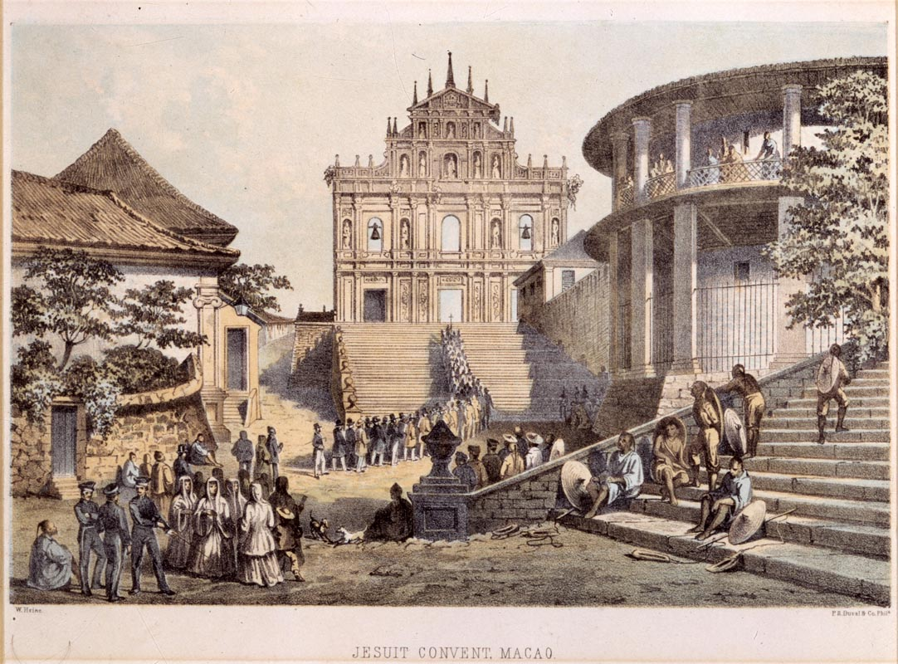

Dr. Thomas Colledge with patients, 1833-1835, by George Chinnery. Colledge opened opthamology clinic.

Peabody Essex Museum 2006 Photo Mark Sexton

http://ocw.mit.edu/ans7870/21f/21f.027/rise_fall_canton_04/cw_gal_02_thumb.html

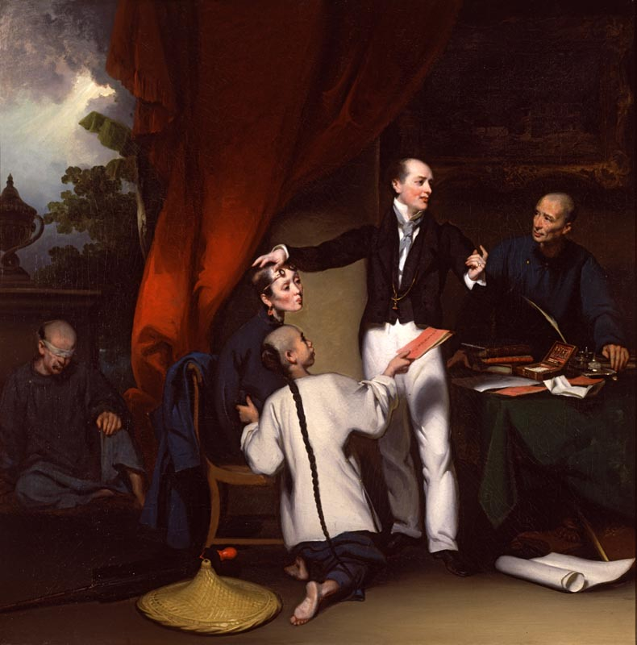

Theatre programme, 14 March 1885. Museum no. theatremuseum-1885

From the Victoria and Albert Museum

http://www.vam.ac.uk/content/articles/t/the-victorian-vision-of-china-and-japan/

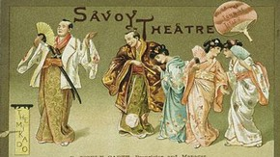

“Reception of the Mission by Shinté”

*Missionary Travels and Researches in South Africa, Including a Sketch of Sixteen Years’ Residence in the Interior of Africa, and a Journey from the Cape of Good Hope to Loanda on the West Coast, Thence Across the Continent, Down the River Zambesi, to the Eastern Ocean*. Presentation copy to Dr. Green from the author and his wife. London: John Murray, 1857.

<http://libweb5.princeton.edu/visual_materials/maps/websites/africa/livingstone/livingstone-images.html>

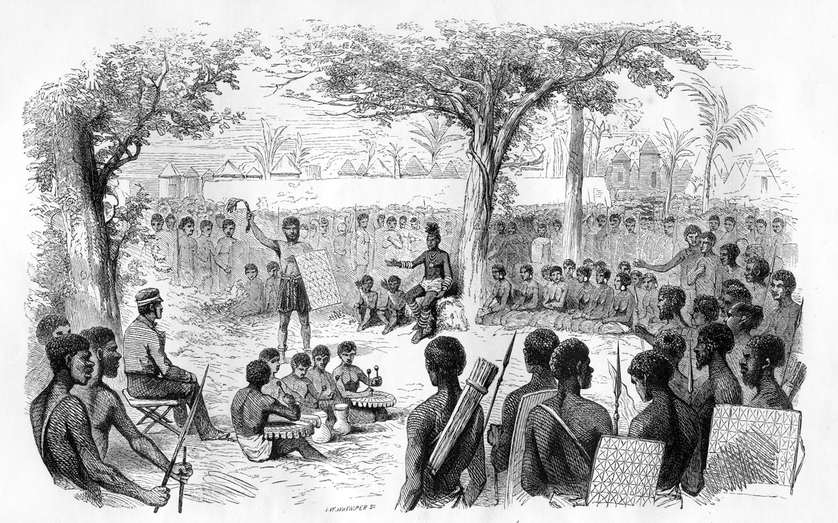

From HOT Lesson, Grade 10, African Imperialism



From HOT Lesson, Grade 10, African Imperialism



From HOT Lesson, Grade 10, African Imperialism



From HOT Lesson, Grade 10, African Imperialism

