Great Leap Forward
Post-war World
From: Nicole Gilbertson, 2015

History Standards: 10.10
Students analyze instances of nation-building in the contemporary world in at least two of the following regions or countries: the Middle East, Africa, Mexico and other parts of Latin America, and China.

CCSS Standards:
Reading, Grade 9-10
- Cite specific textual evidence to support analysis of primary and secondary sources, attending to such features as the date and origin of the information.
6. Compare the point of view of two or more authors for how they treat the same or similar topics, including which details they include and emphasize in their respective accounts.
Writing, Grade 9-10

2. Write informative/explanatory texts, including the narration of historical events, scientific procedures/ experiments, or technical processes.

Guiding Question: What were the effects of the policy of the Great Leap Forward?
Overview of Lesson:
As a class teachers read the background to the class and discuss the questions. Teachers then lead students in a visual analysis of the poster and discuss the guiding questions. For the next part, with the multiple sources, teachers break the students into groups or partners. Students should each review one source below and answer the questions. Then have students share out their responses to the question using evidence from the source. As a class or in larger groups, have students share out each of the sources. Discuss the information provided in each source. Consider which sources are most useful to answer the focus question. Which sources are less useful. As a whole group or large groups, students should answer the final questions requiring them to corroborate the documents to develop a claim using evidence from the four sources.

Background Reading for Historical Context
Mao’s Great Leap Forward and China’s Place in the International Community
China was in a unique position in the 1960s; it could belong to the Second World, because it was communist, or to the Third World, since it was recovering from imperialism and was not yet industrialized. The Chinese leader, Mao Zedong, tried to challenge the dominance of the Soviet Union over the Second World and to influence the Third World at the same time. To bring about Marxian socialism, Mao Zedong first followed the Soviet path. Most of China’s people were rural peasants, and many owned no land at all. A small number of wealthy landowners owned huge amounts of agricultural land in China. The CCP began with a Land Reform movement in 1950. The government took land away from the landlords and divided it among the local peasants. The CCP and local peasants killed more than one million landlords during the bitter campaign. In 1953, Mao’s government began to force these peasants to join collective farms. The CCP nationalized private companies and introduced a Soviet-style Five Year Plan to industrialize the nation. The Communists also introduced equality for women, child-care and education programs, and other programs for peasants and workers. Hoping to help build a strong and independent modern China, many ordinary Chinese enthusiastically supported Mao’s early reforms.
Mao believed that revolution had to continue or it would die. He believed that people had to be stirred to make more and more radical changes in society. He was also not pleased with Soviet leaders and did not want to follow orders from the Soviet Union. In 1958 he began a new program, the Great Leap Forward, which he said would industrialize China faster than Stalin had industrialized the Soviet Union. To accomplish this, the communist party reorganized Chinese farmers into giant communes and directed all agricultural planning.
- What policies did Mao enact in China in the 1950’s?

- How did the Soviet Union influence China’s policies?

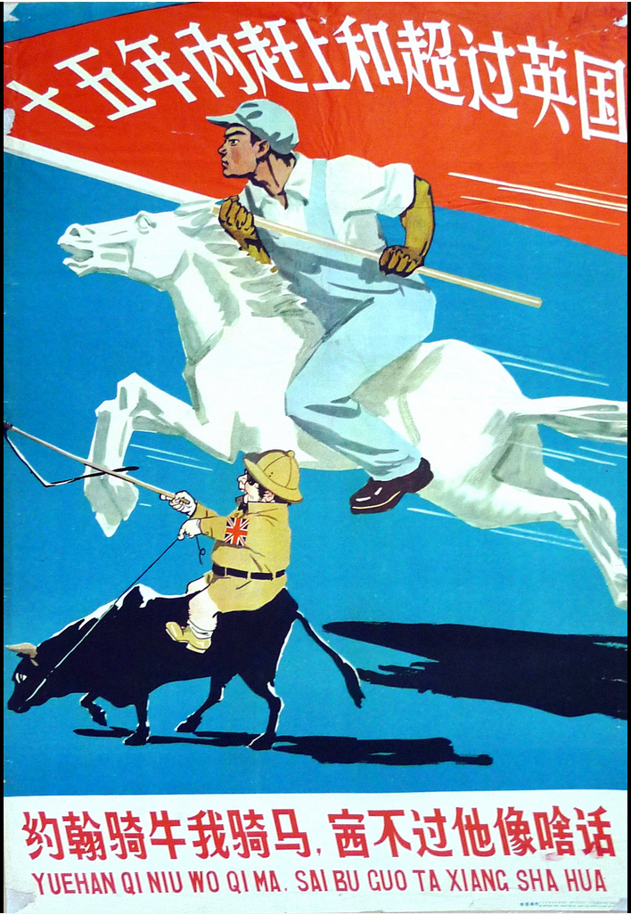 | - What is going on in the image, "John rides the ox and I am on the horse, what a shame if he wins the game." created in China in 1958?  - What message is being communicated by this source? Give specific examples from the imagery of this source to support your answer.
- To be a part of the international group of nations, Chinese leaders attempted many policies to increase Chinese technology, military power, and political authority. The Great Leap Forward is a strategy for increasing China’s relevance and dominance in the world. Given your knowledge of the Soviet Union’s policies to implement communism and China’s Five Year Plans, what do you think might be a part of Mao’s policy of the Great Leap Forward? How will peasants be affected?

Source 1
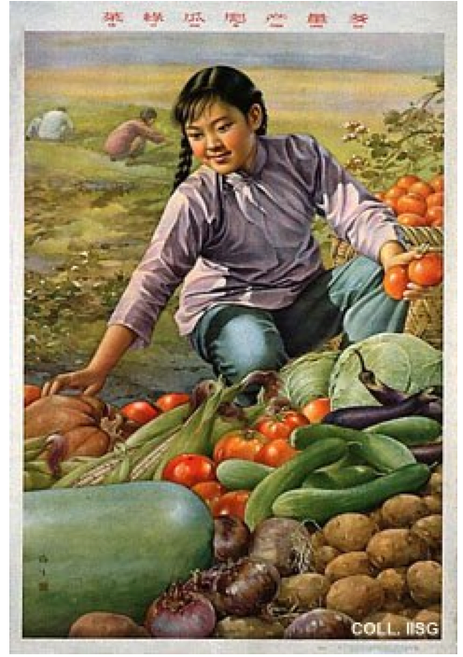 | Citation:  Jin Meisheng, The vegetables are green, the cucumbers plumb, the yield is abundant, 1959. Found at the International Institute of Social History an archive for Communist posters http://www.iisg.nl/exhibitions/chairman/chnintro.php  Questions:  What message is being communicated by this source? Give specific examples from the imagery of this source to support your answer.  According to the poster, what were the effects of the policy of the Great Leap Forward?

Source 2
By the summer of 1958, after a fine harvest had dramatically raised everyone’s hopes, the campaign to end private plots and to organize all of rural China into people’s communes began, with extraordinary apparent success…  The vision was altogether intoxicating, and seemed a complete vindication of Mao’s views on the possibility for sustained growth through the mobilization of mass will and energy…  [However] the grain-production figures had been disastrously over-inflated. The announced total for 1958 of 375 million tons of grain had to be revised downward to 250 million tons…  The Great Leap did bring server fundamental changes to China. The pooling of all household, child-raising, and cooking arrangements had significant effects on family structure, even as it showed that the independent nuclear family remained a more popular form of social organization. The massing of he numbers of rural and city works for giant irrigation, terracing, and construction projects changed the face of China’s landscape…  Mao insisted on heightened extraction of a dwindling peasant surplus…As China’s investment in industry rose to an amazing 43.4 percent of national income in 1959, grain exports to the Soviet Union were also increased to pay for more heavy machinery…The result was famine on a gigantic scale, a famine that claimed 20 million lives or more between 1959 and 1962. | Citation: Jonathan Spence, The Search for Modern China. Second Edition, New York: W.W. Norton and Company, 1999, pages 548-553. Jonathan Spence is a leading historian of modern China and does research and teaches at Yale University.  Questions: According to the reading, how were peasants affected by the Great Leap Forward?  How did Mao respond to the loss of grain produced in China?  According to the reading, infer what you think Mao’s priorities were for the Great Leap Forward given the policies he enacted?

Source 3
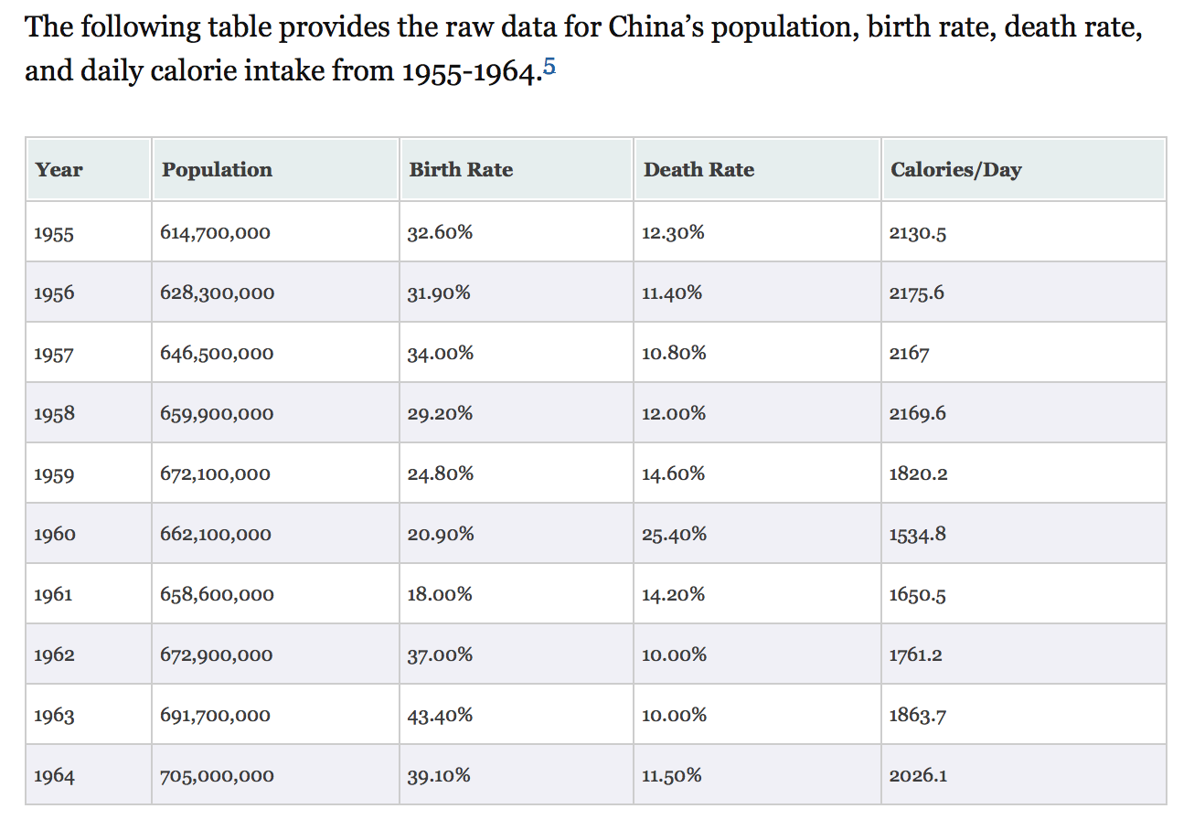
Citation: Basil Ashton et. al., “Famine in China, 1958-61,” Population and Development Review 10.4 (1984): 615, 622. Found at Scott Manning’s website. Manning is a software analyst and history graduate student. http://www.scottmanning.com/content/visualizing-the-great-leap-forward/

Questions:
What information can you learn from the chart?

What are some changes that occurred during the Great Leap Forward (1958-1961), according to the graph?

According to the chart, what can you infer about the effects of the policies of the Great Leap Forward?

Source 4
By the end of 1959 millions of rural Chinese were starving. The communal kitchens served watery soup made of grass and anything else that could be found. As the crisis deepened, China cut itself off from the outside world. Relations with the Soviet Union were broken off so that Krushchev would not learn of the disaster. When problems were admitted, they were blamed on natural causes such as drought, but even then officials continued to insist that food was abundant and the people were happy. Mao began planning another big increase in production targets for 1960. But in much of the country the people were too weak to plant anything. Those in the cities suffered less; they were given grain rations from the central granaries, and thus were the last to be affected by the spread of famine. In the countryside, Party officials had the first claim on what little food was available, so that many of them failed to realize the extent of the catastrophe on the land. Most of those who starved to death were peasants in rural communes. | Citation: Tom Standage, The Edible History of Humanity, New York: Walker Publishing Company, 2009. Standage is a journalist and has published widely on the topics of history, science, and technology.  Questions:  According to the reading, how were Chinese affected by the Great Leap Forward?  What do you think of Mao’s policies? Give evidence from the text to support your answer.

Note-taking chart
Source Citation | Summary of Source | Give an example from the source that explains the effects of the Leap Forward policy. | Does the source provide us with any information about Mao’s policy and China’s role in the international community? If so, include a specific example and explain its significance.

Which evidence do you think is most useful to respond to the question below? Explain your response.
Use the evidence to create a claim that responds to the prompt:
What were the effects of the policy of the Great Leap Forward?

