What were the legacies of the American Revolution?

Guiding Question: Why did the Antifederalists fail?

Introduction
Ratification of the federal Constitution was neither unanimous nor inevitable. Large numbers of Revolutionary patriots, including Samuel Adams, George Mason, and Patrick Henry, did not support the new constitution. Antifederalists never constituted a majority of Americans, but their numbers could be found as far north as New England and as far south as South Carolina. One of the most pressing social and economic problems facing the nation at the time of the Constitutional Convention, and throughout the ratification process, was money. Under the Articles of Confederation, each state had the power to manage and print its own forms of paper currency, or money. This led to major problems because, by 1789, currency from states like Rhode Island had experienced extreme devaluation. Much of this money was worth less than its face value. To understand what this means, imagine trying to buy lunch with a $10.00 bill but the restaurant refusing to serve you because they claim the bill is worth only $1.00. The framers of the Constitution wanted to fix this problem by giving power over money to the new federal government. Thus one of the key goals of the framers was not just to balance power between the three branches of the federal government, but to balance power between the individual states and federal government. Much of the debate over the Constitution concerned the fact that the Constitution took some powers away from the states and give it to the federal government. In addition to increasing the power of the US Congress to tax citizens of the individual states, the federal constitution also barred the individual states from issuing paper money. Antifederalists complained about this transfer of power to the federal government—several Antifederalists wrote against the federal government’s powers of taxation—but the Antifederalists mostly avoided discussing the Constitution’s prohibition against state-issued currency. Why? And does this explain, in part, why the Antifederalists lost the debate?

Source 1

Article 1, Section 10, US Constitution

No State shall enter into any Treaty, Alliance, or Confederation; grant Letters of Marque and Reprisal; coin Money; emit Bills of Credit; make any Thing but gold and silver Coin a Tender in Payment of Debts; pass any Bill of Attainder, ex post facto Law, or Law impairing the Obligation of Contracts, or grant any Title of Nobility.… | Letters of Marque and Reprisal—authorization of individual subject or citizen to commit piracy on the high seas in the name of the government, often as an act of war  Tender—money  Bill of Attainder—law passed by legislature punishing an individual or group of a crime, often without trial

Source: National Archives and Records Administration
https://www.archives.gov/founding-docs/constitution-transcript

Questions
1. Article 1, Section 10 of the Constitution says “no state shall… coin Money; emit Bills of Credit; make any Thing but gold and silver Coin a Tender in Payment of Debts make any Thing but gold and silver Coin a Tender in Payment of Debt.” To which government does the Constitution grant that power?

2. How does the Constitution assign power over monetary policy? Does it assign particular powers to the federal government or deny particular powers to the individual states?

Source 2

Article 9, Articles of Confederation
The united states, in congress assembled, shall never engage in a war, nor grant letters of marque and reprisal in time of peace, nor enter into any treaties or alliances, nor coin money, nor regulate the value thereof nor ascertain the sums and expenses necessary for the defence and welfare of the united states, or any of them, nor emit bills, nor borrow money on the credit of the united states, nor appropriate money…unless nine states assent to the same… | Letters of Marque and Reprisal—authorization of private party to commit piracy on the high seas in the name of the government, often as an act of war

Source: Our Documents https://ourdocuments.gov/print_friendly.php?page=transcript&doc=3&title=Transcript+of+Articles+of+Confederation+%281777%29

Questions
1. How does the Articles limit the power of the central government? Does it assign particular powers to the individual states or deny particular powers to the central government?

Source 3
Amos Doolittle
“The looking glass for 1787. A house divided against itself cannot stand.” (1787)

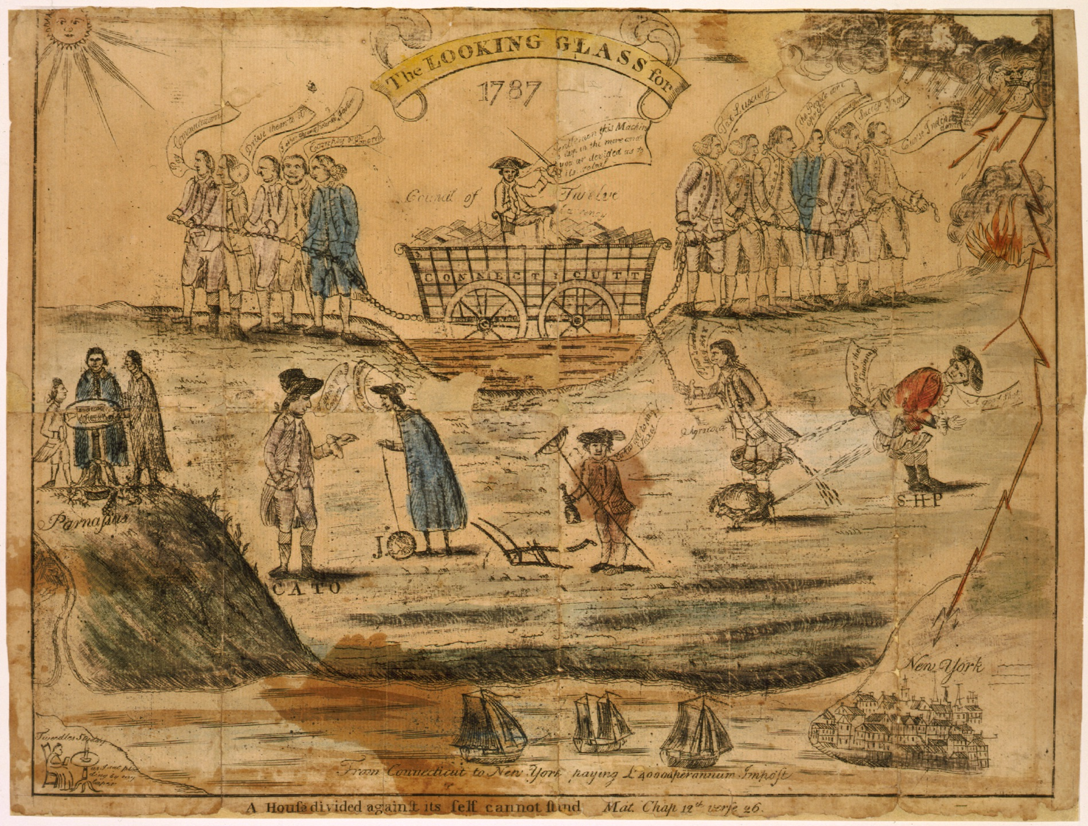
Source: Library of Congress, http://www.loc.gov/pictures/item/2008661778/

Detailed description of “looking glass for 1787” from the Library of Congress:

A satire touching on some of the major issues in Connecticut politics on the eve of the ratification of the U.S. Constitution.

The two rival factions shown are the “Federals,” who represented the trading interests and were for taxes on imports, and the “Antifederals,” who represented agrarian interests and were more receptive to paper money issues. The two groups were also divided on the issue of commutation of military pensions. The artist here evidently sides with the Federals. Connecticut is symbolized by a wagon (top center) loaded with debts and paper money, the weight of which causes it to sink slowly into the mud. Its driver warns, “Gentlemen this Machine is deep in the mire and you are divided as to its releaf--.”
The wagon is pulled in opposite directions by two factions of the state's Council of Twelve. On the left under a beaming sun are five Federal councillors, who proclaim: “Pay Commutation,” “Drive them to it,” “I abhor the antifederal Faction,” and “Comply with Congress.” On the right the sky fills with angry storm clouds spewing thunderbolts, while the earth erupts in flames. Below six of the council's Antifederal members pull on their chain crying: “Tax Luxury,” “the People are oprest,” “curses on to Foederal Govermt.,” “Success to Shays” (an allusion to charges that they sympathized with agrarian radicals led by Daniel Shay in Massachusetts), and “Curse Independence.” The seventh Antifederal on the council, William Williams (here labeled with his press pseudonym “Agricola”), also appears. He stands defecating at right, with his trousers undone and a small animal--probably a skunk--between his feet. Williams remarks, “I fear & dread the Ides of May” (i.e. the May 15 elections to the upper house). The skunk sprays toward Williams's enemy Samuel Holden Parsons (far right, identified as “S--H--P”), president of the state's Society of the Cincinnati. Parsons, also obscenely bending over, sprays back saying, “A good Shot.” In the left middleground, “Cato,” a pseudonymous contributor to the “New Haven Gazette,” comments, “I despise your Copper” to the man beside him, who holds a Connecticut coin and mutters, “Cur's commutation.”

In the center a farmer with a plough, rake, and bottle complains, “Takes all to pay taxes.” In the left foreground three members of the Connecticut Wits stand on the Mount “Parnassus,” and read from a scroll “American Antiquities” (excerpts from their “Anarchiad” published in Connecticut newspapers beginning in October 1786). To the right is the Connecticut shoreline and the buildings of Manhattan, the latter threatened by thunderbolts from the upper right.

Three merchant vessels ply a body of water below, “From Connecticut to New York paying L40000 per annum Impost.” In the left corner a tiny figure sits at a w7riting desk, reading a paper with the verse: “Tweedles Studdy/as I sit plodding by my taper.” This piece alludes to a satirical poem by “Trustless Fox” in the “New Haven Gazette” of November 23, 1786. Its opening lines are: “As I sat plodding by my taper, I wreaked a glance into the paper . . . .” The interpretation given above is largely based on the commentary of a Sotheby's cataloger (see reference below). That writer suggests that “Trustless Fox” and the designer of “The Looking Glass for 1787” may have been one and the same, based on the references to material in the New Haven Press.
Questions:
1. What does the cart at the center of the cartoon represent?

2. Why is the cart stuck in the mud?

3. The Federalists pull the cart towards sunny skies; the Antifederalists pull it towards stormy skies. Is the artist of this cartoon making a Federalist or Antifederalist argument regarding ratification of the Constitution?

Source 4

“Publius” [James Madison]

The Federalist 44

New York Packet (January 25, 1788)
To the People of the State of New York:  A FIFTH class of provisions in favor of the federal authority consists of the following restrictions on the authority of the several States:  1. “No State shall enter into any treaty, alliance, or confederation; grant letters of marque and reprisal; coin money; emit bills of credit; make any thing but gold and silver a legal tender in payment of debts; pass any bill of attainder, ex-post-facto law, or law impairing the obligation of contracts; or grant any title of nobility.…  The extension of the prohibition to bills of credit must give pleasure to every citizen…Had every State a right to regulate the value of its coin, there might be as many different currencies as States, and thus the intercourse among them would be impeded; retrospective alterations in its value might be made, and thus the citizens of other States be injured, and animosities be kindled among the States themselves. | intercourse—trade, business  impeded—delay, prevent

Source: The Avalon Project, Yale Law School
http://avalon.law.yale.edu/18th_century/fed44.asp

Questions:
1. What short-term problem does Madison argue will result if the individual states are allowed to continue printing their own money?

2. What long-term problem does he argue will result if the states remain in control of their own money?

Source 5

“Federal Farmer”

“Examine Coolly Every Article, Clause, and Word”

Letters from the “Federal Farmer” to “The Republican”

New York (November 8, 1787)
The confederation was formed when great confidence was placed in the voluntary exertions of individuals, and of the respective states; and the framers of it, to guard against usurpation, so limited and checked the powers, that, in many respects, they are inadequate to the exigencies of the union. We find, therefore, members of congress urging alterations in the federal system almost as soon as it was adopted.…  The conduct of several legislatures, touching paper money, and tender laws, has prepared many honest men for changes in government, which otherwise they would not have thought of—when when by the evils, on the one hand, and by the secret instigations of artful men, on the other, the minds of men were become sufficiently uneasy, a bold step was taken, which is usually followed by a revolution, or a civil war. | confederation—United States; government under the Articles of Confederation  exertions—efforts  usurpation—unlawful taking of power  tender—money  artful—intelligent but immoral, like a con man

Questions:
1. Why, according to Federal Farmer, are “honest men” calling for a new government in 1787?

2. Is Federal Farmer for or against ratification? Is he complaining about the situation regarding paper money because he supports the federal Constitution? Or is he complaining about paper money because he supports the Articles of Confederation and worries that problems with paper money will persuade most people to reject the Articles in favor of the federal Constitution?

Source 6

Mary M. Schweitzer

“State-Issued Currency and the Ratification of the U.S. Constitution” (1989)

Shays' Rebellion, as it became known, and the Rhode Island currency issues both raised fears the economic policies of individual states could have ill effects across their borders, effects that might lead to invasion by outside forces.…

Certainly a hardening of attitudes toward paper currency is visible in the Constitutional Convention.…The convention quickly voted down a milder version of the clause that had emerged from the Committee of Detail in August and would have allowed state governments to issue bills of credit with the permission of Congress. Instead, the convention had insisted upon an outright prohibition, with little dissent…

Many of the convention delegates had opposed paper money in their own states. More perplexing than the intransigent attitude of the convention representatives was the complete lack of response by the anti-Federalists on the issue. Patrick Henry and Martin both mentioned paper money, but only in the larger context of the loss of state power to the federal government. The papers of “Centennial” in Pennsylvania, considered the anti-Federalist equivalent to the Federalist Papers, failed to mention paper money at all. The possibility of direct taxes being levied from a distant government was mentioned in anti-Federalist pamphlets with far greater frequency than the actuality of the outright prohibition against paper money.

Source: Mary M. Schweitzer, “State-Issued Currency and the Ratification of the U.S. Constitution,” The Journal of Economic History 49, no. 2 (June 1989): 319-320.

Questions:
1. What is Schweitzer’s main argument? What evidence does she present to support her argument?

2. What, according to Schweitzer, was one of the main political fears of the framers with respect to paper currencies issued by the individual states?

3. What about the Antifederalists? Were they against the Constitution’s ban on state-issued currency?

4. Which group, then, offered the nation a solution to the problem of state-issued paper money? The Federalists? Or the Antifederalists? How might of this issue affected the outcome of ratification? Explain your answer in 4-6 sentences.

