How did water power the early Industrial Revolution in the United States? What effect did industrialization have on American rivers?
Topics: Antebellum industrialization in New England, water
By: Erik Altenbernd, UC Irvine History Project

History Standards:
8.6.1 Discuss the influence of industrialization and technological developments on the region, including human modification of the landscape and how physical geography shaped human actions (e.g. growth of cities, deforestation, farming, mineral extraction).

CCSS Standards: Reading, Grades 6-8
1. Cite specific textual evidence to support analysis of primary and secondary sources.
2. Determine the central ideas or information of a primary or secondary source; provide an accurate summary of the source distinct from prior knowledge or opinions.
5. Determine how a text presents information (e.g. sequentially, comparatively, causally).
6. Identify aspects of a text that reveal an author’s point of view or purpose (e.g., loaded language, inclusion or avoidance of particular facts).
7. Integrate visual information (e.g. in charts, graphs, photographs, videos, or maps) with other information in print or digital texts.

CCSS Standards: Writing, Grades 6-8
1. Write arguments focused on discipline-specific content.
2. Write informative/explanatory texts, including the narration of historical events, scientific procedures/experiments, or technical processes.
9. Draw evidence from informational texts to support analysis reflection, and research.

Guiding Questions:
How did water power the early Industrial Revolution in the United States?
What effect did industrialization have on American rivers?

Overview of Lesson:
Students will analyze primary and secondary sources focusing on the centrality of water to industrialization after the War of 1812. The lesson focuses (1) on water as a power source for textile mills in New England, especially Lowell, Massachusetts; (2) how textile mills actually worked (the hydraulic engineering behind early industrialization); and (3) some of the environmental changes that were wrought by the construction of dams, canals, and locks along the Merrimack River in Massachusetts.

For Module One, the students should work in groups focusing on a single image and then report their analysis of the image to the whole class.

For Modules Two and Three, the students can work either independently or in groups. Modules Two and Three conclude with short writing activities.

Student Introduction - Students watch and answer questions in response to a short Smithsonian Channel video on the textile mills of Lowell, Massachusetts.

Module One: Students work in groups on one of three images using the “4C’s of Visual Historical Source Analysis” worksheet; the worksheet will help them analyze the different pieces of information in each separate image. Image 1 is an architectural plan of a New England textile mill initially constructed in 1809; teachers may want to direct the students to focus on the materials used to construct the building as well as the water wheel canal in the bottom right of the drawing. Image 2 is similar to Image 1, except it shows how the factory system set up in Lowell, Massachusetts encompassed multiple factories rather than a single factory; teachers may also want to guide students to recognize the presence of the Merrimack River adjacent to the main factory building in the top section of the image. Image 3 is a landscape print of the whole city of Lowell; again, teachers may want guide the students to focus on the centrality of the Merrimack River and the fact that there are multiple factories and factory complexes in the growing city of Lowell.

Module Two: Students learn about the engineering of antebellum textile mills through two secondary sources (one written, one visual). Students then gather and synthesize information from these sources by way of a short writing assignment.

Module Three: Students learn—through a verbal primary source and visual secondary source—about the evolution of the Lowell canal system and the environmental changes that resulted from ongoing dam, canal, and lock construction. Students should once again use the “4C’s of Visual Historical Source Analysis” for the image, and the “4C’s of Textual Historical Source Analysis” for the written source. After gathering and synthesizing the information from the two sources, the students will write a short writing assignment.

Final Activity:
Students compose a 300- to 400-word essay written as a newspaper report that focuses on the engineering of textile mills and the environmental changes wrought by early river-side industrialization. The final activity forces students to synthesize the information gathered from Modules One through Three.

Documents:
- Smithsonian Channel video on Lowell Massachusetts
- Architectural diagram of Lippitt Mill in West Warwick, Rhode Island.
- Print of Merrimack Mills in Lowell, Massachusetts (1850).
- Print of Lowell, Massachusetts by J.W. Barger (1839)
- Excerpt from Theodore Steinberg, Nature Incorporated.
- Visual depiction of New England textile mill in 1855
- Map of evolution Lowell Canal System.
- Excerpt from Henry David Thoreau, A Week on the Concord and Merrimack Rivers.
4C’s Worksheets
http://historyproject.uci.edu/files/2016/11/4Cs_VisualPSAnalysis.pdf
http://historyproject.uci.edu/files/2016/11/4Cs_TextualPSAnalysis.pdf

Teacher Introduction:
In the United States, industrialization—the process of manufacturing goods in factories with the use of complex machinery—began shortly after the Revolutionary War. In 1783, Samuel Slater, an English immigrant from northern England, established the first textile mill in Pawtucket, Rhode Island. Slater eventually built several cotton-mill communities all across New England. Women and children made up the majority of the workforce in the factories. Meanwhile, life in the the towns where the factories were located was dominated by the companies that owned the factories. The companies owned the housing their workers lived in, owned most of the stores where their workers shopped, and established many of the schools and churches their workers attended. Mill towns like those founded by Slater eventually sprouted up not only all across New England, but in New York, New Jersey, Pennsylvania, Maryland, the District of Columbia, and even in southern states like Virginia and South Carolina.

This model of industrialization underwent significant growth after the War of 1812 (1812-1815). One of the leaders of the next phase of industrialization was Francis Cabot Lowell, an American who closely observed British factories during his travels throughout Great Britain. In 1814, Lowell and his business partners known as the Boston Associates, built a factory in Waltham, Massachusetts. After realizing that environmental conditions in Waltham were ill-suited to further growth (the Charles River could not sustain additional factories), Lowell and his partners in the Boston Manufacturing Company decided to build a new, and much larger, industrial operation about thirty-five miles north of Boston, near the falls of the Merrimack River. The Boston Associates’ venture quickly became the city of Lowell. The operation at Lowell was much larger than that practiced by earlier industrialists like Slater. For one, Lowell eventually became a city of multiple factory complexes rather than a small village with a handful of factories. Like the factories owned by Slater, though, the majority of the workers in factories at Lowell were young women and children.

The early factories built by Slater, Lowell, and other industrialists during the early years of the Industrial Revolution in America were powered entirely by water. Thus all the early textile mills were built near, or right next, to rivers. The technology of these factories was complex, but is relatively easy to understand. Underneath each factory were great waterwheels that turned over and over through a combination of moving water and gravity—the weight of the various water buckets on the wheel helped the current of the river turn the wheel round and round. Connected to the main water wheel were various levers and pulleys that powered the smaller spinning wheels that were used to weave the threads that became fabrics and finished articles of clothing. Because the entire operation was powered solely by water, the preferred building sites were rapids or waterfalls (the same such conditions the Boston Associates chose for the city of Lowell). These sites were preferred due to the fact that the water tended to move rapidly through rapids and falls—the faster the water the greater the amount of energy produced for the factories’ waterworks. As the factory operations expanded over time, new factories had to be built further and further away from the rivers. Industrialists solved this problem by building dams and canals. The early industrialists, therefore, built their empires by diverting water and making water go where they wanted it to go—into the canals, and to great waterwheels, located underneath their factories. As the number of factories expanded, so too did the number of dams and canals. However, this eventually lead to major changes in the ecology of rivers like the Merrimack. A number of fish, salmon, in particular, died out due to the complex system of dams and canals constructed to power Lowell’s factories.

Student Introduction
Student Worksheet

How did water power the early Industrial Revolution in the United States?

Smithsonian Channel, “Aerial America: The Birth of Mass Production in America” (1:22)

http://www.smithsonianchannel.com/videos/the-birth-of-mass-production-in-america/21049

Questions
1. What is the environmental setting of early industrialization in America? What geographic feature do the opening sections of the clip focus on?
2. What was the power source of the textile mills of Lowell, Massachusetts?
3. How many miles of canals powered the various mills, or factories, of Lowell?

Module 1: River-Side Industrialization
Student Worksheet

How did water power the early Industrial Revolution in the United States?

Directions: Use the 4C’s Worksheet to analyze the image below.

Image 1
Architectural diagram of Lippitt Mill (built 1809), West Warwick, Rhode Island.

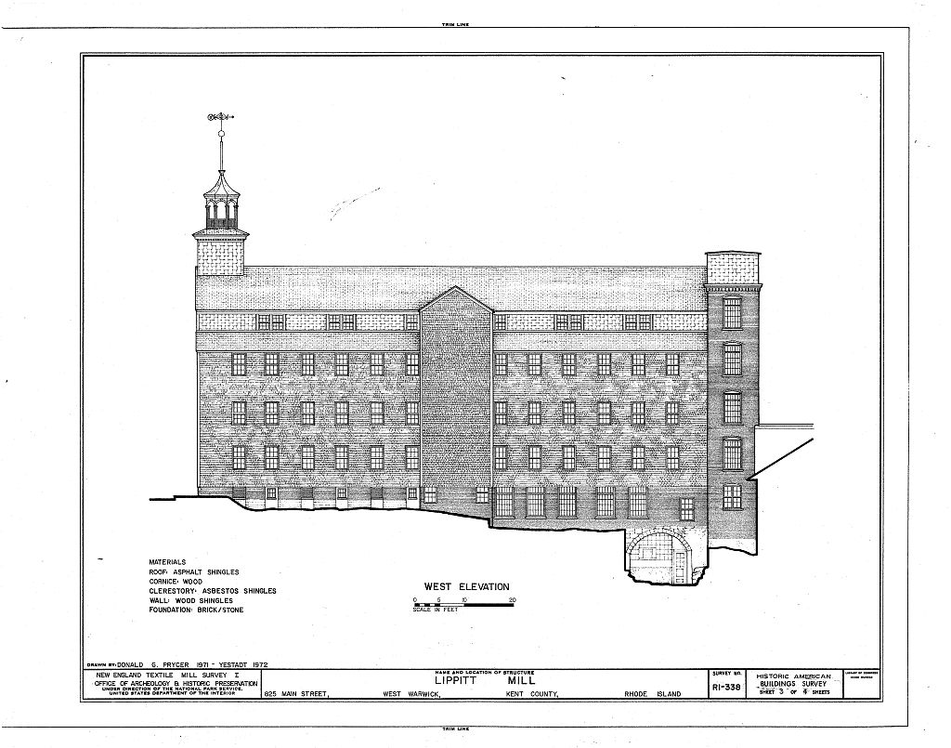
Source: Library of Congress, http://www.loc.gov/pictures/item/ri0025.sheet.00003a/

Module 1: River-Side Industrialization
Student Worksheet

How did water power the early Industrial Revolution in the United States?

Directions: Use the 4C’s Worksheet to analyze the image below.

Image 2
Print of Merrimack Mills in Lowell, Massachusetts (1850).

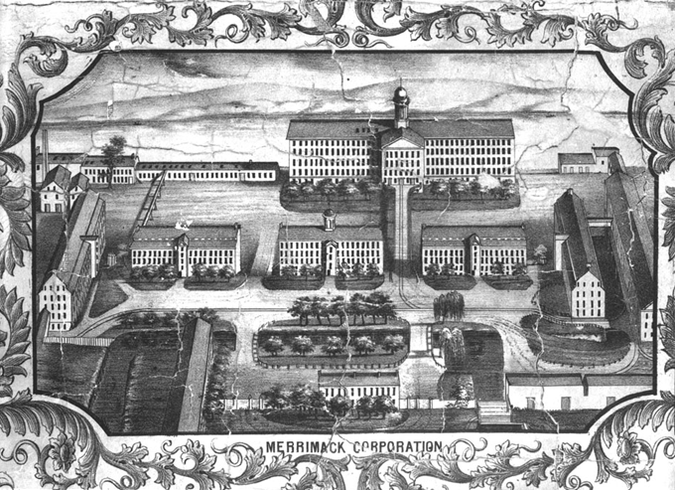

Source: Lowell Historical Society, http://library.uml.edu/clh/all/mi11.htm

Module 1: River-Side Industrialization
Student Worksheet

How did water power the early Industrial Revolution in the United States?

Directions: Use the 4C’s Worksheet to analyze the image below.

Image 3
Print of Lowell, Massachusetts by J.W. Barger (1839)

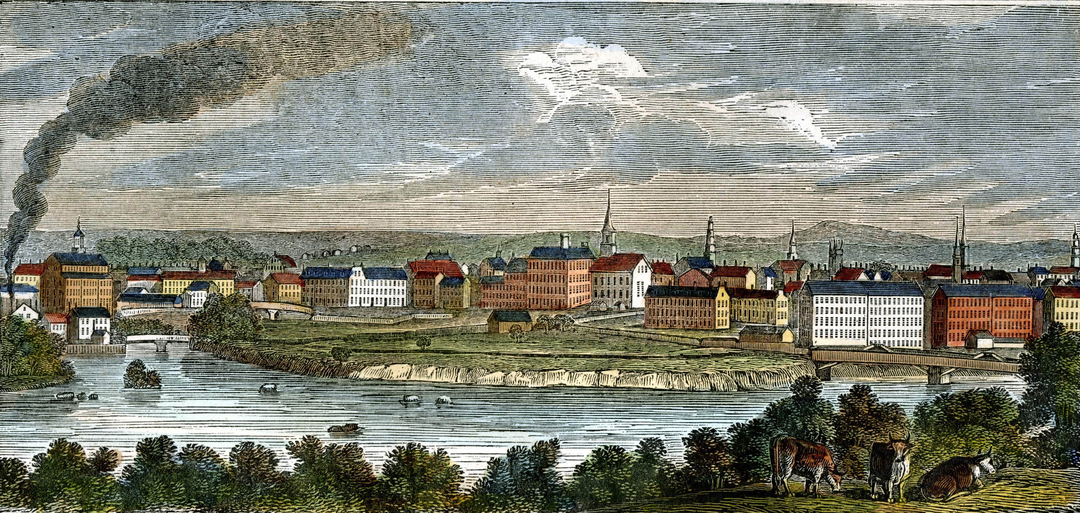

Source: University of Massachusetts Lowell, https://web.uml.edu/gallery/index.php/TIHC/Re-Inventing-America/Primary-Sources/14-a-Lowell-view-1839-LOWE6388

Module 2: Engineering the Merrimack River
Student Worksheet

How did a water-powered textile factory work?

Source 1
Verbal Description of Engineering Works in Lowell, Massachusetts in 1839

Brick buildings hovered over a network of canals that cut the land into angular patches. Arranged neatly in clusters, the buildings looked nearly the same, a sea of uniformity broken occasionally by bell towers that marked off one complex from the next. Everything here seemed set in motion…  Water was forced into canals by a masonry and wood dam that spanned one thousand feet across the Merrimack River. As the water traveled through this complicated system of canals, it was at times diverted into the basements of the brick mill buildings. Concealed below ground were large wheels with buckets attached to rims; as water filled each bucked, the weight made the wheels turn slowly. The wheels were connected to a system of belts, shafts, and pulleys that dispatched power up several floors and across their ceilings. Belts hanging from the ceiling were linked to machinery that spun cotton yarn and wove cloth from the yarn. The process was simplicity itself: water, gravity, and then power and production.  Twenty-eight mills worked here on several hundred acres of land. Six days a week, the noise of about 150,000 spindles and close to 5,000 looms could be heard across the land. The mills were driven by a massive hydraulic enterprise designed with the single-minded purpose of controlling water for production. The factories employed about eight thousand people—three-fourths of whom were women—and produced roughly 50 million yards of cloth each year.… | canal—man-made channel used to divert water from the riverbed  dispatch—to send or do something with a specific purpose  hydraulic—derived from water; machinery operated by liquid under pressure in an enclosed space
Source: Theodore Steinberg, Nature Incorporated: Industrialization and the Waters of New England, New York: Cambridge University Press, 1991, 2-3.

Questions
1. What aspects of industrialization in Lowell does Steinberg describe here?
2. What figures does Steinberg present regarding the industrial capacity of the city?

Source 2
Visual Representation of Engineering of New England Textile Mill in 1855

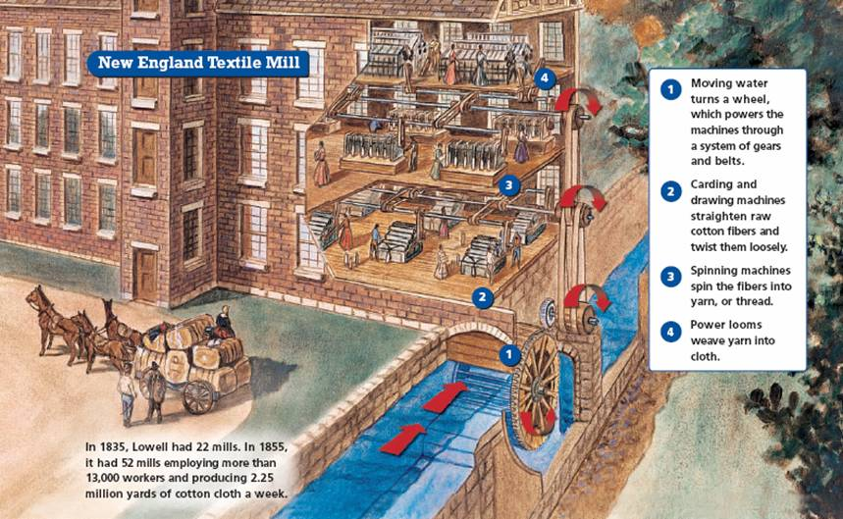

Source: Colorado Springs School District http://teachers.d11.org/teachers/enterpa/Shared%20Documents/Creating%20America/Chapter11/newengland_textile_mill.jpg

Questions
1. In your own words, describe the four aspects of a Pre-Civil War textile mill illustrated above.
2. What figures does the illustration present regarding the growth of Lowell between 1835 and 1855?

Concluding Activity: : How did water power the early Industrial Revolution in the United States?
In 2-3 sentences, explain the basic engineering of a textile mill in antebellum Lowell. Be sure to discuss not only how the factory worked, but how its power source—water—was diverted from the Merrimack River to the site of the factory.

Module 3: Environmental Change on the Merrimack River
Student Worksheet

How did industrialization transform the Merrimack River?

Source 1
Henry David Thoreau on Degradation of Merrimack River

Rising at an equal height with the Connecticut [River], the Merrimack [River] reaches the sea by a course only half as long, and hence has no leisure to form broad and fertile meadows like the [Connecticut], but is hurried along rapids, and down numerous falls without long delay.…  Unfitted to some extent for the purposes of commerce by the sand-bar at its mouth, see how this river was devoted from the first to the service of manufactures. Issuing from the iron region of Franconia, and flowing through still uncut forests, by inexhaustible ledges of granite…it has been offering its privileges in vain for ages, until at last the Yankee race  came to improve them. Standing here at its mouth, look up its sparkling stream to its source, — a silver cascade which falls all the way from the White Mountains to the  sea, — and behold a city on each successive plateau, a busy colony of human beaver around every fall. Not to mention Newburyport and Haverhill, see Lawrence, and Lowell, and Nashua, and Manchester, and Concord, gleaming one above the other.… Instead of the scream of a fish-hawk scaring the fishes, is heard the whistle of the steam-engine, arousing a country to its progress.…  Unlike the Concord, the Merrimack is not a dead but a living stream, though it has less life within its waters and on its banks. It has a swift current, and, in this part of its  course, a clayey bottom, almost no weeds, and, comparatively, few fishes.…Shad and alewives are taken here in their season, but salmon, though at one time more numerous than shad, are now more rare. Bass, also,  are taken occasionally; but locks and dams have proved more or less destructive to the fisheries. The shad make their appearance early in May, at the same time with the  blossoms of the pyrus, one of the most conspicuous early flowers, which is for this reason called the shad-blossom. An insect, called the shad-fly, also appears at the same  time, covering the houses and fences. We are told that “their greatest run is when the apple trees are in full blossom. The old shad return in August; the young, three or four inches long, in September. | hence—consequently; for this reason  commerce—navigation; transportation and trade of goods by way of boat  manufactures—factories  Yankee race—Americans from New England  White Mountains—mountain range in northern New Hampshire  shad and alewives—fish species native to Merrimack River  lock—complex system of gates that allows boats to navigate a river

Source: Henry David Thoreau, A Week on the Concord and Merrimack Rivers, Boston and Cambridge: James Munroe and Company 1849, 90-93.

Questions
1. How does Thoreau describe the Merrimack River at the beginning of paragraph three?
2. Which fish species does he discuss? Which species does he say is no longer living, or found in lesser numbers, in the Merrimack River?
3. What does he identify as the source of the decline of biological diversity in the river? What human activities would lead to die-offs of salmon?

Source 2
Map Showing Evolution Lowell Canal System from 1823-1848

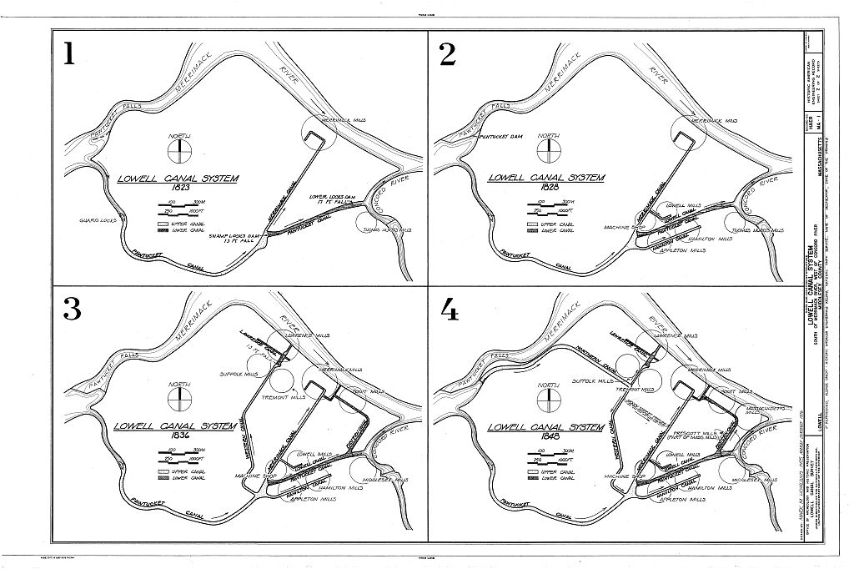
Source: Library of Congress, http://www.loc.gov/pictures/item/ma0543.sheet.00002a/

Questions
1. How did the canal system evolve between 1823 and 1848? Count the number of additions made to the canal system during this time.
2. Does this map support Thoreau’s observation about the fate of salmon and bass in the Merrimack River? Explain your answer.

Concluding Activity: How did industrialization transform the Merrimack River?
In 3-4 sentences, explain the development of water resources in Lowell and how industrialization in Lowell altered the ecology of the Merrimack River.

Final Activity
Student Worksheet

How did water power the early Industrial Revolution in the United States? What effect did industrialization have on American rivers?

By the 1850s, hundreds of textile factories like those in Lowell, Massachusetts could be found all across New England, New York, New Jersey, Pennsylvania, Maryland, the District of Columbia, and even southern states like Virginia and South Carolina. This resulted in a number of changes in American society, one of which was the development of new magazines that focused on technology and engineering-related subjects. Like today’s Popular Mechanics, which was not founded until 1902, these new magazines of the Industrial Revolution published stories that focused on business, industry, and technological change.

Your task for this final assignment is to put yourself in the shoes of an 1840s magazine reporter and write a magazine article detailing two main things: (1) how the factories of Lowell utilized the power of the Merrimack River; and (2) how industrialization changed the ecology of the Merrimack River.

Use all the information you’ve gathered from this lesson. Use your notes from the 4C’s worksheets, your sources on the technology of textile mills before the Civil War, the map illustrating the evolution of the Lowell canal system, and Thoreau’s observations about environmental change to gather what you think is the most relevant information regarding the factories and changes in the river environment.

Write your ideas and key information in the Brainstorming Chart below.

Then piece all your ideas and information together into a 400-word magazine report. Since you are emulating a magazine report, be sure to include the 5W’s and 1H of journalistic writing: who, what, where, when, why, and how.

Finally, before you start writing, keep in mind that your magazine report should answer the guiding questions for this lesson: How did water power the early Industrial Revolution in the United States? What effect did industrialization have on American rivers?
Brainstorming Chart
Student Worksheet

Before you begin writing your report, collect your information and ideas from your three categories of source materials using the Brainstorming Chart below.

Image | Factory Technology | Environmental Changes

