How did Americans and Native Americans respond to westward expansion?
Topics: US expansion, Manifest Destiny
By: Erik Altenbernd, UC Irvine History Project (adapted from UCI Humanities Out There Themes in American History)

History Standards
8.6.1 Describe the purpose, challenges, and economic incentives associated with westward expansion, including the concept of Manifest Destiny (e.g., the Lewis and Clark expedition, accounts of the removal of Indians, the Cherokee’ “Trail of Tears,” settlement of the Great Plains) and the territorial acquisitions that spanned numerous decades.

CCSS Standards: Reading, Grades 6-8
1. Cite specific textual evidence to support analysis of primary and secondary sources.
2. Determine the central ideas or information of a primary or secondary source; provide an accurate summary of the source distinct from prior knowledge or opinions.
5. Determine how a text presents information (e.g. sequentially, comparatively, causally).
6. Identify aspects of a text that reveal an author’s point of view or purpose (e.g., loaded language, inclusion or avoidance of particular facts).
7. Integrate visual information (e.g. in charts, graphs, photographs, videos, or maps) with other information in print or digital texts.

CCSS Standards: Writing, Grades 6-8
1. Write arguments focused on discipline-specific content.
2. Write informative/explanatory texts, including the narration of historical events, scientific procedures/experiments, or technical processes.
9. Draw evidence from informational texts to support analysis reflection, and research.

Guiding Questions:
How did leading American thinkers (such as artists, intellectuals, religious and government leaders) justify America’s westward expansion in the 19th century?

How did Native Americans respond to westward expansion?

Overview of Lesson
Students will analyze primary and secondary sources focusing on Manifest Destiny and the history of US territorial expansion. To complete the lesson, follow the steps below.

- Distribute “4C’s of Visual Primary Source Analysis Worksheet.”
- Discuss and analyze “Grapes, ink scroll painting by Xu Wei, Ming Dynasty” (Source 1) whole group and have each student fill in each box in the 4C’s Worksheet in response to the discussion question, “What were the effects of the exchanges on the Silk Road?”
- Divide the students into groups of 3.
- Give each student a “Sharing Out Chart.”
- Each student individually reads 1 document (Source 2, 3, or 4) looking for possible
answers to the discussion question, filling out the “Sharing Out Chart” as they read.
- Students then share out the information on their charts. Students should focus on
summarizing the content in their document, explaining what they believe the document says in relation to the discussion question, and discussing how these sources support, build upon, or contest one another. Students discuss how these sources answer the discussion question.
- After all group members have shared, the group should have a discussion on possible claim given what they believe the documents say.
Possible discussion starters:
Document xx does not seem to fit with the other documents, because….
Document xx seems to support the ideas in document xxx…..
Document xx seems more credible than document…
I agree/disagree with what Carmen said, because…..
Why do you think that?
How did you come to that conclusion?
Could you summarize your main point again….
Where is the evidence to support this idea…..
- Individually each student should write out his/her claim to respond to the discussion
question as well as the key pieces of evidence that he/she believes support it. Students should also write out any questions that they may have in preparation for a whole group discussion.
- Whole class discussion—below are some possible questions that a teacher could
ask.
What is your claim?
What evidence supports this claim?
What evidence contradicts that claim?
How do we know that is true?
Who are the authors of some of these documents? What do we know
about them?

Documents:
- Frances Palmer, Across the Continent: “Westward the Course of Empire Takes Its Way” (1868)
- Excerpt of John L. O’Sullivan, “The Great Nation of Futurity” (1839)
- Excerpt of John L. O’Sullivan, “Annexation” (1845)
- Excerpt of speech by Chief Seattle

4C’s of Visual Primary Source Analysis Worksheet
http://historyproject.uci.edu/files/2016/11/4Cs_VisualPSAnalysis.pdf

Student Introduction
The United States is a continental nation. The vast majority of US territory is made of the states located in North America—the states located south of Canada and north of Mexico and the Caribbean Sea. We sometimes call these states the “lower 48 states” because they are south of Alaska (the largest state by area) and because they are all connected to each other on the map, unlike Hawai’i, which is located several hundred miles off the coast of California in the Pacific Ocean. The total distance between Los Angeles to Washington, D.C. is roughly 2700 miles. Altogether, the lower 48 states, along with Alaska, Hawai’i, and other national territories, make the United States the third largest nation by area in the world. Do you know which two nations have more territory than the US?

However, the US has not always been a continental nation. Most of the territory that makes up the lower 48 states was acquired from France, Great Britain, Mexico, and dozens of different Native American nations between 1803 and 1845. The largest gains in territory were the Louisiana Purchase of 1803, the annexation of Texas in 1845, and the Treaty of Guadalupe Hidalgo, the 1846 settlement that ended the US-Mexico War of 1846-1848.

Territorial expansion was highly popular during the first half of the nineteenth century. Most citizens of the United States—not most “Americans” (it is important to be precise in our language here)—supported the acquisition of new land. Supporters of westward expansion—the vast majority of lands acquired before the Civil War were immediately west of the nation—could be found among every region and social class of the nation.

Large numbers of artists, writers, poets, scientists, and politicians, as well as farmers and other everyday Americans, all supported westward expansion. Some of the most common, enduring, and therefore famous works regarding this phase of US history were the images and words produced by intellectuals in the United States. Much of the material produced by this class of Americans has survived and provides the basis for our understanding of the central idea, or ideology, of US territorial expansion: Manifest Destiny.

Far less historical evidence documenting how Native Americans experienced and understood US territorial expansion has survived. Still, what has survived provides a very different view of the history of Manifest Destiny and westward expansion.

For this lesson, our guiding questions will be: How did Americans and Native Americans respond to westward expansion?

Source 1
J.M. Ives, after a painting by Frances Palmer, Across the Continent: “Westward the Course of Empire Takes Its Way” (1868).

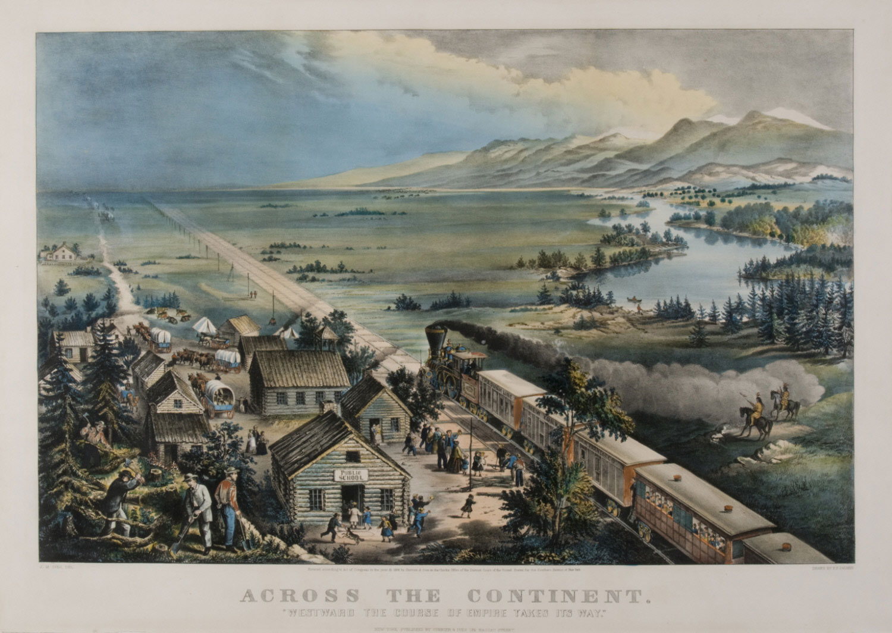
Source: Philadelphia Museum of Art http://www.philamuseum.org/collections/permanent/308328.html?mulR=867563635%7C1

Source 2
John L. O’Sullivan was a nineteenth-century journalist and leading voice of the Democratic Party before the Civil War. He is credited with coining the phrase “manifest destiny” in the journal he founded and edited, the Democratic Review. Like many Americans, O’Sullivan believed that Americans had a right as well as duty to move West and “spread and to possess the whole of the continent which Providence has given us.” He developed his ideas regarding manifest destiny in two articles in the Democratic Review: “The Great Nation of Futurity” (1835) and “Annexation” (1845).

The far-reaching, the boundless future will be the era of American greatness. In its magnificent domain of space and time, the nation of many nations is destined to manifest to mankind the excellence of divine principles…  Yes, we are the nation of progress…This is our high destiny, and in nature’s eternal, inevitable decree of cause and effect we must accomplish it. All this will be our future history…For this blessed mission to the nations of the world, which are shut out from the life-giving light of truth, has America been chosen…Who then, can doubt that our country is destined to be the great nation of futurity? | boundless—without limits; infinite  magnificent—brilliant, grand, outstanding  domain—sphere; area over which power is exercised  manifest—display; show; demonstrate  destiny—idea that one’s future will happen according to a plan rather than chance; not random  inevitable—unavoidable; certain to happen  decree—order having force of law
John L. O’Sullivan, “The Great Nation of Futurity,” The United States and Democratic Review, Volume 6, Issue 23 (November 1839).

Source 3
John L. O’Sullivan was a nineteenth-century journalist and leading voice of the Democratic Party before the Civil War. He is credited with coining the phrase “manifest destiny” in the journal he founded and edited, the Democratic Review. Like many Americans, O’Sullivan believed that Americans had a right as well as duty to move West and “spread and to possess the whole of the continent which Providence has given us.” He developed his ideas regarding manifest destiny in two articles in the Democratic Review: “The Great Nation of Futurity” (1835) and “Annexation” (1845).

Why, were other reasoning wanting, in favor of now elevating this question of the reception of Texas into the Union…to its proper level of a high and broad nationality, it surely is to be found, found abundantly, in the manner in which other nations have undertaken to intrude themselves into [the debate]…for the avowed object of thwarting our policy and hampering our power, limiting our greatness and checking the fulfillment of our manifest destiny to overspread the continent allotted by Providence for the free development of our yearly multiplying millions. | reasoning—thinking  wanting—lacking; absent  Union—the nation; the United States  high and broad nationality—issue of great national concern; issue that everyone should agree on  thwarting—preventing; obstructing  hampering—preventing; delaying  allotted—share or portion of something given as part of a task  Providence—protective or spiritual care given by God or nature
John L. O’Sullivan, “Annexation,” The United States and Democratic Review, Volume 17, Issue 85 (July-August 1845).

Source 4
In 1854, Chief Seattle, the head of several tribes of Indians living near the Puget Sound in Washington state, met with Governor Isaac Stevens to discuss the relocation of his people to a reservation. The speech that Seattle delivered at the time of the meeting was not published until 1887. Even though the speech was reconstructed from notes taken by Dr. Henry Smith, and later underwent two separate translations into English, historians believe that the speech is a reliable historical document. In his speech, Chief Seattle expresses a Native American attitude toward the land and contrasts this attitude with that of American settlers. Chief Seattle was one of the most famous Indian leaders of the nineteenth century. His name was used as the title for the city—Seattle—American settlers founded on the Puget Sound just a few years before his speech.

Your God seems to us to be partial. He came to the white man. We never saw Him; never even hear His voice. He gave the white man laws but He had no word for His red children whose teeming millions filled this vast continent as the stars fill the firmament. No, we are two distinct races and must ever remain so.…  Every hillside, every valley, every plain and grove has been hallowed by some fond memory or some sad experience of my tribe. Even the rocks that seem to lie dumb as they swelter in the sun along the silent seashore in solemn grandeur thrill with memories of past events connected with the fate of my people, and the very dust under your feet responds more lovingly to our footsteps than to yours, because it is the ashes of our ancestors, and our bare feet are conscious of the sympathetic touch, for the soil is rich with the life of our kindred. | partial—to show favoritism; biased  teeming—filled with people or living things  firmament—the sky or heavens  hallowed—made sacred  dumb—without the ability to speak; silent  swelter—to be uncomfortably hot  solemn—formal and dignified  grandeur—impressive appearance  molestation—act of disturbing or interfering with someone or something  conscious—fully aware  sympathetic—to have sympathy or positive feeling  kindred—familiar or related, like kin or family
Speech by Chief Seattle, http://online.sfsu.edu/rone/Environ/seattle.html.

