Significance:
How did former colonies respond to the Cold War and liberation?
How did Angolans respond to the Cold War and liberation?

Source 1
J.P. Laffont, “Independence Coming to Angola,” June 1975, United Nations photo.
These children in Luanda, Angola make victory signs five months before the independence of their country, which took place November 11, 1975.

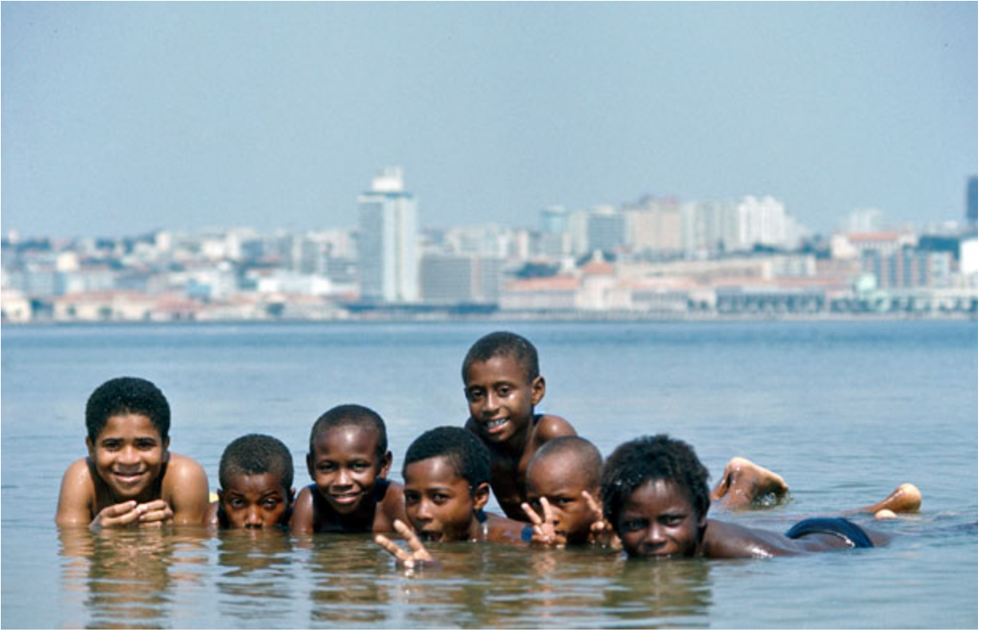

Found at http://exhibitions.nypl.org/africanaage/essay-challenge-of-decolonization-africa.html#proxy

Source 2
Benjamin Talton, “Proxy War in Angola”
The United States' deep investment in destabilizing the democratically elected, post-independence government of Angola is arguably the most profound example of Western influence and its destructive consequences for Africa. In 1975 Angola gained its independence from Portugal, and three nationalist groups subsequently fought for control of the government: the MPLA (Popular Movement for the Liberation of Angola), led by President José Eduardo dos Santos and backed by Cuba and the Soviet Union; UNITA (National Union for the Total Independence of Angola), led by Jonas Savimbi and backed by South Africa and the United States; and the FNLA (National Liberation Front of Angola), backed by Zaire's president, Mobutu Sese Seko (he had changed the name Congo to Zaire in 1971.)
Cuban and Soviet support for MPLA, including Cuban troops led by Che Guevara, forced Zaire and South Africa to withdraw their forces, which allowed the democratically elected MPLA to organize a government. Savimbi and UNITA became the rebel opposition but enjoyed little support beyond Savimbi's Ovimbundu ethnic group and financing from the United States. The basis for American support for UNITA was that Savimbi declared himself an avowed anti-Marxist, in contrast to the nominally Marxist MPLA. Between 1986 and 1991 the United States spent $250 million on a covert operation in Angola and aid to Savimbi. In a 1986 meeting at the White House, U.S. President Ronald Reagan declared Savimbi a "freedom fighter" for his struggle against dos Santos and the MPLA. Yet in 2002, when news of Savimbi's death reached Luanda, the Angolan capital, people poured into the streets shouting, "The terrorist is gone!"
It was only with Savimbi's death that fighting ended between the MPLA government and UNITA. The twenty-seven-year civil war caused so much destruction to the nation that UNICEF declared Angola the worst place in the world to be a child. Angola stands as a harsh illustration of the direct consequence of civil war, Cold War politics, and failures in African leadership.
Found at http://exhibitions.nypl.org/africanaage/essay-challenge-of-decolonization-africa.html#proxy

Source 3
“Cuba in Angola—War of Independence 1975,” BBC, December 2015.
https://www.youtube.com/watch?v=RVqwFYGzL-M

watch 2:16-9:00

Source 4
Letter from Agostinho Neto, the President of Angola, to Cuban leadership asking for continued military and logistical support

January 26, 1975

Dear Comrades,

Given the situation on the ground of our movement and our country, and taking into account the results of the exploratory trip of the official Cuban delegation, we are sending you a list of the urgent needs of our organization. We are confident that you will give it immediate consideration.

- The establishment, organization, and maintenance of a military school for cadres. We urgently need to create a company of security personnel, and we need to prepare the members of our military staff.
- We need to rent a ship to transport the war material that we have in Dar-es-Salaam to Angola. The delivery in Angola, if this were a Cuban ship, could take place outside of the territorial waters.
- Weapons and means of transportation for the Brigada de Intervención that we are planning to organize, as well as light weapons for some infantry battalions.
- Transmitters and receivers to solve the problem of communication among widely dispersed military units.
- Uniforms and military equipment for 10,000 men.
- Two pilots and one flight mechanic.
- Assistance in training trade union leaders.
- Cooperation in the organization of schools for the teaching of Marxism (to solve the problems of the party).
- Publications dealing with political and military subjects, especially instruction manuals.
- Financial assistance in this phase of establishing and organizing ourselves.

We also urge that the Communist Party of Cuba use its influence with other countries that are its friends and allies, especially from the Socialist camp, so that they grant useful and timely aid to our movement, which is the only guarantee of a democratic and progressive Angola in the future.

Comrades, accept our revolutionary greetings and convey the good wishes of the combatants of the MPLA and of the new Angola to Prime Minister Fidel Castro.

Source found in History Blueprint: Cold War “Hot Spots Research Project,” page 19-20, original accessed from Cold War History Project Digital Archive, http://digitalarchive.wilsoncenter.org/collection/173/cuba-and-southern-africa

Source 5

Trailer of the movie, Another Day of Life, to be released 2017. The movie is part animation, part documentary that depicts Polish journalist, Ryszard Kapuscinski’s time in Angola during the last months of colonial rule and the beginning of the civil war.

https://www.youtube.com/watch?v=H0ujMbACCS0

Source 6
Tony Wheeler, Badlands, Lonely Planet, 2010.
Wheeler is the co-founder of Lonely Planet a travel publication.
Poor Angola had the bad luck to be a Portuguese colony and become another of the world’s proxy battlefields when the Lisbon dictatorship collapsed in 1974. Marxism-Leninism would have won, but the US certainly didn’t want that domino falling and through the 1980s the CIA poured military aid into the country, often via the Apartheid government of South Africa. The greenbacks went to Jonas Savimbi and his UNITA (National Union for the Total Independence of Angola) rebel group while on the other side the USSR financed Cuban mercenaries for the MPLA (Popular Movement for the Liberation of Angola). Just like Israel in southern Lebanon, South Africa itself was ready to shift troops into southern Angola anytime the struggle seemed to be going the wrong way. The result was death, injury or refugee status for hundreds of thousands of unfortunate Angolans.
The collapse of the Soviet Union should have terminated the endless struggle and in 1992 the UN supervised an election which the MPLA won. Savimbi promptly reneged on the agreement and went back to war, funding his operations by control over Angola’s rich diamond deposits. Diamonds, it turned out, could also be a terrorist’s best friend, and for another ten years Angola stumbled from crisis to crisis, outrage to outrage. UN representatives pointed out that if dealers in the west refused to buy Angolan diamonds, which were funding Savimbi’s army, his power would have quickly melted away. UNITA’s response was to shoot down UN aircraft carrying humanitarian aid.
Government troops finally managed to kill Savimbi in February 2002, which decisively concluded his long reign of terror. Angola is a Bad Land that just might be emerging from 30 lost years although unhappily the MPLA is hardly corruption free. I made a brief visit to Angola in 2005 although I didn’t venture out of the capital, Luanda. In 2006 the Angolan football team qualified for the World Cup in Germany, an event which for the first time created a real feeling of national unity.
Found at http://tonywheeler.com.au/another-day-of-life-kapuscinskis-angola/

Source 7

Nicholas Kristoff, “Deadliest Country for Kids,” New York Times, March 19, 2015

https://www.nytimes.com/2015/03/19/opinion/nicholas-kristof-deadliest-country-for-kids.html

