What is consumer credit and how does it work?
Topics: Financial literacy, car loans, credit cards, student loans
Erik Altenbernd, UCI History Project

History-Social Studies Standards
12.5 Students analyze the aggregate economic behavior of the U.S. economy.
    - Distinguish between nominal and real data.

CCSS Standards: Reading, Grades 11-12
RH 1. Cite specific textual evidence to support analysis of primary and secondary sources, connecting insights gained from specific details to an understanding of the text as a whole.
RH 2. Determine the central ideas or information of a primary or secondary source; provide an accurate summary that makes clear the relationships among the key details and ideas.
RH7. Integrate and evaluate multiple sources of information presented in diverse formats and media (e.g. visually quantitatively, as well as in words) in order to address a question or solve a problem.
RH 9. Integrate information from diverse sources, both primary and secondary, into a coherent understanding of an idea or event, noting discrepancies among sources.

CCSS Standards: Writing, Grades 11-12
WH 1. Write arguments focused on discipline-specific content.
WH2. Write informative/explanatory texts, including the narration of historical events, scientific procedures/experiments, or technical processes.
WH4. Produce clear and coherent writing in which the development and organization, and style are appropriate to the task, purpose, and audience.
WH6. Use technology, including the Internet, to produce, publish, and update individual or shared writing products in response to ongoing feedback, including new arguments or information.
WH8. Gather relevant information from multiple authoritative print and digital sources, using advanced searches effectively; assess the strengths and limitations of each source in terms of the specific task, purpose, and audience; integrate information into the text selectively to maintain the flow of ideas, avoiding plagiarism and overreliance on any one source and following a standard format for citation.

Overview of Lesson
This lesson focuses on consumer credit, is divided into six modules, and includes a final culminating activity. Each module addresses the following topics: the Big Three consumer reporting bureaus; credit/FICO scores; car loans; plastic money; credit cards; and student loans. Each module can be taught separately or in conjunction with one or more other modules. The parts on the consumer reporting bureaus, credit scores, and plastic money are informational. The parts on car loans, credit cards, and student loans are informational but also include online research and debt and repayment calculation activities. The final lesson has the students compose a public service announcement (PSA) poster about consumer credit. Directions for the PSA activity are included below in the teacher introduction; a student checklist is also included.

Guiding Question
What is consumer credit and how does it work?

Documents
1. Credit Reports and Scores, USA.gov
2. Comparison of free credit reporting websites, Wikipedia
3. “What is a FICO Score?”, YouTube
4. “The Higher your FICO Scores, the better,” graphic and textual image
5. “How Car Loans Work,” BankofAmerica.com
6. “Understanding Vehicle Financing,” Federal Trade Commission
7. “I don’t have a credit card,” Transformers (2007, video clip)
8. “Preferred Payment type, 2014,” pie chart
9. Preferred Payments, bar graph
10. “They had magic cards,” Confessions of a Shopaholic (2009, video clip)
11. “How Does a Credit Card Work?”, YouTube
12. Credit Cards vs. Debit Cards, USBank.com
13. Credit Card Interest, Discover.com
14. “3 Charts That Show Just How Dire The Student Loan Debt Crisis Has Become,
Huffington Post
15. “Student Debt Rising as Wage Growth Stalls,” chart
16. “Student Debt Significantly Outpacing Wage Growth,” chart
17. Estimate of Student Costs at Orange Coast College, table
18. Estimate of Student Costs at CSU Fullerton, table
19. Estimate of Student Costs at UC Irvine, table

PSA Final Activity – Teacher’s Instructions

Public Service Announcements (PSAs) are methods of communicating information in the form of an argument to a wider public who may not know much about the topic. This final activity will allow students to learn more consumer credit by allowing them to develop an argument, or claim, using evidence and then sharing their claim in an engaging format to a larger audience.

For this particular activity, the students will develop a PSA poster that informs other high school students about consumer credit. In this case, the students can make a poster on car loans, credit cards, or student loans. Students should pick one of these three forms of credit.

- Introduce the concept of a Public Service Announcement (PSA) to the students. Ask them if they have seen them. If so, what makes them effective? Has the the PSA changed the students’ behavior regarding the topic? You may want to share some examples with students. Many are readily available at YouTube.

Perhaps the most famous television PSA was the “Brain on Drugs” PSA from the 1980s: https://www.youtube.com/watch?v=3FtNm9CgA6U

Some of the most effective PSAs in recent memory are those that stress the negative effects of cigarettes produced by TheTruth.com. Here’s a link to one of their more memorable PSAs: https://www.youtube.com/watch?v=Y_56BQmY_e8

For more information and links to PSAs, go to the AdCouncil’s website on PSAs:
https://www.psacentral.org/home

- Have students consider the elements of a PSA that make it an effective means of communicating an idea. Students can develop their own criteria about what should be in a PSA and how they are structured. Some ideas may include:
- They are short (usually 60 seconds or less)
- Present an argument about a single issue
- Inform the viewer of key, relevant facts
- Have a clear call to action (usually indicated through text on screen)
- Are based on facts, provide quotations, and cite data
- PSAs use an engaging format of mixed media to hold the viewer’s interest
- Aim to leave a lasting impact
The teacher may want to share the rubric for the PSA with the students and review another PSA using the criteria/checklist.

- Students develop their “pitch” and poster. In groups, students should work together to develop a specific topic, an argument, and a concept that is engaging. Students should focus on identifying not only a particular form of credit but an issue or problem associated with that form of credit. Students can then begin drafting they poster. Drafts can made digitally or on paper. Teachers should stress to the students that they need only need to incorporate both text and images but that they need to strike a balance between text and images. Students should also include relevant facts—facts that support the main idea or claim of their poster. Students should also be encouraged to revise and refine their poster drafts. Sample PSA poster lessons can be found here:
http://www.centerdigitaled.com/artsandhumanities/How-to-Create-the-Perfect-Public-Service-Announcement.html

http://www.takethechallengenow.net/wp-content/uploads/2014/10/HS-Lesson-10-What-to-do-PSA-Posters.pdf

http://www.readwritethink.org/files/resources/30157_activity_sheet.pdf

http://www.usd305.com/cms/lib/KS01001292/Centricity/Domain/295/Const.SCourt.Poster.pdf

- Students work on their PSA poster. This may include: researching the topic, finding data, and drafting the poster. Some PSAs on consumer credit, including student-made video PSAs, can be found here:
https://www.youtube.com/watch?v=UahKlcJA7QI

https://www.youtube.com/watch?v=jMw9MAq59T4

https://www.youtube.com/watch?v=k3JB7rMXbhA

- Students share PSA posters with the class. Teachers may want students to write a reflection response for one PSA or their experience creating their own PSA.

- Teachers can grade the posters using the rubric included. The rubric is based on the following parameters:

- Content and Topic: the PSA has a clear topic, that is easy to understand, and stays on topic.

- Argument and Message: the PSA has a clear argument and communicates this effectively to the audience.

- Based on Evidence: the PSA presents evidence to support the argument that is based on facts, which may be cited either in the PSA or in supporting documents.

- Collaboration: All group members participate in the creation of the PSA. Some tasks might include: researching evidence to support claims, developing visuals and props, developing the storyboard, and creating and editing the video.

Sources used to create this assignment:
http://rock-your-world.org/curriculum/
http://www.readwritethink.org/files/resources/30157_activity_sheet.pdf
http://i42.tinypic.com/6isp3p.jpg

Public Service Announcement Rubric
CATERGORY | 4 | 3 | 2 | 1
Content | Students create an original, accurate and interesting PSA that adequately addresses the issue. | Students create an accurate PSA that adequately addresses the issue. | Students create an accurate PSA but it does not adequately address the issue. | The PSA is not accurate.
Originality | The PSA is exceptionally creative and “grabs” the audience’s attention. | The PSA is mostly creative. | The PSA is somewhat creative. | The PSA has no creativity.
Presentation | All group members take an active part in the presentation. Voices are clear and projected. Audiences’ questions are answered. | Most group members take an active part in the presentation. Voices are clear and projected. Most audiences’ questions are answered. | Some group members take an active part in the presentation. Most voices are clear and projected. Some audiences’ questions are answered. | One group member took an active part in the presentation. Voice is clear and projected. Audiences’ questions are not answered.

Student Public Service Announcement Checklist

- We have a message/claim for our PSA

Write claim here:

- We have an effective draft of the poster

- We have pictures/images

- We have statistics

- We have textual information

- Our PSA message is clearly stated on the poster

Introduction
What is credit? In our modern capitalist economy, credit refers to two main things: money issued to a consumer to buy goods and services, and the ability of consumers to access money that can be used to buy goods and services, an issue usually referred to as creditworthiness. More often than not, when we talk about credit we are talking about money—more specifically, a loan made by a lender (i.e. a bank or financial institution) to a borrower (i.e. an individual consumer). Loans made by banks or other financial institutions are legal contracts. They are contracts because both parties (the borrower and lender) typically agree that the borrower will suffer penalties if he or she fails to pay back the money borrowed from the lender.

Today, individual consumers have access to a wide variety of consumer credit. Consumer credit is money loaned to consumers for the purpose of buying goods or services. For instance, when a person takes out a loan to buy a car, or uses a credit card to pay a mechanic for repairs on that car, the buyer is using consumer credit to buy a good and service. After the buyer purchases goods and services, these forms of consumer credit become consumer debt—money that must be paid back to the lender.

Consumer credit is a key part of everyday life in the modern United States. In 2015, consumer spending—purchases of goods and services—made up roughly 70% of the nation’s gross domestic product (GDP), and accounted for 1.5-2.0% of national economic growth.

There are two main forms of consumer credit: installment credit and revolving credit.

Installment credit is usually issued in the form of a loan that is repaid over a set period of months or years. The installments, or individual payments, are usually made once per month. Financial institutions typically charge the borrower interest for the duration of the loan. Installment loans are also usually issued for a particular amount of money, usually the amount of money needed to pay for an expensive consumer good or service. Home loans, car loans, and student (or education) loans are some of the most common forms of installment credit.

Revolving credit (or a revolving line of credit) is a different form of consumer credit. Like installment credit, borrowers also pay interest on revolving credit, but, unlike installment credit, there is no fixed loan amount and no fixed repayment period. Put another way, revolving credit is a set amount of money that a borrower can use to buy multiple goods or services rather than a single item like a car or house. Repayment is based not on the total credit limit but on the actual amount borrowed. For instance, if the borrower uses only $5,000 of a $10,000 line of credit, the borrower only repays $5,000 (plus interest). Also, the borrower has a choice regarding how much they pay each month. Unlike an installment loan, the borrower does not pay a fixed amount every month. Instead, the borrower can pay the minimum payment requirement, more than the minimum payment, or the entire balance (i.e. the money borrowed plus interest). Credit cards are the most common form of revolving credit.

How do you get a loan or credit card? How does the bank or lending institution decide how much money to lend you? How does the lending institution determine how much interest to charge you? Answers to these questions depend on your creditworthiness. Creditworthiness is a word used to describe your ability to pay back the money loaned to you. Lenders determine creditworthiness using reports and credit ratings/scores supplied by consumer reporting bureaus.

Part 1. Consumer Reporting Bureaus

Today, consumer credit is monitored by three large credit reporting companies named Experian, Equifax, and TransUnion. Most lending institutions use information supplied by the Big Three consumer credit bureaus to decide whether or not to issue a loan or credit card. Whenever a consumer applies for a loan or credit card, the lending institution will request a report about the applicant’s financial history from one, or more than one, of the Big Three bureaus before making a decision about the application. In recent years, the federal government has taken a greater interest in regulating this industry and protecting the rights of individual consumers. Every consumer in the United States is entitled to free credit reports from the Big Three bureaus. The website AnnualCreditReport.com is the most trusted website for requesting a personal credit report.

Source 1
Credit Reports and Scores
USA.gov

https://www.usa.gov/credit-reports

Questions

1. What kind of information is included in a credit report?

2. How often can you request a free credit report from the Big Three agencies?

3. Why would you want to check your credit report?

4. What is a credit score? Describe a credit score in 2-3 sentences.

5. Are the reporting bureaus required by law to provide you with your credit score?

Source 2
Comparison of free credit reporting websites
Wikipedia

https://en.wikipedia.org/wiki/Comparison_of_free_credit_report_websites

Questions

6. According to the Federal Trade Commission (the federal agency that protects consumer rights), what is “the ONLY authorized source for the free annual credit report?”

7. How many different credit report websites does the spreadsheet list?

8. Which reporting service provides you a report from each of the Big Three agencies?

Part 2. Credit Score/FICO Scores

To qualify for a credit card or loan, you generally need to have a credit history. The Big Three bureaus do more than just monitor your financial history; they also issue something called a credit score. Credit scores usually run on a scale of 300-850. They present a simplified summary, or snapshot, of your financial history. A high score indicates two things: a decent income and a good track record for paying back loans and other forms of consumer credit. Along with credit reports, credit scores play a key role in determining creditworthiness, and, thus, whether a bank or financial institution will issue you a loan or credit card.

Source 3

In 1956, two Stanford University researchers named William Fair and Earl Isaac established a company in San Jose, California to monitor and rate the credit histories of individual American consumers. The company they started was called Fair, Isaac, and Company. Today the company is known by the acronym FICO. Over the last sixty years, FICO’s formula for determining an individual’s credit score has become the standard formula in the consumer credit industry. Today, roughly 90% of all credit reporting agencies use FICO’s formula to determine your credit score.

“What is a FICO Score?” Explainer Video
YouTube (2:06)

https://www.youtube.com/watch?v=1ZuySqt7wxY

Questions

9. How does this video define a FICO score?

10. What is the number range of a FICO score?

11. What does a high FICO score mean for a lender?

12. What, according to this video, are the advantages of FICO scores?

Source 4
“The Higher your FICO Scores, the better”
MyFICO.com

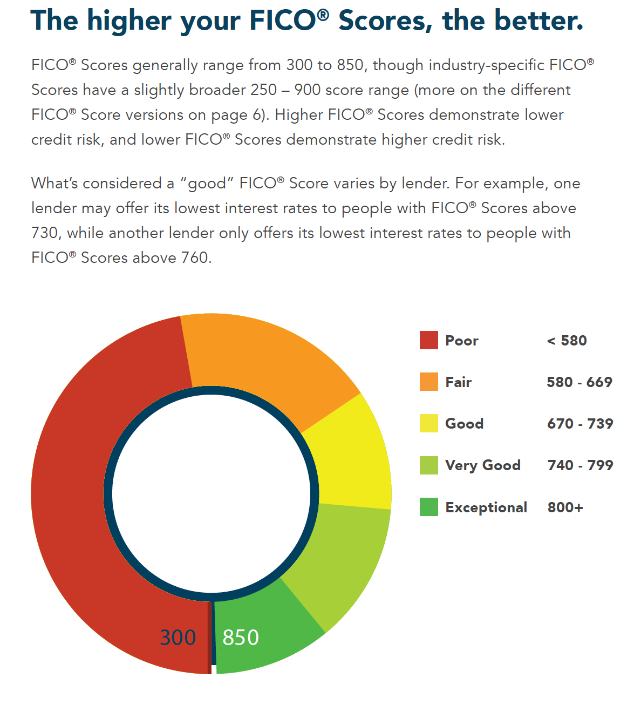
Source: MyFICO.com, http://www.myfico.com/Downloads/Files/myFICO_UYFS_Booklet.pdf

Questions

13. What does a higher FICO score indicate?

14. What does a lower FICO score indicate?

15. What is a “good” FICO score?

Part 3. Car Loans

Today, there are two main ways to buy new or used cars: 1. to pay the price of the car in full, the way you use cash to buy a cup of coffee at Starbucks; or 2. to make a down payment on the car and then finance the rest. Financing a car, means taking out an installment loan. Securing an installment loans typically requires a down payment, an initial payment for a portion of the car, usually 10-20% of the total cost. Installment loans are the way most Americans buy cars, and have been a common method of car purchases since the 1920s. Securing a car loan today usually requires two things: a good credit/FICO score and enough monthly income to afford the monthly installments.

Source 5
“How Car Loans Work”
Bank of America

https://www.bankofamerica.com/auto-loans/how-car-loans-work/

Questions

16. What is the term “loan amount” mean?

17. What is the loan amount on a $25,000 car with a $500 trade-in, and a $1000 down payment?

18. What is an APR?

19. What is a “loan term?”

20. What is the standard range of yearly terms for auto loans?

21. What three factors play a large role in determining your monthly payment?

Source 6
“Understanding Vehicle Financing”
Federal Trade Commission

https://www.consumer.ftc.gov/articles/0056-understanding-vehicle-financing#fin

Questions

22. What are the two main forms of auto financing?

23. What are the advantages of “direct lending?”

24. What are the advantages of “dealership financing?”

25. What information will you have to provide to secure a car loan?

Car Loan Activity

Buying a car requires understanding not only how much the car costs but whether or not you can afford to make the monthly payments on the car. To determine if you can afford the car you want, you have to consider all your monthly expenses. Knowing your monthly spending and savings commitments and habits will understand what kind of car you can afford.

Step 1. Pick a car you would like to buy. Then go online and find a realistic price for a new or used model of your choice.

Step 2. Complete the Monthly Net Pay graphic organizer below.

Start with your monthly take-home pay, or net income—the amount you earn after taxes and other deductions.
Then subtract the amount you need for all your savings goals and monthly expenses, including monthly credit card payments and payments for housing and utilities, and insurance payments. (NOTE: Banks and other lenders require full insurance on all cars financed with installment loans.)
The remaining balance is the maximum you can afford to put toward the monthly payment for a vehicle and any new related expenses, like vehicle insurance.

Step 3. Complete the Auto Loan Figures graphic organizer.

Insert the make, model, and year of the car you would like to buy.

Then insert the price you found online.

Then determine how much money you intend to put down on the car.

After that, insert the loan amount.

Then click the link and insert your information into the online car payment calculator.

Experiment with the loan term to see if you can get your monthly payment to match your budget.

Finally, insert your final monthly payment into the the graphic organizer.

Can you afford your preferred car?

Monthly Net Pay $
Savings | -$
Rent/Mortgage Payment | -$
Utilities | -$
Food | -$
Credit Card(s) | -$
Insurance (Car, home, life) | -$
Education | -$
Personal/Entertainment | -$
Medical Expenses | -$
Other | -$
Remaining Income | -$

Auto Loan Figures
Make/Model/Year of Car
Price | $
Total Money Down  (Down Payment & Trade-in) | -$
Loan Amount | $
Interest Rate | $
Term/Length of Loan | Months (= Years)
Monthly Payment | $

Auto Loan Calculator:
https://www.nerdwallet.com/blog/loans/car-loan-calculator/

Part 4. Plastic Money

Consumer credit a is a relatively recent development in US economic history. American companies began offering installment consumer credit in the 1920s (by the end of the 1920s, most radios and cars bought in the US were bought with installment loans). Revolving lines of consumer credit were not extended to consumers until after World War II. What would eventually become the Visa credit card, was invented by Bank of America in 1966. Since that time, credit cards have become increasingly common. So much so, that plastic money has replaced cash, or paper money. After the spread of ATMs (Automated Teller Machines) in the 1970s and 1980s, banks started issuing plastic cards to customers with checking and savings accounts. Customers used these cards to access the ATMs, and, eventually, these cards evolved into the modern debit card—a card that looks like a credit card, and can be used to buy goods and services like a credit card, but that is tied not to a checking or savings account rather than a credit account. By the early 2000s, plastic money had become far more common than paper money. The root of this major change was invention of the credit card in 1966.

Source 7
“I don’t have a credit card!”
Transformers (2007, 2:45-3:51)

https://www.youtube.com/watch?v=sjTIpSu7npE

Source 8
American Payment Preferences

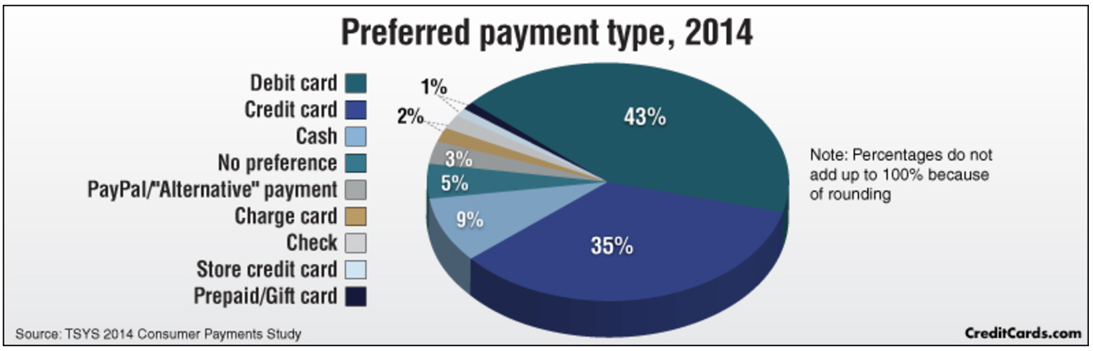
Source: CreditCards.com, http://www.creditcards.com/credit-card-news/payment-method-statistics-1276.php

Questions

26. Which two forms of payment did most Americans prefer in 2014?

27. What percentage of Americans prefer to pay with plastic money?

28. In your opinion, why do Americans prefer to pay with plastic rather than paper money?
Source 9
Preferred Payments
CreditCards.com

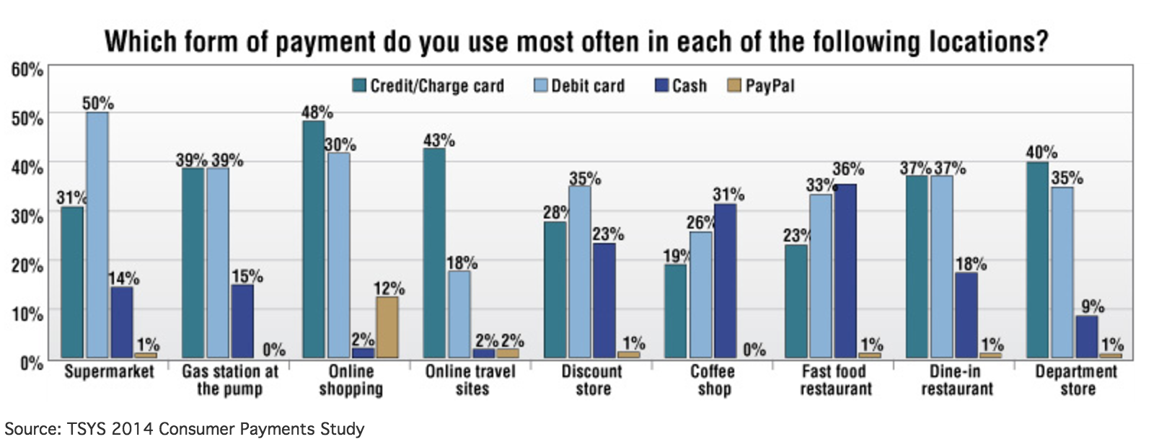
Source: CreditCards.com, http://www.creditcards.com/credit-card-news/payment-method-statistics-1276.php

Questions

29. Which payment type is most preferred for online shopping?

30. Where do Americans generally prefer to use debit cards?

31. Are there any locations where Americans prefer to use cash?

32. Are your spending habits, or those of your family, similar to those illustrated here? Explain how they are similar, or different, in 2-3 sentences.

Part 5. Credit Cards
Despite their recent history, credit cards are now an integral part of the US economy. Some statistics show that more than 70% of Americans have credit cards, and that those that own credit cards own, on average, at least three different credit cards. But how do credit cards work. Banks like to say that credit cards provide great flexibility to the consumer. However, banks like consumers to use credit cards because the banks make substantial amounts of money on the interest they charge the credit card holder.

Source 10
“They had magic cards!”
Confessions of a Shopaholic (2009, 0:00-1:50)

https://www.youtube.com/watch?v=XdXAZUE9KyU

Questions

33. Why do the filmmakers describe plastic money as “magic?”

34. Is there a danger to having access to “magical” money?

Source 11
How Does a Credit Card Work?
YouTube (3:08)

https://www.youtube.com/watch?v=Yy1OxM_18EQ

Questions

35. What two options does Sam have once he buys his couch and mini fridge using his credit card?

36. What is the advantage of paying off the total amount?

Source 12
Credit Cards vs. Debit Carts
US Bank

https://www.usbank.com/credit-cards/how-credit-cards-work.html

Questions

37. What are the “core differences” between a debit card and a credit card?

38. What type of fees—separate from interest—are normally attached to credit cards?

39. According to this webpage, what is the main advantage to having a credit card?

40. Why is it important to make the minimum payment on your credit card every month?

Source 13
Credit Card Interest
Discover Card Website

https://www.discover.com/credit-cards/resources/how-does-my-credit-card-interest-work

Questions

41. How is credit card interest—the APR or Annual Percentage Rate—calculated? Calculate the annual interest on a credit card with a 15% APR and a balance of $2000.

42. What typically happens to the APR of a credit card account when the customer fails to make a payment on time?

Credit Card Activity

Buying stuff with credit cards can be a lot of fun—magical even. It can almost feel like you’re getting something you want for free. However, buying goods with credit cards can also be dangerous. If you fail to manage your expenditures and account, you can become heavily indebted in a short period of time. More than that, paying back large credit card bills can take months and even years.

Step 1. Look over the credit card chart below. Pick a type of credit card you would like to have.

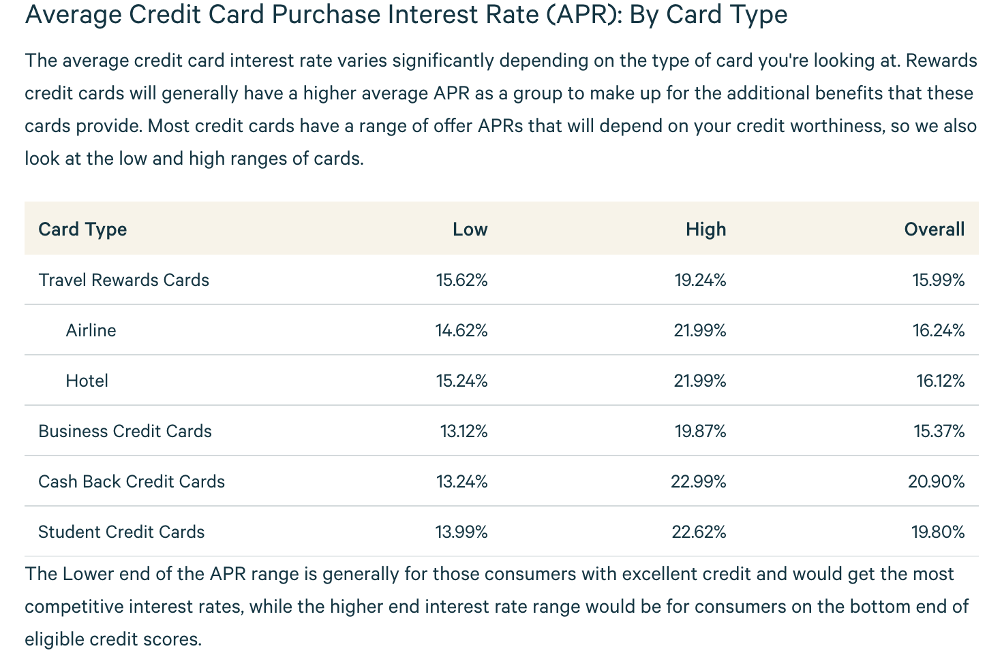
Source: ValuePenguin.com, https://www.valuepenguin.com/average-credit-card-interest-rates

Step 2. Choose five consumer goods or services (e.g. TVs, game consoles, smartphones, clothes, jewelry, meals at expensive restaurants, etc.) you would like to buy or own right now. Then go online and price the objects. Write the specific name of the object (type of consumer good, brand, and model) and the retail price in the chart below. Make sure the total amount of goods totals at least $3000.

Consumer Good  (type, make, model) | Price
1. | $
2. | $
3. | $
4. | $
5. | $
Total Amount Charged | $
Step 3. Click on the link below to calculate how long it will take to pay off your credit card balance.
1. Insert the total amount owed (or charged) and an APR into the loan repayment calculator. Then look over the data, paying particular attention to how long it will take to repay the money charged.
2. Then calculate three different repayment plans for that APR: one for the minimum monthly payment (4%), one for 8%, and one for 12%.
3. Then write down the information for each box below: the monthly payment amount, the APR, time to pay off the credit card, and the total repayment amount (principal + interest).
4. Be sure to enter all the information above for all three APRs (low, medium, and high) included in the APR graphic included in Step 1.

http://www.bankrate.com/calculators/credit-cards/credit-card-minimum-payment.aspx

Payment per Month (APR) | Time Required to Reach $0 Balance | Total Repayment Amount
$ ( - low)
$ ( - low)
$ ( - low)
$ ( - med.)
$ ( - med.)
$ ( - med.)
$ ( - high)
$ ( - high)
$ ( - high)

Part 6. Student Loans

Another common form of installment loans offered in the United States today are student loans. Student loans are private and federal government-backed loans issued to college students to pay for tuition and other expenses associated with education after high school. Student loans have become one of the primary means for making college accessible to students all across America. Tuition at most universities costs thousands of dollars a year. Since many students can’t afford to pay thousands of dollars a year to go to college, many students take out loans to pay for tuition and other expenses. In this way, student loans are good—they make college accessible for millions of Americans. However, in recent years, the number of students graduating college with high rates of student loan debt has grown at an alarming rate. In 2015, approximately 70% of college graduates left higher education with student load debt. Today, approximately 44 million Americans hold student loan debt equally approximately $1.3 trillion. In California, the average graduate leaves college more than $22,000 in debt.

Source 14
PBS News Hour
“Why Student Debt is ‘a crisis’ for some borrowers” (video, 0:00-3:40)

http://www.pbs.org/newshour/bb/student-debt-crisis-borrowers/

Questions

43. How much money in does Chris Savelle owe in student loans?

44. How much money in does Jessica Love Jordan owe in student loans?

45. What is the median amount of student loan debt across the US?

46. What two factors does the video point out as contributing to rising levels of student loan debt?

47. What is the total dollar amount of student loan debt in the US?

48. What according to this video is the “disease” rather than the “symptom” of student loan debt.

Source 15
Tuition Costs of Colleges and Universities
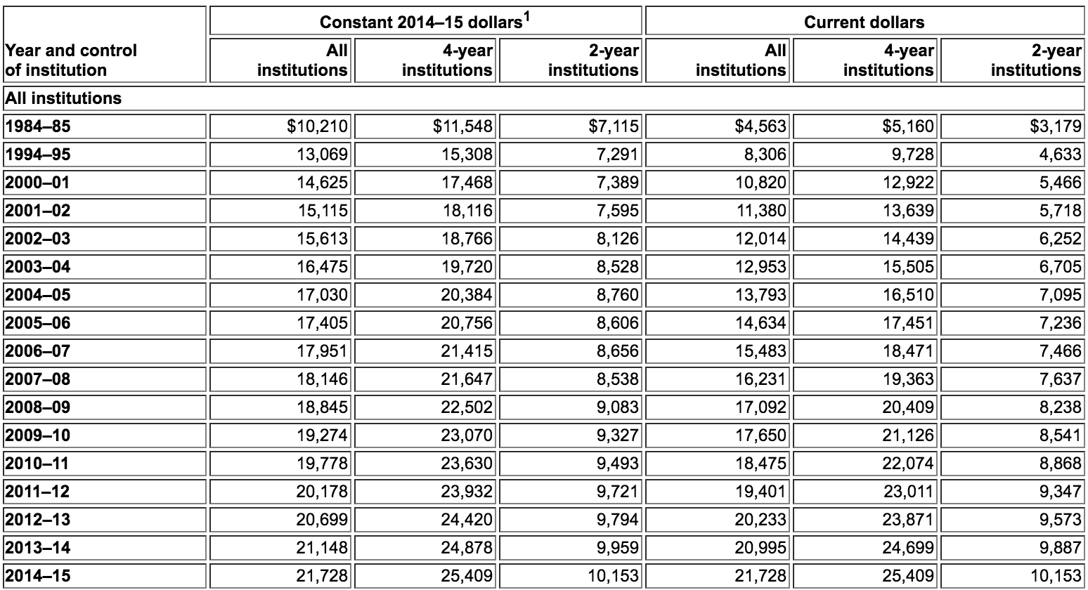
Source: National Center for Educational Statistics, https://nces.ed.gov/fastfacts/display.asp?id=76

Questions

49. What was the average cost of tuition in constant dollars for a 4-year college in 1984-85?

50. What was the average cost of tuition in constant dollars for a 4-year college in 2014-2015?

51. What is the difference in constant dollars between 1984-85 and 2014-2015?

52. What is the overall percentage increase of college tuition over this thirty-year time span?

Source 16
“3 Charts That Show Just How Dire The Student Loan Debt Crisis Has Become”
Huffington Post
February 3, 2016

President Barack Obama has said that a college degree “has never been more valuable.” But if you borrow to finance your degree, the immediate returns are the lowest they’ve been in at least a generation, new data show.  Wages for the typical recent college graduate working full time have risen just 1.6 percent over the last 25 years, after adjusting for inflation, according to the Federal Reserve Bank of New York.  Meanwhile, student debt burdens for the typical bachelor’s degree recipient who borrowed for college have increased about 163.8 percent, according to Education Department data analyzed by Mark Kantrowitz, a financial aid expert; Brad Hershbein, an economist at the W.E. Upjohn Institute for Employment Research; and The Huffington Post.  In 1990, the typical college student graduated with debt equivalent to 28.6 percent of her annual earnings. By 2015, that number had shot up to 74.3 percent, data show.  Student debt at graduation for the typical bachelor’s degree recipient could exceed annual wages by 2023, if both figures continue to grow at the same annual rate of the last 25 years, according to a HuffPost analysis.  Roughly 42 million Americans collectively owe more than $1.3 trillion on their student loans, federal data show. Total student debt has doubled during the Obama administration. More than 90 percent of student debt is either owned or guaranteed by the U.S. Department of Education.  Stagnant wages and the jump in student debt levels has prompted growing concern among government policymakers and financial industry executives that student debt risks slowing U.S. economic growth as households reduce their spending to make their student loan payments.  About 7 of every 10 college graduates now borrows to pay for higher education, up from about half in the 1990s, data show.  Surveys and academic research have suggested that student debtors are delaying home purchases, avoiding medical care and starting fewer small businesses. On Tuesday, a new report argued that student debt is hurting Americans’ ability to save for retirement.  The increase in debt accompanied by no growth in earnings has pushed student debtors into distress. Nearly 11.6 percent of student loan balances are at least 90 days delinquent, almost double the level in 2003, data show.  The Consumer Financial Protection Bureau estimates that 1 in 4 student loan borrowers are either in default or struggling to stay current, even though virtually all borrowers with federal student loans are able to make monthly payments indexed to their earnings.  To be sure, unemployment rates for college grads are lower than those for high school graduates. And college graduates typically receive higher pay than Americans who didn’t graduate with a college degree. Over a lifetime those extra earnings could add up to more than $1 million.  But as the cost of higher education rises and Americans flock to college campuses out of fear they’ll be economically left behind, perhaps it’s time for policymakers to stop declaring that college is worth it and instead redouble their efforts to ensure that student debt doesn’t hold back the economy. | delinquent—behind in monthly payments  default—behind in payments over an extended period of time, usually 6-9 months
Source: Huffington Post, http://www.huffingtonpost.com/entry/3-charts-student-debt-crisis_us_56b0e9d0e4b0a1b96203d369

Questions

53. What is the percentage increase of wages for college graduates over the last twenty-five years?

54. Which is higher—the percentage increase rise in wages or the percentage increase in college tuition calculated from Source 15?

55. What is the percentage increase of debt burdens for college graduates over the last twenty-five years?

56. Why, according to this report, is the student debt crisis a threat to the US economy?

57. What, according to this report, are the major advantages of having a college degree?

Source 17
Chart of College Graduate Debt to College Graduate Wages

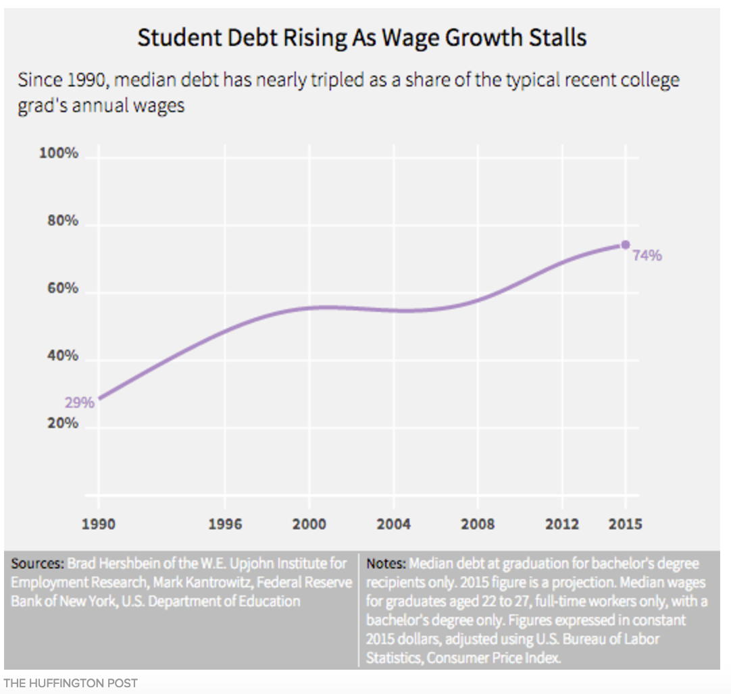
Source: Huffington Post, http://www.huffingtonpost.com/entry/3-charts-student-debt-crisis_us_56b0e9d0e4b0a1b96203d369

Questions

58. What financial issue does this chart illustrate?

59. What percentage of 2015 college graduates’ annual earnings was consumed by paying back college debts?

Source 18
Chart of College Graduate Debt and Wage Growth

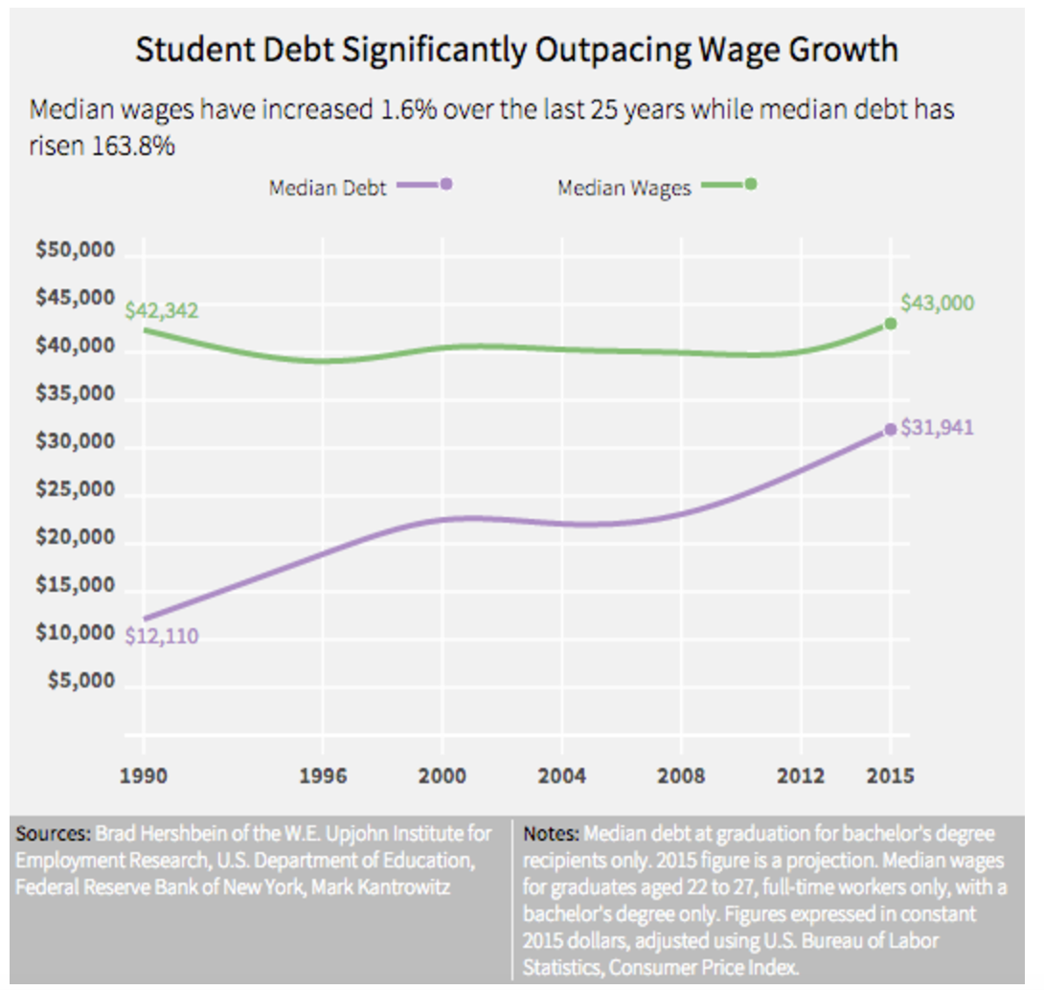
Source: Huffington Post, http://www.huffingtonpost.com/entry/3-charts-student-debt-crisis_us_56b0e9d0e4b0a1b96203d369

Questions

60. Which grew more between 1990-2015, median college graduate debt or median college graduate wages?

61. What is the difference between college graduate median debt and median wages?

Student Loan Activity

Millions of students attend college every year in the United States. In fall 2016, an estimated 20.5 million students enrolled in American colleges and universities (5.2 million more than in fall 2000).

More and more students enroll in college every year. Since 2000, a college education has become more expensive all over the US. Today, most college students will have to go into debt to finance a college education.

For this final exercise, you will (roughly) calculate the cost of attending Orange Coast College, CSU Fullerton, and UC Irvine.

Step 1. Read over the three charts detailing estimated expenses of attending Orange Coast College, CSU Fullerton, and UC Irvine.

Step. 2. Calculate the costs of attending each college/university.

Determine which institution(s) you’ll attend and if you’ll live on campus or at home.

Then identify which expenses you think you and your family can pay out-of-pocket, and which expenses you think you will have to cover through student loans.

Then write the total amount financed through loans for each year of your college education in the graphic organizer below.

Step 3. Add up the total amount you estimate you’ll need to finance to complete a bachelor’s degree in Orange County and write that figure in the “Total Amount Financed” box below.

Step 4. Use the student loan repayment calculator to determine your monthly payment, how long it will take to pay back your student loans, and the total repayment amount including interest.

Estimated Costs for Undergraduate Students Orange Coast College

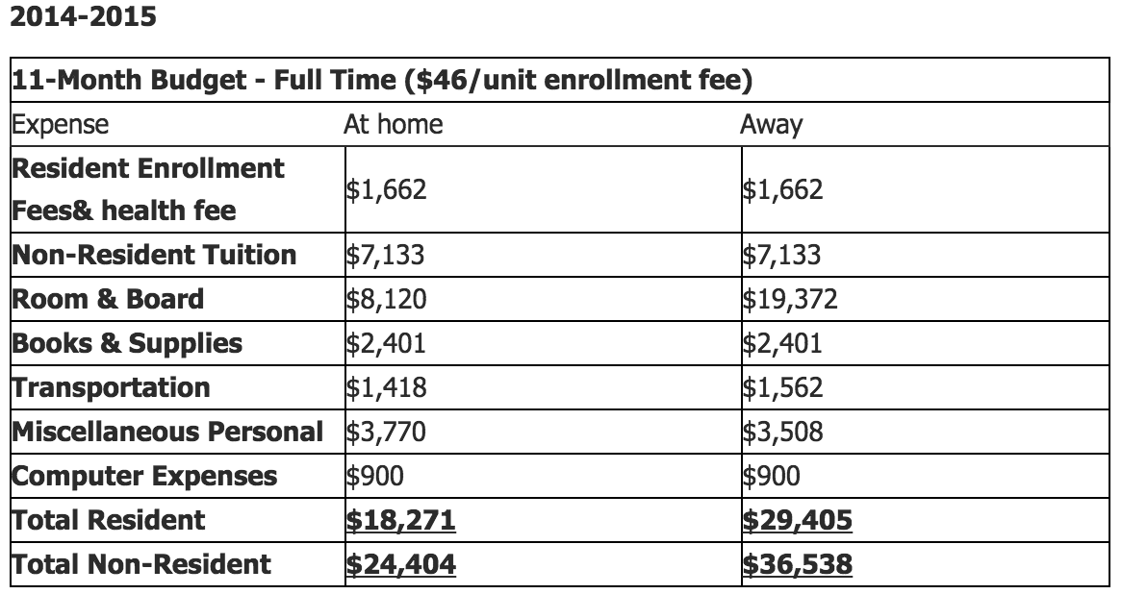

Estimated Costs for Undergraduate Students at CSU Fullerton

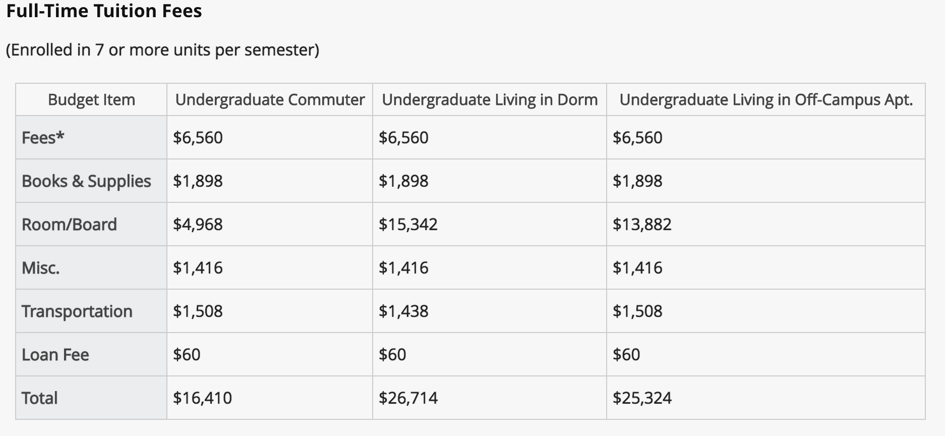

Estimated Costs for Undergraduate Students at UC Irvine

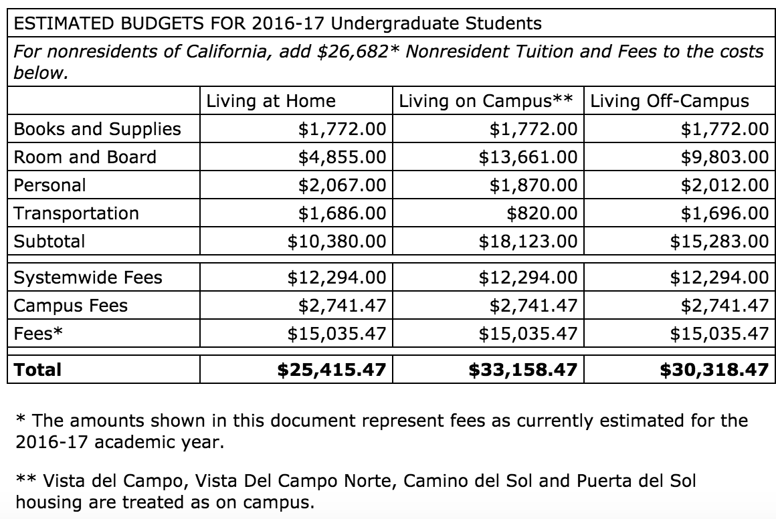

Student Loan Repayment Estimations
Year of College | Institution Name | Amount Financed
Year 1 |  | $
Year 2 |  | $
Year 3 |  | $
Year 4 |  | $
Year 5 |  | $
Year 6 |  | $
Total Amount Financed |  | $

College Loans Repayment Figures
Total Amount Financed | $
Monthly Payment | $
Years/Months to Repay Loans
Total Repayment Amount | $

