How did westward expansion help cause the Civil War?
Topics: Missouri Compromise, Compromise of 1850, Civil War
Erik Altenbernd, UC Irvine History Project

History Standards
8.9 Students analyze the early and steady attempts to abolish slavery and to realize the ideals of the Declaration of Independence.
8.9.5 Analyze the significance of…the Missouri Compromise (1820)…[and] the Compromise of 1850…

8.10 Students analyze the multiple causes, key events, and complex consequences of the Civil War.
8.10.1 Compare the conflicting interpretations of state and federal authority…
8.10.2 Trace the boundaries constituting the North and the South, the geographical differences between the two regions…

CCSS Standards: Reading, Grades 6-8
RH 1. Cite specific textual evidence to support analysis of primary and secondary sources.
RH2. Determine the central ideas or information of a primary or secondary source; provide an accurate summary of the source distinct from prior knowledge or opinions.
RH5. Determine how a text presents information (e.g. sequentially, comparatively, causally).
RH7. Integrate visual information (e.g. in charts, graphs, photographs, videos, or maps) with other information in print or digital texts.

CCSS Standards: Writing, Grades 6-8
WH 1. Write arguments focused on discipline-specific content.
WH 2. Write informative/explanatory texts, including the narration of historical events, scientific procedures/experiments, or technical processes.
WH 9. Draw evidence from informational texts to support analysis reflection, and research.

Guiding Question
1. How did westward expansion help cause the Civil War?

Overview of Lesson
This multi-media lesson teaches students to assess the causes of the Civil War. With particular attention to maps, it draws the students’ attention to the causes of the Civil War: sectionalism and the ways westward expansion created crises that exacerbated sectional tensions regarding slavery. It also focuses on the Missouri Compromise of 1820 and the Compromise of 1850, and highlights how the Missouri Compromise (temporarily) put a lid on sectional discord, and how the Compromise of 1850 worsened sectional tensions by, among other things, altering the uneasy truce set forth by the Missouri Compromise.

The lesson is informational as well as analytical and thus could be taught either at the beginning or the end of the Civil War unit.

The lesson includes a short introduction and is divided into four short parts:
- The Missouri Compromise
- The Compromise of 1850
- A short reading that identifies westward expansion as a cause of the Civil War and thus helps the students synthetize the information on the Missouri Compromise and Compromise of 1850.
- Final essay activity that includes “Historians Toolbox” graphic organizer.
Documents
- “Causes of the Civil War,” PBS, History Detectives (video)
- “The Missouri Compromise,” adapted from The Oxford Companion to United States History (excerpt).
- “Map of US Territorial Expansion and US States,” National Atlas (map)
- “Map f the Status of Slavery before the Missouri Compromise,” Mapping History, University of Oregon (map)
- “Map f the Status of Slavery after the Missouri Compromise,” Mapping History, University of Oregon (map)
- “The Compromise of 1850,” adapted from The Oxford Companion to United States History (excerpt).
- Map of the Compromise of 1850, source unknown (map)
- “American Civil War” by James B. McPherson (excerpt)
Teacher Outline for Final Activity
The final activity provides a scaffold—the “Historians Toolbox” graphic organizer”— for the students to answer the question: How did westward expansion help cause the Civil War?

Students will use the “Historians Toolbox” to gather evidence and outline their essays. The procedure is as follows:

Step 1. Pick a source—a map or reading—from the lesson on the Missouri Compromise. Then fill in the information from that source in the “Historians Toolbox” graphic organizer.

Step 2. Pick a second source—a map or reading—from the lesson on the Compromise of 1850. Then fill in the information from that source in the “Historians Toolbox” graphic organizer.

Step 3. Pick a third source—a map or reading—from the lesson that provides additional evidence regarding westward expansion and the Civil War. Then fill in the information from that source in the “Historians Toolbox” graphic organizer.

Step 4. Follow directions 1, 2, and 3 outlined after the “Historian’s Toolbox” graphic organizer.

Step 6. Outline your essay using the outline template, or model, listed after the “Historian’s Toolbox” graphic organizer.

Step 7. Write your essay using your outline as a guide.

Introduction
What caused the Civil War? Could it have been avoided? Historians have been asking these questions for more than 100 years.

The main cause of Civil War, of course, was slavery. However, in and of itself, slavery does not explain why the Civil War happened. To better understand the origins, or causes, of the Civil War we need to look not only at slavery, but other issues related to slavery.

One of those other issues is westward expansion. The acquisition of new territories starting with the Louisiana Purchase of 1803 opened a stinky can of worms that proved impossible to contain. Beginning in 1817, and for more than forty years thereafter, Americans debated—and, in places like Kansas, literally fought over—whether or not slavery should be allowed in the West.

The first major dispute over slavery in the West began in 1817 when the territory of Missouri petitioned Congress for statehood; this dispute was resolved by way of the Missouri Compromise of 1820. The next major dispute over slavery in the West broke out after the US-Mexico War of 1846-1848. The disputes that emerged at that time were resolved—temporarily—by the Compromise of 1850.

In this lesson, you will review the Missouri Compromise and Compromise of 1850 to understand how westward expansion helped cause the Civil War.

Source 1
“Causes of the Civil War”
PBS, History Detectives

Causes of the Civil War (1:37)
http://www.pbs.org/opb/historydetectives/feature/causes-of-the-civil-war/
1. What, according to this video, was the main aim of States’ Rights?
2. What was the main point of conflict regarding westward expansion?
3. How are these two issues—States’ Rights and westward expansion—interrelated, or connected? Explain your answer in 2-4 sentences using at least one piece of evidence from the video.

Source 2
“The Missouri Compromise”
Adapted from The Oxford Companion to United States History (2001)

In 1817, Missouri became the second territory within the boundaries of the Louisiana Purchase (after Louisiana itself) to apply for statehood. Missouri applied to enter as a slave state.  In February 1819, Congressman James Tallmage of New York proposed that no further slaves be allowed into Missouri and that children of slaves in the state be freed at age twenty-five. His proposal, along with a similar one regarding the Arkansas Territory, sparked impassioned debate.  When Congress returned in 1820, Senator Jesse B. Thomas of Illinois proposed a compromise that became law in March 1820:  Maine whose simultaneous bid for statehood had been blocked by southern senators, was admitted as a free state; Missouri came in as a slave state; and, most significantly, Missouri’s southern border—the 36°30' parallel—was extended westward as the boundary north of which slavery would not be permitted within the Louisiana Purchase.  The significance of the Missouri controversy became clear only many years later. First, it provided the context for the first full-scale debate over what in the middle decades of the century as the central issue of the sectional crisis: the territorial expansion of slavery. Second, it revealed the power of sectional loyalties to overwhelm loyalty to political parties. Third, the Missouri Compromise set the precedent for congressional authority in determining the spread of slavery into the West. | impassioned—filled with great emotion  simultaneous—occurring, happening at same time  sectional crisis—political conflict between Northern and Southern states over slavery  sectional loyalties—loyalty to region (i.e. North or South) rather than political party
Source: Paul S. Boyer, et al., Oxford Companion to United States History (New York: Oxford University Press, 2001), 508.

Questions

4. What proposal sparked debate over Missouri statehood in 1819?

5. What are the three key features of the Missouri Compromise?

6. What, according this reading, were the three most significant aspects of the Missouri Compromise?
Source 3
Map of US Territorial Expansion and US States

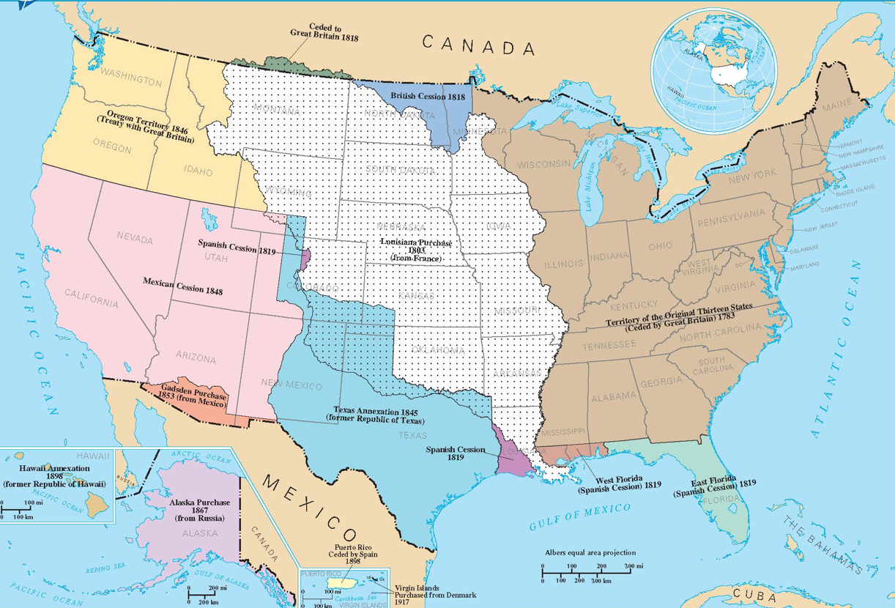
Source: National Map, https://nationalmap.gov/small_scale/printable/territorialacquisition.html#list

Source 4 - Map of Status of Slavery before the Missouri Compromise

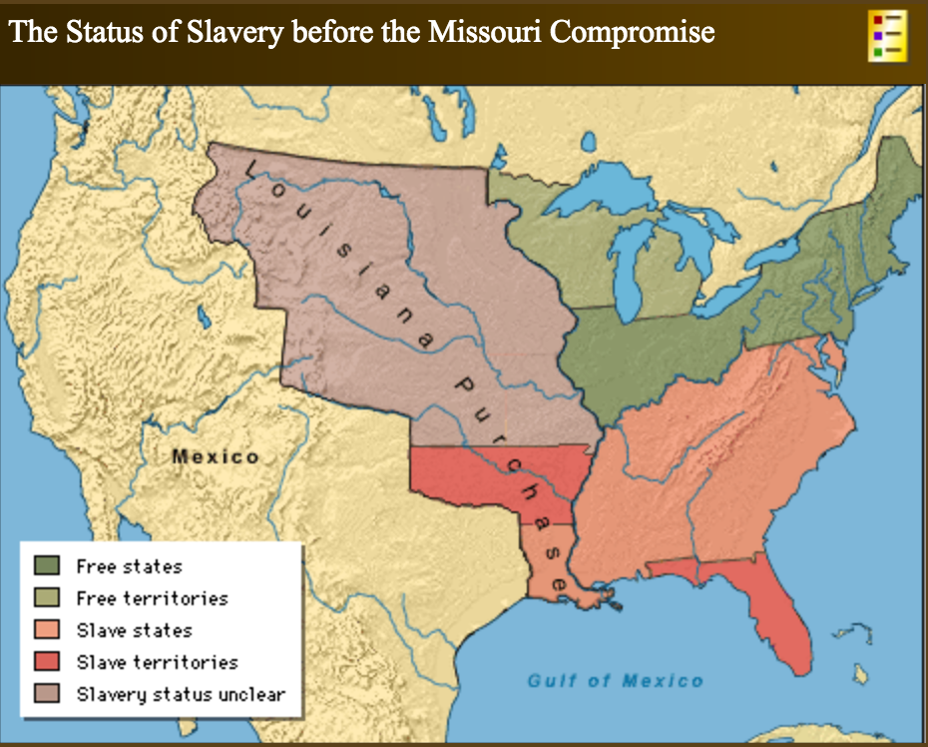

Source 5 - Map of Status of Slavery after the Missouri Compromise

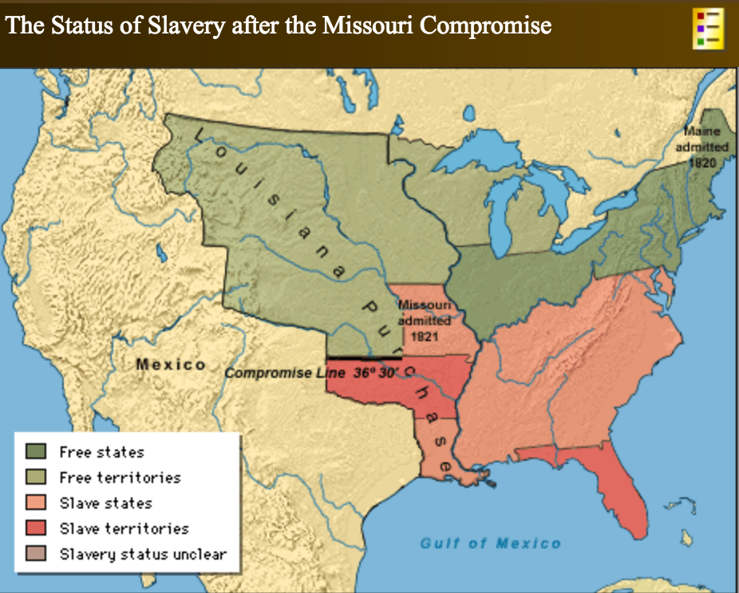
Source: http://mappinghistory.uoregon.edu/english/US/US19-01.html
Questions for Sources 3-5

7. Looking at Source 3, which modern states were created all, or in part, from the Louisiana Purchase of 1803?

8. What three pieces of information does Source 4 illustrate regarding the status of slavery in the Louisiana Purchase before the Missouri Compromise?

9. What three changes regarding the status of slavery in the Louisiana Purchase does Source 5 illustrate?

10. Looking at Source 5, who made out worse as a result of the Missouri Compromise—those in favor of slavery in the West or those opposed to slavery in the West? Explain your answer in 2-3 sentences.

Source 6
“The Compromise of 1850”
Adapted from The Oxford Companion to United States History (2001)

The Compromise of 1850 was a series of laws passed by Congress to settle the deepening sectional crisis over slavery.  Although passed separately, the laws followed a tradition—set by the Missouri Compromise—over slavery’s expansion and designed to secure compromises from both sides of the debate.  First, the slave state of Texas relinquished its territorial claims to neighboring New Mexico.  Legislation organizing the territories of New Mexico and Utah included popular sovereignty—a new policy that permitted the settlers in New Mexico and Utah to decide to allow or ban slavery when they applied for statehood.  California was admitted as a free state over the protests of southerners fearful of a free state majority in the Senate.  A tough new Fugitive Slave Act was passed to stop interference by northerners with the capture and return of fugitive slaves.  Finally, Congress banned public slave-trading in Washington, D.C., a compromise between antislavery forces demanding total abolition of slavery in the capital and southerners who viewed any restriction as unconstitutional.  The Compromise of 1850 briefly muted sectional hostilities and delayed civil war for a decade. However, the compromise unraveled due to the Fugitive Slave Act, and when an overconfident Senator Stephen A. Douglas, in the Kansas-Nebraska Act of 1854, helped reverse the Missouri Compromise of 1820 by opening Kansas to slavery on the basis of popular sovereignty. | sectional crisis—political conflict between Northern and Southern states over slavery  relinquish—to willingly stop doing something; to give up  interfere—to prevent a person or process from carrying out an action or series of actions  mute—to quiet or silence  unravel—to take apart or undo something twisted or closely tied together.
Source: Paul S. Boyer, et al., Oxford Companion to United States History (New York: Oxford University Press, 2001), 149-150.

Questions

11. What are the five major laws passed as part of the Compromise of 1850?

12. What was the policy of popular sovereignty?

13. Why did the Compromise of 1850 eventually “unravel?”

Source 7
Map of the The Compromise of 1850

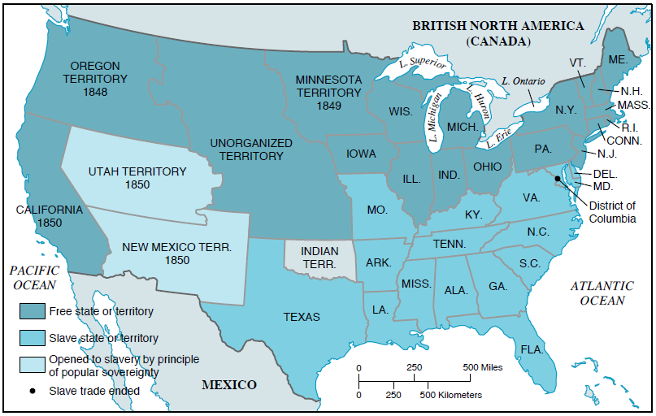

Questions

14. Looking at Source 2, which modern states were created all, or in part, from the Mexican Session (the lands ceded by Mexico after the US-Mexico War)?

15. Looking at Sources 5 and 7, how did the policy of popular sovereignty overturn the Missouri Compromise?

16. Looking at Source 7, who potentially made out worse as a result of the Compromise of 1850—those in favor of slavery in the West or those opposed to slavery in the West? Explain your answer in 2-3 sentences.

Source 8
“American Civil War”
By James M. McPherson

In this essay, James M. McPherson, Professor of History at Princeton University and one of the leading historians of the Civil War, discusses the causes of the Civil War.

The Civil War is the central event in America’s historical consciousness. While the Revolution of 1776-1783 created the United States, the Civil War of 1861-1865 determined what kind of nation it would be. The war resolved two fundamental questions left unresolved by the Revolution:  1. Whether the United States was to be a dissolvable confederation of sovereign states or an indivisible nation with a sovereign national government.  2. Whether this nation, born of a declaration that all men were created equal, would continue to exist as the largest slave-holding country in the world.  Northern victory in the Civil War preserved the United States as one nation and ended the institution of slavery that had divided the country from its beginning.  The Civil War started because of uncompromising differences between the free and the slave states over the power of the national government to prohibit slavery in the territories that had not yet become states. When Abraham Lincoln won election in 1860 as the first Republican president on a platform pledging to keep slavery out of the territories, seven slave states in the Deep South seceded and formed a new nation, the Confederate States of America. | consciousness—state of being awake and aware of one’s surroundings  dissolve—to close down, dismiss, or end, as in a meeting  indivisible—something that cannot be divided  uncompromising—to be unwilling to compromise or agree to work with others
Source: Adapted from essay in Civil War Sites: The Official Guide to the Civil War Discovery Trail, 2nd ed. (Guilford, CN: Globe Pequot Press, 2008), xvii.

Questions

17. Why does James McPherson say the Civil War is “the central event in the American historical consciousness?”

18. What two problems did the United States inherit after it broke away from Great Britain?

19. What issue, according to McPherson, started (or caused) the Civil War? Explain your answer in 2-3 sentences.

Final Activity
The main cause, or issue behind, the outbreak of the Civil War in 1861 was slavery. However, by itself, slavery is an imprecise answer to the question What caused the Civil War?

Additional factors along with slavery caused the Civil War. More than that, some of those factors played a role in making slavery a political problem without a solution.

As we have seen in this lesson, westward expansion was one of those additional factors.

For this final activity, your job is to explain how westward expansion helped make slavery a political problem without a solution.

To do this, you will need to answer the question How did westward expansion help cause the Civil War?

To answer the question below, you will need to gather information and evidence to support your main claim, or answer to this question.

To gather evidence, follow the steps below using the “Historian’s Toolbox” graphic organizer.

Step 1. Pick a source—a map or reading—from the lesson on the Missouri Compromise. Then fill in the information from that source in the “Historians Toolbox” graphic organizer.

Step 2. Pick a second source—a map or reading—from the lesson on the Compromise of 1850. Then fill in the information from that source in the “Historians Toolbox” graphic organizer.

Step 3. Pick a third source—a map or reading—from the lesson that provides additional evidence regarding westward expansion and the Civil War. Then fill in the information from that source in the “Historians Toolbox” graphic organizer.

Step 4. Follow directions 1, 2, and 3 outlined after the “Historian’s Toolbox” graphic organizer.

Step 6. Outline your essay using the outline template, or model, listed after the “Historian’s Toolbox” graphic organizer.

Step 7. Write your essay using your outline as a guide.

Historian’s Toolbox: Organizing Evidence to Write

Inquiry Question: How did westward expansion help cause the Civil War?

Source Citation | Summary:  What is the information presented in the source?  Describe what you see/read in the source. | Evidence:  What are some specific quotes or information from the source that allows you to answer the question? | Analysis:  “This means that…”  “This shows that…”  “This source is important to our understanding because…” | Claim:  Explain how this source answers the inquiry question.
Source 1
Source 2
Source 3

- Examine the Claim column and create one claim that unifies the ideas you present. For example, instead of having three sentences about different causes for an event, create one sentence with all of the causes of an event.
Write your Claim here:

- Organize your evidence. Do you want to present the evidence in chronological order or another way? List how you will organize your evidence here:

- How does the evidence support your claim? Give some specific analysis explaining why you think this evidence is important to answer the inquiry question.

You are ready to write! Use the outline below to develop a paragraph:

- Introduce the topic (time period, location, major historical figures)
  - What was the Chicano Movement?
  - When did it take place?
  - Where did it take place?
  - Who were some of the leaders of the movement?
  - What were the movements aims or goals?
- Main claim
- Evidence #1 and analysis (Chicano Park mural)
- Evidence #2 and analysis (source on Chicano Movement)
- Evidence #3 and analysis (source on Chicano Movement)
- Concluding sentence restating your claim

