Did African Americans attain equal rights after the Civil War?
Topics: Reconstruction; African American history
Catherine Christensen, UC Irvine History Project

History Standards
8.11 Students analyze the character and lasting consequences of Reconstruction.
8.11.1 List the original aims of Reconstruction and describe its effects on the political and social structures of different regions.
8.11.3 Understand the effects of the Freedman’s Bureau and the restrictions placed on the rights and opportunities of freemen, including racial segregation and “Jim Crow” laws.
8.11.4 Trace the rise of the Ku Klux Klan and describe the Klan’s effects.
8.11.5 Understand the Thirteenth, Fourteenth, and Fifteenth Amendments to the Constitution and analyze their connection to Reconstruction.

CCSS Standards: Reading, Grades 6-8
RH 1. Cite specific textual evidence to support analysis of primary and secondary sources.
RH2. Determine the central ideas or information of a primary or secondary source; provide an accurate summary of the source distinct from prior knowledge or opinions.
RH3. Evaluate various explanations for actions or events and determine which explanation best accords with textual evidence…
RH7. Integrate visual information (e.g. in charts, graphs, photographs, videos, or maps) with other information in print or digital texts.

CCSS Standards: Writing, Grades 6-8
WH 1. Write arguments focused on discipline-specific content.
WH 2. Write informative/explanatory texts, including the narration of historical events, scientific procedures/experiments, or technical processes.
WH4. Produce clear and coherent writing in which the development, organization, and style are appropriate to the task, purpose, and audience.
WH 9. Draw evidence from informational texts to support analysis, reflection, and research.

Guiding Question
1. Did African Americans attain equal rights after the Civil War?

Overview of Lesson
This lesson examines the course of Reconstruction by focusing on the issue of African American civil rights, particularly voting rights. The first part of the lesson familiarizes the students with the three main programs of Reconstruction (Lincoln’s 10% plan, Presidential Reconstruction, and Radical Reconstruction). Part two asks the students to assess African American participation in politics (both voting and office holding). Part three helps the students make direct connections between African American participation in politics in the early years of Reconstruction and the restriction of African American voting rights in the latter years of Reconstruction and during rise of Jim Crow segregation.

The lesson is organized as follows:
- Introduction
- What did Reconstruction Mean
- African Americans in Politics
- The Rise of Jim Crow
- Final Activity
Documents
- Secondary source on Lincoln’s 10% plan (excerpt)
- Secondary source on Presidential Reconstruction (excerpt)
- Secondary source on Radical Reconstruction (excerpt)
- Secondary source on civil rights and Reconstruction (excerpt)
- “First Colored Senator and Representatives in the 41st and 42nd Congresses,” Currier and Ives (1872, image)
- “Colored Rule in Reconstruction,” Harper’s Weekly (1874, image)
- Birth of a Nation (1915, film clip)
- Black Codes (excerpt)
- Literacy Test (excerpt)
- “The First Vote,” Harper’s Weekly (1867, image)
- Ku Klux Klan Letter (1868, excerpt)
- Plessy v. Ferguson, majority decision (1896, excerpt)
Teacher Outline: Part 1. What does Reconstruction mean?

Step 1: Begin class by discussing what the word “Reconstruction” means, and consider whether it means “to build again” or to “build a new”? Ask the class to imagine the state of the nation after the Civil War and the destruction both to the physical landscape and to the morale, the economy and spirit of the nation.

Step 2: Divide students into groups of three and assign each groups a different “Reconstruction Plan”—either Lincoln’s Plan, Presidential Reconstruction or Radical Reconstruction. (There will be about 3-4 groups working on the same plan.) Ask students to read their Reconstruction Plan, and to briefly paraphrase/summarize what their plan says.

Step 3: Select one student representing each of the three plans to share with the class their program for Reconstruction (as explained in the reading.) Students will listen to each proposal and then reconvene in their group to discuss the merits/problems with each. They will be asked to take notes on each plan.

Step 4: Each group will then develop their own plan for Reconstruction. Students will take turns sharing out their plan. They will submit both their summary, their notes taken from the presentations and their group Reconstruction Proposal.

Teacher Outline: Part 2. African Americans in Government

Step 1: Ask students to use their textbook to define the 13th, 14th, and 15th Amendments. They will then fill in the table to both copy verbatim and and provide a summary or explanation of what they think the amendment means. Explain to students that the amendments are not always clear and easy to understand and to just “guess” what they state.

Step 2: Ask students to read about the success of black enfranchisement and political participation and answer the questions that follow.

Step 3: Introduce students to Source 1 & 2—representations of black political participation. Ask them to analyze what they see and write a short explanation of the differences between the two. For source 2 you might encourage the use of the 4Cs to facilitate analysis and also project the image on screen given the details of the cartoon.

Step 4: Explain to students that you will view a clip from Birth of a Nation—the first feature length film that debuted in 1915. Explain that D.W. Griffith was sympathetic to Southerners and ask students to consider how he portrays black participation.

Step 5: In pairs, have students discuss the following question: “How does Birth of a Nation portray the political participation of blacks during Reconstruction?” Have students share out what they discuss and then consider the effect of such a representation on the larger nation. Ask them what people outside the south might have believed as a result of such a representation?

Step 6: Explain to students that Southerners were determined to end black participation and that follow up lessons will continue to explain how they accomplished this.

Teacher Outline: Part 3. Rise of Jim Crow

Step 1: Divide students into four groups. Each will read a primary source and answer questions to understand the ways Southern governments abridged the rights of freedmen and women. (Group 2 will have 2 sources).

Step 2: Divide students into new groups, with each group representing one of the four sources/groups. Students will share out the meaning of their primary source and fill in table with notes.

Step 3: As a group, students will discuss how the sources they have read help answer the question: Did African Americans attain political rights after the Civil War?

Step 4: Students write a paragraph response individually to the lesson question.

Teacher Outline: Final Activity. Socratic Seminar

Step 1: To begin the final activity, remind students of the lesson question: Did African Americans attain equal rights after the Civil War? Then explain that they will analyze two primary sources—a political cartoon and quotation—that will help them think more about that question. They will also need to consider what they learned from the previous portions of the lesson. On the board, ask students to recall how previous parts of lesson might help them answer the question. Then explain to students that the class will continue to think about the question through a Socratic Seminar— a format where students seek deeper understanding of complex ideas in the text through thoughtful dialogue.
Step 2: Divide students into groups of four and distribute Sources 1 & 2 as well as the guiding questions. Have students work on the questions for each source together as a group, but answer the questions individually on worksheet.

Step 3 (Speakers): Select four students (one from each group). These four students are responsible for discussing a given set of questions about the experience for a given amount of time (we recommend 10 minutes). They are the only ones who speak; even the teacher will not say a word once the discussion has begun.

Step 4 (Observers): At the same time, select four other students to form the outside circle to observe the four participants; each observer will be assigned the task of assessing one of the four speakers. Each observer will complete a checklist and give feedback on his/her designated participant’s performance.

Step 5 (Notetakers): Everyone else in the class takes guided notes on the discussion.

Step 6: After the discussion, invite observers to share positive comments, then provide your own specific constructive feedback so that everyone in the room will learn more about how to do well in a public speaking format. Then allow the rest of the class to offer comments on the Socratic Seminar.

Introduction
Reconstruction is the period of US history that follows the Civil War. The Civil War ended in April 1865, but, in some ways, Reconstruction began on January 31, 1865—the day Congress adopted the 13th Amendment, the amendment that formally ended slavery in the United States. The states did not ratify the 13th Amendment until early December 1865, but the legal and permanent end of slavery began in January of that year.

From this perspective, Reconstruction overlaps with the Civil War and is closely related to the Civil War. However, it is separate and distinct from the Civil War.

The nation faced two major issues during Reconstruction:

1. How would the Southern states be reconstructed after the Civil War? In this sense, Reconstruction refers to two sub-issues:
A. Political reconstruction: the reincorporation of the Confederate states back into the
United States.
B. Physical reconstruction: the physical rebuilding of the South and southern economy,
which was devastated by the fighting during the war and by emancipation (before the
war, the 4 million African Americans held in bondage in the South were worth more
money than all the land in the South).

2. Were African Americans socially and politically equal to white Americans after the Civil War? In many ways, the most pressing problem facing the nation after the Civil War was the status of former slaves, especially African American men Americans at the time called “freedmen.” Black men were free, but, socially speaking, would they be equal to white men? Black men were free, but, would they be given all the rights of citizens—could they vote in elections and serve as members of the state and federal governments? These questions were open-ended and fiercely debated during Reconstruction.

This lesson will focus on some of the ways Americans disagreed over Reconstruction and the central question that has haunted Americans since emancipation: Were African Americans socially and politically equal to white Americans after the Civil War?

Part 1. What did Reconstruction Mean?
After the Civil War, there was disagreement about how the country should rebuild again. Should the South be welcomed back into the Union without any punishment? Should former slaves be given full citizenship? Three major programs were envisioned in response to these difficult questions.

Source 1: Lincoln’s 10% Plan

Lincoln’s plan was known as the 10% Plan and it offered pardons to any Confederate who swore loyalty to the Union and the US Constitution.  When the number of people who took an oath of allegiance equaled 10% of the number of voters who participated in the election of 1860, the state would be readmitted to the Union after organizing a new state government which abolished slavery. Lincoln was assassinated before this plan could be put into effect.  In his Second Inaugural address Lincoln expressed his attitudes about Reconstruction. He said: “With malice toward none, with charity [to provide help] for all, with firmness in the right as God gives us to see the right, let us strive on to finish the work we are in, to bind up the nation's wounds, to care for him who shall have borne the battle and for his widow and his orphan, to do all which may achieve and cherish a just and lasting peace among ourselves and with all nations.” | pardon—to forgive or be forgiven for committing a crime or offense  malice—intent to harm  charity—to voluntarily help someone in need  cherish—to care for something or hold something dear, important

Summarize the 10% Plan:

Part 1. What did Reconstruction Mean?
After the Civil War, there was disagreement about how the country should rebuild again. Should the South be welcomed back into the Union without any punishment? Should former slaves be given full citizenship? Three major programs were envisioned in response to these difficult questions.

Source 2: Presidential Reconstruction (i.e. Andrew Johnson’s Plan)

After Lincoln’s assassination, Andrew Johnson took office with a different plan for Reconstruction. Being a Southerner himself, Johnson’s plan was lenient towards the southern states. His plan granted pardons to anyone taking a loyalty oath to the United States except for high ranking Confederate political and military leaders, and people owning property worth more than $20,000.  In Johnson’s view, the southern states had never given up their right to govern themselves, and the federal government had no right to determine voting requirements in Southern states.  Under Johnson’s Presidential Reconstruction, all land that had been confiscated by the Union Army and distributed to the freed slaves by the army were returned to the original owners. Apart from being required to uphold the abolition of slavery, swear loyalty to the Union, and pay off their war debts, southern state governments were allowed to whatever they wished.  Johnson did not concern himself much with the plight of freed slaves and allowed Southern states to pass “black codes,” or laws which severely limited the civil rights of freedmen. Johnson had little sympathy for black Americans and was even quoted as saying “This is a country for white men, and by God, as long as I am President, it shall be a government for white men.” | lenient—less harsh punishment for doing something wrong  pardon—to forgive or be forgiven for committing a crime or offense  confiscated—taken as punishment  distributed—given out

Summarize Presidential Reconstruction:

Part 1. What did Reconstruction Mean?
After the Civil War, there was disagreement about how the country should rebuild again. Should the South be welcomed back into the Union without any punishment? Should former slaves be given full citizenship? Three major programs were envisioned in response to these difficult questions.

Source 3: Radical Reconstruction

After Lincoln’s assassination, Congress refused to pass President Andrew Johnson’s plan for Reconstruction, and refused to seat any congressmen elected from former Confederate states.  Led by the Radical Republicans, Congress developed its own plan known as “Radical Reconstruction,” which was committed to helping newly freed slaves and harsher punishment for Southern states.  In addition to refusing to seat any person elected to Congress from any former Confederate state, Congress passed its own laws concerning the southern states.  The first laws it passed helped newly freed slaves, such as The Civil Rights Act.  Radical Reconstruction also included the Reconstruction Acts which divided the South into 5 military districts with the military commander of the district given complete authority.  No state would be allowed back into the Union until it ratified the 14th Amendment and guaranteed the right to vote for African American men.  The 14th Amendment punished Confederate supporters and gave citizenship to former slaves. It also said that no state could deny to anyone, including African Americans, the equal protection of the law and due process of law.  The Radical Republicans also drafted the 15th amendment, which stated that the right to vote could not be denied on the basis of race.  Eventually, all the former Confederate states were readmitted into the Union under this plan. | seat—accept into Congress  Radical Republicans—Republicans against slavery and in favor of social and political equality for African Americans

Summarize Radical Reconstruction:

Part 1. Student Notes

Our Plan (write name):

Plan 2 (write name and summarize below):

__________________________________________________________________________

__________________________________________________________________________

__________________________________________________________________________

__________________________________________________________________________

__________________________________________________________________________

__________________________________________________________________________

__________________________________________________________________________

Plan 3 (write name and summarize below):

__________________________________________________________________________

__________________________________________________________________________

__________________________________________________________________________

__________________________________________________________________________

__________________________________________________________________________

__________________________________________________________________________

__________________________________________________________________________

Part 2. African Americans in Politics
The 13th, 14th, and 15th Amendments, also known as the Civil War Amendments, not only ended slavery but provided for the civil rights of African Americans after emancipation. One of the key—and most debated—features of the attempt of Radical Republican to promote social equality for African Americans was voting rights. In the early years of Reconstruction, African Americans played a key role in American politics and the Republican Party.

Reading 4
African Americans in Politics during Reconstruction

Before the Civil War began, African Americans had only been able to vote in a few northern states, and there were virtually no black officeholders. After the war, and with the passage of the 13th, 14th and 15th Amendments, African Americans were granted citizenship and the right to vote. Beginning in 1867, blacks began to take part in politics and started voting in large numbers.  During Reconstruction, some 2,000 African Americans held public office, from the local level all the way up to the US Senate. Fourteen black men served in the House of Representatives between 1869 and 1877, six served as lieutenant governors, and more than 600 served in southern state legislatures.  Almost half of the elected black delegates served in South Carolina and Louisiana, where blacks had the longest history of political organization.  Many black leaders during Reconstruction had gained their freedom before the Civil War. Hiram Revels, the first African American elected to the U.S. Senate was born free in North Carolina and attended college in Illinois. Blanche K. Bruce, elected to the Senate in 1875 from Mississippi, had lived a privileged life as a slave and also received some education.  In response to the gains made by black Americans, many white southerners tried to deny their qualifications for politics and attempted to remove them from office and voting. | officeholder—person elected to political office or position  delegate—political representative

What gains did African Americans during Reconstruction make as a consequence of the 13th, 14th, and 15th Amendments?

Analyze the following sources.
Source 1. "First Colored Senator and Representatives in the 41st and 42nd Congress of the United States." 1872
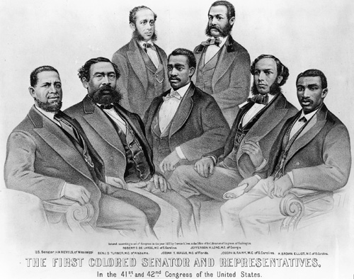

Source 2. “Colored Rule in A Reconstruction State” Harpers Weekly, March 14, 1874
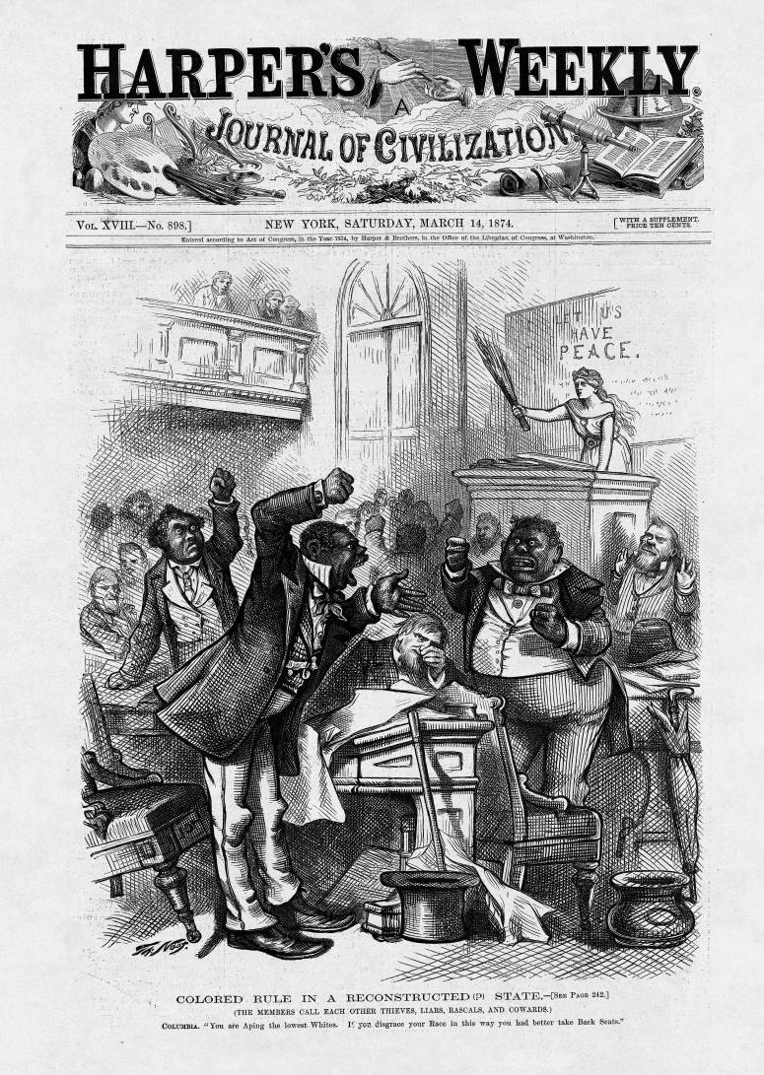
In source 1, African Americans are shown as _________________________________
This is seen in (explain details of picture that lead you to this conclusion)

In source 2, African Americans are shown as _________________________________
This is seen in (explain details of picture that lead you to this conclusion)

Now watch the following clip from the film Birth of a Nation (1915).

https://www.youtube.com/watch?v=R4v_yRFf4-Y&feature=related

In pairs, discuss the following question: “How does Birth of a Nation portray the political participation of blacks during Reconstruction?”

Part 3. The Rise of Jim Crow
White southerners and the Democratic Party worked hard to restrict African American civil rights during Reconstruction. The Black Codes (the laws passed right after the Civil War that established a system of quasi-slavery), the restriction of African American voting rights, and threats of violence by terrorist groups like the Ku Klux Klan were used to restrict Black rights and limit racial equality. Eventually, these efforts resulted in Jim Crow laws that enforced racial segregation and African American social and political inequality.

Group 1 Handout
Black Codes

… it shall not be lawful for any freedman, free negro, or mulatto to intermarry with any white person…and any person who shall so intermarry, shall be deemed guilty of felony, and on conviction thereof shall be confined in the State penitentiary for life…  All freemen, free negroes and mulattoes in this state, over the age of eighteen years…with no lawful employment or business, or found unlawfully assembling [gathering] themselves together, either in the day or night time…shall be deemed vagrants, and on conviction shall be fined…  No freedman, free negro or mulatto, not in the military service of the United States government, and not licensed so to do by the board of police of his or her county, shall keep or carry fire-arms of any kind, or ammunition, dirk or bowie knife…  If any freedman, free negro or mulatto convicted of any of the misdemeanors provided against in this act, shall fail…to pay the fine…such person shall be hired out…to any white person who will pay said fine and all costs, and take said convict... | mulatto—person born to one black parent and one white parent  dirk—short knife, dagger  bowie knife—long double-bladed hunting knife  misdemeanor—minor crime

What do the Black Codes forbid former slaves to do?

How different do you think these laws are from slavery?

What kinds of punishments did black codes involve?

Which black code had the most severe punishment? Why do you think that was the case?

Part 3. The Rise of Jim Crow
White southerners and the Democratic Party worked hard to restrict African American civil rights during Reconstruction. The Black Codes (the laws passed right after the Civil War that established a system of quasi-slavery), the restriction of African American voting rights, and threats of violence by terrorist groups like the Ku Klux Klan were used to restrict Black rights and limit racial equality. Eventually, these efforts resulted in Jim Crow laws that enforced racial segregation and African American social and political inequality.

Group 2 Handout
Source 2A - Harper’s Weekly Cartoon

Text at bottom of image reads: “THE FIRST VOTE”

Group 2 Handout
Source 2B - Literacy Test

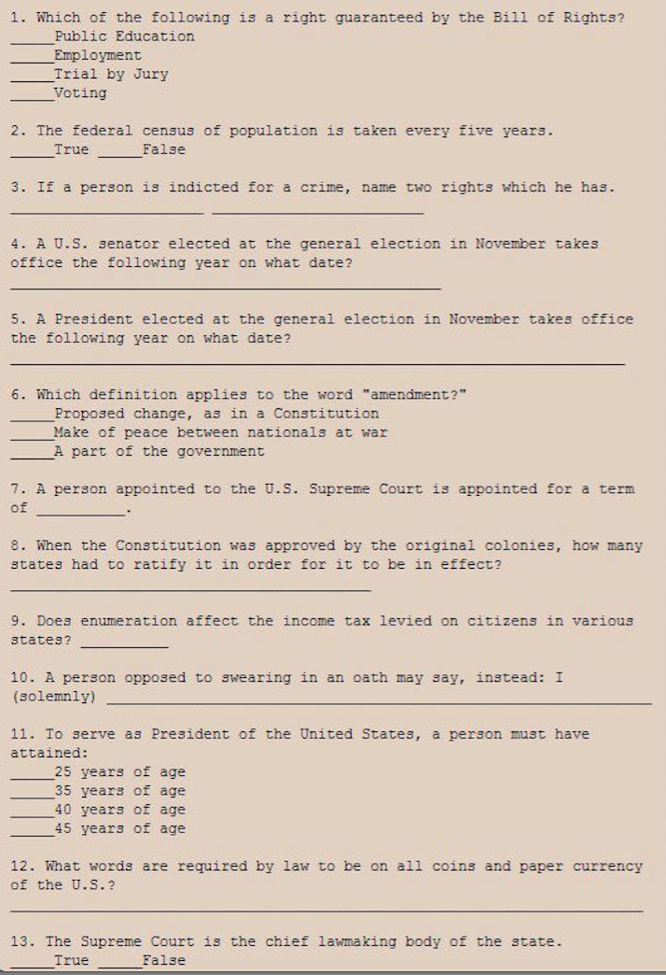

According to these two sources, how did white Southerners seek to influence how African Americans voted, or exclude African Americans from voting altogether?

Source 2A:

Source 2B:

What do these sources tell us about African American voting rights during Reconstruction?

Part 3. The Rise of Jim Crow
White southerners and the Democratic Party worked hard to restrict African American civil rights during Reconstruction. The Black Codes (the laws passed right after the Civil War that established a system of quasi-slavery), the restriction of African American voting rights, and threats of violence by terrorist groups like the Ku Klux Klan were used to restrict Black rights and limit racial equality. Eventually, these efforts resulted in Jim Crow laws that enforced racial segregation and African American social and political inequality.

Group 3 Handout
Letter from Ku Klux Klan Member to African American Voter

To Jeems,  Davie. you. must. be, a good boy.…  I am here now as a Locust in the day Time and. at night I am a Ku Klux sent here to look after you and all the rest of the radicals and make you know your place.  I have got my eye on you every day, I am at the Ford of the creek every evening From Sundown till dark I want to meet you there next Saturday tell platt Madison we have, a Box. For him and you. We nail all, radicals up in Boxes and send them away to KKK - there is. 200 000 ded men retured to this country to make you and all the rest of the radicals good Democrats and vote right with the white people you have got it to do or leave this country no n***** is safe unless he Joins the Democratic Club then you will be safe and have friends.  Take heed and govern yourself accordingly and give all your Friends timely warning.  --Ku, Klux, Klan | locust—large grasshopper that eats crops and can fly great distances  radicals—anyone who supports Black voting and civil rights, especially Republicans

What do you think the writer means telling Jeems Davie to “know his place?”

What kind of “box” do you “nail” people up in? What is he threatening?

Why is Jeems Davie being threatened?

What does this source tell us about the voting rights of African American during Reconstruction?

Part 3. The Rise of Jim Crow
White southerners and the Democratic Party worked hard to restrict African American civil rights during Reconstruction. The Black Codes (the laws passed right after the Civil War that established a system of quasi-slavery), the restriction of African American voting rights, and threats of violence by terrorist groups like the Ku Klux Klan were used to restrict Black rights and limit racial equality. Eventually, these efforts resulted in Jim Crow laws that enforced racial segregation and African American social and political inequality.

The excerpt below is from Plessy v. Ferguson (1896), the famous Supreme Court case that upheld Jim Crow laws and legal segregation. The case stemmed from an 1892 incident in which an African-American train passenger, Homer Plessy, refused to sit in a car for black passengers, breaking a Louisiana law.

Group 4 Handout
Plessy v. Ferguson (1896)

…that all railway companies carrying passengers in their coaches in this State shall provide equal but separate accommodations for the white and colored races by providing two or more passenger coaches for each passenger train, or by dividing the passenger coaches by a partition so as to secure separate accommodations…  A statute which implies merely a legal distinction between the white and colored races—a distinction which is founded in the color of the two races…has no tendency to destroy the legal equality of the two races, or reestablish a state of involuntary servitude. | coaches—passenger cars  partition—thin screen or wall that divides a room or similar space  distinction—difference  involuntary—forced  servitude—slavery

What do you think “equal but separate means?”

What is the bases of the legal difference stated by the court?

How “equal” do you think black and white accommodations were? Why do you think that?

Ultimately what is the court saying about segregation—what is the main idea or claim?

Now that you are in a new group, share the information you gathered about your source. Give the “main idea” about the source you read. As each member shares what their source was about, fill in the table to completion.

Source 1 | Source 2a:  Source 2b:
Source 3: | Source 4:

Now, as a group, think about the various sources and discuss the the lesson question: Did African Americans attain political rights after the Civil War?

After your group examines and speaks about these sources, write a paragraph answer to the above question.
____________________________________________________________________________________________________________________________________________________________________________________________________________________________________________________________________________________________________________________________________________________________________________________________________________________________________________________________________________________________________________________________________________________________________________________________________________________________________________________________________________________________________________________________________________________________________________________________________________________________________________________________________________________________________________________________________________________________________________________________________________________
__________________________________________________________________________________________________________________________________________________________________________________________________________________________________________________________________________________________________________________________________________________________________________________________________________________________________________________________________________________________________________________________________________________________________________________________________________________________________________________________________________________________________________________________________________________________________
Final Activity. Socratic Seminar

For this final activity, you will take part in a Socratic Seminar that addresses the lesson question: Did African Americans attain equal rights after the Civil War?

Step 1: To begin, consider the lesson question: Did African Americans attain equal rights after the Civil War? To answer this question, everyone in the class will analyze two final primary sources—a political cartoon and quotation. You should also consider the sources and you analyzed in the other parts of the lesson.

Step 2: Work with fellow students in groups of four. Examine and analyze Sources 1 & 2 as well as the guiding question. Work together at first, but questions on the worksheet by yourself.

Step 3 (Speakers): Four students from the class will be chosen to be a Speaker. The Speaker will speak for period of time about African American civil rights during Reconstruction. The Speaker is the only one who will speak once discussion has begun.

Step 4 (Observers): At the same time, four other students to form the outside circle to observe the four Speakers. Each Observer will be assigned the task of assessing one of the four speakers. Each Observer will complete a checklist and give feedback on his/her designated participant’s performance.

Step 5 (Notetakers): Everyone else in the class will take guided notes on the discussion.

Step 6: After the discussion, the Observers will share positive comments based on their observations. Then the teacher and rest of the class will offer comments on the Socratic Seminar.

Source 1. Quote from W.E.B. DuBois
W.E.B. DuBois was one of the most important African American intellectuals of the twentieth century. In addition to being a sociologist and historian, DuBois was also civil rights activist.

…the slave went free; stood a brief moment in the sun; then moved back again toward slavery.

W.E.B. DuBois

Source 2. Thomas Nast, “The Union as it was/The Lost Cause, worse than slavery,” Harper’s Weekly (October 24, 1874)

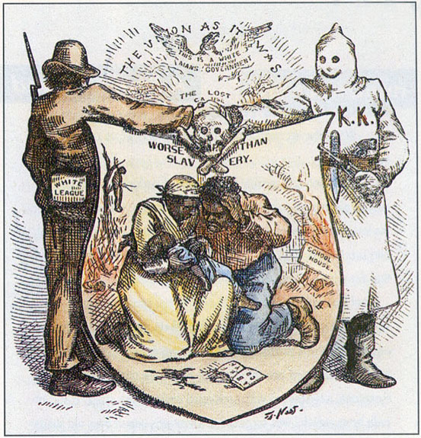
Members of the White League and Ku Klux Klan shake hands over an African American couple (center) who huddle over the dead body of their baby, while a black body hangs from a tree (left) and a black school house burns right).

Text at the top of the cartoon reads: “THE UNION AS IT WAS. THIS IS A WHITE MAN’S GOVERNMENT. THE LOST CAUSE. WORSE THAN SLAVERY.”

Questions for Socratic Seminar On Reconstruction

The participants will discuss these questions. Audience members will take notes on this handout.

- What is the main claim of the image?
________________________________________________________________________________________________________________________________
________________________________________________________________________________________________________________________________
- What details from the image support this interpretation?
________________________________________________________________________________________________________________________________
________________________________________________________________________________________________________________________________
- How does this image support or contradict the claim made by W.E.B. Dubois?
________________________________________________________________________________________________________________________________________________________________________________________________________________________________________________________________4. What other sources from the lesson on Reconstruction support this interpretation?
________________________________________________________________________________________________________________________________________________________________________________________________________________________________________________________________5. Do you agree or disagree with DuBois? Why? Explain.
________________________________________________________________________________________________________________________________________________________________________________________________________________________________________________________________FOR AUDIENCE MEMBERS ONLY: Which participant do you most agree with, and WHY? (USE BACK IF NECESSARY.)
________________________________________________________________________________________________________________________________________________________________________________________________________________________________________________________________________________________________________________________________________________________________________________________________________________________________________________________________________________________________________________________________________________________________________________________________________________________________________________________________

Socratic Seminar Observation Checklist

Observer:________________________________ Date:_______________

Person Being Observed:______________________________

Check off the description that best applies to your subject’s performance in today’s Socratic Seminar.

ANALYSIS
How often did the member participate?
- Always
- Often
- Rarely
- Never

Did the individual participate voluntarily, or did he/she need to be prompted?
- Always participated without prompting
- Often participated without prompting
- Rarely participated without prompting
- Only participated with prompting
- Not Applicable: The subject did not participate at all.

How would you describe the depth of the individual’s analysis? (Did he/she infer/make connections/ draw conclusions/ make judgments?)
- Deep
- Solid
- Weak

UNDERSTANDING
Choose the word that best describes the individual’s understanding of the text.
- Deep
- Solid
- General
- Weak
- It’s hard to know because the individual rarely participated.

ACTIVE LISTENING & EXTENSION
Check off any of the following used by the individual to demonstrate active listening.
- Body language (eye contact, nodding, etc.)
- Comments
- Questions

How often did the individual extend the conversation with comments or questions that followed up on another member’s statements?
- Often
- Rarely
- Never

EVIDENCE
How often did the individual use evidence from the text to support his/her statements?
- Always
- Often
- Rarely- relied more on opinion than text
- Never- relied completely on opinion

COMMENTS (Be specific)
________________________________________________________________________________________________________________________________________________________________________________________________________________________________________________________________________________________________________________________________________________________________________________________________________________________________________________________________________________________________________________________________________________________________________________________________________________________________________________________________

