What did Harriet Tubman do during and after the Civil War?
Topics: Civil War, Abolitionism, Harriet Tubman
Erik Altenbernd, UC Irvine History Project

History Standards
8.9 Students analyze the early and steady attempts to abolish slavery and to realize the ideals of the Declaration of Independence.
8.9.1 Describe the leaders of the movement (e.g.…Harriet Tubman…).

8.10 Students analyze the multiple causes, key events, and complex consequences of the Civil War
8.10.7 Explain how the war affected combatants, civilians, the physical environment, and future warfare.

CCSS Standards: Reading, Grades 6-8
1. Cite specific textual evidence to support analysis of primary and secondary sources.
2. Determine the central ideas or information of a primary or secondary source; provide an accurate summary of the source distinct from prior knowledge or opinions.
5. Determine how a text presents information (e.g. sequentially, comparatively, causally).
6. Identify aspects of a text that reveal an author’s point of view or purpose (e.g., loaded language, inclusion or avoidance of particular facts).

CCSS Standards: Writing, Grades 6-8
1. Write arguments focused on discipline-specific content.
2. Write informative/explanatory texts, including the narration of historical events, scientific procedures/experiments, or technical processes.
9. Draw evidence from informational texts to support analysis reflection, and research.

Overview of Lesson
Much of what we learn and know about Tubman focuses on her life before the Civil War. This lesson walks the students through the life of Harriet Tubman during and after the Civil War. The lesson focuses on three topics: 1. the US Treasury Department’s decision to replace Andrew Jackson with Tubman on the front of the $20 bill; 2. Tubman’s life and actions during the Civil War; and 3. Tubman’s almost forty-year struggle to secure a veteran’s pension from the federal government after the Civil War.

Guiding Question
What did Harriet Tubman do during and after the Civil War?

Documents
- “Harriet Tubman Wins Unofficial Contest to be On $20 Bill,” NPR (excerpt, 2015)
- “Harriet Tubman to Replace Andrew Jackson on the $20 Bill,” ABC News (video, 2016)
- “Harriet the Spy: How Tubman Helped the Union Army,” National Geographic.com (excerpt, 2016)
- “‘Nurse, Spy, Cook’: How Harriet Tubman Found Freedom through Food,” NPR (excerpt, 2016)
- “Compensation for Civil War Services,” Harriet Tubman Historical Society (excerpt)
Introduction

In April 2016, the US Treasury Department announced that Andrew Jackson will be replaced as the face of the $20 bill. Starting around 2020, the new face of the $20 bill will be Harriet Tubman. Initially, Treasury intended to remove Alexander Hamilton from the $10 bill and replace him with the face of a famous American woman.

Harriet Tubman is one of the most famous abolitionists in American history. The best known “conductor” of the Underground Railroad, Tubman was a fugitive slave who returned to the South nineteen times to guide slaves to the North. In all, she helped free over 300 enslaved Americans—including members of her own family—before 1860.

Today, we remember Harriet Tubman—and will soon honor her on our national currency—for her repeated actions of bravery before the Civil War. However, Tubman lived a fairly long life. She died in 1913, which means she lived for almost fifty years after the Civil War ended in 1865. What did Harriet Tubman do after the war? Just as important, what did she do during the Civil War?

Document 1
“Harriet Tubman Wins Unofficial Contest to be On $20 Bill”
The Two-Way, NPR
May 13, 2015

During 2015, a group called Women on 20s hosted an online poll where people around the country could vote for who they wanted to see on the $20 bill. This article explains some of the details about how, and why, Harriet Tubman won the poll.

The Women on 20s campaign, which seeks to put a female face on the $20 bill, has announced a winner: Harriet Tubman, the escaped slave whose ingenuity and courage led other captives to freedom.  Tubman narrowly edged Eleanor Roosevelt, finishing with 118,328 votes to Roosevelt's 111,227, according to Women on 20s. More than 600,000 votes were cast over 10 weeks, including more than 350,000 in the final round that began on April 5.  Early on, Roosevelt had led Tubman by nearly 15,000 votes, but the final round brought a reversal.  We’ll note that Tubman's appearance on the $20 bill would have a special historical resonance: That's the same amount she eventually received from the U.S. government as her monthly pension for her service as a nurse, scout, cook and spy during the Civil War, as well as for her status as the widow of a veteran.  A petition has now been sent to President Obama asking him “to order the Secretary of the Treasury to change the current portrait portrayed on our American $20 bank note to reflect the remarkable accomplishments of an exemplary American woman who has helped shape our Nation's great history.”  In the Women on 20s vote, Rosa Parks came in third, with 64,173 votes, and Wilma Mankiller, the first woman to become the Cherokee Nation's chief, was fourth, with 58,703. Others on the ballot included Susan B. Anthony, Sojourner Truth, Clara Barton and Elizabeth Cady Stanton. | pension—monthly or annual payment of money to an individual (usually an elderly person) for prior service to a government or organization

Questions

1. What is the name of the organization that asked President Obama to put Harriet Tubman on the $20 bill?

2. How did Women on 20s decide that Harriet Tubman should be on the $20 bill?

3. Which other famous American women received votes in Women on 20s public poll?
Document 2
“Harriet Tubman to Replace Andrew Jackson on the $20 Bill”
ABC News

Less than a year after Women on 20s petitioned President Obama to put Harriet Tubman on the $20 bill, the Treasury Department officially announced Jackson would be removed from the front of the bill in favor of Tubman. However, Tubman was not part of Treasury’s original plan. The initial plan was to change the $10 bill by replacing the face of Alexander Hamilton with that of a famous American woman.

http://abcnews.go.com/GMA/video/harriet-tubman-replace-andrew-jackson-20-bill-38564960

Questions

4. Who is Harriet Tubman replacing on the front of the $20 bill?

5. Which founding father was supposed to be removed from the $10 bill?

6. Why did the Treasury Department decide to keep Alexander Hamilton on the $10 bill?

7. What changes are being made to the $10 bill?

8. What year will the new “Tubman” be issued by the Treasury Department?

Portrait of Harriet Tubman (ca. 1860-1875), https://www.nps.gov/media/photo/gallery.htm?id=C8C22F7E-155D-451F-675CD5F8A8A77596
Document 3
“Harriet the Spy: How Tubman Helped the Union Army” (2016)
National Geographic.com
April 21, 2016

Harriet Tubman is best remembered for her actions before the Civil War. However, she continued to work hard to end slavery after 1861. During the Civil War, Tubman worked as cook, nurse, and spy for the Union army.

In 1863, Harriet Tubman led soldiers with Colonel James Montgomery to raid rice plantations along the Combahee River in South Carolina. They set fire to buildings, destroyed bridges, and freed many of the slaves on the plantations.  When slaves saw Tubman’s ships with black Union soldiers on board, they ran towards them as their overseers helplessly demanded that they stay.…  In addition to being the first woman in U.S. history to lead a military expedition, Tubman—whom John Brown called “General Tubman”—was a Union army spy and recruiter.…  The use of former slaves as spies was a covert operation—President Abraham Lincoln didn’t even tell the Secretary of War or the Secretary of Navy about it. The man in charge of the secret spy ring was Secretary of State William Seward, who’d met Tubman when his house was a stop on the Underground Railroad.  Tubman and other former slaves were effective as spies because white Confederates devalued their intelligence.…  Venturing into Confederate territory, these spies would gather information from slaves about Confederate plans.…for instance, that slaves would tell spies where Confederate troops had dropped barrels filled with gunpowder into rivers to attack Union boats. Information gained from these spies became known as “black dispatches.”  It was brave for any ex-slave to venture into Confederate territory (these people were not legally “free”; they were still fugitives under the law). And it was especially brave for Tubman to do so, since she was well-known as an abolitionist. | overseer—white man who managed slaves on day-to-day basis  covert—secret  venture—a risky or dangerous journey
Source: National Geographic Magazine, http://news.nationalgeographic.com/2016/04/160421-harriet-tubman-20-dollar-bill-union-spy-history/

Questions

9. What wartime action did Harriet Tubman lead in 1863?

10. Was it common knowledge during the war that former slaves were being used as spies by the Union Army? Cite 2 examples from the text to support your answer.

11. Why did former slaves make for effective spies? Cite 2 examples from the text to support your answer.

12. Why was it an act of bravery for former slaves, and abolitionists like Tubman, to work as spies?

Document 4
“‘Nurse, Spy, Cook’: How Harriet Tubman Found Freedom through Food”
Foodways, NPR
April 27, 2016

Harriet Tubman…spent her whole adult life raising money either to rescue slaves or help them start life afresh on free soil. While her abolitionist friends in the North were generous contributors to the cause, Tubman also self-funded her heroic raids through an activity she enjoyed and excelled at: cooking.  Tubman's role as a professional cook, which provided her with a much-needed source of money in her long and poverty-stricken life, has often been overlooked.…  On the…raids Tubman conducted “down into Egypt” over the course of a decade, one of the many challenges she faced was keeping her party of rescued slaves fed on their long and arduous journey – often through snow, icy rain and swamps, with teams of armed men and dogs searching for the runaways. To keep babies from crying and attracting attention, she dosed their bread with laudanum to put them to sleep.…  During the Civil War, Tubman worked as a nurse and a spy, but supplemented her income by running an eating-house in Beaufort. There, she sold Union soldiers root beer, pie and ginger bread, which she baked during the night, after her day's work. When she put in a claim for a Civil War pension, her role was described as “nurse, spy and cook.”  …when Tubman made history by leading three Union gunboats in the famous 1863 Combahee River Raid that freed 700 slaves in South Carolina, she described how the throngs of slave women came streaming towards “Lincoln's gun-boats” with their babies, baskets, chickens and pigs.  One woman brought along two pigs, one white, one black. All three were taken on board, and the pigs promptly christened after a Confederate Civil War general and the president of the Confederate States of America: “de white pig Beauregard, and de black pig Jeff Davis.” | “down into Egypt”—the South; reference to the Bible (early books of Bible discuss how ancient Israelites were held as slaves in Egypt)  laudanum—liquid drug commonly used in 1800s  pension—monthly or annual payment of money to individual (usually an elderly person) for prior service to government or organization  throng—large crowd of people standing closely to one another
Source: http://www.npr.org/sections/thesalt/2016/04/27/475768129/nurse-spy-cook-how-harriet-tubman-found-freedom-through-food

Questions

13. What did Harriet Tubman do to make money during the Civil War?

14. What did the slaves Tubman freed in South Carolina bring with them to?

15. What is the main claim of the author of this article? In 2-3 sentences, put the author’s claim into your own words and provide two pieces of evidence presented in support of the author’s claim.

Document 5
“Compensation for Civil War Services”
Harriet Tubman Historical Society

In the summer of 1865 Harriet Tubman returned home to Auburn, New York from Virginia where she was serving in a hospital near Fort Monroe. Without a steady income it was difficult for Tubman to make ends meet, as she was in charge of her elderly parents and constantly providing for those looking for refuge in her home. Tubman sought compensation for her services during the Civil War which turned into a 34 year ordeal. Because her services as a nurse, cook, spy and scout were not documented compensation was hard to get. All Tubman had received was $200 for 3 years of service.  In 1865 she appealed to the federal government for the first time and then a second time in 1867. Influential friends and community leaders published letters in newspapers advocating for Tubman, arguing that she deserved a veteran’s pension.  In 1874 New York Congressman, McDougall, pressed the issue in Congress. McDougall’s bill, which proposed $2000 for Tubman, passed the House but was rejected by the Senate for lack of documentation.  In 1890, two years after her second husband, Nelson Davis, died a law was passed under which Tubman was eligible to receive a war veteran widow’s pension of $8 a month. Nelson Davis served as Private Nelson Charles in Company G, Eighth United States Colored Infantry from September 25, 1863 to November 10, 1865. For the first time in her life, Harriet Tubman had a steady and reliable income. However, the application for her services in the Civil War was struck in the bureaucracy pipeline.  In 1898, several of her close friends…pursued Tubman’s application for a veteran’s pension. Tubman was already 78 years old and living in undeserved poverty.…  On January 19, 1899, a new bill was introduced in the House that proposed an increase of her current pension to $25 a month for her services as a nurse in the U.S. Army. While acknowledging her service and dedication to the country as a nurse, the Senate argued that the number of nurses on the pension roll at a rate higher than $12 a month was very few and that there were no valid reasons why Tubman should receive a pension of $25 a month. The Committee of Pensions instead decided that her widow pension would be increased to $20 a month in consideration of her personal services to the country.  The Act was approved by Congress on February 28, 1899.  Unfortunately, the Act does not acknowledge her services in the Civil War. In February 1899, when Tubman was 79 years old—and 34 years after her first application—a widow’s pension was granted to Tubman for the sum of $240 per year. | pension—monthly or annual payment of money to individual (usually an elderly person) for prior service to government or organization
Source: Adapted from http://www.harriet-tubman.org/compensation-for-civil-war-services/

Questions

16. How many years did Harriet Tubman spend trying to secure a veteran’s pension for her service to the nation during the Civil War?

17. What kind of pension did Tubman receive in 1890?

18. How much money did Harriet Tubman eventually receive from Congress in 1899?

19. Did Tubman ever receive a pension for her own service to the nation during the war?

20. Why did Congress deny Tubman’s repeated requests for a veteran’s pension?

US Congress, “An Act Granting an increase of pension to Harriet Tubman Davis” (1899)

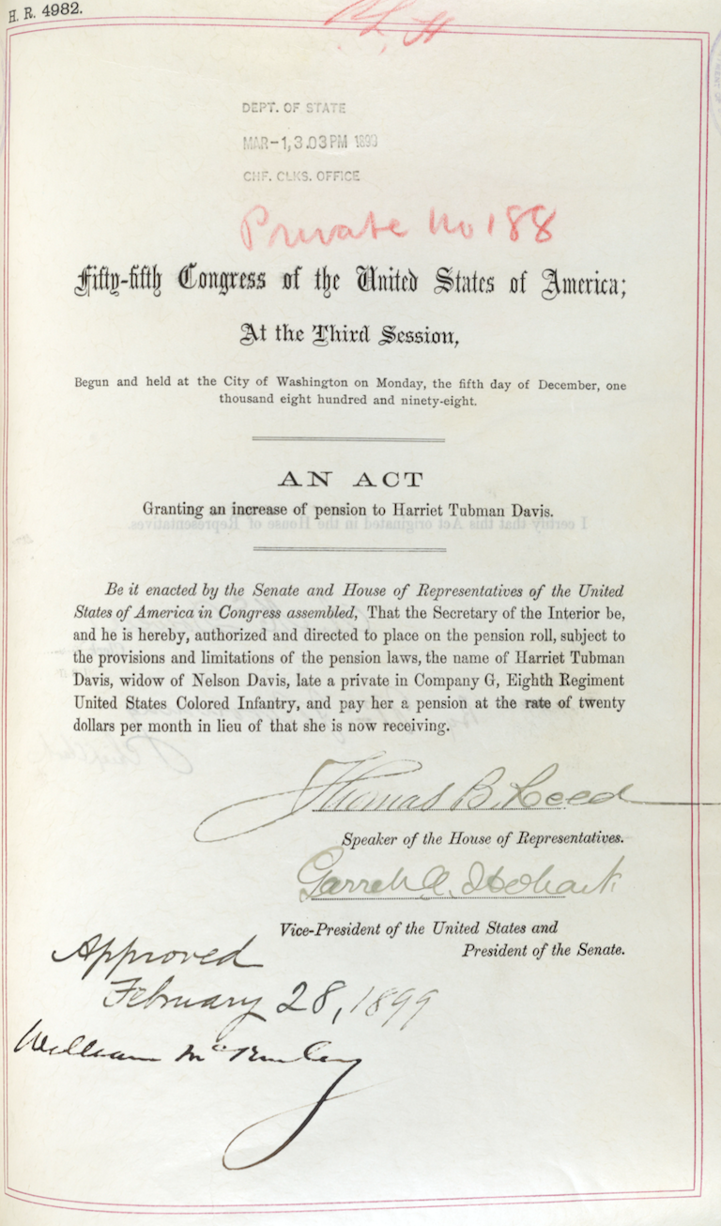
Source: https://www.archives.gov/legislative/resources/education/tubman

Final Activity

For many years, Harriet Tubman petitioned for a veteran’s pension but was denied by Congress. While her pension was eventually increased to $20 per year, the increased pension she received in 1899 was a widow’s pension—a pension granted not for her own actions during the war but for the actions of her husband during the war.

Many people think it is highly appropriate that Tubman be included on the $20 bill. In addition to being an American hero worthy of honor and respect, $20 is the precise amount Tubman eventually received from Congress after more than thirty years of pension petitions. In this light, inclusion on the $20 bill illustrates not only Tubman’s acts of heroism before the Civil War, but all her efforts in support of the Union and to free her enslaved brothers and sisters during the War as well.

For this final activity, your task is to answer the question: What did Harriet Tubman do during and after the Civil War?

To answer this question, you’ll need to identify the specific actions Tubman took during the Civil War.

Use the “Historians Toolbox Graphic Organizer” below to assemble your historical evidence and develop a short essay about Tubman’s life during the war.

After you’ve filled out the graphic organizer, write a short essay 1. That explains Tubman’s life during the war; 2. that explains Tubman’s attempts to secure a pension from the government; and 3. how Tubman’s actions during and after the war eventually led to her inclusion on the $20 bill.
Historian’s Toolbox: Organizing Evidence to Write

Inquiry Question: What did Harriet Tubman do during and after the Civil War?

Source Citation | Summary:  What is the information presented in the source? | Evidence:  What are some specific quotes or information from the source that allows you to answer the question? | Analysis:  This means that…  This shows that…  This source is important to our understanding because… | Claim:  Explain how this source answers the inquiry question.
Tubman during the War (write title of source below)

Tubman’s Attempts to Secure Pension (write title of source below)

Tubman New Face of $20 Bill (write title of source below)

- Examine the Claim column and create one claim that unifies the ideas you present. For example, instead of having three sentences about different causes for an event, create one sentence with all of the causes of an event.
Write your Claim here:

- Organize your evidence. Do you want to present the evidence in chronological order or another way? List how you will organize your evidence here:

- How does the evidence support your claim? Give some specific analysis explaining why you think this evidence is important to answer the inquiry question.

You are ready to write! Use the outline below to develop a paragraph:

Introduce the topic (time period, location, major historical figures)
Claim
Evidence #1 and analysis
Evidence #2 and analysis
Evidence #3 and analysis
Concluding sentence restating your claim

