What were the consequences of the Pacific sea otter trade of the eighteenth and nineteenth centuries?
Topics: Pacific World; maritime trade; sea otter fur trade; California; California Indians; Island of the Blue Dolphins
Erik Altenbernd, UC Irvine History Project

History Standards
8.8 Students analyze the divergent paths of the American people in the West from 1800 to the mid-1800s and the challenges they faced.
8.8.5 Discuss Mexican settlements and their locations, cultural traditions, attitudes toward slavery, land-grant system, and economies.

CCSS Standards: Reading, Grades 6-8
RH 1. Cite specific textual evidence to support analysis of primary and secondary sources.
RH 2. Determine the central ideas or information of a primary or secondary source; provide an accurate summary of the source distinct from prior knowledge or opinions.
RH 3. Identify key steps in a text’s description of a process related to history/social studies…
RH 4. Determine the meaning of words and phrases as they are used in a text, including vocabulary specific to domains related history/social studies.
RH 7. Integrate and evaluate multiple sources of information presented in diverse formats and media (e.g. visually, quantitatively, as well as in words) in order to address a question or solve a problem.

CCSS Standards: Writing, Grades 6-8
WH 1. Write arguments focused on discipline-specific content
WH2. Write informative/explanatory texts, including the narration of historical events, scientific procedures/experiments, or technical processes.
WH4. Produce clear and coherent writing in which the development and organization, and style are appropriate to the task, purpose, and audience.

Guiding Question:
What were the consequences of the Pacific sea otter trade of the eighteenth and nineteenth centuries?

Overview of Lesson
This lesson is the first of two humanities lessons on California, California Indians, and the Pacific World of the eighteenth and nineteenth centuries.
Building on recent research on California and the Pacific World before the US-Mexico War of 1846-1848, and using excerpts from the Scott O’Dell’s novel Island of the Blue Dolphins (1960), the lesson examines the short- to medium-term impact of Transpacific trade and the international sea otter pelt trade on California Indians, particularly the Native people of San Nicolas Island, the most remote of the Channel Islands of Southern California.

The lesson is organized as follows:
1. A detailed introduction on trade in the Pacific Ocean from the sixteenth through nineteenth centuries.
2. A section on trade and California as a Pacific World site of encounter.
3. A section on sea otters, sea otter habitats, and the decline of Pacific sea otter populations due to overhunting during the eighteenth and nineteenth centuries
4. A final section on Russian and Native Alaskan sea otter hunting along the coast of California during the nineteenth century and the effects of the sea otter trade on Native Californians.
5. Final activity that has students write an 8-sentence paragraph.

Each section includes excerpts from Island of the Blue Dolphins and highlights the historical figures and events that inspired the novel.

Documents
- Map of Sites of Encounter and Trade in Pacific Ocean in early 1800s (map)
- “Seas of Commerce” from David Igler, The Great Ocean (excerpt)
- Island of the Blue Dolphins (excerpt)
- “Seas of Commerce” from David Igler, The Great Ocean (excerpt)
- Island of the Blue Dolphins (excerpt)
- “Kelp Forest” (video)
- “Historical Range and Current Range of Sea Otters (map)
- Natural History of Sea Otters (excerpt)
- Island of the Blue Dolphins (excerpt)
- “Aleutian Islander’s Sea Otter Spear; Spear Head (image)
- “Aleut Hunting Gear” (image)
- Island of the Blue Dolphins (excerpt)
- “Letter from Ivan Kuskov to Leontii Hagemeister, Chief Manager of the Russian American Company in Sitka, Russian Alaska” (excerpt)

Teacher Outline for Final Activity
The final activity for the lesson has the students synthesize the information from the various primary and secondary sources into an 8-sentence paragraph. The 8-sentence paragraph is outlined below— see the final activity below for the color-coded graphic organizer—but essentially has the students outline a five-paragraph essay in a single paragraph.

In this case, the 8-sentence paragraph has the students analyze cause and effect in an understudied phases of California history.

The students’ 8-sentence paragraph should answer the inquiry question: What were the consequences of the Pacific sea otter trade of the eighteenth and nineteenth centuries?

It should also include six main components:

1. A central claim or thesis.

2. Two pieces of supporting evidence.

3. Two analytical sentences that provide additional information about your evidence and that explain why your evidence supports your central claim.

4. A conclusion, or concluding sentence.

Introduction
European colonization of the Americas began with Icelandic Vikings in the tenth century (900s CE), but really took off in the sixteenth century (1500s CE). This period of colonization was led by Spain and began in October 1492 when Christopher Columbus first landed in the Bahamas. After colonizing Puerto Rico, Cuba, and other islands in the Caribbean Sea in the early 1500s, the Spanish moved west and south to conquer the Aztecs in Mexico in 1521, and the Inca in Peru in 1536. Prior to that, in 1513, the Spanish explorer Vasco Núñez de Balboa became the first European to see the Pacific Ocean; less than a decade later, in 1522, Spanish ships led by the explorer Ferdinand Magellan sailed across the Pacific to complete the first circumnavigation, or journey across all of the Earth.

Exploration and colonization went hand-in-hand. Five decades later, the Spanish continued to push west across the Pacific Ocean to establish the city of Manila and colonize other parts of the Philippines, an archipelago, or chain of islands, located thousands of miles away from Mexico on the western edge of the Pacific near China.

The Spanish established Manila for the purposes of trade. Beginning in 1565, Spanish galleons (large sailing ships with three or more masts) made regular trips across the Pacific to trade silver mined in Mexico and Bolivia for a variety of goods from East Asia, including silk, spices, rugs and cotton fabrics, porcelain, ivory, and lacquerware. After unloading American silver in Asia, the galleons transported East Asian goods back to the Americas. Once there, the bulk of the goods were transported to galleons in the Caribbean, which then transported them across the Atlantic Ocean to Seville, Spain; some of the goods were also traded throughout Mexico and Peru. By the end of the sixteenth century (1500s), the ports of Manila (in the Philippines) and Acapulco (in Mexico) served as the main points of connection in this long-distance trade route known as the Manila Galleon.

Map of the Manila Galleon Trade Routes
Source: http://www.skyscrapercity.com/showthread.php?t=302340&page=939

Before the Spanish and other Europeans arrived in the Pacific Ocean, indigenous peoples of the Pacific—that is, people who lived near the waters of the Pacific Ocean before the arrival of Europeans—traded a wide variety of goods. The Aleut and Kodiak peoples of Alaska traveled great distances by canoe to hunt sea otters and seals. Through trade with with other Native peoples and Europeans, many of the seal and otter hides they harvested eventually made their way to Eastern Asia. Trade was also an important part of life for the Indian peoples of California. For instance, the Chumash Indians of the Santa Barbara area had an ocean-based economy and traded widely with the Tongva Indians of the Southern Channel Islands and areas of Los Angeles and Orange County.

The arrival of the Spanish and other Europeans in the seventeenth century expanded the distances and frequency of trade across the Pacific. By the time of the California Gold Rush in 1849, ships from more than twenty different nations could be found sailing the waters of the Pacific. Islands like Hawai’i served as the primary point of connection, or site of encounter, during the nineteenth century (1800s CE). However, California was also a key part of this wide world of travel and trade. For example, between the end of the American Revolution in 1783 and the end of the United States-Mexico War in 1846—the year California became part of the United States—almost 1000 ships from around the world visited the coast of California.

Painting of Canton, China (1800)
Source: https://ocw.mit.edu/ans7870/21f/21f.027/rise_fall_canton_04/cw_gal_01_thumb.html

Source 1
Map of Sites of Encounter and Trade across the Pacific Ocean in the early 1800s

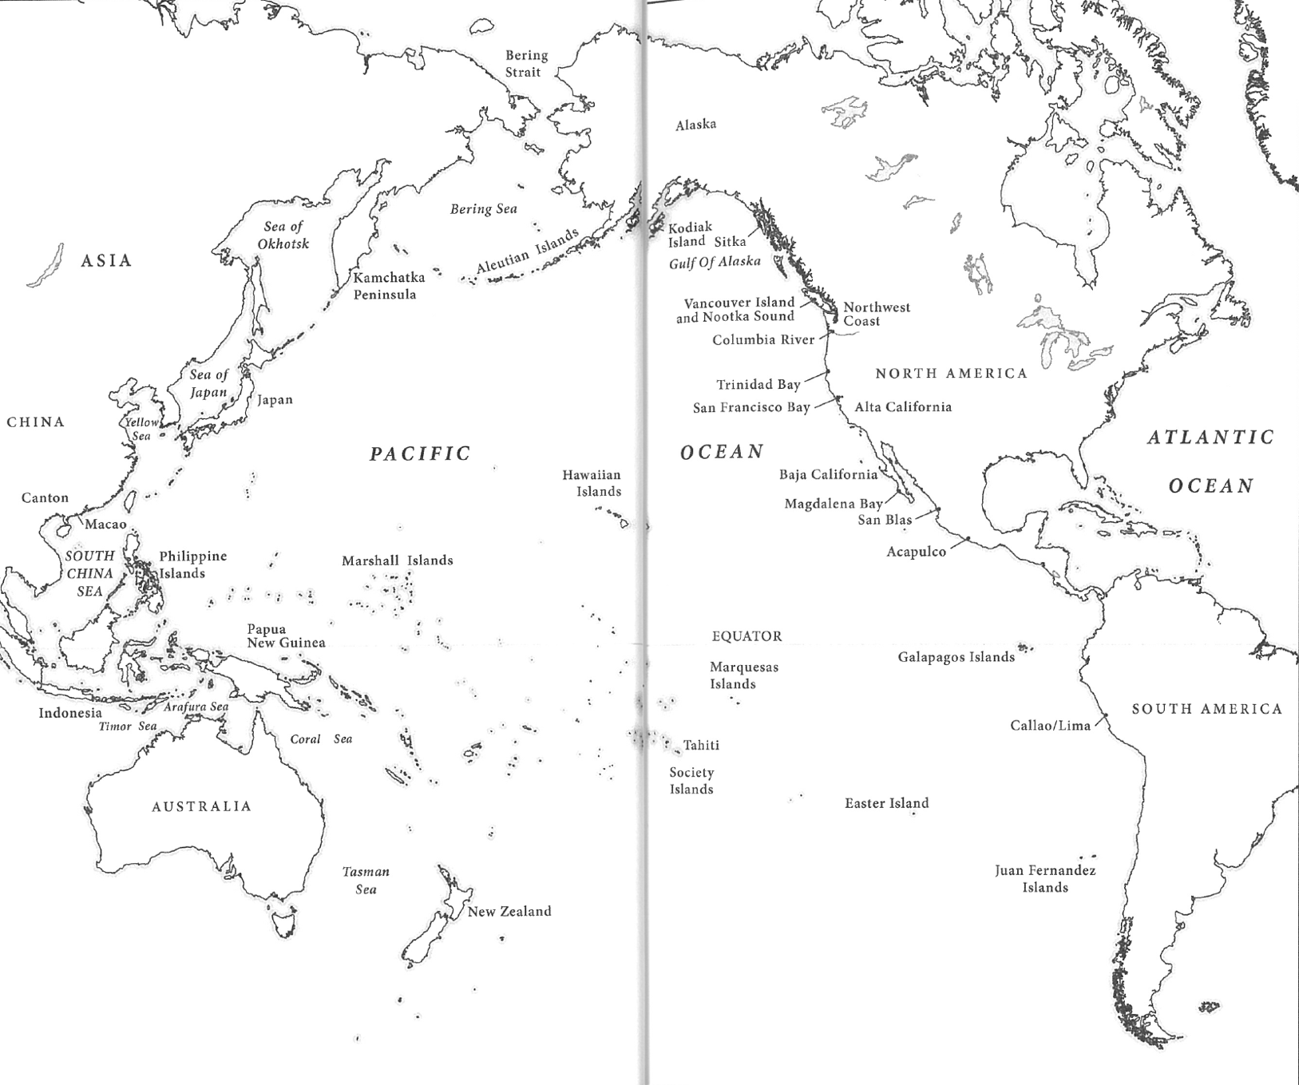
Source: David Igler, The Great Ocean (2013)
Part 1. California: Pacific World Site of Encounter
Much like today, thousands of people from all over the world traveled to the lands and waters of California during the early nineteenth century (1800s). The land, and especially coast, of California was part of a series of trade routes that linked together the different waters, lands, and peoples of the Pacific Ocean. But what brought distant peoples to California in the early 1800s? What items—or material goods—were people at the time interested in acquiring before leaving California?

Painting of the American merchant ship, Lelia Byrd
Source: http://www.sandiegoyesterday.com/wp-content/uploads/2011/01/Battle-of-San-Diego-Bay.pdf

Source 2
“Seas of Commerce” (2013)
By David Igler

This source describes the Transpacific travels of the Lelia Byrd, a famous ship that sailed across the Pacific Ocean three separate times and brought the first horses to Hawai’i.

The Lelia Byrd traversed the Pacific three times over the course of two years. These crossings posed significant dangers to any sailing vessel, but was even more perilous for a small and leaky ship. The 175-ton Lelia Byrd sailed from Canton to the Northwest Coast of America, returned back across the ocean to Canton, and charted a final course for North America before a slow, waterlogged journey to Hawai’i. The ship covered over twenty thousand miles of open ocean, not including its numerous journeys down the American coastline between the Columbia River and Guatemala. William Shaler and his twenty-five crewmembers sighted trading vessels every time they approached land. They saw European, American, and Asian vessels as they passed Macao and entered Canton’s Pearl River Delta, indigenous canoes and Atlantic-based ships on the American coastline, and Hawaiian outriggers in the Sandwich Islands. Native seacraft in particular plied the coastal waters at almost every place the ocean touched shore. | traverse—to cross over or through  perilous—dangerous  Canton—English name for Guangzhou, a major port city in southern China  waterlogged—saturated or full of water  Columbia River—large river that flows into Pacific Ocean between US states of Oregon and Washington  Macao—major port city in Southern China colonized by Portuguese in 1500s  Sandwich Islands—Hawaiian Islands
Source: David Igler, The Great Ocean: Pacific Worlds from Captain Cook to the Gold Rush (New York: Oxford University Press, 2013), 17.

Questions

1. How many times did the Lelia Byrd sail across the Pacific Ocean in the first decade of the nineteenth century?

2. What nations, or peoples, did the crew of the Lelia Byrd encounter during its travels?

3. Use a highlighter to mark all the locations mentioned in this reading and the introduction on Source 1 map.

Source 3
Island of the Blue Dolphins
By Scott O’Dell

Island of the Blue Dolphins was written by Scott O’Dell and first published in 1960. The main character of the novel is a girl named Karana. Karana is based on a real woman named Juana Maria, and many of the events that take place in Island of the Blue Dolphins are based on actual events that took place on San Nicolas Island, a small island located about 60 miles off the coast of Orange County. One such series of events were those that happened in 1814 after Russians and Native Alaskans the Russians called Aleuts arrived on San Nicolas Island looking for sea otters.

I remember the day the Aleut ship came to our island. At first it seemed like a small shell afloat on the sea. Then it grew larger and was a gull with folded wings. At last in the rising sun it became what it really was—a red ship with two red sails.  My brother and I had gone to the head of a canyon that winds down to a little harbor which is called Coral Cove. We had gone to gather roots that grow there in the spring.  My brother Ramo was only a little boy half my age, which was twelve. He was small for one who had lived so many suns and moons, but quick as a cricket. Also foolish as a cricket when he was excited. For this reason and because I wanted him to help me gather roots and not go running off, I said nothing about the shell I saw or the gull with folded wings.  I went on digging in the brush with my pointed stick as though nothing at all were happening on the sea. Even though I knew for sure that the gull was a ship with two red sails.  But Ramo’s eyes missed little in the world. They were black like a lizard’s and very large, and like the eyes of a lizard, could sometimes look sleepy. This was the time when they saw the most. This was the way they looked now. They were half-closed, like those of a lizard lying on a rock about to flick out its tongue to catch a fly.…  Ramo was standing on on foot and then the other, watching the ship because he had never seen one. I had never seen one either, but I knew how they looked because I had been told.…  By the time I filled my basket, the Aleut ship had sailed around the wide kelp bed that encloses our island and between the two rocks that guard Coral Cove. Word of its coming had already reached the village of Ghalas-at. Carrying their weapons, our men sped along the trail which winds down to the shore. Our women were gathering at the edge of the mesa.  I made my way through the heavy brush and, moving swiftly, down the ravine until I came to the sea cliffs. There I crouched on my hands and knees. Below me lay the cove. The tide was out and the sun shone on the white sand of the beach. Half the men from or village stood at the water’s edge. The rest were concealed among the rocks at the foot of the trail, ready to attack the intruders should they prove unfriendly.  As I crouched there in the toyon bushes, trying not to fall over the cliff, trying to keep myself hidden and yet to see and hear what went on below me, a boat left the ship. Six men with long oars were rowing. Their faces were broad, and shining dark hair fell over their eyes. When they came closer I saw that they had bone ornaments thrust through their noses.  Behind them in the boat stood a tall man with a yellow beard. I had never seen a Russian before, but my father had told me about them, and I wondered, seeing the way he stood with his feet apart and his fists on his hips and looked at the little harbor as though it already belonged to him, if he were one of those men from the north whom our people feared. I was certain of it when the boat slid in to the shore and he jumped out, shouting as he did so.  His voice echoed against the rock walls of the cove. The words were strange, unlike any I had ever heard. Slowly then he spoke in our tongue.  I come in peace and wish to parley,” he said to the men on the shore.  None of them answered, but my father, who was one of those hidden among the rocks, came forward down the sloping beach. He thrust his spear into the sand.  “I am the Chief of Ghalas-at,” he said. “My name is Chief Chowig.”  …The Russian smiled and held up his hand, calling himself Captain Orlov. My father also held up his hand. I could not see his face, but I doubted that he smiled in return.  “I have come with forty of my men,” said the Russian. “We come to hunt sea otter. We wish to camp on your island while we are hunting.”  My father said nothing. He was a tall man, though not as tall as Captain Orlov, and he stood with his bare shoulders thrown back, thinking about what the Russian had said. He was in no hurry to reply because the Aleuts had come before to hunt otter. That was long in the past, but my father still remembered them. | Aleut—Native people from Aleutian Islands of Alaska  kelp bed—area underwater with a large amount of the seaweed kelp  tide—rise and fall of water level along beach or shoreline due to attraction of moon and sun  toyon bush—large evergreen bush native to California that grows red berries  parley—to negotiate or discuss an agreement with an opponent or enemy
Scott O’Dell, Island of the Blue Dolphins (New York: Dell Laurel-Leaf, 1960), 1-6.

Source 3
Island of the Blue Dolphins
By Scott O’Dell
Questions

4. Why has the crew of the ship arrived on Karana’s island?

5. Had Karana ever seen Aleut and Russian sailors before?

6. How does Karana know about these foreigners? Explain your answer using at least two pieces of evidence from the text.

7. Use GoogleMaps to locate San Nicolas Island and then use a colored pen to locate and name San Nicolas Island on Source 1.

Source 4
“Seas of Commerce” (2013)
By David Igler

This source continues the story of the Lelia Byrd after its arrival off the coast of Northern California. One of the places the ship visited in 1804 was Trinidad Bay, an inlet, or small bay, located about 300 miles north of San Francisco. At Trinidad Bay, the crew of the Lelia Byrd sought to trade goods with the Yurok, the group of Native Californians who lived nearby in the village of Tsuräu. The Yurok had seen foreign ships and traders before, but were not interested in trading with Captain William Shaler and his men. How is the story here similar to that in the opening chapter of Island of the Blue Dolphins?

Trinidad Bay, California
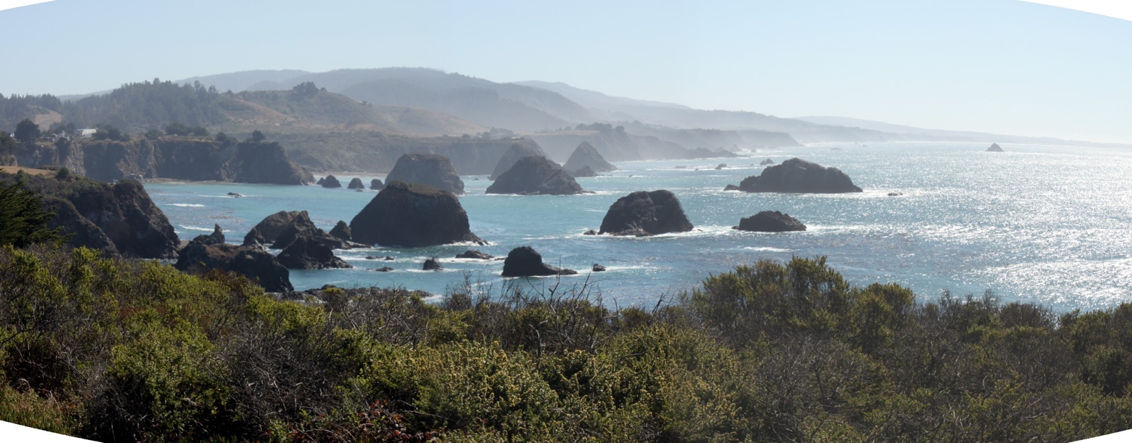
Source: http://www.pacificwatershed.com/projects/watershed-based-plan-development-trinidad-rancheria

On May 11, 1804, after the Lelia Byrd’s third Pacific Crossing, [Captain William] Shaler moored the ocean-battered brig in Trinidad Bay, an inlet far north of the coastal swath of Alta California governed by Spain. The Yurok called this place Tsuräu, so named for the village located on the bay’s shore. Shaler needed a foremast, water, and furs, and he planned to attain these necessities through aggressive trade with the local villagers. The Yurok required nothing from this group. But they had learned from previous encounters to use caution with light-skinned foreigners. At the very least, the Yurok expected gifts for their tolerance and supplies.  During the first two days, the Yurok traded alongside the ship and openly resisted the foreigners’ attempts to come ashore. On three occasions the Yurok stopped a shore landing party from the Lelia Byrd and, in one incident, they confiscated the water casks the crewmembers sought to fill. Breaking the casks, the Yurok made off with the most valuable part: the iron hoops. The Yurok would turn these hoops into daggers and other useful tools. Angered by the Yurok’s resistance, Shaler ordered the firing of rifles from the Lelia Byrd’s launch on May 14, to which the natives responded with a “cloud of arrows.” Finally, the foreigners took four Yurok as hostages, forcing the villages to allow Shaler’s men on shore for wood and water. They entered the village of Tsuräu and managed to offend most everyone.…The ship and its offensive men departed several days later carrying the necessary supplies as well as some sea otter pelts acquired in trade. Shaler’s journal noted all these incidents… | Moor—to tie a ship to an anchor or dock  brig—sailing ship with two masts  Trinidad Bay—small bay located in Northern California  Alta California—“high” or upper California; territory of New Spain that included all or parts of California, Nevada, Utah, Arizona, New Mexico, Wyoming, and Colorado  foremast—mast  located closest to bow, or front of ship  cask—large barrel-like container used for storing liquids  dagger—small knife
Source: David Igler, The Great Ocean: Pacific Worlds from Captain Cook to the Gold Rush (New York: Oxford University Press, 2013), 17-18.

Source 4
“Seas of Commerce” (2013)
By David Igler

Questions

8. Use a highlighter to mark all the locations mentioned in this reading on the Source 1 map.

9. What historical document, or primary source, serves as the basis for this narrative about the encounters between Yurok Indians and the crew of the Lelia Byrd?

10. Who are people in need in this story of encounter—the Yurok Indians or the American crew of the Lelia Byrd? Explain your answer in 2-3 sentences.

11. What did the Yurok do when the crewmembers tried to come ashore to fill their casks with fresh water?

12. Why do you think the Yurok did not want to trade with Shaler and his men? Explain your answer in 2-3 sentences.

Source 4
“Seas of Commerce” (2013)
By David Igler

13. Identify 2 ways the story of the Yurok and Lelia Byrd is similar to the excerpt from Island of the Blue Dolphins (Source 2) and 2 ways that it is different from the excerpt from Island of the Blue Dolphins (Source 2).

Similarities | Differences
A. | A.
B. | B.

Part 2. Sea Otters
During the early years of the nineteenth century (1800s), large numbers of Russians, Native Alaskans, Americans, and others came to Spanish California to hunt sea otters. A remarkable marine mammal, sea otters possess the densest fur of any mammal on Earth. In the late eighteenth and early nineteenth centuries, their furs, or pelts, were used to make articles of winter clothing like robes, jackets, and hats. Sea otter pelts were highly prized among the wealthy in China, Japan, Russia, western Europe, and the United States. Thus, during the early nineteenth century, sea otter pelts were one of the most important commodities, or items of trade, in the Pacific World.

Southern Sea Otters Floating in Kelp Bed
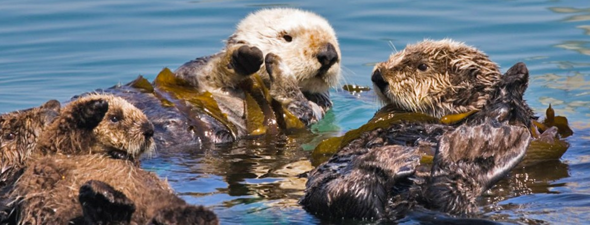
Source: https://lawaterkeeper.org/sea-otters/

Source 5
Island of the Blue Dolphins
By Scott O’Dell

The wide beds of kelp which surround our island on three sides come close to the shore and spread out to sea for a distance of a league. In these deep beds, even on days of heavy winds, the Aleuts hunted. They left the shore at dawn in their skin canoes and did not return until night, towing after them the slain otter.  The sea otter, when it is swimming, looks like a seal, but is very different. It has a shorter nose than a seal, small webbed feet instead of flippers, and fur that is thicker and much more beautiful. It is also different in other ways. The otter likes to lie on its back in the kelp beds, floating up and down to the motion of the waves, sunning itself or sleeping. They are the most playful animals in the sea.  It was these creatures that the Aleuts hunted for their pelts.  From the cliff I could see the skin canoes darting here and there over the kelp beds, barely skimming the water, and the long spears flying like arrows. At dark the hunters brought their catch into Coral Cove, and there on the beach the animals were skinned and fleshed. Two men, who also sharpened the spears, did this work, laboring far into the night by the light of seaweed fires. In the morning the beach would be strewn with carcasses, and the waves red with blood.  Many of our tribe went to the cliff each night to count the number killed during the day. They counted the dead otter and thought of the beads and other things that each pelt meant. But I never went to the cove and whenever I saw the hunters with their long spears skimming over the water, I was angry, for these animals were my friends. It was fun to see them playing or sunning themselves among the the kelp. It was more fun than the thought of beads to wear around my neck. | kelp—seaweed that grows in large amounts off coast of North America  Aleut—Native Alaskans of Aleutian Islands  pelt—skin of animal with fur or hair  strewn—scattered  carcass—body of dead animal
Scott O’Dell, Island of the Blue Dolphins (New York: Dell Laurel-Leaf, 1960), 16-17.

Source 5
Island of the Blue Dolphins
By Scott O’Dell
Questions

14. How do the Aleuts hunt sea otters in this passage?

15. How does Karana describe the beach after the hunters skinned the otters?

16. How do the other members of Karana’s tribe respond to killing of sea otters? Provide at least one piece of evidence from the text to support your answer.

17. How does Karana respond to the killing of sea otters? Provide at least two piece of evidence from the text to support your answer.

Source 6
“Kelp Forest”
PBS, Jean Michel-Cousteau: Ocean Adventures
YouTube Video

Kelp Forest (2:54)
https://www.youtube.com/watch?v=v_aSl3iL7rM
18. How much can healthy kelp grow in ideal conditions?
19. Where in California is Los Lobos? Use GoogleMaps to locate Los Lobos and describe its location in California in 2-3 sentences.
20. What are some of the features of a healthy kelp forest?
21. What is an ecosystem?
22. What happens to a kelp forest when sea otters are removed from the ecosystem? Explain your answer in 2-3 sentences.
Source 7
Map of Historical and Current Range (i.e. habitat) of Sea Otters

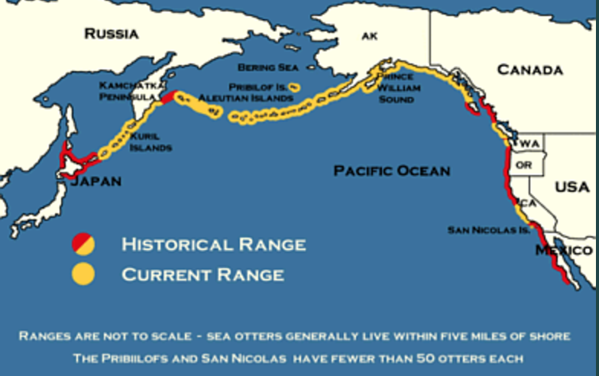
Source: https://www.werc.usgs.gov/ProjectSubWebPage.aspx?SubWebPageID=1&ProjectID=91

Questions

23. What do the regions outlined in yellow represent?

24. What do the regions outlined in red represent?

25. What modern nations make up the historical range of the sea otter?

26. Why do sea otters live in just a portion of their historical range—what, do you think, caused the decline in the sea otter population? Explain your answer in 1-2 sentences?

Source 8
Natural History of Sea Otters

Sea Otter Eating Sea Urchins
Source: https://www.esa.org/esa/tag/sea-otters/

Description of Species:  Sea Otters are about four feet long and weigh an average of 65 pounds for males and 45 pounds for females.…They’re known for the use of tools when eating. Because they love mollusks, sea otters will use rocks as hammers and anvils to help open the shells.…Grooming is important as it forces air bubbles into their fur that acts as insulation.  Habitat:  …The original habitat of the sea otter ranged from the Kurile Islands of Japan, to the Aleutian Chain of Alaska, along the coasts of Washington and Oregon, and down the coast of California to Baja California. There used to be a continuous distribution of sea otters but their thick pelts made them the favorite quarry of early fur traders in the 1700’s and 1800’s.…  Natural History:  Sea otters have extremely thick fur. Estimates put the number of hairs per square inch at about one million, while dogs only have about 60,000 hairs per square inch. In the 18th century, otter fur was prized in the Russian, Chinese, and Japanese courts. Land otters were hunted extensively and became scarce. During an expedition to find a land passage between Asia and North America, Vitus Bering discovered the Aleutian Islands and Alaska. Stranded on an island on the way back to Russia, Bering and some 30 others died. The survivors, among them a scientist named Georg Wilhelm Steller, subsisted on sea otters and a sea cow until they were able to build a new ship from the original, damaged ship. The remaining members of the expedition would bring back to Russia 900 otter pelts that would fetch a price of $30,000.  Russian fur traders quickly set out for the Aleutians and forced the aid of Aleut hunters.…  In 1812, the Russians established Fort Ross on the coast of Bodega Bay [California] to be used as a center for their fur trade operations in California and as agricultural land. By 1839, Fort Ross was abandoned due to the dwindling numbers of otters and the land was sold. Between 50,000 and 150,0000 otters were taken by the Russians. After the Russians left, traders from other countries came into the Bodega Bay area and resumed the killing of otters and took thousands more.… | mollusk—invertebrate sea animal with soft body but hard shell, like an abalone  habitat—place or environment where animal naturally lives  quarry—animal taken by predator or hunter; prey  court—public residence of king, queen, head of government, or important social figure  Vitus Bering—Dutch explorer that worked for Russian government during the 1700s; famous for exploring eastern Asia and Alaska  sea cow—large marine mammal (now extinct) similar to manatee that lived in Bering Sea, the arctic sea between Asia and North America
Source: http://online.sfsu.edu/bholzman/courses/Spring99Projects/otter.htm

Source 8
Natural History of Sea Otters
Questions

27. How do sea otters manage to eat the mollusks they take from kelp forests?

28. How thick, or dense, is a sea otter’s fur? How might people use sea otter fur?

29. What nation dominated the sea otter hunt and trade during the eighteenth and nineteenth centuries?

30. How many sea otters did the Russian hunters of Fort Ross remove from California and North America before Fort Ross closed in 1839?

31. Where in California was Fort Ross located? Use GoogleMaps to locate Fort Ross State Historic Park and describe its location in 2-3 sentences.

Source 8
Natural History of Sea Otters

Looking at Cause and Effect

Example:

CAUSE:  Sea otters have really thick fur. |  | EFFECT:  Sea otter pelts were useful in the construction of winter clothing.

32. Sources 8 and 7 show a number of cause and effect relationships between people and sea otters. Use Sources 8 and 7 to fill in the Cause and Effect boxes below.

CAUSE:  Sea otter pelts where in great demand for winter clothing in China, Japan, Russia, Western Europe, and the United States. |  | EFFECT:
CAUSE:  Russians established Fort Ross in 1812. |  | EFFECT:
Part 3. Russians, Native Alaskans, and Native Californians
Russian traders began hunting sea otters in eastern Asia. When the population of sea otters in Asia declined, they moved east across the Northern Pacific to Alaska, and then south down the west coast of North America. In Alaska, Russian hunters forced the finest hunters of sea otters, the Aleuts, or Native peoples of the Aleutian Islands, into virtual slavery to help them harvest sea otters. In 1803, American hunters partnered with the Russian-American Company (the fur trading company that dominated global trade of sea otter pelts) to hunt sea otters up and down New Spain, from Trinidad Bay in Northern California, to San Nicolas in Southern California, to Baja California further south.

Source 9
Island of the Blue Dolphins
By Scott O’Dell

The Aleuts left on a sunless day. Out of the north deep waves rolled down upon the island. They broke against the rocks and roared into the caves, sending up white sprays of water. Before night a storm would certainly strike.…  The men who were working on the canoe had stopped and were watching my father and Captain Orlov. The other men of our tribe stood at the foot of the trail.…  “One string of beads for one otter pelt is not our bargain,” my father said.  “One string and one iron spearhead,” said Captain Orlov, lifting two fingers.  “The chest does not hold that much,” my father answered.  “There are more chests on the ship,” said the Russian.  “Then bring them to the shore,” my father said.…  “The rest of the pelts must stay here,” he said, facing Captain Orlov, “until the chests are brought.”  The Russian drew himself up stiffly and pointed to the clouds that were blowing in toward the island.  “I load the ship before the storm arrives,” he said.  “Give us the other chests. Then I will help you with our canoes,” my father replied.…  I do not know what happened first, whether it was my father who raised his hand against the hunter whose path he barred, whether it was this man who stepped forward with a bale of pets on his back and shoved my father aside. It all happened so quickly that I could not tell one act from another. But as I jumped to my feet and Ulape screamed and other cries sounded along the cliff, I saw a figure lying on the rocks. It was my father and blood was on his face. Slowly he got to his feet.  With their spears raised our men rushed down across the ledge. A puff of white smoke came from the deck of the ship. A loud noise echoed against the cliff. Five of our warriors fell and lay quiet.  Ulape screamed again and flung a rock into the cove. It fell harmlessly beside Captain Orlov. Rocks showered into the cove from many places along the cliff, striking several of the hunters. Then our warriors rushed in upon them and it was hard to tell one from the other. …  The Aleuts had dropped the bales of otter. They drew knives from their belts and as our warriors rushed upon them the two lines surged back and forth along the beach. Men fell to the sand and rose to fight again. Others fell and did not get up. My father was one of these.  For a long time it seemed that we would win the battle. But Captain Orlov, who had rowed off to the ship when the battle started, returned with more of his Aleuts.  Our warriors were forced backward to the cliffs. There were few of them left, yet they fought at the foot of the trail and would not retreat.  The wind began to blow. Suddenly Captain Orlov and his Aleuts turned and ran to the boat. Our men did not pursue them. The hunters reached the ship, the red sails went up, and the ship moved slowly between the two rocks that guard the cove.…  The storm struck us as we ran, driving rain into our faces. Then other women were running beside us and their cries were louder than the wind. At the bottom of the trail we came upon our warriors. Many had fought on the beach. Few had left it and of all these all were wounded.  My father lay on the beach and the waves were already washing over him. Looking at his body, I knew he should not have told Captain Orlov his secret name, and back in our village all the weeping woman and sad men agreed that this had so weakened him that he had not lived through the fight with the Aleuts and the dishonest Russian.  That night was the most terrible time in all the memory of Ghalas-at. When the fateful day had dawned the tribe numbered forty-two men, counting those who were too old to fight. When night came and the women had carried back to the village those who had died on the beach of Coral Cove, there remained only fifteen. Of these, seven were old men.  There was no woman who had not lost a father or a husband, a brother or a son. | Aleut—Native people from Aleutian Islands of Alaska  barred—blocked  bale—group of items tied, or bundled, together with rope, cords, or hoops  Ulape—Karana’s older sister
Scott O’Dell, Island of the Blue Dolphins (New York: Dell Laurel-Leaf, 1960), 20-27.

Source 9
Island of the Blue Dolphins
By Scott O’Dell
Questions

33. Why does violence break out between the Russians and Aleuts and Natives of Ghalas-at?

34. What was the trade agreement between the Russian hunter, Captain Orlov, and Chief Chowig, Karana’s father and chief of Ghalas-at?

35. What were the effects of the violence in this passage on the Native peoples of the Island of the Blue Dolphins? Why was the battle so one-sided? Explain your answer in 2-3 sentences using at least 2 pieces of evidence from the text.

Source 10
“Aleutian Islander’s Sea Otter Spear; Spear Head; Full Size.” (1874)
New York Public Library

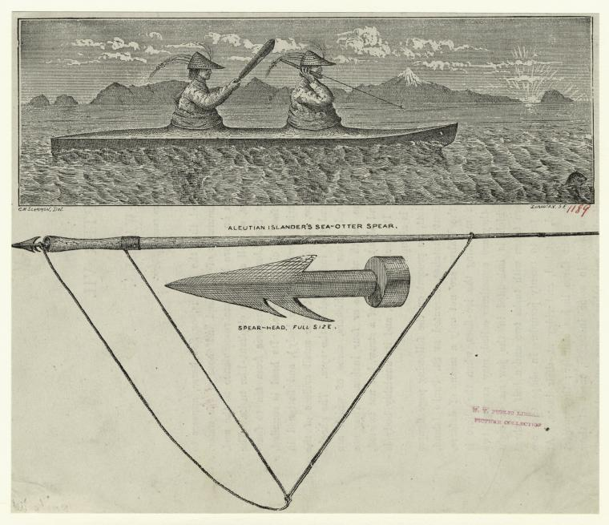
Source: https://digitalcollections.nypl.org/items/510d47e1-0d91-a3d9-e040-e00a18064a99

Source 11
Aleut Hunting Gear (1909)
Smithsonian Alaska Native Collections

Caption: “Men wearing hunting hats and gut parkas demonstrate the placement of a dart in a throwing board. Umnak Island, Aleutian Islands, 1909.”

Source: http://alaska.si.edu/media.asp?id=45&object_id=44
Questions for Source 10
“Aleutian Islander’s Sea Otter Spear”
& Source 11 “Aleut Hunting Gear”

36. What do you see in these images of Aleut hunters?

37. Does the Aleut hunting technology and techniques look effective for the purposes of hunting sea otters? Explain your answer in 2-3 sentences.

38. How do these images connect with the excerpt regarding Aleut hunters in Island of the Blue Dolphins (Source 7)? Explain your answer in 2-3 sentences.

Source 12
Analysis of Island of the Blue Dolphins, Chapter 4
By Susan Morris

Island of the Blue Dolphins is a work of historical fiction. Parts of the novel are fiction—totally made up; other parts are based on the experiences of the author, Scott O’Dell; still other parts are based on real history. As mentioned above, the early chapters of the book are based on a real conflict that broke out between the Nicoleño Indians of San Nicolas Island and Russian and Aleut otter hunters in 1814.

During the 1800s (nineteenth century), commercial sea otter hunting was in full force. Russians, as well as Americans and the British, engaged in the enterprise, trading their skins for goods in China. Russians initially hunted in Alaska, and required Alaska Natives to hunt with them.  When the sea otter populations diminished in Alaska, the Russian and Alaska Native hunters moved south to Spanish-held California. The Channel Islands, off the California coast, were ideal hunting grounds because of high sea otter populations and distance from the Spanish on the mainland.  We know that Russians brought Alaska Native hunters to San Nicolas Island because four documents from 1818 discuss a massacre on the island that involved a Russian-led hunting group. This group was sent to the island to hunt for the Russian American Company (RAC), a commercial enterprise (or business) that had exclusive rights granted by the Russian government to hunt fur-bearing animals in North America.  The Il’mena, a RAC ship, brought a crew of Alaska Native sea otter hunters and a Russian overseer, Iakov Babin, to San Nicolas Island in 1814.…  The Alaska Natives began hunting otter, but the native inhabitants of San Nicolas Island may not have been happy about their intrusion on the island. According to a letter dated July 15, 1818, written by Ivan Kuskov, manager of Fort Ross, the Russian colony in northern California, the Nicoleños killed one of the Alaska Natives while they were on the island.  The remaining Alaskan hunters were angry about the death and killed many Nicoleños in return. The letter does not state how many Nicoleños died, or how many survived.  Russian officials learned of the massacre and were concerned about the violent events. Documents show that three RAC managers…asked for information about the deaths on San Nicolas Island. They held the Russian overseer, Iakov Babin, responsible for the massacre. Letters tell us that Babin was sent from California to Russian Alaska and was scheduled to sail to RAC headquarters in St. Petersburg, Russia, to answer questions about the murder and mass killings on San Nicolas Island in 1814. | commercial—concerned with business; activity focused on making a profit  massacre—deliberate killing of large number of people
Source: Susan Morris/National Park Service, https://www.nps.gov/subjects/islandofthebluedolphins/morris.htm

Source 12
Analysis of Island of the Blue Dolphins, Chapter 4
Questions

39. What was the Russian-American Company (RAC)?

40. Why did the Russian and Aleut hunters sail to San Nicolas Island?

41. What, according to this source, happened after the Russian fur trading ship arrived at San Nicolas Island in 1814? Explain your answer in 2-3 sentences.

Source 13
Excerpt of Letter from Ivan Kuskov to Leontii Hagemeister, Chief Manager of the Russian American Company in Sitka, Russian Alaska
July 15, 1818

Dear Sir Leontii Andreevich,  Per your instruction…to explain the incident concerning the fur trader Iakov Babin, which took place on San Nicolas Island. Upon his arrival in 1814 with the ship Il’mena from Sitka, fur trader Babin was to stay with the Tarakanov hunting party. However, Tarakanov ordered him to stay behind on San Nicolas Island with some canoes, while the rest of the Tarakanov party went to stay on San Clemente Island.  …From there, the Pedler went to San Nicolas Island where Babin and the rest of the hunting party were staying. But Babin was not on the island. As it happened…Nepogod’ev also found out from the remaining Kad’iaks (Alaska Natives) that the locals of San Nicolas Island killed one of Babin’s otter hunters. In retaliation, Babin was insolent and acted inhumanely toward the islanders. | Per—in accordance with; in compliance with  insolent—rude or arrogant lack of respect
Source: National Park Service, https://www.nps.gov/subjects/islandofthebluedolphins/primary4.htm

Questions

42. Who was Ivan Kuskov (look in Source 11)?

43. Who was Iakov Babin (look in Source 11)?

44. Identify 2 ways the story of the Nicoleños and crew of the Il’mena is similar to, or different from the story of the Yurok and crew of the Lelia Byrd (Sources 1 and 3). Explain your answer in 3-4 sentences.

Similarities | Differences
A. | A.
B. | B.
Final Activity. What were the consequences of the Pacific sea otter trade of the eighteenth and nineteenth centuries?
In this lesson, you have learned about how the various peoples of the Pacific Ocean became more tightly connected after the sixteenth century (1500s). By looking at some passages of Island of the Blue Dolphins, and other sources, you have also learned about how California became integrated into larger patterns of trade across the Pacific Ocean. As the novel and other sources show, interaction and trade in the Pacific Ocean was not always pleasant—it meant death for large numbers of sea otters (and other mammals) and sometimes violence and death for different groups of people.

Your task for this final activity is to write an 8-sentence paragraph that describes the causes and effects of the sea otter trade of the eighteenth and nineteenth centuries.

Your 8-sentence paragraph should answer the inquiry question: What were the consequences of the Pacific sea otter trade of the eighteenth and nineteenth centuries?

It should also include six main parts:

1. A central claim or thesis.

2. Two pieces of supporting evidence.

3. Two analytical sentences that provide additional information about your evidence and that explain why your evidence supports your central claim.

4. A conclusion, or concluding sentence.

To prepare your 8-sentence paragraph, look over the char below. Also feel free use the graphic organizer below to to brainstorm or bullet point your ideas.

After you have made notes for all four parts of your 8-sentence paragraph, use your notes to write your 8-sentence paragraph.

The 8-Sentence Paragraph
Remember: Both pieces of evidence must relate back to your central claim and thus the whole paragraph.

Sentence 1 – Central Claim: state the topic of your paragraph and the main point, or claim, you want to make about the topic.

Sentence 2 – Supporting Evidence: identify and introduce basic facts regarding source #1

Sentence 3 – Provides context or additional information about supporting evidence.

Sentence 4 – Analytical sentence that illustrates, explains how, evidence supports central claim.

Sentence 5 – Supporting Evidence: identify and introduce basic facts regarding source #2

Sentence 6 – Provides context or additional information about supporting evidence.

Sentence 7 – Analytical sentence that illustrates, or explains how, evidence supports central claim.

Sentence 8 – Conclusion: summarizes paragraph by restating topic and claim–does does not introduce new information.

8-Sentence Paragraph
Inquiry Question:
What were the consequences of the Pacific sea otter trade of the 18th and 19th centuries?
Central Claim
Supporting Evidence
Information/Context
Analysis
Supporting Evidence
Information/Context
Analysis
Conclusion

