How interconnected were the distant regions of the world in 300 CE?
Introductory lesson to geography of the 7th grade History and Geography course
CCSS Standards: Reading, Grade 6-8
1. Cite specific textual evidence to support analysis of primary and secondary sources.
7. Integrate visual information (e.g., in charts, graphs, photographs, videos, or maps) with other information in print and digital texts.

Writing, Grade 6-8
9. Draw evidence from informational texts to support analysis reflection, and research.
Overview of Lesson:

This lesson will allow teachers to introduce students to the geographic features that will be an important part of the 7th grade World History and Geography curriculum. The lesson begins with a map activity. Students will create a world map that they can use throughout the entire course. Students will then engage in a gallery walk to consider points of connection and sites of encounter between people across the world. Finally, the lesson will ask students to consider what was going on during these encounters and to develop a claim based on evidence from the sources.

- Student fill in a world map individually using their textbooks, an atlas, or information from the internet. Teachers should explain that Afroeurasa is made up of the continents of Africa, Europe, and Asia and will be focus of the course of study. The map and activity are listed below.
- Students will then do a gallery walk with the sources listed below. Each of the sources highlights the interconnected nature of the world. For each of the sources, students will work in partners to answer the following questions for each source:
- What is the main idea of the source? Summarize what is going on in the source in 2-3 sentences.
- Where is the source from? Locate this on your map and make a record of it.
- What does this source have to do with the concept of interconnection? Use evidence from the source to support your claim.

- As a summation activity as students:
What areas were interconnected? How were people interconnected in 300 CE (trade, war, discovery)? Give examples from the sources to support the claims.
World Map Activity
Fill in the following on the map:
- A Compass rose and identify the Eastern and Western hemispheres
- The continents (Africa, Asia, Australia, Europe, North America, and South America)
- The world’s oceans (Pacific, Atlantic, and Indian) the following bodies of water: Arabian Sea, Red Sea, Mediterranean Sea, Gulf of Mexico, South China Sea
- Empires: Roman Empire (Mediterranean Region and Europe), the Sassanian Persian Empire (Southwestern Asia), Gupta Empire (South Asia), and China (East Asia), Mayan Empire (Central America)
- Label the Silk Road

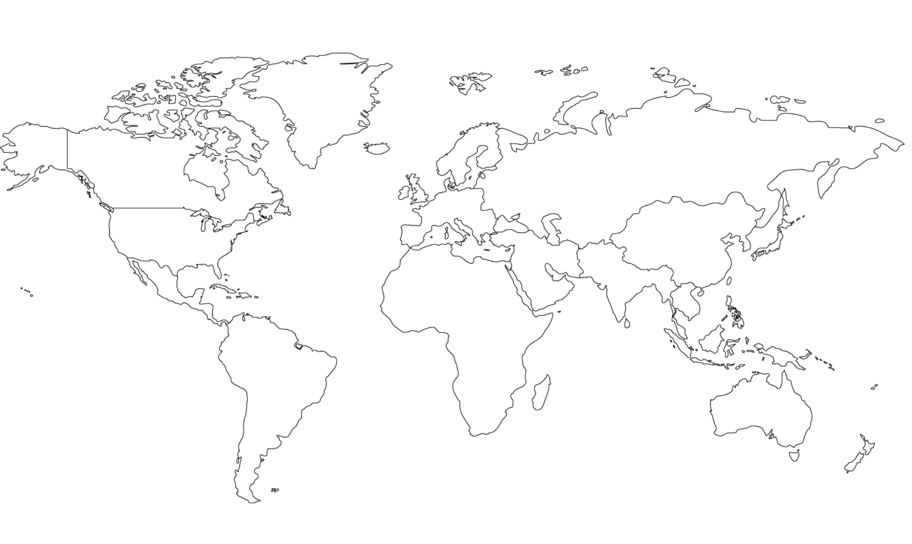

Source 1: The Ancient City of Teohituacan

Construction at Teotihuacán began around 150BC, and continued until 250AD. At its height, the city covered 21 square miles and was home to as many as 200,000 people, making it the largest city in the western hemisphere…

[During an excavation of a pyramid,] An array of gigantic conch shells from the Caribbean, Pacific and Gulf coasts were also found in the tunnel. Some are engraved with distinctive Mayan hieroglyphics, confirming strong ties between the elites of Teotihuacán and Mayan communities as far south as Guatemala and Belize.  Other relics [ancient artifacts] include exquisite jade ornaments imported from Guatemala, woven straw mats probably reserved for the elites, rubber balls used in an ancient ball game, striking ceramics pots from neighboring states, and animal bones from migratory birds, jaguars and even a bear. | 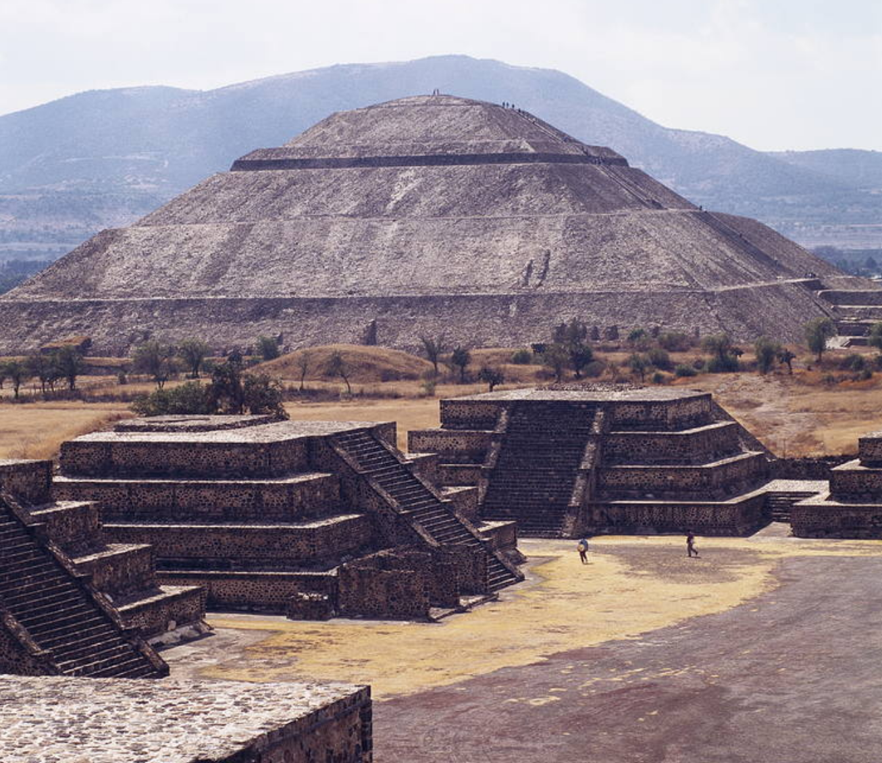
Text from https://www.theguardian.com/science/2017/apr/24/mexicos-ancient-city-guards-its-secrets-but-excavation-reveals-new-mysteries
Images from http://whc.unesco.org/en/list/414

Source 2: The Seated Buddha

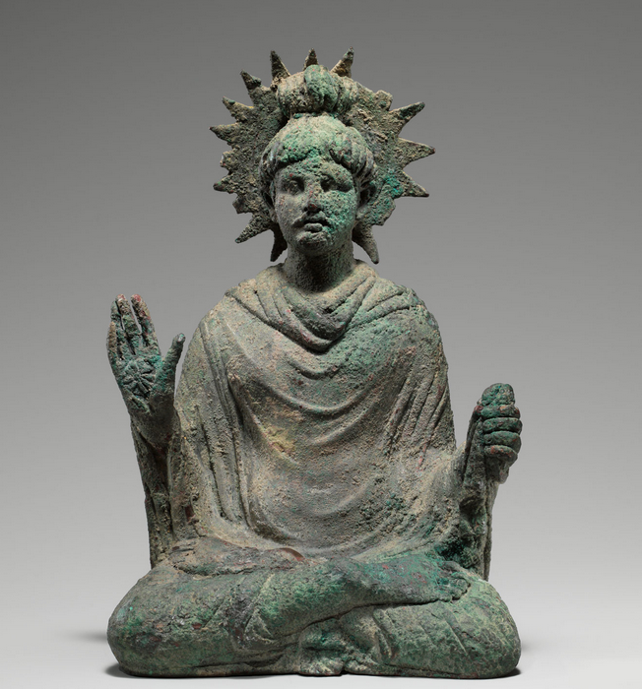 | Created in 1st to mid 2nd century BCE, this bronze sculpture of the Buddha was found in what is today’s Pakistan. He sits in a yogic posture holding his right hand in abhaya mudra (a gesture of approachability); his unusual halo has serrations that indicate radiating light. His hairstyle, the form of his robes, and the treatment of the figure reflect stylistic contacts with the classical traditions of the West, particularly Greek and Roman culture. This Buddha looks more like Roman sculpture than most Buddhas found in India and other parts of Asia.

Found at http://www.metmuseum.org/toah/works-of-art/2003.593.1/

Source 3: The Story of India
Video: “Trade and the Discovery of the Monsoon”

http://www.pbs.org/thestoryofindia/gallery/photos/8.html#trade_video

Source 4: The Western Regions according to the Hou Hanshu

This was written for the Chinese Han Empire by Fan Ye in 445

The Kingdom of Da Qin 大秦 (the Roman Empire)  The Kingdom of Da Qin (the Roman Empire) is also called Lijian. As it is found to the west of the sea, it is also called the Kingdom of Haixi (Egypt). Its territory extends for several thousands of li. It has more than four hundred walled towns. There are several tens of smaller dependent kingdoms. The walls of the towns are made of stone…  The seat of government (Rome) is more than a hundred li (41.6 km) around. In this city are five palaces each ten li (4.2 km) from the other. Moreover, in the rooms of the palace the pillars and the tableware are really made of crystal. The king goes each day to one of the palaces to deal with business. After five days, he has visited all of them…  This country produces plenty of gold, silver, and precious jewels, luminous jade, ‘bright moon pearls,’ fighting cocks, rhinoceroses, coral, yellow amber, opaque glass, whitish chalcedony red cinnabar, green gemstones…  They make gold and silver coins. Ten silver coins are worth one gold coin…  The people of this country are honest in business; they don’t have two prices. Grain and foodstuffs are always in good supply…  The king of this country always wanted to send envoys to the Han, but Anxi (Parthia), wishing to control the trade in multi-coloured Chinese silks, blocked the route to prevent [the Romans] getting through [to China].  In the ninth yanxi year [166 CE], during the reign of Emperor Huan, the king of Da Qin (the Roman Empire), Andun (Marcus Aurelius Antoninus), sent envoys from beyond the frontiers through Rinan (Commandery on the central Vietnamese coast), to offer elephant tusks, rhinoceros horn, and turtle shell. This was the very first time there was [direct] communication [between the two countries]. The tribute brought was neither precious nor rare, raising suspicion that the accounts [of the ‘envoys’] might be exaggerated. | li—form of measurement, like a mile  pillars—columns or decoration  luminous—bright  chalcedony—precious stone  grain—wheat or other type of dry seed to use to make food  envoy—government diplomat  tribute—a gift meant to show respect

How interconnected were the distant regions of the world in 300 CE?
Fact Finding Worksheet

Source  Record the name of the source | What is the main idea of the source? Summarize what is going on in the source in 2-3 sentences. | Where is the source from? What other locations are discussed in the source? Locate these places on your map and make a record of it. | How does this source show that the world was interconnected? Use evidence from the source to support your claim.
Source 1

Source 2

Source 3

Source 4

Conclusion:
What areas were interconnected? How were people interconnected in 300 CE (trade, war, discovery)? Give examples from the sources to support the claims.

