What were the results of the Industrial Revolution?
What were the effects of fossil fuel use during the Industrial Revolution?
Content Standards | 10.3 Students analyze the effects of the Industrial Revolution in England, France, Germany, Japan, and the United States.  - Analyze why England was the first country to industrialize.  - Examine how scientific and technological changes and new forms of energy brought about massive social, economic, and cultural change (e.g., the inventions and discoveries of James Watt, Eli Whitney, Henry Bessemer, Louis Pasteur, Thomas Edison).  10.4 Students analyze patterns of global change in the era of New Imperialism in at least two of the following regions or countries: Africa, Southeast Asia, China, India, Latin America, and the Philippines.  - Describe the rise of industrial economies and their link to imperialism and colonial-ism (e.g., the role played by national security and strategic advantage; moral issues raised by the search for national hegemony, Social Darwinism, and the missionary impulse; material issues such as land, resources, and technology).  - Discuss the locations of the colonial rule of such nations as England, France, Germany, Italy, Japan, the Netherlands, Russia, Spain, Portugal, and the United States.
Common Core State Standards | RH 9-10 1. Cite specific textual evidence to support analysis of primary and secondary sources, attending to such features as the date and origin of the information.  RH 9-10 2. Determine the central ideas or information of a primary or secondary source; provide an accurate summary of how key events or ideas develop over the course of the text.  RH 9-10 9. Compare and contrast treatments of the same topic in several primary and secondary sources.  WH 9-10 2. Write informative/explanatory texts, including the  narration of historical events, scientific  procedures/experiments, or technical processes.  WH 9-10 4. Produce clear and coherent writing in which the  development and organization, and style are appropriate to the  task, purpose, and audience.

In this lesson, students will learn about the energy revolution that emerged in Great Britain through the increased use of fossil fuels and the development of technology that harnessed these new types of power. Students work in groups to read and analyze the sources and answer the questions. The teacher can jigsaw each of the parts of the lessons—Parts 1-4—and then students can each report out on how their sections allow them to answer the lesson question: What were the effects of fossil fuel use during the Industrial Revolution?
For a culminating activity, teachers can assign students an informational writing response. Students summarize the information they have learned to create a textbook excerpt describing energy use during the Industrial Revolution. They can also create an infographic to accompany their description using the Easely program found at:
https://www.easel.ly/
or infogram.com
Some examples you can show them are:
https://infogram.com/the-industrial-revolution-1gdk8pdxqze1mq0
or
https://infograph.venngage.com/p/208208/infographic-on-industrialization
Finally, students can link this to today by doing online research to identify charts, graphs, articles, and/or maps that compare energy use in our contemporary world to the Industrial revolution through one of these topics: fossil fuels vs. renewables, pollution, technology resulting from renewable energy use, global trade in renewable energy technology and sources.
Part 1: Fossil Fuels and the Energy Revolution
The Industrial Revolution was energized by coal and eventually by petroleum and natural gas. Fossil fuels that drive steam and electrical engines made possible a huge increase in the amount of productive energy available to humans. Read and analyze the sources below and answer the guiding questions to consider our guiding question:
What were the effects of fossil fuel use during the Industrial Revolution?

Source: J.R. McNeill and William H. McNeill, The Human Web: A Bird’s-Eye View of World History, New York: W.W. Norton and Company, 2003, pages 230-32.

[T]he Industrial Revolution transformed the energy base of human society. Energy is essential for making things, for transport, and for bodily survival. Before the use of fossil fuels, people could harness only a tiny fraction of the energy available on earth... Wind and water power, available only in favorable locations, also harnessed a fraction of the annual energy delivered to the earth from the sun…By burning wood or charcoal, people could tap energy stocks accumulated in trees over a century or two. But ultimately all these methods provided a very limited energy harvest, which meant that almost all people would always be poor, dependent upon grinding toil for their rice or bread.
Fossil fuels changed all that…People around the world had known of coal’s uses for a long time, and Song China had used it on a large scale in its iron industry. London had burned coal for home heating from at least the thirteenth century. Britain had abundant coal deposits…
With cheap British coal it became easier to stay warm in winter and to stoke the energy intensive industries.

Questions:
- What types of energy were available to people to use before the Industrial Revolution?
- What type of fossil fuel is mentioned in the text?
- How did energy use change after the use of fossil fuels?

Source: 1834 “Report of a Select Committee of the House of Commons on Steam Carriages”
It has been said that in Great Britain there are above a million of horses engaged in various ways in the transport of passengers and goods, and that to support each horse requires as much land as would upon an average support eight men. If this quantity of animal power were displaced by steam-engines, and the means of transport drawn from the bowels of the earth [coal], instead of being raised upon its surface [food for horses], then… as much land would become available for the support of human beings as would suffice for an additional population of eight millions; … The land which now supports horses for transport or turnpike roads would then support men, or produce corn for food, and the horses return to agricultural pursuits.

Found in Richard G. Wilkinson, “The English Industrial Revolution,” in The Ends of the Earth, edited by Donald Worster, Cambridge: Cambridge University Press, 1988, p. 90.
Questions:
- How does horsepower compare to steam power?
- What does this article say the benefits of coal use would be?

Source: Global Energy Consumption Chart
This is measured in terrawatt hours, which measures large amounts of energy. This is often how energy companies measure energy use.
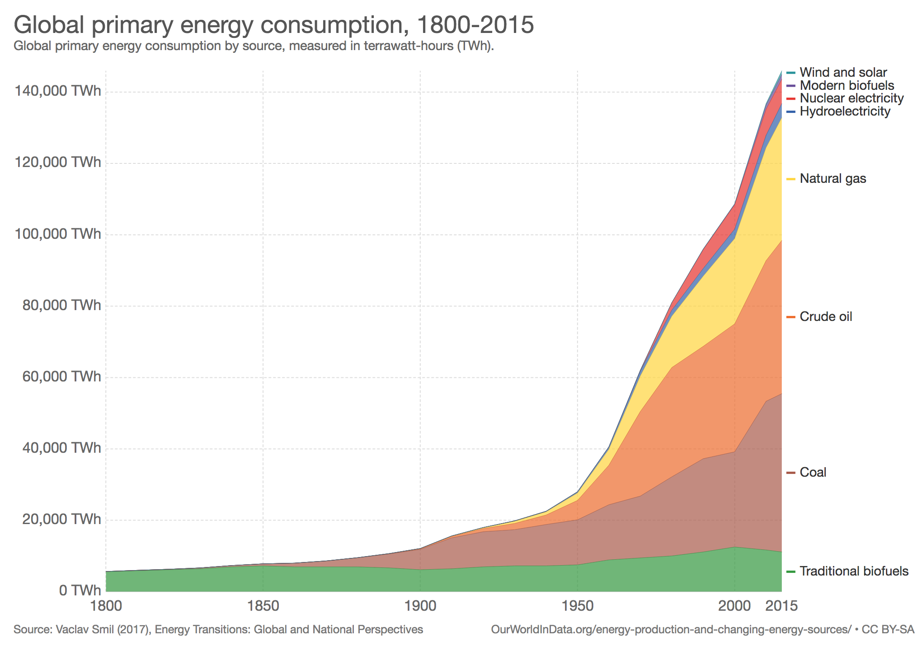

Found at: https://ourworldindata.org/energy-production-and-changing-energy-sources/

Questions:
- Describe the ways the coal use increases over time.
- Describe the changes of energy use over time.
- What types of fossil fuels were used during the Industrial Revolution?

Part 2: Energy Powers Technology
The ability of Britons to harness the power of fossil fuels allowed for the development of inventions that facilitated the use of these new power sources. As these inventions led to the increase of coal production, new technologies emerged that allowed people to better use coal and the steam that it generated. Read and analyze the sources below and answer the guiding questions to consider our guiding question:
What were the effects of fossil fuel use during the Industrial Revolution?

Source: J.R. McNeill and William H. McNeill, The Human Web: A Bird’s-Eye View of World History, New York: W.W. Norton and Company, 2003, page 232.

Most coal seams were of no use to the iron industry because coal’s impurities made iron brittle. But after 1709 this no longer mattered, because an ironmaster named Abraham Darby figured out that coke, a purer carbon derived from coal, served admirably. This resolved an energy bottleneck in iron production, allowing an expansion that could not have happened using the traditional fuel, charcoal. The second technical innovation came in the form of steam engines, which had existed in rudimentary forms in China and France as well as in England. The problem of draining water from coal mines inspired several advances in steam engine design, the most important one credited to the Scotsman James Watt in the 1770’s. Where coal was almost free, at pitheads, coal-powered steam engines pumped out groundwater, which allowed miners to dig deeper and deeper.
By 1800, Britain had about 2,000 steam engines, most of them employed pumping water of out of coal mines. This made coal cheaper still…Mobile steam engines, on locomotives and ships, eventually became standard…This was the technological heart of the Industrial Revolution in Britain.

Questions:
- How was coal used before the Industrial Revolution?
- What inventions allowed for the expansion coal mining?
- What inventions resulted from the expansion of coal mining?

Source: William Bell Scott, “In the nineteenth century the Northumbrians show the world what can be done with iron and coal.” 1861. Courtesy Wallington, the National Trust.
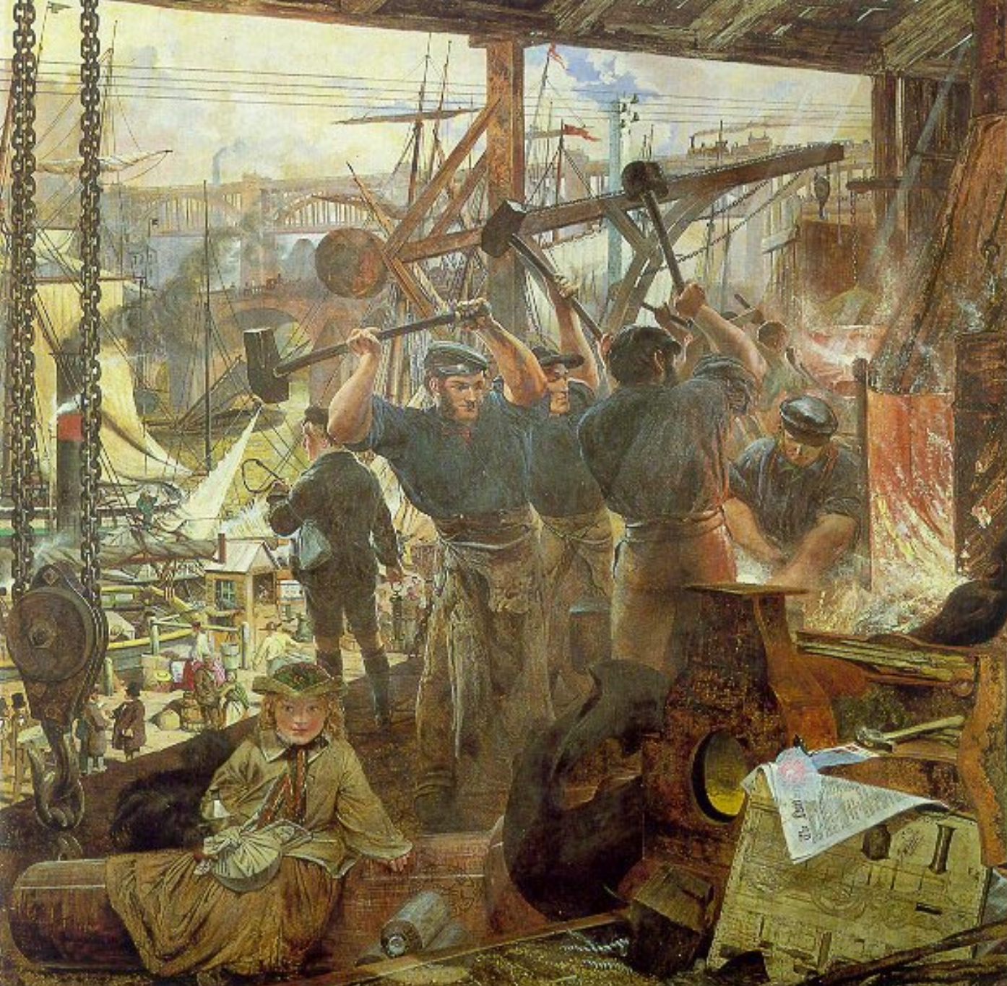

Questions:
4. This image is set in a 19th century engineering workshop. What types of work was going on in the image?
5. Where was the workshop located? What activity was going on outside of the workshop?
6. Describe the types of technology that are represented in the image.

Source: J. M. W. Turner, Rain, Steam, and Speed, 1844.
View the image and listen to the discussion at the link below to answer the questions.
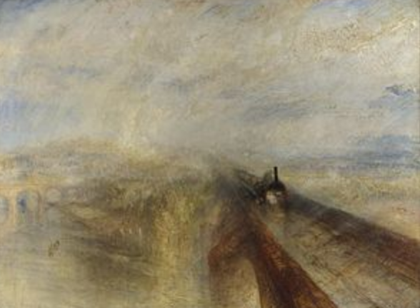 | Smarthistory  https://www.youtube.com/watch?v=pPsqUFuysbU  watch until 2:11
7. Why was the train a symbol of the Industrial Revolution?
8. How did people ride on and use trains during in the Industrial Revolution?
9. How was transportation transformed in this period with the train?

Part 3: Energy and Population
Industrialization, particularly large-scale factories powered by steam created from the burning of large amounts of coal, changed the face of cities all across the world in the nineteenth century. While coal-fired factories were engineering marvels and considerably increased efficiency and manufacturing output in a number of industries, coal-fired factories also produced a number of negative side effects as well. The sky lines, not to mention daily life, of many European and American cities came to be dominated by coal-fired factories. More than that, the smoke that spilled out of the factories’ smoke stacks resulted in nasty forms of air pollution that created health problems for those that worked in, or lived near, the factories. Read and analyze the sources below and answer the guiding questions to consider our guiding question:
What were the effects of fossil fuel use during the Industrial Revolution?

Source Modern World History textbook
The British market town of Manchester numbered 17,000 people in the 1750’s. Within a few years, it exploded into a center of the textile industry. Its population soared to 40,000 by 1780 and 70,000 by 1801. Visitors described the “cloud of coal vapor” that polluted the air, the pounding noise of steam engines, and the filthy stench of its river. This growth of industry and rapid population growth dramatically changed the location and distribution of two resources—labor and people.

Questions:
- How did Manchester’s population change during the Industrial Revolution?
- What were the consequences of fossil fuel use in Manchester?

Source: Air pollution in Widnes, a town outside of Liverpool and close to Manchester, England in the late 19th century
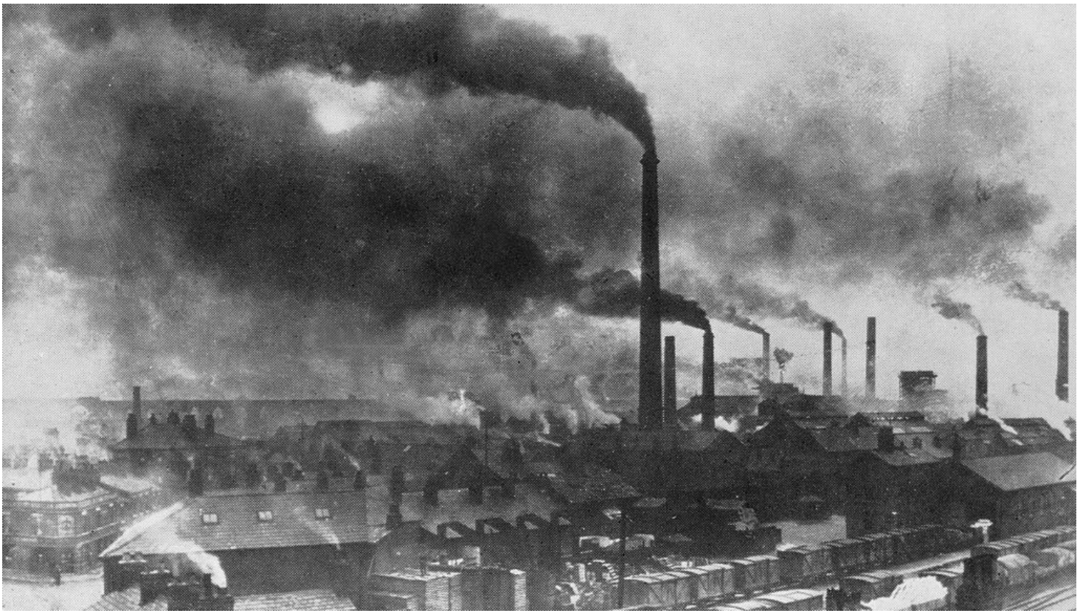
Hardie, D. W. F., A History of the Chemical Industry in Widnes, Imperial Chemical Industries Limited, 1950. Found at : https://ourworldindata.org/london-air-pollution/#note-10
Questions:
- Describe what you see in this photo.
- What were the consequences of fossil fuel use in Windes?

Source: Charles Dickens, Hard Times (1854, excerpt)

In his novel Hard Times (1854), Charles Dickens created the fictional city of Coketown to draw attention to some of the negative side effects caused by industrialization. In the excerpt below, Coketown stands in for Manchester and the many other industrial towns of northern England.

. . . Let us strike the key-note, Coketown, before pursuing our tune.

It was a town of red brick, or of brick that would have been red if the smoke and ashes had allowed it; but as matters stood, it was a town of unnatural red and black like the painted face of a savage. It was a town of machinery and tall chimneys, out of which interminable serpents of smoke trailed themselves for ever and ever, and never got uncoiled. It had a black canal in it, and a river that ran purple with ill-smelling dye, and vast piles of building full of windows where there was a rattling and a trembling all day long, and where the piston of the steam-engine worked monotonously up and down, like the head of an elephant in a state of melancholy madness. . . .

Questions:
- How did Dickens describe Coketown?
- What adjectives does Dickens use to describe the effects of coal burning?
- What were the consequences of fossil fuel use in Coketown?

Part 4: Energy and Empire
As Britons found new ways to use steam to power their machines, they were better able to explore and expand their empire. This created new networks between Britain and its colonies as well as new dependencies as the British economy became increasingly specialized in manufacturing. Read and analyze the sources below and answer the guiding questions to consider our guiding question:
What were the effects of fossil fuel use during the Industrial Revolution?

Source: Steamships

Transporting goods and people on the water was sometimes a slow process. Moving against the current was difficult. Winds too calm to sail also created delays.  Steamboats could move against the current regardless of the wind’s direction or strength. People worried that putting a steam engine on a boat would cause a fire. Engineer William Symington conducted one of the first successful trials of a steamboat, a boat powered by a steam engine. Symington saw a way to capture the efficiency of the Watt engine and the simplicity of the Newcomen engine. He created an engine that would work on a boat without fear of the boat catching fire. | 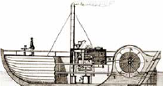
From: California Education and the Environment Initiative I Unit 10.3.1. and 10.3.5. I Britain Solves a Problem and Creates the Industrial Revolution, page 122.

Questions:
- What were the benefits of steamships?
- What technological innovations were required before the steamship could be used more widely?

Source: Joahn Charles Ready Colomb, “Imperial Federation, map of the world showing the extent of the British Empire in 1886”
View image at the website to zoom in and answer the questions below.
https://collections.leventhalmap.org/search/commonwealth:x633f896s

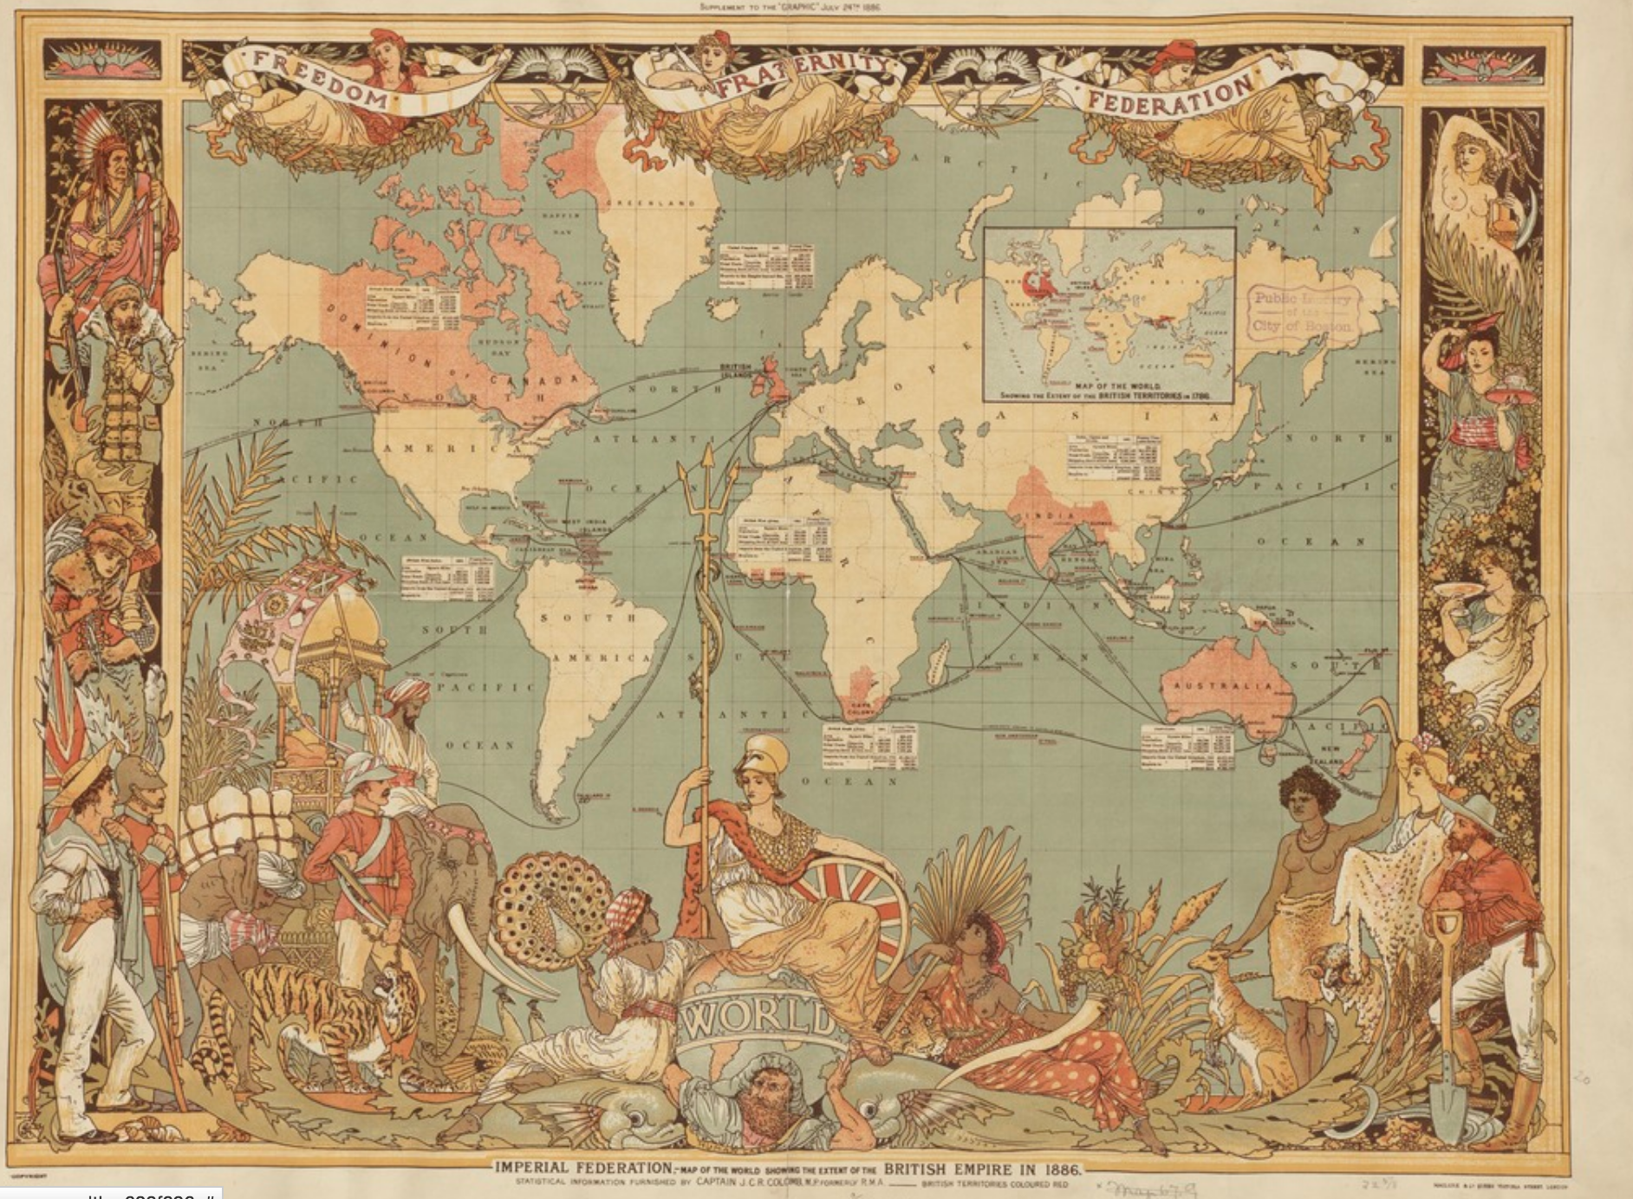

Questions:
3. Identify Britain on the map and consider where the shipping lanes travel. It’s empire is identified in red, list its colonies in the 1860s.

4. Read the charts on the map. What information do these contain? Are British net importers or exporters (do they import or export more from their colonies?)?

5. Examine the images of people on the margins of the map. Describe who is pictured. How are the British represented? How are the colonies represented?

6. What is the message, or idea that this map communicates, to the viewer?

Source W.S Jevons, British economist writing in 1865. His book is entitled The Coal Question.
[U]nfettered commerce…founded on the material basis of our coal resources, have made the several quarters of the globe our willing tributaries…The plains of North American and Russia are our corn-fields; Chicago and Odessa our granaries; Canada and the Baltic our timber-forests; Australasia contains our sheep-farms, and in Argentina and on the western prairies of North American are our herds of oxen, Peru sends her silver, and the gold of South Africa and Australia flows to London; the Hindus and Chinese grow tea for us; and our coffee, sugar and spice plantations are all in the Indies. Spain and France are our vineyards, and the Mediterranean our fruit-garden; and our cotton-grounds, which for long have occupied the Southern United States, are now being extended everywhere in the warm regions of the earth.

Questions:
- What types of relationships does Britain have with its colonies and other trading partners according to this source?
- How is this source similar and different to the map above?
- How did Britain benefit from increased trade resulting from steamship’s ability to move people and goods around the globe?

