Were the 1920s a time of cultural change?
Topic: 1920s, race, gender, sexuality
By: Jessica Christian, UC Irvine History Project

History-Social Science Standards:

11.5 Students analyze the major political, social, economic, technological, and cultural developments of the 1920s.
- Analyze the passage of the Nineteenth Amendment and the changing role of women in society.
- Describe the Harlem Renaissance and new trends in literature, music, and art, with special attention to the work of writers (e.g., Zora Neale Hurston, Langston Hughes).
- Trace the growth and effects of radio and movies and their role in the worldwide diffusion of popular culture.
Discuss the rise of mass production techniques, the growth of cities, the impact of new technologies (e.g., the automobile, electricity), and the resulting prosperity and effect on the American landscape.

CCSS Standards: Reading, Grades 11-12
1. Cite specific textual evidence to support analysis of primary and secondary sources, connecting insights gained from specific details to an understanding of the text as a whole.
2. Determine the central ideas or information of a primary or secondary source; provide an accurate summary that makes clear the relationships among the key details and ideas.
3. Evaluate various explanations for actions or events and determine which explanation best accords with textual evidence, acknowledging where the text leaves matters uncertain.
4. Determine the meaning of words and phrases as they are used in a text, including analyzing how an author uses and refines the meaning of a key term over the course of a text…
5. Analyze in detail how a complex primary source is structured, including key sentences, paragraphs, and larger portions of the text contribute to the whole.
6. Evaluate authors’ differing points of view on the same historical event or issue by assessing the authors’ claims, reasoning, and evidence.
7. Integrate and evaluate multiple sources of information presented in diverse formats and media (e.g., visually, quantitatively, as well as in words) in order to address a question or solve a problem.
8. Evaluate an author’s premise, claims, and evidence by corroborating or challenging them with other information.
9. Integrate information from diverse sources, both primary and secondary, into a coherent understanding of an idea or event, noting discrepancies among sources.

CCSS Standards: Writing, Grades 11-12
1. Write arguments focused on discipline-specific content.
2. Write informative/explanatory texts, including the narration of historical events, scientific procedures/ experiments, or technical processes.
4. Produce clear and coherent writing in which the development and organization, and style are appropriate to the task, purpose, and audience.
8. Gather relevant information from multiple authoritative print and digital sources, using advanced searches effectively; assess the strengths and limitations of each source in terms of the specific task, purpose, and audience; integrate information into the text selectively to maintain the flow of ideas…

Guiding Questions:
Were the 1920s a time of cultural change?

Overview of Lesson:
In this lesson, students will learn about changes and continuities in the 1920s, particularly focused on cultural and social areas. Students will analyze primary and secondary sources that explore race, gender, and sexuality in the 1920s.

Students can work individually or in groups as they progress through each of the four modules of the lesson.

Part One: Students learn about segregation and mixed race spaces in the north by reading and analyzing texts from The New Yorker and The Mob Museum website.

Part Two: Through watching clips from the 1929 film “Black and Tan” students consider the way that the African American community was impacted by the new interested in jazz music and culture. The prosperity of the 1920s was not distributed equally.

Part Three: Students explore photographs and descriptions of flappers to understand how the new woman of this era challenged gender roles for women.

Part Four: LGBT history is highlighted through an exploration of images and analysis of Gertrude “Ma” Rainey’s 1928 song “Prove It On Me Blues.”

Final Activity #1: For a culminating activity, teachers can have students take sides in a debate. The sides can be assigned or students can choose for themselves. The class can be divided in half or in smaller groups (the latter is modelled in the lesson). Students argue that the 1920s were, or were not, a time of cultural change. There is evidence for both sides, and evidence that some things changed culturally while others did not, in the lesson.

Sources:
- The New Yorker on segregation at the Cotton Club in the 1920s.
- The Mob Museum website description of segregation and mixed race spaces, clubs called “Black and Tans.”
- “Black and Tan” Film (1929), two clips.
- “Black and Tan” Film Poster (1929).
- Humanities Out There Great Gatsby Lesson, page 10, background on flappers.
- Image of Women’s Dresses from the 1910s, New York Public Library online collection.
- Image of Women’s Dresses from 1926, Sears Catalog.
- Photograph of a Beach Censor in 1925, Getty Images.
- Photograph of African American flappers, from the National Museum of American History.
- California Social Science/History Framework, Lines 432-436, excerpt on LGBT history in the 1920s.
- Advertisement for Gertrude “Ma” Rainey’s “Prove It On Me Blues” (1928)
- Photograph of Gertrude “Ma” Rainey from the 1920s.
- “Prove It On Me Blues” (1928) song.
- “Prove It On Me Blues” lyrics from outhistory.org.

Introduction
Student Worksheet

The 1920s ushered in many changes. New forms of technology were introduced, or became more widely available. Cars, previously only accessible for the wealthy, became affordable for average Americans. Electricity lit up cities. While the light bulb, like cars, was not brand new, the technology spread in the 1920s. Other new technology allowed for the spread of different cultural productions. Radio and films allowed Americans across the country to have access to the same music, dance, and stories. A song played by a band at the Cotton Club in Harlem might be recorded and featured on the radio, or a film, and thus reach nationwide audiences.
Harlem, a New York City neighborhood located north of Central Park, was an African American community in the 1920s. It was the location of the Harlem Renaissance, an outpouring of art, literature, music, and other cultural forms that celebrated black culture and identity. But while nightclubs like the Cotton Club played jazz and serve as an example of the fun side of the 1920s, they also masked the class inequalities and poverty that disproportionately impacted communities of color like African American Harlem. The 1920s was overall a time of economic boom and growth but the prosperity was uneven.
Gender roles (the expected work, interests, and behavior assigned to a given gender in the society) also shifted in the 1920s in many areas. Politics serves as one example. Women were finally granted suffrage (the right to vote) in 1920 after a decades long fight led by feminists for the privilege. Before, and even after, the 19th amendment passed many believed women being active in politics was not an acceptable role for their gender.
So not everyone agreed with these changes. Some disagreements divided people along generational lines (old vs. young), some along geographic lines (urban vs. rural), and others along class and racial lines. Older ideas did not just disappear with the new decade. The cult of domesticity, the white middle-class standard that women were supposed to be domestic, pious (Protestant Christianity being the dominant religion), pure (heterosexuality only in marriage), and submissive, remained the preference for many.
As you explore this lesson consider what change looked like, and if it was experienced by everyone in the United States. This will allow you to answer the lesson’s question:

Were the 1920s a time of cultural change?

After Reconstruction ended in the post-Civil War South, policies of racial segregation (often called Jim Crow) were enacted to keep blacks and whites separate. To escape the discrimination and harsh conditions of this system many African Americans chose to move North starting in the 1910s, in what became known as The Great Migration. But the North was not free of discrimination. While segregation was not always the legal policy, most spaces separated blacks and whites.

Part 1: Jazz Clubs

Source 1: Claudia Roth Pierpoint, “Black, Brown and Beige: Duke Ellington’s Music and Race in America,” The New Yorker, May 17, 2010
https://www.newyorker.com/magazine/2010/05/17/black-brown-and-beige

“More than half a century after the Civil War, the most famous night club [The Cotton Club] in New York was a mock plantation. The bandstand was done up as a white-columned mansion, the backdrop painted with cotton bushes and slave quarters. And the racial fantasy extended well beyond décor: whites who came to Harlem to be entertained were not to be discomfited by the presence of non-entertaining Negroes. All the performers were black—or, in the case of the chorus girls, café au lait—and all the patrons white, if not by force of law then by force of the thugs at the door.”

1. What did the Cotton Club look like?
2. Who went to and worked at the Cotton Club?
3. What is the author arguing about segregation?
4. What type of culture did the Cotton Club create and/or re-create? Was it indicative of a cultural change? Things staying the same? Both at the same time?

Source 2: “Black and Tans” excerpt from the Mob Museum Website
http://prohibition.themobmuseum.org/the-museum/

“In many parts of the United States in the 1920s, segregation of black and white was the rule, if not the law. But the peculiar circumstances of the Prohibition era challenged that. So-called ‘black and tans’ referred to speakeasies and nightclubs where whites and blacks socialized and danced together as patrons. Ironically, Prohibition began right as jazz music was emerging as the pop music of America, mostly among the younger white set. In New York, the center of American jazz in the mid-’20s, many young whites went to the predominately black Harlem district to mingle and hear jazz performed by mostly African-American band members in small clubs…

Among the more well-known ‘black and tan’ clubs during Prohibition were Connie’s Inn (owned by bootlegger Conrad Immerman) and Small’s Paradise in New York…Other speakeasies for the wealthy, such as the Cotton Club, owned by bootlegger Owney Madden, in Harlem, had whites as patrons with African-Americans as jazz performers and service staff.”

1. What was a “black and tan” in the 1920s?
2. How were “black and tans” different than places like The Cotton Club?
3. The author is arguing that segregation and jazz in the 1920s were connected because…
4. How and why were spaces segregated even as music and culture crossed racial boundaries?

Part 2: Black and Tan Fantasy

“Black and Tan Fantasy” was a 1927 song by African American musician and Cotton Club Orchestra leader Duke Ellington. The song was featured in the 1929 film “Black and Tan,” which starred Duke Ellington and the Cotton Club Orchestra. Look at the film poster and watch the film (or the featured clips) so that you can answer the questions that follow.

Source 3: “Black and Tan” Film (1929)
https://www.youtube.com/watch?v=TWge47vuatY

“Black and Tan” (3:06-06:02 and 11:36-13:01)
1. Describe the plot of the film. What is the main conflict?

Source 4: “Black and Tan” Film Poster (1929)
http://www.imdb.com/title/tt0019701/

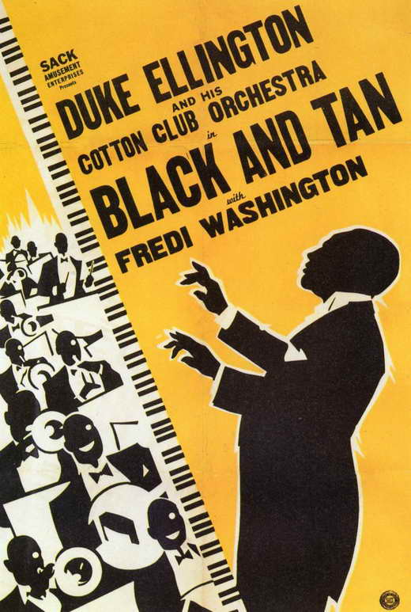

2. Does the poster depict the plot well? Why might they have used this poster to promote the film?
3. What economic concerns do African Americans have in the film?
4. Who profited from the commodification of black jazz culture?
5. How does the white announcer, and the unseen white audience, respond to dancer Fredi’s collapse? Did you expect a different reaction? How might this reflect how African American culture, and the black performers themselves, was treated by whites in society at the time?
6. What might the “Black and Tan Fantasy” (the name of the new song played in the film) be for African Americans?

Part 3: Flappers

“New social practices and ideas accompanied the rising consumer culture, and the United States experienced a radical transformation of social mores. Many women who had entered the workplace in large numbers during the First World War, and had gained the vote with the passage of the Nineteenth Amendment (1920), began to feel more confident. In turn, flappers began to challenge the conservative morality that women were expected to uphold. They engaged in petting, smoked in public, attended speakeasies, drank illicitly, and were easily identifiable by their unconventional conduct and dress. Flappers cultivated a boyish look, cut their hair short into styles like the bob and shingle, abandoned corsets, flattened their breasts by wrapping fabric tightly around their upper bodies, and sported knee-length skirts over their straight, skinny hips. Images of flappers abounded on popular magazine covers and in other areas of popular culture, and F. Scott Fitzgerald immortalized them in his popular postwar fiction.”
Citation: Great Gatsby Lesson, Humanities Out There

Zelda Fitzgerald, born Zelda Sayre, came to symbolize the new woman/flapper in 1920s United States. Her husband called her “the first American Flapper” and she was known for resisting social expectations. Even in High School in the 1910s she drank, smoked, wore revealing outfits, and spent most of her time with men. This was part of her charm, at least for Fitzgerald and the many other men who courted her. The two married and became notorious for their wild partying, having attained celebrity status after his first novel was published.

Citation: https://www.biography.com/people/zelda-fitzgerald-021617

Source 5: Lisa Hix, “Great Gatsby Still Gets Flappers Wrong,” Collectors Weekly, May 3, 2013.
Found at: https://www.collectorsweekly.com/articles/the-great-gatsby-still-gets-flappers-wrong/

But Zelda [Fitzgerald], as fearless and trail-blazing as she was, can’t even embody the flapper movement fully. For one, it was not all white women, as NYU’s Modern America reports: “For the time being, the bob and the entire Flapper wardrobe, united blacks and whites under a common hip-culture.” Secondly, the flapper’s rebellion against Victorian sexual mores didn’t start among the high-society debutantes, but in “working-class neighborhoods and radical circles in the early 1900s before it spread to middle-class youth and college campuses.”
… The flapper movement wasn’t simply a fashion trend…it was a full-blown, grassroots feminist revolution. After an 80-year campaign by suffragists, women were finally granted the right to vote…When the U.S. entered World War I in April 1917, many women entered the workforce, and when the soldiers returned in November 1918, their female counterparts were reluctant to give up their jobs.
As a result, young, unmarried women experienced far greater financial independence than they’d ever had before…Suddenly, it was possible for women to go out and enjoy freedom and rebellion in a way they never had before when they were beholden to their fathers or husbands.

1. How could you identify a flapper?
2. What types of ideas and social expectations did flappers challenge?
3. What changes are the authors arguing flappers represented?

Flapper Fashion
Source 6: Women’s Dresses, 1910s
https://digitalcollections.nypl.org/items/510d47e0-ef0c-a3d9-e040-e00a18064a99

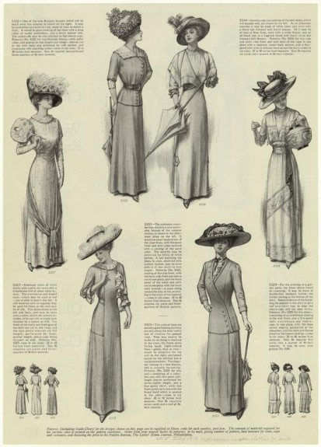

Source 7: Women’s Dresses, 1920s
Source: Sears Catalog, 1926

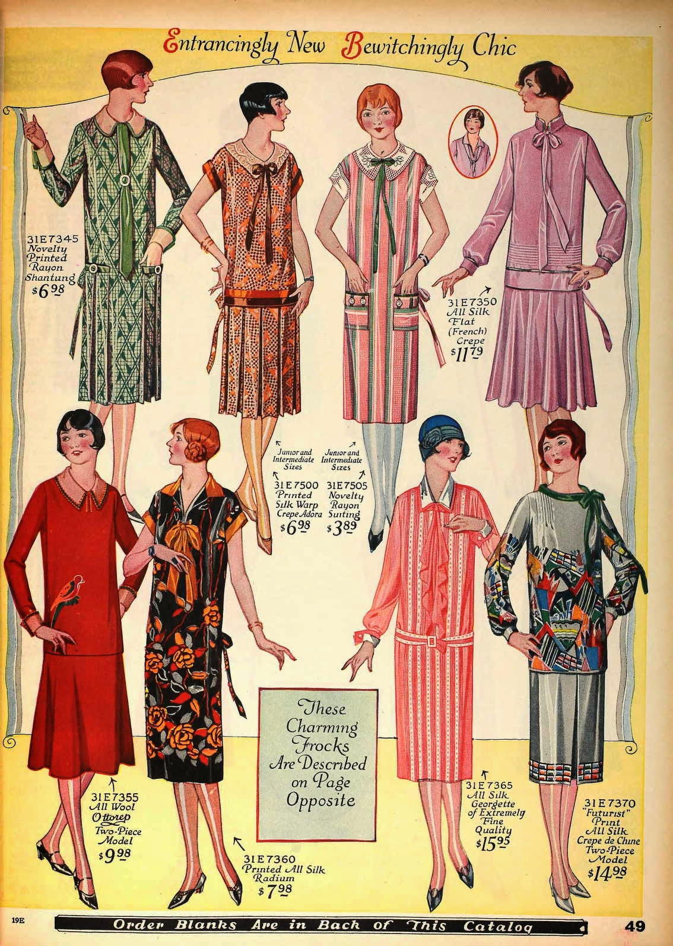

Source 7: Beach Censor, 1925
Found at: http://www.gettyimages.com/photos/smokey-buchanan-from-the-west-palm-beach-police-force-measuring-the-bathing-suit-of-betty-fringle-on-palm-beach-to-ensure-that-it-conforms-with-regulations-introduced-by-the-beach-censors

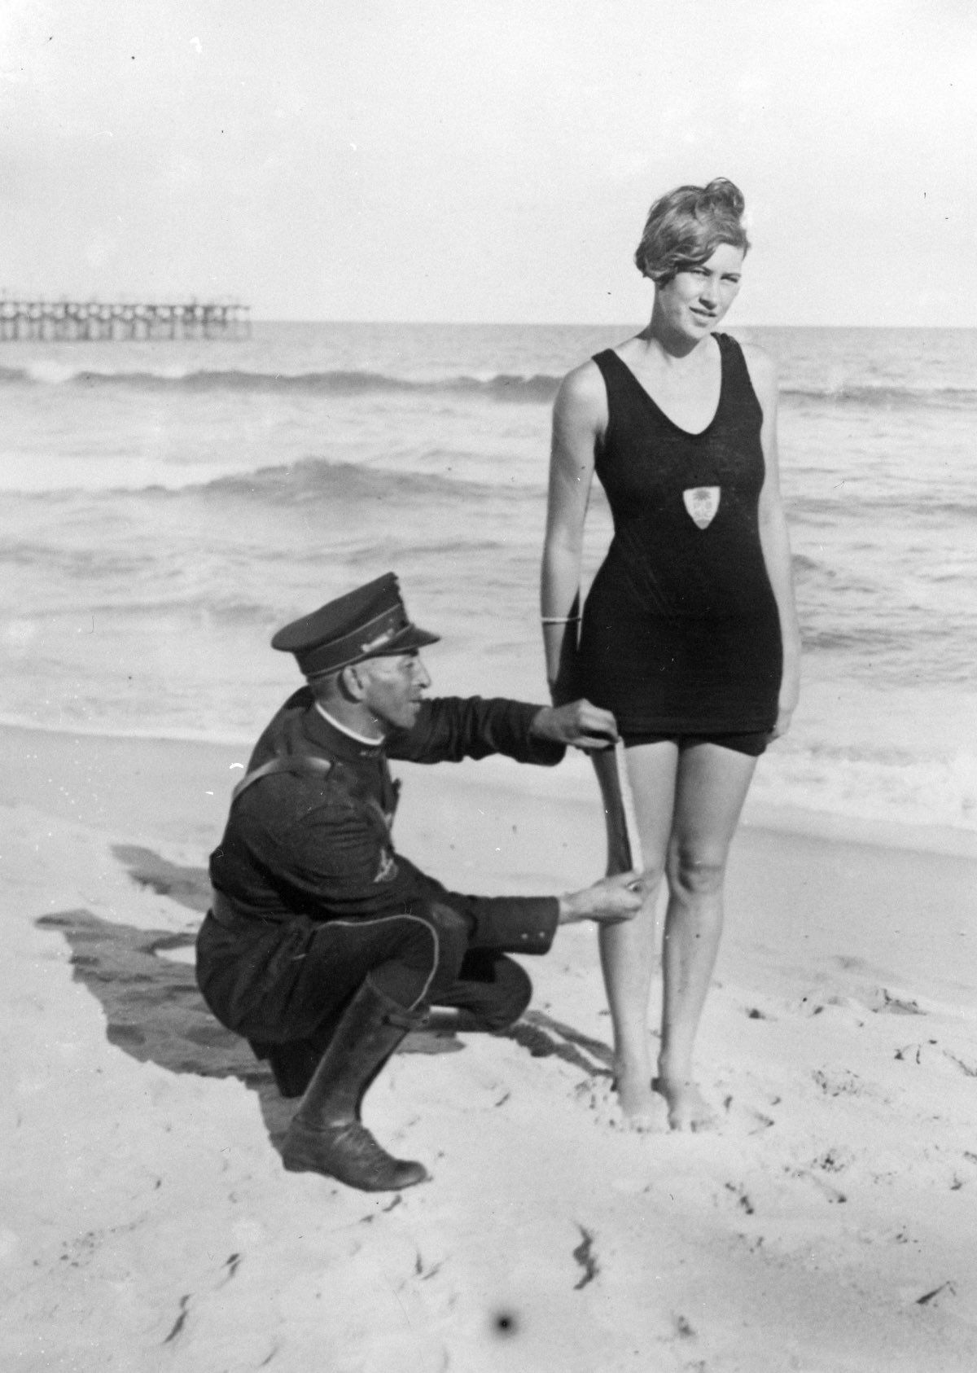

Source 8: Six Howard University students watch a football game in the 1920s.
Found at: https://www.npr.org/sections/pictureshow/2011/07/07/137651983/photo-history-the-fashions-of-women-of-color

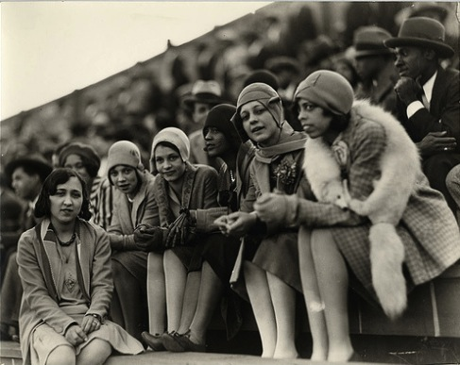

1. What shifts in fashion between the 1910s and 1920s do the first two images show?
2. Do the images from the 1920s fit with the text’s description of flappers?

“Flapper: A British term for the New Woman of the 1920s, who challenged conventional forms of behavior and dress. The name was first used metaphorically to describe women as butterflies trying out their new wings.”

Source: Humanities Out There Great Gatsby Lesson, page 10

Given the above definition of a flapper, do you think it’s a fitting name for the New Woman of the 1920s? List evidence for the position you take.

(Example: The first two images show how much more of the legs flapper dresses showed, which supports the definition because it was a newer, less conventional style.)

Part 4: LGBT Communities

New Women sometimes challenged not only gender roles but heterosexuality as well. While discrimination and judgement about LGBT individuals and communities was still prevalent, there were also public expressions of homosexual desire and relationships. One of the places this occurred was in Harlem.

“LGBT life expanded in 1920s Harlem. At drag balls, rent parties, and speakeasies, rules about acceptable gendered behavior seemed more flexible for black and white Americans than in other parts of society, and many leading figures in the ‘Renaissance’ such as [writers Langston] Hughes, [Alain] Locke, [Countee] Cullen, and [singer and song writer Gertrude “Ma”] Rainey were lesbian, gay, or bisexual.”
From the California Social Science/History Framework, Lines 432-436

1. In what places/ways did members of the LGBT community express themselves in the 1920s?

Source 9: Gertrude “Ma” Rainey’s “Prove It On Me Blues” Advertisement 1928
Found at: http://outhistory.org/exhibits/show/rainey/rainey2

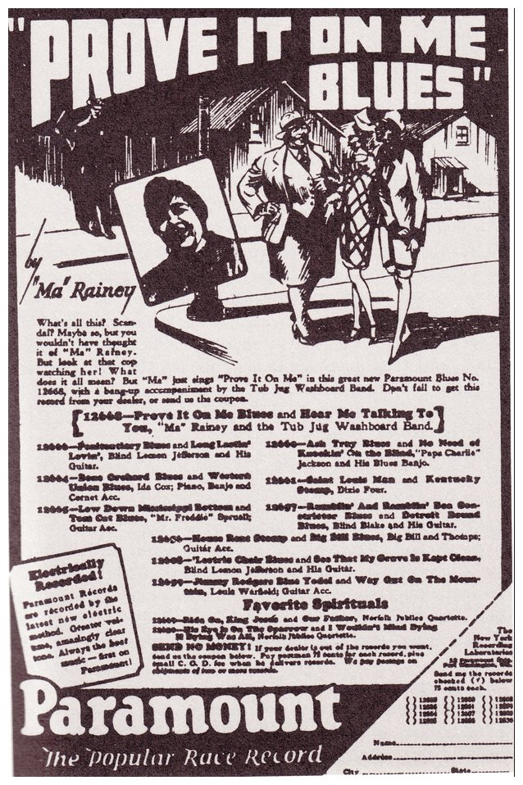

Source 10: Gertrude “Ma” Rainey photo
Found at: http://outhistory.org/exhibits/show/rainey/rainey2

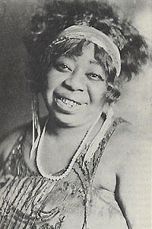

1. What does the advertisement for the song show?
2. How is Ma Rainy depicted in the photograph versus the advertisement? She’s the center figure in suit jacket, vest, and tie. Compare to flappers.

LGBT themes appeared in some music and other cultural forms in the 1920s. Review the lyrics below and listen to “Prove It On Me Blues” sung by Ma Rainey, a song which deals with lesbian relationships: https://www.youtube.com/watch?v=IlCso6BMGUo
Source 11: “Prove It On Me Blues” Lyrics
http://outhistory.org/exhibits/show/rainey/rainey2

Went out last night, had a great big fight
Everything seemed to go on wrong
I looked up, to my surprise
The gal I was with was gone.
Where she went, I don’t know
I mean to follow everywhere she goes;
Folks say I’m crooked.
I didn’t know where she took it
I want the whole world to know.
They say I do it, ain’t nobody caught me
Sure got to prove it on me;
Went out last night with a crowd of my friends,
They must’ve been women, ‘cause I don’t like no men.

It’s true I wear a collar and a tie,
Makes the wind blow all the while
Don’t you say I do it, ain’t nobody caught me
You sure got to prove it on me.

Say I do it, ain’t nobody caught me
Sure got to prove it on me.
I went out last night with a crowd of my friends,
It must’ve been women, ‘cause I don’t like no men.

Wear my clothes just like a fan
Talk to the gals just like any old man
Cause they say I do it, ain’t nobody caught me
Sure got to prove it on me.

3. What is this song about?
4. Was the LGBT community in the 1920s part of a cultural change or changes?

Final Activity #1: Debate
Student Worksheet

Were the 1920s a time of cultural change? Why or why not?

You will work as a group to answer these questions. Groups will then share their responses with the class. Each person in the group will have a chance to present.

Student 1
Come up with claim (thesis statement) based on the evidence from this lesson.

Student 2
- We have made this decision for the following reasons: (give specific evidence from the sources in the lesson)
  - Reason 1

as shown in source ______________________________________

  - Reason 2

as shown in source ______________________________________

  - Reason 3

as shown in source ______________________________________

Student 3
- Counterargument to a group who has decided the opposite of your group.

Student 4
- Final statement recapping the group’s decision and main evidence

