Under the Gupta Empire, how did monks, nuns, merchants, and scholars spread religious ideas and technological innovations throughout AfroEurasia?

From the Framework | The Gupta monarchs reunified much of the subcontinent in the third century CE, ushering in what some scholars have termed the “Classical Age” of India. As they study the question: Under the Gupta Empire, how did the environment, cultural and religious changes, and technological innovations affect the people of India? students learn that the Gupta dynasty (280-550 CE) presided over a rich period of religious, socio-economic, educational, literary, and scientific development, including the base-ten numerical system and the concept of zero. The level of interaction in all aspects of life–commercial, cultural, religious–among peoples across various regions of the Indian subcontintent was intensive and widespread during this time period, much more so than in earlier periods. This helped produce a common Indic culture that unified the people of the subcontinent. Buddhist monasteries and Hindu temples and schools spread. Sanskrit became the principal literary language in many regions of the Indian subcontinent.
Common Core State Standards | RH 6-8 1. Cite specific textual evidence to support analysis of primary and secondary sources.  RH 6-8 2. Determine the central ideas or information of a primary or secondary source; provide an accurate summary of the source distinct from prior knowledge or opinions.  RH 6-8 7. . Integrate visual information (e.g., in charts, graphs, photographs, videos, or maps) with other information in print and digital texts.  WH 6-8 2. Write informative/explanatory texts, including the narration of historical events, scientific procedures/ experiments, or technical processes.  WH 6-8 6. Use technology, including the Internet, to produce and publish writing and present the relationships between information and ideas clearly and efficiently.
Lesson Description | In this lesson, students will learn about the achievements of the Gupta Empire and how these spread throughout AfroEurasia on the Silk Road. Students work in groups to read and analyze the sources and answer the questions. The teacher can jigsaw each of the parts of the lessons—Parts 2-5—and then students can each report out on how their sections allow them to answer the lesson question:  Under the Gupta Empire, how did monks, nuns, merchants, and scholars spread religious ideas and technological innovations throughout AfroEurasia?  Also, if the teacher would like to show additional video of India, you may want to include The Story of India, clipa linked below for the introduction.  To show students a video of Faxian, or Fa Hsien, click on the link below and in the text of the Silk Road video, you will see a link for the Fa Hsien. Click on that to view the video that introduces him and the Gupta empire. Note that the video does not include the description of untouchables, Dalits, that are referred to as outcasts in the text. You may ask your students why that is and what arguments that this video tries to make about India.  http://www.pbs.org/thestoryofindia/gallery/photos/11.html#silk_road
Summative Activity Idea #1 | For a culminating activity, teachers can assign students an informational writing response. Students will develop a claim based on the evidence that they read and reviewed. The culminating activity will work if the students read each part or only one. They can also create an infographic to accompany their description using the Easely program found at:  https://www.easel.ly/  Examples of infographics:  https://www.pinterest.com/pin/295267319292702995/  https://ahrefs.com/blog/wp-content/uploads/2016/06/what-is-an-infographic-thumb.png
Summative Activity Idea #2 | In the Sites of Encounter in the Medieval World Lesson 6: Calicut, the “Indian and Southeast Asian Art” activity has students compare art and architecture from India and Southeast Asia. When students have compiled their evidence, the teacher asks them why they think Southeast Asian rulers would adopt religious ideas and artistic styles from Indian kingdoms.  pages 25-38 http://chssp.ucdavis.edu/programs/historyblueprint/soe-6-calicut.pdf

Introduction

In this lesson, we will study the Gupta Empire, a civilization in current-day India that lasted from 320-550 C. E. This period of the Gupta Empire was considered a Golden Age because it was an important time for the development of art, religion, astronomy, and math that impacted many people and societies during that time and up until our own.

As you know, some people in this period traveled very far for religious purposes or to take part in trade. We will read the writings of one traveler, Faxian, who visited Gupta India. This will begin our study of Gupta India and will allow us to begin to answer our lesson question:
Under the Gupta Empire, how did monks, nuns, merchants, and scholars spread religious ideas and technological innovations throughout AfroEurasia?

Source: Faxian A Record of Buddhist Kingdoms, 414 C.E.
Faxian was a Buddhist monk from China. Faxian was interested in learning more about his religion and visiting the places important for Buddhism. He considered India a holy land. His trip, which lasted for 15 years, allowed him to visit where the Buddha lived and to find important Buddhist writings and art. Below, he describes Gupta society as he saw it during his travels.

All south from this is named the Middle Kingdom [India]. In it the cold and heat are finely balanced, and there is neither frost nor snow. The people are numerous and happy…The king governs without beheading or other corporal punishments. Criminals are simply fined, lightly or heavily, according to the circumstances. The king’s body-guards and attendants all have salaries. Throughout the whole country the people do not kill any living creature, nor drink intoxicating liquor, nor eat onions or garlic. The only exception is that of the Chandalas, or outcasts. That is the name for those regarded as wicked men, and they live apart from others. When they enter the gate of a city or a market-place, they strike a piece of wood to make themselves known, so that men avoid them, and do not come into contact with them. In that country, they do not keep pigs and fowls, and do not sell live cattle; in the markets there are no butcher’s shops and no dealers in intoxicating drink. | corporal punishment—hurting someone physically because they did something wrong  salaries—regular payment for work, income  intoxicating liquor—alcohol  outcasts—a group of people who do work that is seen as “unclean” and so are treated as inferior by others in that society  fowls--chickens
1. What does Faxian say about the rulers of Gupta India?

2. What does Faxian record about the people of Gupta India?

3. Was Faxian’s description of Gupta India positive or negative? Use specific answers from the evidence to support your claim.

Part 1: Gupta India and the AfroEurasian World

The AfroEurasian world was connected by the Silk Road, which stretched over land and water to connect the people of the medieval world. Examine the map of the Silk Road in 400 C.E. and answer the questions below.
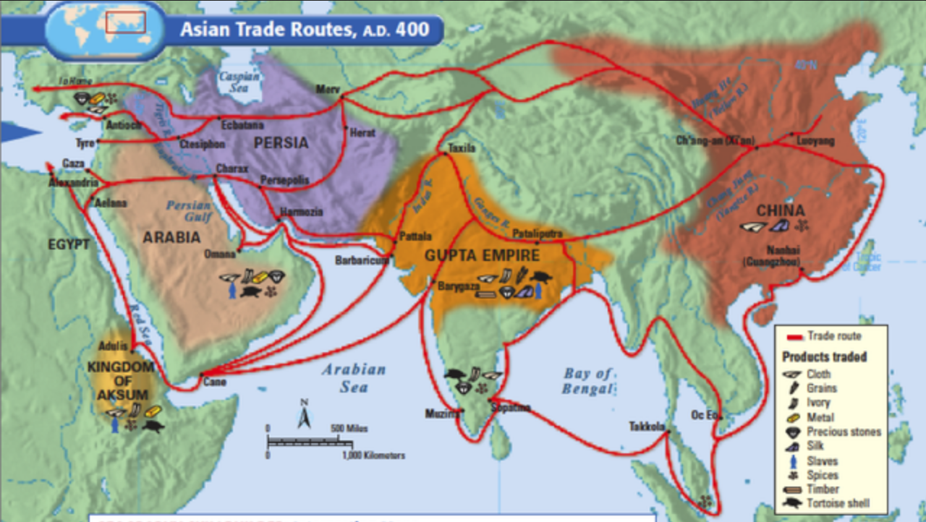
- Where was the Gupta Empire located on the Silk Road?
- What items did the Gupta Empire trade?
- With what other civilizations did the Gupta Empire trade?

The Gupta Empire was led by a dynasty of kings who united their kingdoms and brought wealth to the empire. The most notable of these Gupta kings were Samudragupta (335-375) and Chandragupta II and (375-415). These rulers held power over their kingdom by creating networks between local rulers who owed taxes or tribute to the Guptas. One way that historians understand the strength of their power is by studying the coins created during their rule. These gold and silver coins show that the Gupta Empire was wealthy and interested in trade. The coins depict, or show King Samudragupta as he wanted to be remembered holding the symbol of power, a scepter or staff, and on the other side there is a Hindu goddess. Even people who had never seen the king, could understand his power and wealth when they used these coins.
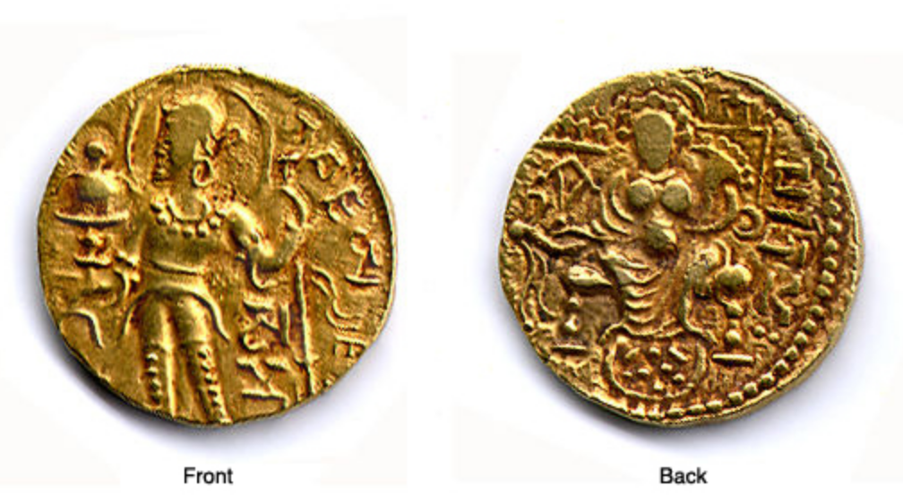
Image of coins from University of Washington’s Silk Road online exhibition:
https://depts.washington.edu/silkroad/exhibit/guptas/guptas.html

The Guptas reigned over the Golden Age of India because they promoted the spread of ideas. These rulers did this through patronage. Patronage is when someone who has wealth and power gives money to support individuals who have artistic or intellectual skills. For example, the Gupta kings were interested in poetry so they invited important writers to their court and provided them with the things, such as a place to live and study, food, and money, so they could produce art. The Guptas were patrons to artists, scholars of mathematics and astronomy, Hindu priests, and Buddhist monks and nuns. In the sections below, you will find out more about the types of people and places that the Gupta kings patronized and that made the Gupta Empire the Golden Age of India.

Part 2: The Origin of Zero
Read and analyze the source below to answer the guiding questions to consider our guiding question:
Under the Gupta Empire, how did monks, nuns, merchants, and scholars spread religious ideas and technological innovations throughout AfroEurasia?

Source: Source: Sarah Gibbens, “Ancient Text Reveals New Clues to the Origin of Zero,” National Geographic Magazine, September 16, 2017.

To learn about how the idea of zero was used and discovered read the article at:
https://news.nationalgeographic.com/2017/09/origin-zero-bakhshali-manuscript-video-spd/

Questions
1.Who invented the concept of zero?

2. Why was this important?

3. How did this idea spread throughout AfroEurasia?
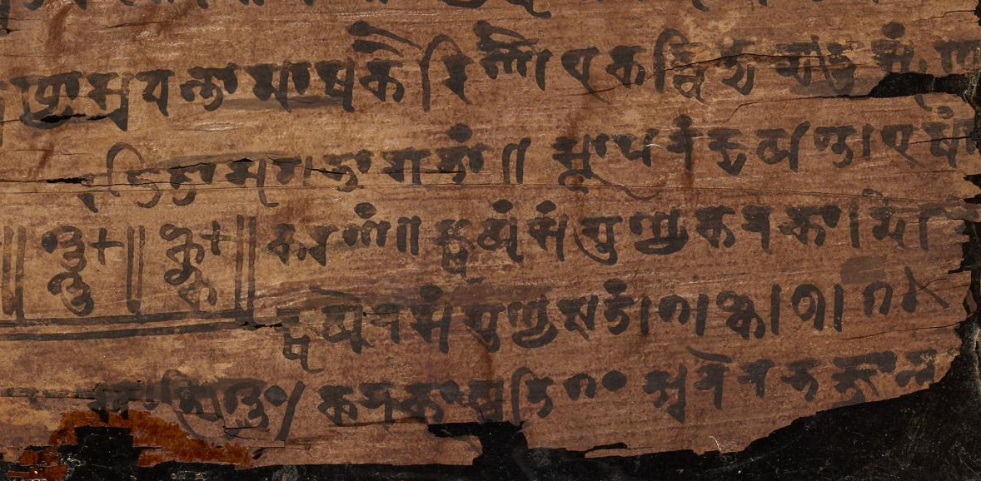
In this close-up image, you can see the use of a dot as a placeholder in the bottom line. This dot evolved into the use of zero as a number in its own right.

Part 3: Spread of Buddhism on the Silk Road
Buddhism emerged in India and spread across Asia through the trade routes, such as the Silk Road. Buddhist merchants built temples and other religious buildings on the trade routes, often in caves. The monks and nuns who staffed these religious sites spread the religion by preaching and teaching the merchants and travelers. According to the Asia Society, “Buddhism's essential message — that earthly life is an endless round of rebirth, suffering and death, but that the cycle of suffering can be ended with rebirth in paradise through Buddhist faith and practice — had wide appeal, and its universalism enabled it to cross boundaries of space, language, and ethnicity with ease.” View the map and answer the questions below about the spread of Buddhism during the Gupta Empire.
Quote from Asia Society article “Belief Systems on the Silk Road” http://asiasociety.org/education/belief-systems-along-silk-road

Read and analyze the source below to answer the guiding questions to consider our guiding question:
Under the Gupta Empire, how did monks, nuns, merchants, and scholars spread religious ideas and technological innovations throughout AfroEurasia?
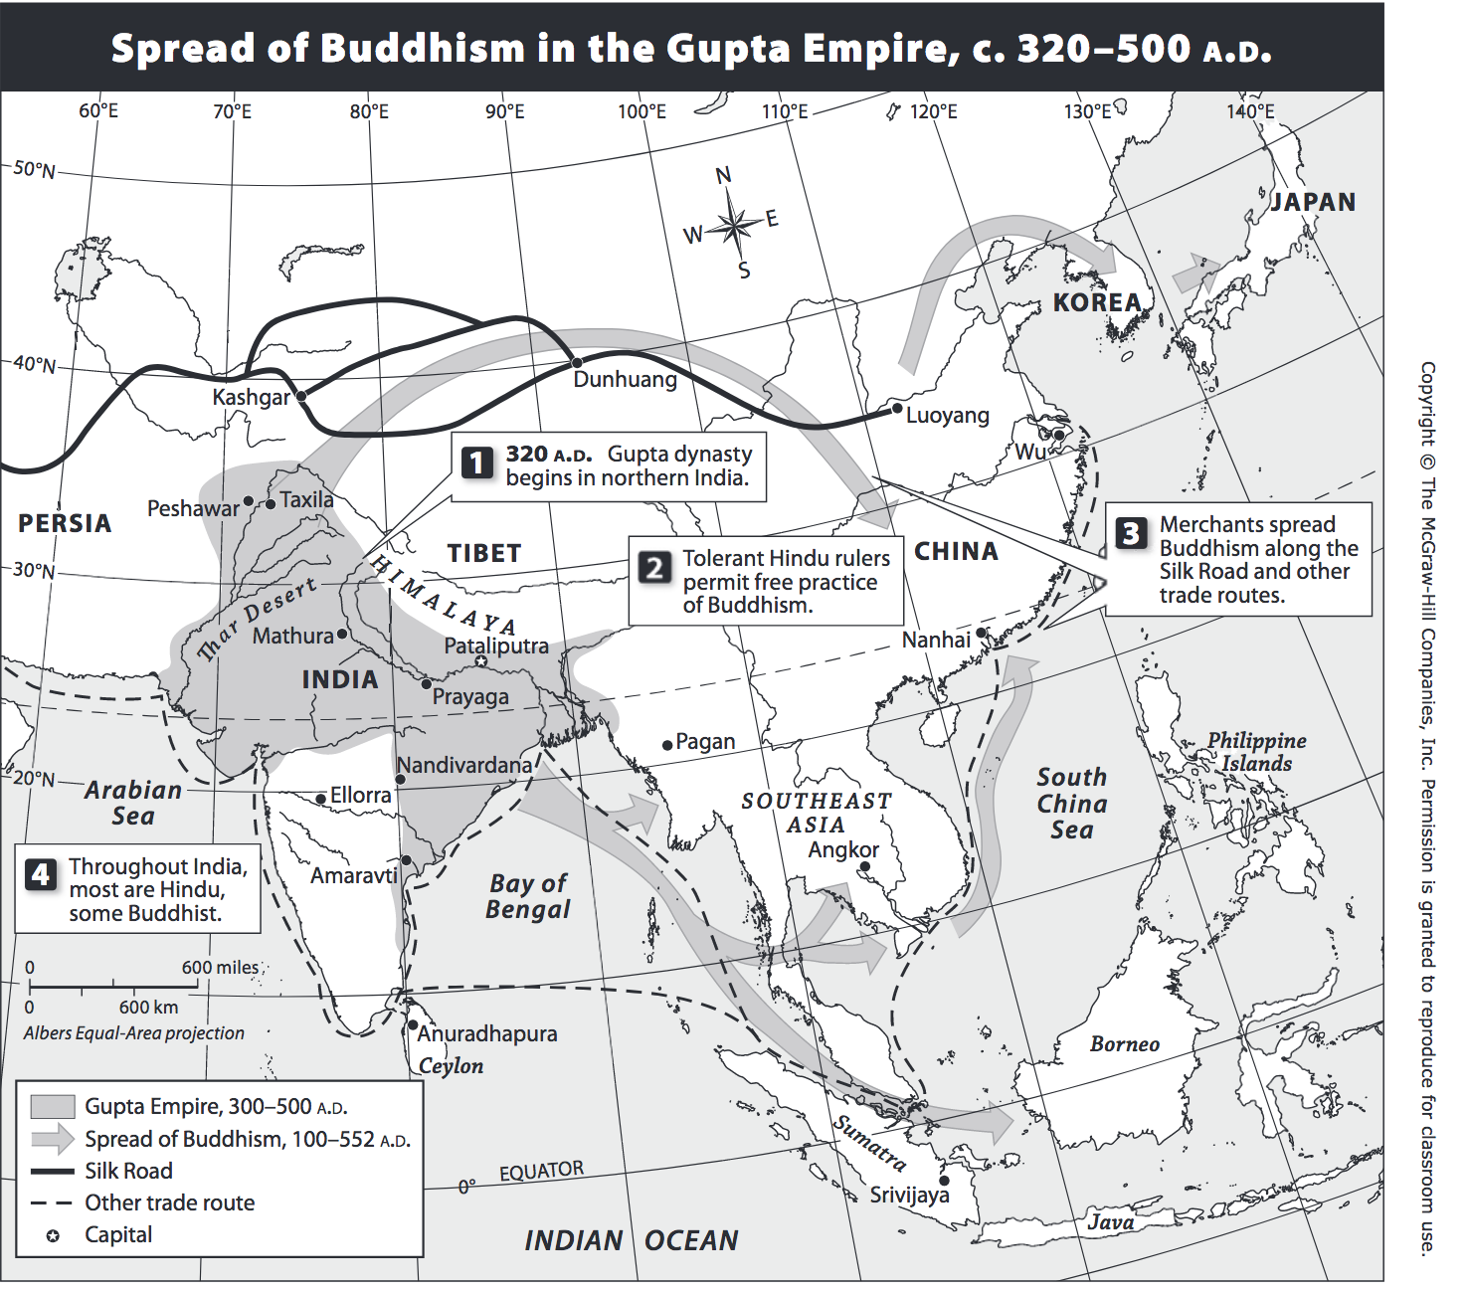
- Where did Buddhism start?

- Where did Buddhism spread to during the Gupta Empire?

- Why does Buddhism spread so far during this period?

Part 4: Literature of the Gupta Empire
The Gupta kings valued literature and often surrounded themselves with scholars and writers. One of the most famous of this period was Kalidasa. He was considered one of the Nine Gems, or nine extraordinary people of the king’s court. He wrote poetry and plays in Sanskrit.

Read analyze the poem below to answer the guiding questions to consider our guiding question:
Under the Gupta Empire, how did monks, nuns, merchants, and scholars spread religious ideas and technological innovations throughout AfroEurasia?

Source: Kalidasa, “The Rains”
Found at http://www.gutenberg.org/files/16659/16659-h/16659-h.htm#Page_211

Source | Vocabulary | Questions
The rain advances like a king  In awful majesty;  Hear, dearest, how his thunders ring  Like royal drums, and see  His lighting-banners wave; a cloud  For elephant he rides,  And finds his welcome from the crowd  Of lovers and brides. | advances—moves forward  majesty--royal power | 1. Circle all the words that Kalidasa uses to describe rain.
The clouds, a mighty army, march  With drumlike thundering  And stretch upon the rainbow’s arch  The lighting’s flashing string;  The cruel arrows of the rain  Smite then who love, apart  From whom they love, with stinging pain,  And pierce them to the heart. | Smite--hit | 2. What feeling do you get from this poem?
3. How does he describe power?

4. What can this tell us about how Kalidasa imagines the role of the king in Gupta society?

Part 5: Astronomy during the Gupta Empire
The study of the stars, space, and seasons were all important to Indians for use in religious practices of the Hindus. In addition because of the importance of oceanic trade, scholars needed to know how to navigate using the tides and the stars. For these reasons, astronomy was important in this period.
View the video from The Story of India and answer questions below:
Under the Gupta Empire, how did monks, nuns, merchants, and scholars spread religious ideas and technological innovations throughout AfroEurasia?

Source: http://www.pbs.org/thestoryofindia/gallery/photos/16.html#astronomy

1. What did Gupta scientists discover, or prove?

2. Why do the scientist and narrator, Michael Wood, argue that Aryabhata was important?

3. How did this knowledge impact world history?

Final Project
Based on the information you learned about the emergence and spread of ideas and technological innovations during the Gupta Empire you will now answer the lesson question:
Under the Gupta Empire, how did monks, nuns, merchants, and scholars spread religious ideas and technological innovations throughout AfroEurasia?

You will answer this question by creating claim to answer the question and use evidence from the sources to support this claim.
First, make a list of all of the ideas and technological innovations you learned about in the lesson:
Idea or innovation example | Evidence/Source
1.

2.

3.

Then, consider how these ideas spread throughout AfroEurasia and describe this below.
These ideas were supported in the Gupta Empire by _______________________

These ideas spread across AfroEurasia by _______________________________

Use this information to develop a paragraph explaining your answer to the lesson question:
Under the Gupta Empire, how did monks, nuns, merchants, and scholars spread religious ideas and technological innovations throughout AfroEurasia?

Claim—Explain how ideas and innovations spread from the Gupta Empire.

Example 1—give evidence from the source to support your main idea.

Example 2—give evidence from the source to support your main idea.

Example 3—give evidence from the source to support your main idea.

Closing—Explain why this is important for world history.

