What was it like growing up in the Civil War?

Content Standards | 8.10 Students analyze the multiple causes, key events, and complex consequences of the Civil War.  1. Compare the conflicting interpretations of state and federal authority as emphasized in the speeches and writings of statesmen such as Daniel Webster and John C. Calhoun.  2. Trace the boundaries constituting the North and the South…  5. Study the views and lives of leaders (e.g., Ulysses S. Grant, Jefferson Davis, Robert E. Lee) and soldiers on both sides of the war, including those of black soldiers and regiments.  6. Describe critical developments and events in the war, including the major battles…  7. Explain how the war affected combatants, civilians, the physical environment, and future warfare.
Common Core State Standards | RH 6-8 1. Cite specific textual evidence to support analysis of primary and secondary sources.  RH 6-8 2. Determine the central ideas or information of a primary or secondary source; provide an accurate summary of the source distinct from prior knowledge or opinions.  RH 6-8 4. Determine the meaning of words and phrases as they are used in a text, including vocabulary specific to domains related  history/social studies.  RH 6-8 7. Integrate and evaluate multiple sources of information  presented in diverse formats and media (e.g. visually, quantitatively, as well as in words) in order to address a question or solve a problem.  WH6-8 2. Write informative/explanatory texts, including the  narration of historical events, scientific procedures/experiments, or technical processes.  WH46-8. Produce clear and coherent writing in which the  development and organization, and style are appropriate to the task, purpose, and audience.

Key
- Young girls working in the mills changed bobbins on the spinning-frames and also spinning according to the text.
- The mill did not allow the workers to bring books into the mill according to their printed regulations.
- Larcom at first went to work with a light heart and because it was new, the work seemed easy. She was learning and thought that the mill was better than school.
- After time went on, Larcom's feelings about working in the mill did change. She felt confined and would try to avoid the unending noise in the mill by leaning out of a window. She also surrounded the window-seat with newspaper clippings of poetry pasted all around.

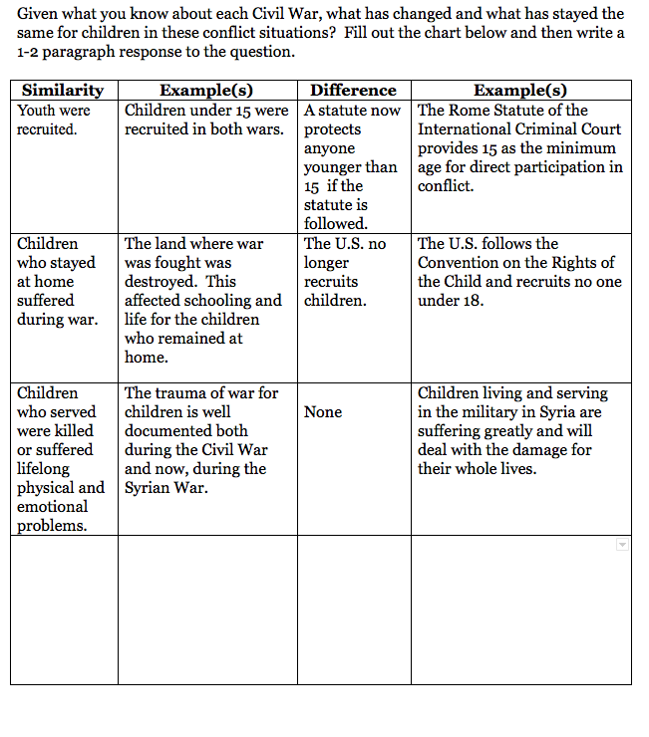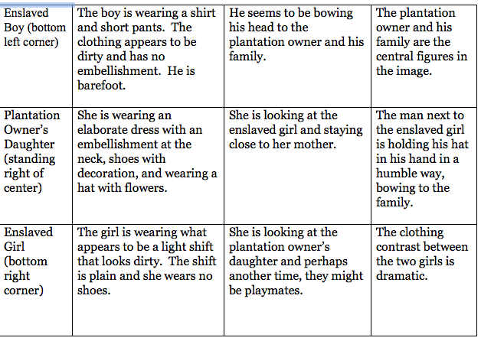
- The differences are striking between the two girls. It is clear that the plantation owner's daughter is well fed and clothed. Her clothing is elaborate and quite fancy for daytime. She would not want for anything including luxuries. The slave girl, on the other hand, is wearing a very light shift with no decoration. It barely covers her to her knees. Her appearance suggests a child who might not have enough to eat or blankets to keep her warm at night.
- The painting shows two female children meeting. The quote talks about the bonds that often formed between slaves and owner's children. It is evident that the two girls are looking at each other, so that reinforces the idea that they might be playmates at another time. While they might be playmates, the image shows the vast difference in their positions in life.
- Enslaved children began work as early as two or three. Older children eight to twelve began field work. By adolescence most were sold or hired to neighboring plantations.
- The youngest slave children were given simple tasks like watching younger children, picking up trash, finding kindling, bringing water, shooing birds off of crops, weeding, or removing grubs from plants. Older children eight to twelve began field work where they were often treated harshly. In this same time period, children in the South and North had very different lives. The well-to-do children had lavish clothing, education, rich food and leisure time to learn languages, read, write and play music. The middle class child did chores to help at home or on the farm, but usually attended school. The poorer class often sent their children to work rather than to school to help the family.
- Slave children made their lives more bearable by playing simple games, interacting with their community and practicing their religion. Some were even able to get some education in forbidden schools.
- The theme is similar to the earlier passage. The General is again struck by the youth of the drummer boys and in fact, all of the troops. In this section, the General elaborates on his worry about the inexperience and youth of his men and the soldiers on the other side as well.
- The General has found Joby crying and he stops to talk to him. The General reminds Joby of a father the way he smells. The General shares that he was crying last night too. He talks about how both sides are unprepared for the fighting ahead and that it may be a long war.
- The General feels that both sides should just turn around and train for four more months to be ready. The way things stand now, he feels none of the men are prepared on either side, but they all think they are going to be heroes and live forever. This is what brought the General to tears.
- The men who enlisted so eagerly and thought they would never die learned something different on the battlefield watching the innocent drummer boy and others die. The reality of war forced them to face hard facts and mature in their thinking.
- The song tells us that children played an important role on the battlefield. they were not just on the sidelines out of danger, but in fact, were in the middle of the action.
- As he lay dying, the drummer bay calls on his Mother in heaven and asks to be taken home to her. He says that he loved his country and his God and tried his best to serve them both. The song ends with mention of the many homes and hearts left empty by the loss of sons.
- In the photo, William Black is shown wearing his jacket draped around his shoulders. His left arm is in a sling shattered by an exploding shell. His expression is somber and he is not looking at the photographer.
- Younger boys usually were employed as drummer boys or other musicians, orderlies and also soldiers.
- While William Black and others like him may have recovered to some extent from the physical wounds of battle, they also carried with them the emotional scars as well. The horrors of war do not go away once the soldier leaves the battlefield. The young are even more vulnerable to this horror.
- Griffith Thomas is portrayed in his uniform with his pack and bedroll in place. He is standing tall and looks prepared for the battles ahead. He has a look of resolution on his face. The background is a rather elaborate one, perhaps in a photography studio.
- The image evokes a sense of preparedness and bravery. Griffith's expression is serious, but he looks very young. In comparison to the photo of William, both young men are very solemn, but William's has a sadness about it while Griffith's image evokes a feeling of preparedness and determination.
- It is surprising that drummer boys were targeted on the field. At first, I thought they would be on the sidelines, but once I learned that they were sending battle orders down the line, it became evident that they would be in the thick of battle and would be targets.
- Susie King Taylor is shown in her full nursing uniform with her hands folded. She is looking forward, although not directly at the camera. There is a pastoral background and Susie is sited in a serene pose.
- Susie's image is more romanticized and the feeling evoked is one of preparedness, but in a gentler and calmer way.
- The war definitely impacted the girls who witnessed the violence and its impact. Many girls were used to nurse the wounded or saw the horrors of the war. The impact might have not been as dramatic for the girls, but especially in the South, the wounded were close as many battles were fought on southern soil.
- Many aspects of life changed for children on the home front. Schooling was often altered and jobs that children were responsible for increased. Many children left school to carry extra burdens for their family.
- Children did jobs once done by their fathers or brothers. They worked on the family farm, helped in the family business and did domestic chores as well.
- Children expressed patriotism through their actions filling in for missing family members. They also sang patriotic songs and played patriotic games mirroring the actual war.
- Schools were an important place for learning about patriotism. They taught love and support for the Union or the Confederacy and used song and verse to enforce the patriotic message.
- During the war, children enjoyed entertainment such as reading and public events meant to glorify the war effort. There were plays, concerts and parades as well as photo displays, magic lantern shows, traveling panorama shows, and in the North Sanitary Fairs.
- These entertainments all had a patriotic theme. The Sanitary Fairs collected money for the war effort.
- This form of entertainment could have influenced children to want to join the war effort or actually go to battle.
- It’s mostly women and children in the painting. They are moving from the dark (left side) of the painting into the light (right side) of the painting.
- Answers will vary. Sample response: African Americans chose to take a risk by running away from slavery and toward freedom, a choice that became more common as Union lines came closer. This was a risk. Their owners or other Southerners might catch and punish them. They might not be accepted by the Union. But it was worth it for the chance to gain their freedom.
Final Activity: Answers will vary.

What was it like growing up in the Civil War?

Part 1: Youth Before the War
Starting in the mid-1700s many people in the United States started to think about childhood in new ways. Before that, Puritans thought that babies had bad and wicked ideas from the moment they were born. Leading up to the Civil War, “childhood came to be associated with a set of positive meanings and attributes, notably innocence, freedom, creativity, emotion, spontaneity…[Many] did not see childhood as a state to be hurried through in order to achieve adulthood” (https://www.bl.uk/romantics-and-victorians/articles/perceptions-of-childhood).
Thus youth became defined as a distinct stage of life, a time for innocent enjoyment, rather than the Puritan understanding that children needed harsh discipline to force them to mature and act like adults.

Discussion Question
Are these definitions of childhood similar to those we use today?

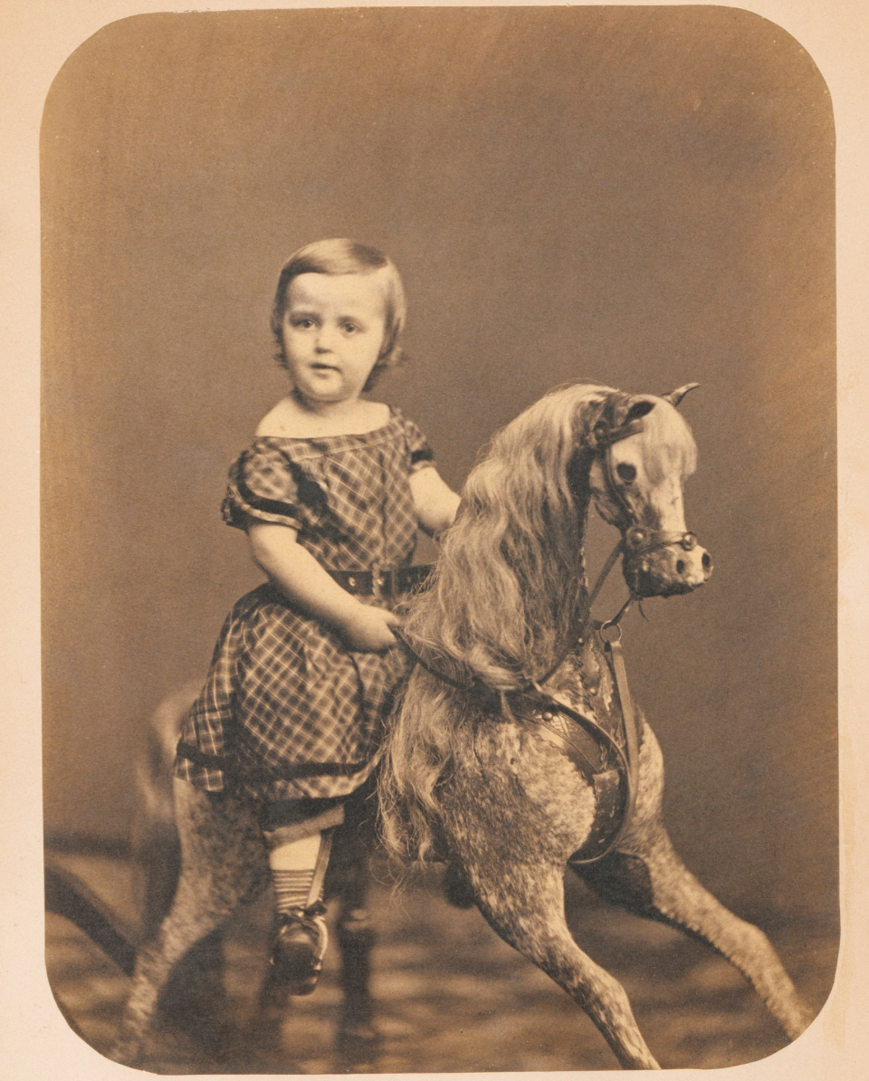
Girl on Hobby Horse, 1865
https://learninglab.si.edu/resources/view/202416#

Northern Childhood
As the 19th century continued, the North became more and more industrialized and urbanized, unlike the rural South. Wealthy children had long had more leisure time, access to more toys and games, and received better education than their poorer peers. Children from lower-class families often had to work instead of going to school. “Although [poorer] children had been servants and apprentices throughout most of human history, child labor reached new extremes during the Industrial Revolution. Children often worked long hours in dangerous factory conditions for very little money” (http://www.history.com/topics/child-labor).
Source 1: Lucy Larcom, A New England Childhood, 1889
Lucy Larcom, who started working in the textile mills of Lowell, Massachusetts at age 11, describes her experiences:
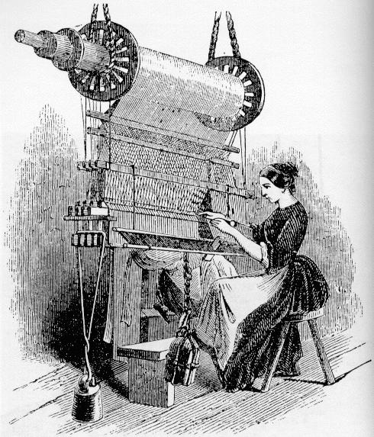
Girl Weaving in a Mill
http://csivc.csi.cuny.edu/americanstudies/files/lavender/graphics/weaving.jpg

“So I went to my first day’s work in the mill with a light heart. The novelty of it made it seem easy…just to change the bobbins on the spinning-frames…I liked it better than going to school…At this time I had learned to do a spinner’s work…The [mill’s] printed regulations forbid us to bring books into the mill, so I made my window-seat into a small library of poetry, pasting its side all over with newspaper clippings…We did not forget that we were working-girls, wearing course aprons suitable to our work, and that there was some danger of our becoming drudges. I know that sometimes the confinement of the mill became wearisome to me. In the sweet June weather I would lean far out of the window, and try not to hear the unceasing clash of sound inside” | Spinning-frames-a machine for twisting, and winding yarn  Forbid-to prohibit (something); make a rule or law against:  Drudges-a person who does menial, distasteful, dull, or hard work.  Unceasing-not stopping; continuous
Found at: https://www.learner.org/workshops/primarysources/lowell/docs/larcom.html

Summarize the main ideas from the text

- What type of work did girls do in the mills?

- How did the mill try to restrict the freedom of the workers?

- How did Larcom feel about working in the mills?

Draw Inferences: Make a claim based on what you know from the text

- Did her feelings about the mill change over time? Why or why not? Give evidence from the source to support the claim.

Southern Childhood

“At the top of white society, in terms of both prestige and power, were members of the upper class, typically families that owned large numbers of slaves...They often had leisure time to engage in activities unique to the well-to-do: reading and writing books, playing musical instruments, and learning foreign languages…  [Middle-class children, on the other hand, did] chores to help keep the farm going. By the 1850s, yeoman children generally attended school, but most of them went only four or five months a year, when farm chores and activities at home slowed down…  Poor white children were often sent to work outside the home [rather than to school] in order to help their families make ends meet.”  https://www.ncpedia.org/history/1776-1860/antebellum-whites | Prestige-respect and admiration felt for someone or something  Leisure-use of free time for enjoyment.  Yeoman-farmers who were also abolitionists  Make ends meet-earn enough money to live without getting into debt

Source 2: Black and White Children on a Plantation

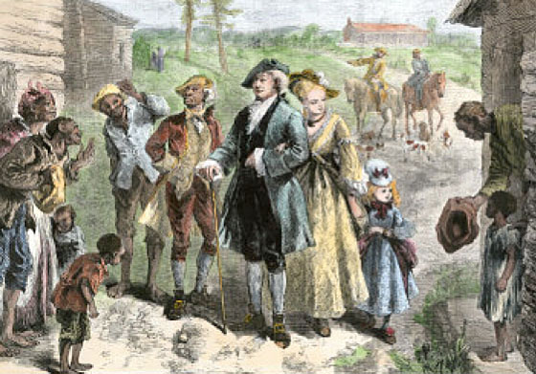

Plantation Owner’s Family Visiting the Slave Quarters
Found at: http://georgiainfo.galileo.usg.edu/gastudiesimages/Slavery%20in%20Colonial%20America%201.htm

Source 3: Africans In America, “Conditions of Antebellum Slavery”
“Black and white children were especially in a position to form bonds with each other. In most situations, young children of both races played together on farms and plantations… Because they were so young, they would have no understanding of the system they were born into. But as they grew older they would learn to adjust to it in whatever ways they could.”
Found at: http://www.pbs.org/wgbh/aia/part4/4p2956.html

Summarize the main ideas from the image

- Describe the children in the painting. What are they wearing and doing?

Child | Wearing | Doing | Other Details?
Enslaved Boy (bottom left corner)

Plantation Owner’s Daughter (standing right of center)
Enslaved Girl (bottom right corner)

Draw Inferences: Make a claim based on what you know from the image

- What do the differences between the white girl and slave children show about their lives? Give evidence to support your claim.

- How does the painting compare and contrast with the quote?

Image from Anti-Slavery Almanac, 1840
Enslaved children experienced very different childhoods than white children in the South. Slave owners did not usually think of them as having childhood traits of “innocence, freedom, creativity, emotion, spontaneity.”

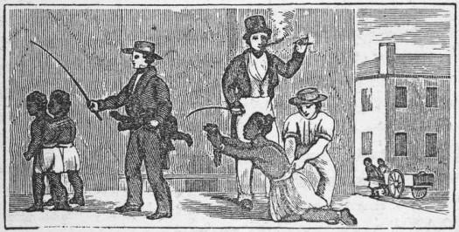
Slave Children Separated from their Mother
Found at: http://kuow.org/post/slave-mothers-love-56-carefully-stitched-words

Source 4: Steven Minz, “Childhood and Transatlantic Slavery”
“Children as young as two or three might work at domestic chores, including childcare or collecting trash and kindling, toting water, scaring away birds, weeding, or plucking grubs off of plants. Generally, in the U.S. South, children entered field work between the ages of eight and 12. Slave children received harsh punishments, not dissimilar from those meted out to adults. They might be whipped or even required to swallow worms they failed to pick off of cotton or tobacco plants. During adolescence, a majority of slave youth were sold or hired away…Despite slavery's hardships and brutalities, many slave children were able to experience something that we would consider a childhood. Children played with home-made toys, including improvised marbles and hobby horses. Even where education was forbidden or strongly discouraged, a surprising proportion—perhaps between five and ten percent—learned how to read and write. Through their activities, games, religion, and relations with kin and other members of the slave community, children were able to make life bearable.”  Found at: http://chnm.gmu.edu/cyh/case-studies/57 | Domestic-running of a home or to family relations  Meted-to deliver a punishment  Improvised-done or made using whatever is available  Bearable-able to endure or tolerate
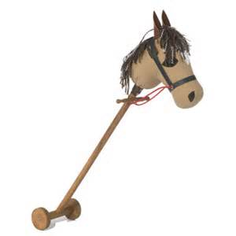
19th Century Hobby Horse
Found at: https://victorianchildren.org/victorian-toys-and-victorian-games/

Summarize the main ideas from the text

- Describe the childhoods of enslaved children.

- What type of activities and work did slave children do? How does this compare to the activities and work of white children in the North and South?

- How did slave children make their lives more bearable?

Part 2: Young People on the Battlefield

“At the start of the Civil War, the legal age to enlist and become a soldier was 17. As the war continued with high casualties for both the North and the South, recruiters often overlooked the age of…any boy willing to enlist. These boys often had dreams of great adventures and fighting the enemy when in reality, those who enlisted would usually find themselves in a supportive role. Many served units as messengers, [drummer boys,] helped collect and bury the dead and attend to wounded soldiers. Responsibilities of a drummer boy reached beyond marching troops into battle, their drum calls would communicate with soldiers in the field.”
Found at: http://www.eiu.edu/eiutps/childrenincivilwar.pdf

Source 5: “Drummer Boy of Shiloh” by Ray Bradbury
“Why, it’s the drummer boy, isn’t it?”  The boy nodded, not knowing if his nod was seen. “Sir, is that you?”  “I assume it is.” The man’s knees cracked as he bent still closer.  He smelled as all fathers should smell, of salt sweat, ginger tobacco, horse and boot leather, and the earth he walked upon. He had many eyes. No, not eyes, brass buttons that watched the boy.  He could only be, and was, the General.  “What’s your name, boy?” he asked.  “Joby,” whispered the boy, starting to sit up.  “All right, Joby, don’t stir.” A hand pressed his chest gently, and the boy relaxed. “How long have you been with us, Joby?”  “Three weeks, sir.”  “Run off from home or joined legitimately, boy?”  Silence.  “Damn-fool question,” said the General. “Do you shave yet, boy? Even more of a damn-fool. There’s your cheek, fell right off the tree overhead. And the others here not much older. Raw, raw, damn raw, the lot of you. You ready for tomorrow or the next day, Joby?”  “I think so, sir.”  “You want to cry some more, go on ahead. I did the same last night.”  “You, sir?”  “God’s truth. Thinking of everything ahead. Both sides figuring the other side will just give up, and soon, and the war will be over in a few weeks, and us all home. Well, that’s not how it’s going to be. And maybe that’s why I cried.”  “It's going to be a crazy time,” said the General. “Counting both sides, there’s a hundred thousand men, give or take a few thousand out there tonight, not one as can spit a sparrow off a tree, or knows a horse clod from a minnieball. Stand up, bare the breast, ask to be a target, thank them and sit down, that’s us, that’s them. We should turn tail and train four months, they should do the same. But here we are, taken with spring fever and thinking it blood lust, taking our sulfur with cannons instead of molasses as it should be, going to be a hero, going to live forever. And I can see all of them over there nodding agreement, save the other way around.”  page 169-170 | legitimately-when you do something legitimately, you do it lawfully  raw-new to an activity or job and therefore lacking experience or skill  taking our sulfur with cannons instead of molasses-sulfur was used to fire cannons but also in medicine. Molasses is a syrup, used at the time to mask the unpleasant taste of medicines.
Summarize the main ideas from the text(s)

- How does this section from the fictional Drummer Boy compare to the introduction to Part 2: Young People on the Battlefield?

- In your own words, describe what is happening in this part of the story.

- What does the General think of the youth who are fighting on both sides?

Draw Inferences: Make a claim based on what you know from the text

- Based on this section and your own ideas, how do you think war might force young people to mature quickly?

Source 6: Drummer Boy of Shiloh Song, 1863
Look at the lyrics below and listen to this song from the Civil War:
https://www.youtube.com/watch?v=qRdmiWfYIKU

On Shiloh's dark and bloody ground,  The dead and wounded lay;  Amongst them was a drummer boy,  Who beat the drum that day.  A wounded soldier help and him up--  His drum was by his side;  He clasp'd his hands, then he rais'd his eyes,  And prayed before he died.  He clasp'd his hands, then he rais'd his eyes,  And prayed before he died.  Look down upon the battle field,  Oh, Thou our Heavenly Friend!  Have mercy on our sinful souls!"  The soldier's cried--"Amen."  For gathered 'round a little group,  Each brave men knelt and cried;  They list'ned to the drummer boy,  Who prayed before he died,  They list'ned to the drummer boy,  Who prayed before he died.  "Oh, Mother," said the dying boy,  "Look down from heaven on me,  Receive me to thy fond embrace--  Oh, take me home to thee.  I've loved my country as my God;  To serve them both I've tried,"  He smiled, shook hands--death seized the boy  Who prayed before he died.  He smiled, shook hands--death seized the boy  Who prayed before he died.  Each soldier wept, then, like a child--  Stout hearts were they, and brave;  The flag his winding--sheet--God's Book  The key unto his grave.  They wrote upon a simple board  These words; This is a guide  To those who'd mourn the drummer boy  Who prayed before he died.  To those who'd mourn the drummer boy  Who prayed before he died.  Ye angels 'round the Throne of Grace,  Look down upon the braves,  Who fought and died on Shiloh's plain,  Now slumb'ring in their graves!  How many homes made desolate--  How many hearts have sighed--  How many, like that drummer boy,  Who prayed before they died!  How many, like that drummer boy,  Who prayed before they died! | Amongst-To be among other people  Thou-used to indicate the person or thing addressed):  Thy-another word for the  Fond-loving; affectionate:  Seized-to take possession or control of  Stout-bold, brave, feerless  Mourn-to feel or express sorrow or grief.  Ye-another word for you  Slumb’ring-to sleep, to be in a state of inactivity,

Summarize the main ideas from the song

- What does the song tell us about the role of children in battle?

- Are there any references to the home front, to those left behind while others went to the battlefield?

Biographies and Photo Analysis

Source 7: William Black

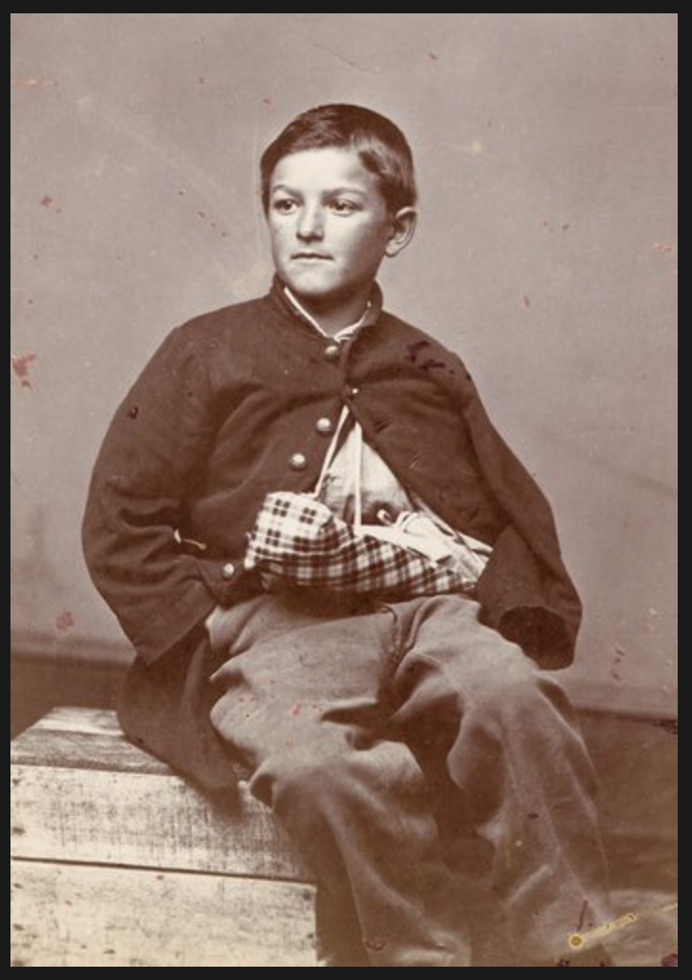

“Tens of thousands of boys under the age of 18 witnessed the brutality of the Civil War firsthand while serving as musicians, messengers, orderlies and even soldiers. Some became prisoners of war; many were killed in battle or died of disease. Those that survived—like William Black, who was 12 years old when an exploding shell shattered his arm—carried the physical and emotional scars with them throughout their lives”.
Found at: http://www.nytimes.com/slideshow/2011/10/05/opinion/disunion-children.html

Summarize the main ideas

- How is William Black portrayed in this picture? Describe how he’s sitting, his clothes, his injury, and anything else you notice in the photograph.

- Based on the text, list the type of jobs younger boys usually did.

Draw Inferences: Make a claim based on what you know

- What might the text mean by emotional scars?

Source 8: Griffith Thomas

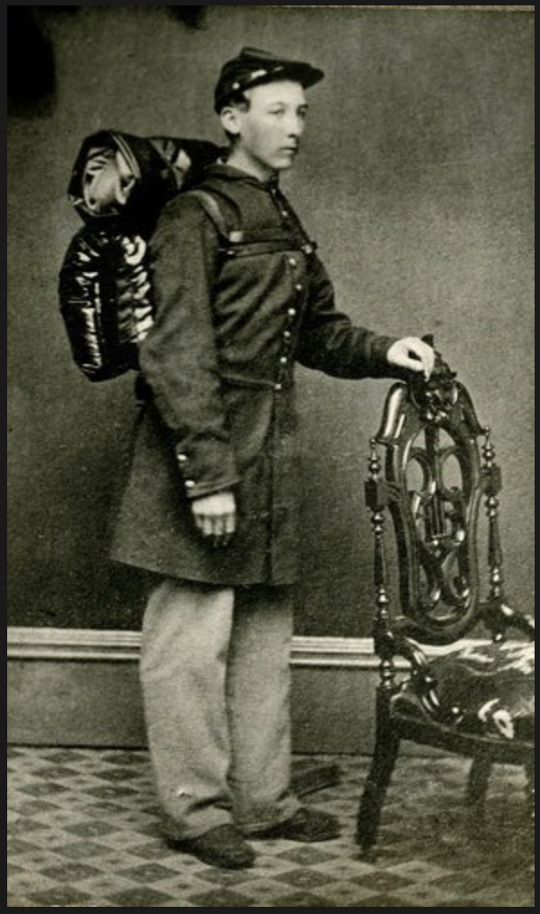

“Boys, like Griffith Thomas who joined the Wisconsin Heavy Artillery as a musician at 16, enlisted with dreams of adventure, but soon realized the severity of camp life—and the terrors of the battlefield. Young drummers were especially targeted by the enemy because their drumbeats communicated orders on the chaotic battlefield.”
Found at: http://www.nytimes.com/slideshow/2011/10/05/opinion/disunion-children.html

Summarize the main ideas

- How is Griffith Thomas portrayed in this picture? Describe how he’s standing, his clothes, the background, and anything else you notice in the photograph.

- What type of feeling does this image evoke? How does it compare to the photograph of William Black?

Draw Inferences: Make a claim based on what you know

- Does it surprise you that drummer boys were targeted more on the battlefield? How might this have impacted the way these boys matured?

Source 9: Susie King Taylor
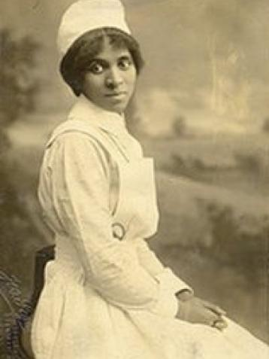

“Susie King Taylor was born on a plantation in Georgia in 1848 and allowed to go to Savannah to live with her grandmother in 1855. Despite the harsh laws against the formal education of African Americans, she attended secret schools taught by black women and was tutored by two white youths. In April 1862, she fled to Union occupied St. Simons Island. Quickly noted for her advanced education, she became the first black teacher to openly educate African Americans in Georgia at the age of 14. She married Edward King, a black officer in the 33rd United States Colored Infantry Regiment, and served as a nurse, laundress, and taught reading and writing to soldiers in his regiment until the end of the war. In 1902, she privately published a book of her experiences as a nurse entitled Reminiscences.”
Found at: https://www.civilwar.org/learn/articles/children-civil-war

Summarize the main ideas

- How is the Susie King Taylor portrayed in this picture? Describe how she’s sitting, her clothes, and anything else you notice in the photograph.

- How does it compare to the photographs of the boys?

Draw Inferences: Make a claim based on what you know

- How might war have impacted girls who witnessed the violence and its impact? Might girls have had emotional scars and increased health issues, as seen in boys who experienced war?

Part 3: Children and the Home Front

Source 10: Marcie Schwartz, “Youth in Wartime”
“On the home front, both northern and southern children became critical to the war effort in a variety of ways. Children took up jobs that their fathers or brothers had left vacant or those that their mothers could not manage alone as the new head of the household. Children would help tend to livestock and crops, serve as clerks or helpers for the family business, cook meals, and watch their younger siblings while still trying to attend school. At school, children would build little Fort Sumters [where the Civil War started] of mud and wooden blocks […] put up clothespins for soldiers, ruthlessly slaughtering them with shot from cannons made of old brass pistol barrels fastened to blocks of wood. Thirteen year old Dan Beard of Cincinnati, Ohio recalled making little Jefferson Davises [the President of the Confederacy] "of potatoes and put sticks in them for legs. We hung the desperate potato men by their necks and shot them with squibs from firecrackers.” In the classroom, patriotism was also alive and well. John Bach McMaster of New York City remembered “every morning after Bible reading, the young woman who presided at the piano would sing a war song, the boys joining in, and that done, a second and perhaps a third would follow.” Many children, however, dropped out of school to support their families, and many others turned to homeschooling when their schools were closed for lack of funding or attendance, or when their schoolmaster went off to war.” | Clothespins- A device such as a forked piece of wood or plastic, for fastening articles to a clothesline  Ruthlessly-without pity or compassion, cruel  Squibs-a firecracker broken in the middle so that it burns with a hissing noise  Presided-to the place of authority or control occupy
Found at: https://www.civilwar.org/learn/articles/children-civil-war-home-front

Summarize the main ideas

- What changed for children on the home front while the war was going on?

- List the type of work children did on the home front during the war.

- How did children express patriotism on the home front?

Draw Inferences: Make a claim based on what you know from the text
- Why might schools have taught children about patriotism at this time?

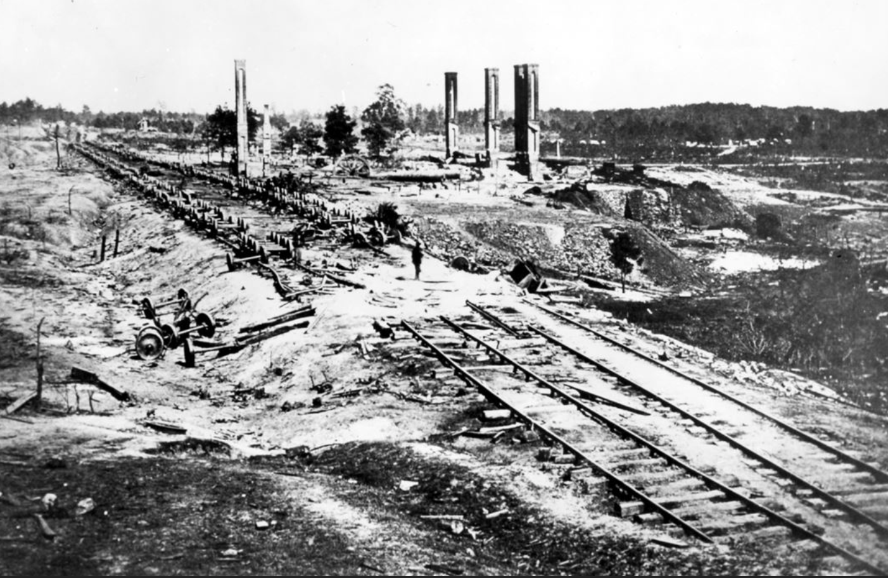
The Remains of Atlanta, 1864
Found at: http://www.post-gazette.com/local/city/2014/08/31/The-burning-of-Atlanta-seared-into-America-s-memory/stories/201408310090
Source 11: Marcie Schwartz, “Youth in Wartime”
“The ‘home front’, however, especially in the South, was constantly under threat. Many of the battles were named after the towns that witnessed them, guerrilla raids harassed non-combatants, troops were garrisoned in houses and barns, and both armies left homes in ruins and fields littered with the dead and dying. In besieged cities, the situation for children and their families became desperate as the weeks turned into months of shelling… Fifteen year old Tillie Pierce’s house was repurposed as [a] hospital for the wounded of Gettysburg and when she returned home she ‘fairly shrank back the awful sight presented. The approaches were crowded with wounded, dying and dead. By this time amputating benches had been placed about the house […]I saw the wounded throwing themselves wildly about, and shrieking with pain while the operation was going on. Just outside the yard I noticed a pile of limbs higher than the fence. It was a ghastly sight.’… [S]eventeen year old Jennie [McCreary], was tasked with rolling bandages. She and her next door neighbors ‘had not rolled many before we saw the street filled with wounded men. I never thought I could do anything about a wounded man but I find I had a little more nerve than I thought I had. [The first soldier] had walked from the field and was almost exhausted. He threw himself in the chair and said, 'O girls, I have as good a home as you. If I were only there!' He fainted directly afterward. That was the only time I cried.’”  Found at: https://www.civilwar.org/learn/articles/children-civil-war-home-front | Non-combatants- a person who is not directly involved in combat; a civilian in wartime  Garrisoned-the place where troops are stationed  Besieged-to crowd around; surround  Repurposed-the reason something exists has been changed for another purpose  Ghastly-terrible; very bad

Summarize the main ideas from the text

- What kinds of risks did children and their families face on the home front?

- Describe the responses of children to these risks.

Draw Inferences: Make a claim based on what you know from the text

- How might these experiences have shaped the lives and maturity of children on the home front?

Source 13: Theodor Kaufman, On to Liberty, 1867

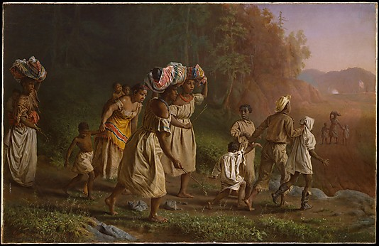

African-Americans escaped slavery and walked across the battlefields to free themselves. Entire families attempted to join the Union Army. Because the U.S. did not have a legal standing for these people, they were given the legal name of ‘contraband’ (escaped slaves).
Found at: https://www.metmuseum.org/art/collection/search/11287

Summarize the main ideas from the text

- What stands out to you in the image?

Draw Inferences: Make a claim based on what you know from the image

- How did African Americans actively participate in their own freedom?

Final Activity: What was it like growing up in the Civil War?

One of the challenges of doing history is that some of the sources of history no longer exist or they exist, but we do not have any information about them. Below is a portrait of a child soldier. Examine the image and fill out the portrait analysis form using evidence from the image. After you do this, you will answer the lesson question: What was it like growing up in the Civil War?

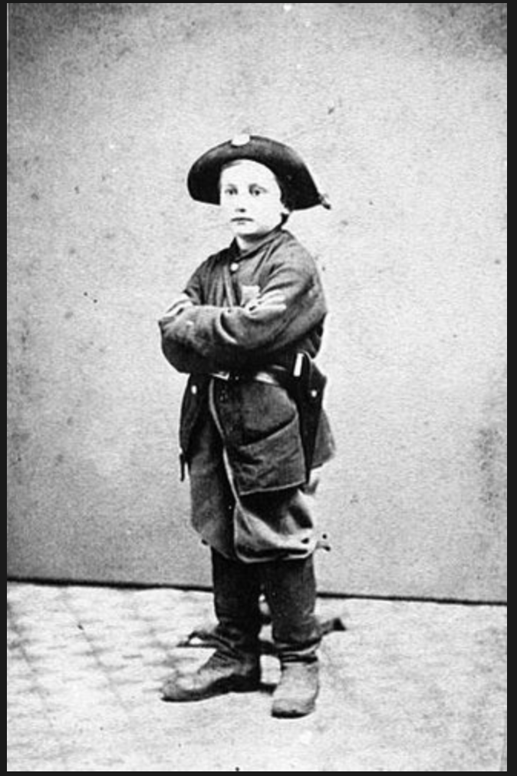

Image found at: http://www.nytimes.com/slideshow/2011/10/05/opinion/disunion-children.html

LEFT HAND: What has he “left” behind or is missing? ____________________________________________________________________________________________________Evidence from image or other sources: ________________________________________________________________________________________________________________________________________________________________________________________________________________________________________________________________________________________________________________________________________________________________
HEART: What does he care most about? __________________________________________________________________________________________________Evidence from image: ____________________________________________________________________________________________________________________________________________________________________________________________________________________________________________________________________________________________________________________________________________________________________
What significant events have he experienced? ________________________________________________________________________________________________________________Evidence from other sources: ____________________________________________________________________________________________________________________________________________________________________________________________________________________________________________________________________________________________________________________________________________________

SHOULDERS: What burdens does he carry? __________________________________________________________________________________________________Evidence from image or other sources: ________________________________________________________________________________________________________________________________________________________________________________________________________________________________________________________________________________________________________________________________________________________________________
EYES: How does he see the world? ____________________________________________________________________________________________________ Evidence from image or other sources: _______________________________________________________________________________________________________________________________________________________________________________________________________________________________________________________________________________________________________________________________________________________________
CLOTHING: What does his clothing tell us about him? __________________________________________________________________________Evidence from image: ______________________________________________________________________________________________________________________________________________________

CONTEXT: What brought him to this place? ______________________________________________________________________________________Evidence from image or other sources: __________________________________________________________________________________________________________________________________________

BRAIN: What is he thinking about? ___________________________________________________________________________________
Evidence from image: _______________________________________________________________________________________________________________________________________

MOUTH: What reasons would he give for being a soldier? ______________________________________Evidence from image or other sources: _____________________________________________________________________________________________________________________________________________________________________________________________

Chart and Writing Activity
Given what you know about each Civil War and the boy pictured in the photograph, write a biography of this soldier. Using the analysis you did of the portrait and the ideas and background from the other sources in the lesson, create a fictional biography of this boy to tell the reader: What was it like growing up in the Civil War?
Name and birthplace

The boy’s life before the war
The boy’s life during the war before he joined the military.

Explanation of why he joined the war—[you may want to build on ideas of freedom from lesson 1]

Discussion of the way that his life has changed as a soldier.

Conclusion explaining why we should remember his story.

