Why does the United States have Indian reservations?
Topics: Native Americans, Indian Reservation System
Erik Altenbernd, UC Irvine History Project

California History-Social Science Standards
8.5 Students analyze U.S. foreign policy in the Early Republic.
8.5.3. Outline the major treaties with American Indian nations during the administrations of the first four presidents and the varying outcomes of those treaties.

8.8 Students analyze the divergent paths of the American people in the West from 1800 to the mid-1800s and the challenges they faced.
8.8.1 Discuss the election of Andrew Jackson as president in 1828, the importance of Jacksonian democracy, and his actions as president (e.g., the spoils system, veto of the National Bank, policy of Indian removal, opposition to the Supreme Court).
8.8.2 Describe the purpose, challenges, and economic incentives associated with westward expansion, including the concept of Manifest Destiny (e.g., the Lewis and Clark expedition, accounts of the removal of Indians, the Cherokees’ “Trail of Tears,” settlement of the Great Plains) and the territorial acquisitions that spanned numerous decades.

8.12 Students analyze the transformation of the American economy and the changing social and political conditions in the United States in response to the Industrial Revolution.
8.12.2 Identify the reasons for the development of federal Indian policy and the wars with American Indians and their relationship to agricultural development and industrialization.

11.1 Students analyze the significant events in the founding of the nation and its attempts to realize the philosophy of government described in the Declaration of Independence.

11.2 Students analyze the relationship among the rise of industrialization, large-scale rural-to-urban migration, and massive immigration from Southern and Eastern Europe.

11.10 Students analyze the development of federal civil rights and voting rights.
11.10.5 Discuss the diffusion of the civil rights movement of African Americans…and how the advances influenced the agendas, strategies, and effectiveness of the quests of American Indians…for civil rights and equal opportunities.

CCSS Standards: Reading, Grades 6-8
RH 1. Cite specific textual evidence to support analysis of primary and secondary sources.
RH 2. Determine the central ideas or information of a primary or secondary source; provide an accurate summary of the source distinct from prior knowledge or opinions.
RH 5. Determine how a text presents information (e.g. sequentially, comparatively, causally).
RH 6. Identify aspects of a text that reveal an author’s point of view or purpose (e.g., loaded language, inclusion or avoidance of particular facts).
RH 7. Integrate visual information (e.g. in charts, graphs, photographs, videos, or maps) with other information in print or digital texts.

CCSS Standards: Writing, Grades 6-8
WH 1. Write arguments focused on discipline-specific content.
WH 2. Write informative/explanatory texts, including the narration of historical events, scientific procedures/experiments, or technical processes.
WH 4. Produce clear and coherent writing in which the development, organization, and style are appropriate to task, purpose, and audience.
WH 9. Draw evidence from informational texts to support analysis, reflection, and research.

CCSS Standards: Reading, Grades 11-12
RH 1. Cite specific textual evidence to support analysis of primary and secondary sources, connecting insights gained from specific details to an understanding of the text as a whole.
RH 2. Determine the central ideas or information of a primary or secondary source; provide an accurate summary that makes clear the relationships among the key details and ideas.
RH3. Evaluate various explanations for actions or events and determine which explanation best accords with textual evidence, acknowledging where the text leaves matters uncertain.
RH7. Integrate and evaluate multiple sources of information presented in diverse formats and media (e.g. visually quantitatively, as well as in words) in order to address a question or solve a problem.
RH9. Integrate information from diverse sources, both primary and secondary, into a coherent understanding of an idea or event, noting discrepancies among sources.

CCSS Standards: Writing, Grades 11-12
WH 1. Write arguments focused on discipline-specific content.
WH2. Write informative/explanatory texts, including the narration of historical events, scientific procedures/experiments, or technical processes.
WH4. Produce clear and coherent writing in which the development and organization, and style are appropriate to the task, purpose, and audience.

Smithsonian National Museum of the American Indian Essential Understandings
NMAI Essential Understanding 3: People, Places, and Environments
For thousands of years, indigenous people have studied, managed, honored, and thrived in their homelands. These foundations continue to influence American Indian relationships and interactions with the land today.
NMAI Essential Understanding 6: Power, Authority, and Governance
American Indians devised and have always lived under a variety of complex systems of government. Tribal governments faced rapid and devastating change as a result of European colonization and the development of the United States. Tribes today still govern their own affairs and maintain a government-to-government relationship with the United States and other governments.

Overview of Source Set
This source set provides an overview of the development of the Indian reservation system during the eighteenth and nineteenth centuries. The chronological scope of the document spans the Early Republic, Jacksonian, antebellum, and postbellum periods. The document set ends just before the Dawes Act of 1887.

The source set is divided into five parts: a general introduction, three sections on federal Indian policy, and a final activity. The introduction lays out key details about Indian reservations and federally-recognized tribes and contextualizes those topics within the framework of the long history of colonization of Native American lands. Part 1 examines ideas of assimilation and segregation in the Early Republic through the works of Thomas Jefferson. Part 2 examines Andrew Jackson and Indian Removal with an eye on how developments in the 1820s, 1830s, and 1840s laid the foundation for the advent of the reservation system in the 1850s. Part 3 focuses on the antebellum and postbellum periods and illustrates how the reservation system emerged as a consequence of westward expansion during the 1840s and 1850s, and how the system became increasingly entrenched in the 1860s and 1870s. The final activity focuses on development of a five-paragraph essay on the origins of the reservation system and includes a graphic organizer to help the students map their essays.

Documents
1. Map of Indian Lands in the United States (Bureau of Indian Affairs)
2. Thomas Jefferson to Benjamin Hawkins, August 13, 1876 (letter, excerpt)
3. Thomas Jefferson, Notes on the State of Virginia (1785, excerpt)
4. Thomas Jefferson to William Henry Harrison, Gov. Indiana Territory, 1803 (letter, excerpt)
5. Andrew Jackson, First Annual Message (1829, excerpt)
6. Indian Removal Act (1830, excerpt)
7. Map Showing the Lands assigned To Emigrant Indians West of Arkansas & Missouri (1843)
8. Alexander H. H. Stuart, “Report of the Secretary of the Interior” (1851, excerpt)
9. Map of Mean Center of Population for the United States, 1790-1900 (online animated map)
10. Francis A. Walker, The Indian Question (1874, excerpt)
11. Map showing the location of the Indian reservations within the limits of the United States and territories (1888)

Introduction: Colonization of Native America did not end during the colonial period of US history.
American Indians and Alaska Natives are colonized peoples living within the boundaries of the United States.

There are currently 567 federally-recognized Indian tribes in the United States. A federally-recognized tribe is an American Indian or Alaska Native tribal group that has been officially acknowledged or accepted by the federal government. Federal recognition is important for Native peoples. Among other things, federal recognition establishes a formal legal relationship between the tribe and the United States. Federally-recognized tribes have an official government-to-government relationship with the federal government, which means that the tribal group is a semi-independent nation with territorial sovereignty (i.e. power over its own lands), its own government, legal system, and tax collection system. A “nation-to-nation relationship” with the federal government also means the tribe has access to various health care, housing, and education programs managed by the Bureau of Indian Affairs.

Not all American Indian or Alaska Native tribal groups are recognized by the federal government. For instance, there are currently 109 federally-recognized tribes in California, but 45 tribal communities within California without federal recognition status.

Federally-recognized Indian tribes, and members of federally-recognized Indian tribes, govern four different categories of lands in the United States: federal Indian reservations, federal allotted lands, federal restricted status lands, and state Indian reservations. The most well-known and extensive of these four types of Indian lands are federal Indian reservations. An Indian reservation is a parcel of land reserved, or set aside, as a permanent homeland for a particular tribal community. Indian Reservations are permanent because they are governed by a treaty with the United States or by federal law, executive order, or administrative action.

There are currently 326 separate Indian reservations in the United States. Note that that there are 567 federally-recognized Indian tribes but only 326 Indian reservations. This means that while all tribal communities that have a reservation are federally-recognized tribes, not all federally-recognized tribes live on reservations.

Nationwide, the Indian reservation system is quite large. Altogether, the system is approximately 56.2 million acres, or roughly 88,000 square miles, which makes it larger than the state of Idaho and larger than all but the ten largest states in the US. The largest reservation is the Navajo Nation Reservation, which spans 16 million acres across Arizona, New Mexico, Utah. The smallest reservation is the cemetery of the Pit River Tribe of California, which is just 1.32 acres.

Like all Indian lands, the reservation system is a system of colonial rule. Legally, the “government-to-government” status extended to federally-recognized tribes recognizes the sovereignty—the power of self-governance and self-rule—of those tribal communities, meaning that those tribes have a political status independent of the United States. However, since 1831, the federal government has also viewed Indian tribes as “domestic dependent nations”—meaning, nations independent of the United States but also nations within the Unites States, secondary to the United States, and thus subject to US law and power. The idea of Indian tribes as “domestic dependent nations” was established by Chief Justice John Marshall in Cherokee Nation v. Georgia, a famous Supreme Court case from the Jacksonian Era that addressed issues related to Indian Removal.
The political and legal status of American Indians and Alaska Natives as a colonized people in the modern United States has a deep history, one that goes back to the earliest days of the European colonization of North America. Modern colonization of Native America began with the arrival of Christopher Columbus in 1492. However, Europeans began roughly 1000 years ago when the Norse, or Vikings, began colonizing Greenland and, then, shortly after that, parts of eastern Canada. However, these early European colonies did not last. The Norse abandoned their last settlements in Greenland in the middle decades of the fifteenth century—less than fifty years before Christopher Columbus first sailed to the Bahamas and Caribbean Sea. Columbus initiated a new, more extensive, more sustained, and permanent phase of European colonization of Native American lands. This new phase of European colonization was very diverse and resulted in the establishment of multiple European colonies—multiple European societies—across much of North and South America.

Map of Norse (i.e. Viking) Settlements in Greenland and Canada from Norse Sagas
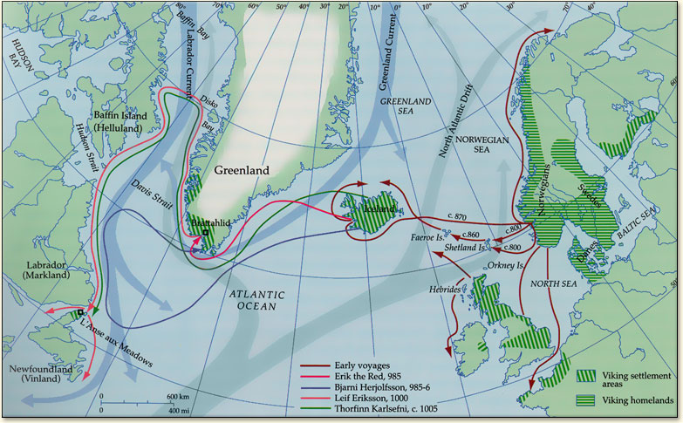
Source: http://vinland-map.brandeis.edu/explore/historical/index.php

European invasion and colonization of the Americas affected Native Americans in countless ways. Native Americans had long traded with one another prior to the arrival of Europeans, but the arrival of Europeans opened new opportunities for trade not only between Native Americans and Europeans, but among different groups of Native Americans as well. War and other forms of violence were a part of Native American life before European colonization, but the arrival of Europeans likewise changed patterns of warfare and violence across Native America. One part of this new world of violence was Indian slavery. Approximately 12.5 million Africans were enslaved and forcibly removed from Africa to work, live, and die as slaves in the Americas (this number does not include African Americans born into slavery in the New World). In addition to these Africans, approximately 2.5 to 5 million Native Americans were sold into slavery from about 1500-1900. Perhaps the most significant form of change brought to Indian lands by Europeans was disease. Old World diseases like small pox, influenza, yellow fever (and more) killed upwards of 90% of Natives within fifty years of first contact with Native peoples. Moderate estimates of the population of Precolumbian America (i.e. North and South America before the arrival of Columbus) peg the population at roughly 50 million, about 10% of which lived north of Mexico. So, if disease killed roughly 90% of the population of Precolumbian North and South America, that means roughly 45 million Native Americans died in what historian Alfred Crosby has calls “surely the greatest tragedy in the history of the human species.” California is a case in point. After just eighty years of colonization by Spain and the Republic of Mexico, and then thirty years of colonization by the United States—the California Gold Rush of 1849-1855 led to what some historians argue was the genocide of California Indians—the population of Native California was just a fraction of what it was prior to colonization. In 1769, the year of the establishment of the first California mission in San Diego, the population of Native California was approximately 310,000 people. By 1880, the Native population of the Golden State was just 16,000—a decline of 95%.

Map of Spanish, Portuguese, and British Colonies in 1780
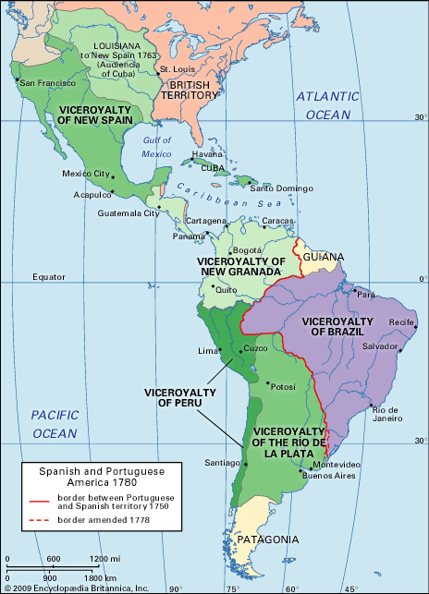
Source: https://www.britannica.com/art/Latin-American-architecture

European colonization of North America began with Columbus in 1492 and began to end in 1775. During the late eighteenth century, and throughout the nineteenth century, European colonists and their colonial-born descendants in the Americas began to break away from their colonial mother countries. One by one, Great Britain, France, Portugal, and Spain lost multiple colonies in the New World due to various wars of independence, beginning with the American War of Independence (1775-1783).

For the United States, the colonial period ended in 1776, the year the Continental Congress in Philadelphia adopted the Declaration of Independence. However, colonization of Native America did not end with the colonial period. Americans fought dozens of battles against Native Americans after independence. More than that, the federal government negotiated dozens and dozens of treaties with different Native American tribes between 1778 and 1871. In fact, managing relations with Indian peoples made up a large part—if not the largest part—of US foreign relations until the Gilded Age.

The modern system of Indian reservations was developed during this time and a lasting testimony to the colonization of Native American lands before and after American independence
Source 1
Map of Indian Lands in the United States (Bureau of Indian Affairs)

Source: Bureau of Indian Affairs, https://www.bia.gov/sites/bia.gov/files/assets/public/pdf/idc013422.pdf

Questions for Source 1

1. What regions of the United States have the most Indian reservations?

2. What regions of the United States have the fewest (or zero) Indian reservations?

3. What US state has the most Indian reservations?

4. Why do you think almost every Indian reservation in the US is west of the Mississippi River? In 2-3 sentences, write a brief explanation—feel free to speculate—regarding why you think Indian reservations are found in the western rather than eastern part of the United States.

Part I. Thomas Jefferson and Assimilation
The federal government devised the series of policies that created the first Indian reservations during the Treaty Period (1774-1871) of Native American history. After the Revolutionary War, federal Indian policy oscillated, or moved back and forth, between two opposite objectives: segregation and assimilation. At certain times, federal decision makers pursued policies that sought to assimilate, or integrate, Indians into mainstream American society. At other times, federal officials pursued the opposite: policies that sought to segregate Indians from mainstream American society. By the 1820s, segregation would come to dominate federal Indian policy. At that time, the main policy associated with segregation was Indian Removal: the forced relocation of Native Americans from their ancestral homelands in the American South to what would come to be known, first, as Indian Territory, and, later, as the State of Oklahoma.

Source 2
Thomas Jefferson to Benjamin Hawkins, August 13, 1786 (letter)

Perhaps no American wrote more about the question of Indian assimilation versus Indian segregation (i.e. removal) than Thomas Jefferson. Jefferson debated this issue time and again before, during, and after his time in the White House (Jefferson served as president from 1801-1809). The excerpt below is from a letter Jefferson wrote to Benjamin Hawkins, a former senator from North Carolina and agent to the Creek Indians of Georgia.

Your favor of June 14. is come to hand and I am to thank you for your attention to my queries on the subject of the Indians….The attention which you pay to their rights also does you great honor, as the want of that is a principle source of dishonor to the American character. The two principles on which our conduct towards the Indians should be founded are justice and fear. After the injuries we have done to them, they cannot love us, which leaves us no alternative but that of fear to keep them from attacking us. But justice is what we should never lose sight of, and in time it may recover their esteem. | favor—letter  queries—questions  want—lack  esteem—respect, admiration
Source: Founders Online, https://founders.archives.gov/documents/Jefferson/01-10-02-0159.

Question

5. Why does Jefferson compliment Hawkins at the beginning of this letter?

6. What does Jefferson identify as “the two principles” of Indian policy during the Early Republic?

7. Based on your reading of the Jefferson’s letter, which of the two principles of Indian policy is used most often in the United States in the 1780s? That said, which of the two principles does Jefferson prefer was used most often? Explain your answer in 2-3 sentences using 2 pieces of evidence from the excerpt.

8. Who does Jefferson blame for the poor state of relations between white Americans and Native Americans?
Source 3
“Query VI” from Notes on the State of Virginia (1785)
By Thomas Jefferson

This excerpt is from Thomas Jefferson’s famous book, Notes on the State of Virginia. Written in response to a series of questions sent to Jefferson from French intellectuals, Jefferson here argues that Native Americans are equal to white Europeans and Americans in most, if not all, respects.

The Indian of North America…I can speak of him somewhat from my own knowledge, but more from the information of others better acquainted with him, and on whose truth and judgment I can rely. From these sources I am able to say…that he is neither more defective in ardor…than the white reduced to the same diet and exercise: that he is brave, when an enterprise depends on bravery…  A remarkable instance of this appeared in the case of the late Col. Byrd, who was sent to the Cherokee nation to transact some business with them. It happened that some of our disorderly people had just killed one or two of that nation. It was therefore proposed in the council of the Cherokees that Col. Byrd should be put to death, in revenge for the loss of their countrymen. Among them was a chief called Silòuee, who, on some former occasion, had contracted an acquaintance and friendship with Col. Byrd. He came to him every night in his tent, and told him not to be afraid, they should not kill him. After many days deliberation, however, the determination was, contrary to Silòuee's expectation, that Byrd should be put to death, and some warriors were dispatched as executioners. Silòuee attended them, and when they entered the tent, he threw himself between them and Byrd, and said to the warriors, ‘this man is my friend: before you get at him, you must kill me.’ On which they returned, and the council respected the principle so much as to recede from their determination….  To judge of the truth of this, to form a just estimate of [the Indians’] genius and mental powers, more facts are wanting, and great allowance to be made for those circumstances of their situation which call for a display of particular talents only. This done, we shall probably find that they are formed in mind as well as in body, on the same module with the…‘Homo sapiens Europæus.’ | defective—lacking  ardor—passion, enthusiasm  transact—conduct  disorderly—reckless; lawless  genius—intellect; intelligence  wanting—lacking  module—level  Homo sapiens Europæus—humans living or derived from Europe; old scientific classification for humans developed by the Swedish naturalist Carl Linnaeus in 1758
Source: Documenting the American South, http://docsouth.unc.edu/southlit/jefferson/jefferson.html

Questions

9. Does Jefferson base his opinions and conclusions regarding Native Americans primarily on his own experiences or the experiences of others? Explain your answer in 2-3 sentences using at least 1 piece of evidence from the reading.

10. Why does Jefferson relay the story of Colonel Byrd—what argument is he trying to support using the story of Colonel Byrd as evidence? Explain your answer in 3-4 sentences using at least 2 pieces of evidence from the reading.

11. How does the story of Colonel Byrd illustrate Jefferson’s argument about the actions of white Americans in his Benjamin Hawkins?

12. What does the term “Homo sapiens Europæus” mean?

13. What is Jefferson’s final conclusion, or main argument, about Native Americans?

Title Page of Jefferson’s Notes on the State of Virginia
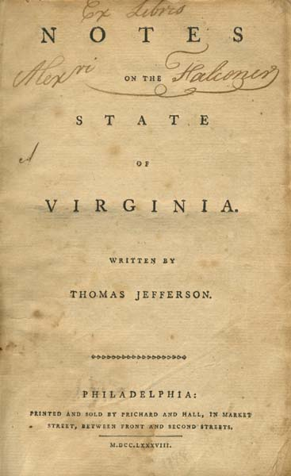
Source: Documenting the American South, http://docsouth.unc.edu/southlit/jefferson/jefferson.html
Source 4
Thomas Jefferson to William Henry Harrison, Gov. Indiana Territory, February 27, 1803

Prior to becoming president in 1801, Thomas Jefferson sometimes argued that Indians should be treated fairly because they were equal to white Americans, and that they should be assimilated into American society. Jefferson’s idea of assimilation, which he shared with a number of other educated Americans, was called philanthropy. The basic idea of philanthropy was that conflict between Indians and white settlers was inevitable due to the intense hunger for land among white Americans. Thus, to save Indians from conflict—and inevitable defeat and extinction—Jefferson argued Indians should adopt American culture and become yeoman farmers: farmers that live and practice agriculture on a small tract of land. For white Americans like Jefferson, the idea of philanthropy seemed to solve multiple problems at once: By becoming yeoman famers, Indians would not only become American, they would live on smaller tracts of land and thereby open their ancestral homelands to settlement by white Americans. In this scenario, assimilation would also keep the peace by eliminating reasons for conflict and war between Native Americans and white Americans.

But what if Indians did not want to become yeoman farmers? As president, Jefferson anticipated that outcome and, in this excerpt, argues that, if Indians do not become yeoman farmers and assimilate, they will have to be removed to lands west of the Mississippi River.

[O]ur system is to live in perpetual peace with the Indians, to cultivate an affectionate attachment from them…and by giving them effectual protection against wrongs from our own people. [T]he decrease of game rendering their subsistence by hunting insufficient, we wish to draw them to agriculture, to spinning & weaving….  When [the Indians] withdraw themselves to the culture of a small piece of land, they will perceive how useless to them are their extensive forests…To promote this disposition to exchange lands…and be glad to see the good and the influential individuals among them run in debt, because we observe that when these debts get beyond what the individuals can pay, they become willing to lop them off by a cession of lands....In this way our settlements will gradually circumscribe and approach the Indians, and they will in time either incorporate with us as citizens of the United States, or remove beyond the Mississippi....Should any tribe be foolhardy enough to take up the hatchet at any time, the seizing of the whole country of the tribe, and driving them across the Mississippi, as the only condition of peace, would be an example to others, and a furtherance of our final consolidation…. | cultivate—grow; encourage  game—animals being hunted  subsistence—to maintain living at minimum level  culture—tilling; agricultural labor  disposition—preference  cession—transfer; to give up  circumscribe—surround  foolhardy—foolish; reckless  hatchet—small ax with short handle to be used with one hand  consolidation—to become stronger, more solid
Source: Founders Online, https://founders.archives.gov/documents/Jefferson/01-39-02-0500

Questions

14. In what ways are Jefferson’s ideas about Native Americans in this letter similar to those in Sources 2 and Source 3? Explain your answer in 2-3 sentences using at least 1 piece of evidence from either Source 2 or Source 3.

15. What does Jefferson mean when he says the federal government should “be glad to see the good and the influential individuals among them run in debt?” Explain your answer in 2-3 sentences.

16. What are Jefferson’s ideas regarding war—does he want war with the Indians or does he see war as a policy of last resort?

17. What does Jefferson say will happen if Native Americans go to war against the United States? Explain your answer in 3-4 sentences using at least 1 piece of evidence.

18. Who stood to gain most from Jefferson’s ideas of philanthropy and assimilation: Indians or white Americans? Explain your answer in 2-3 sentences.

Official Portrait of Thomas Jefferson by Rembrandt Peale (1800)
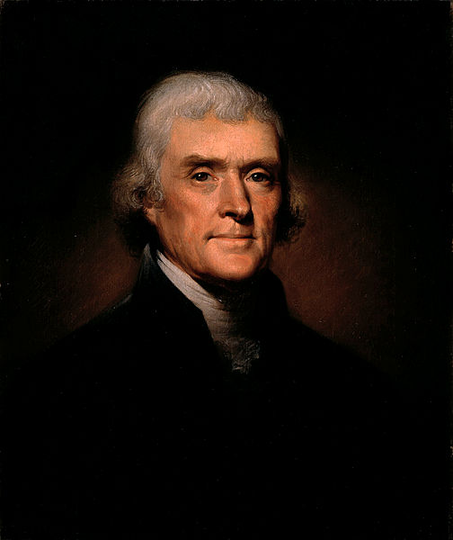
Source: The White House Historical Association, https://library.whitehousehistory.org/fotoweb
Part 2. Indian Removal: Early Step in the Development of Indian Reservations
A pivotal moment in the history of Indian reservations in the United States was Indian Removal, the series of laws, policies, and Supreme Court decisions from the 1820s and 1830s that resulted in the forced relocation of thousands of Native Americans to territory west of the Mississippi River. During the 1830s and 1840s, this region became known as Indian Territory. Indian Territory was concentrated in what later became the state of Oklahoma, but also covered parts of what later became the states of Kansas and Nebraska.

Map of Indian Territory and Indian Removal during the 1830s
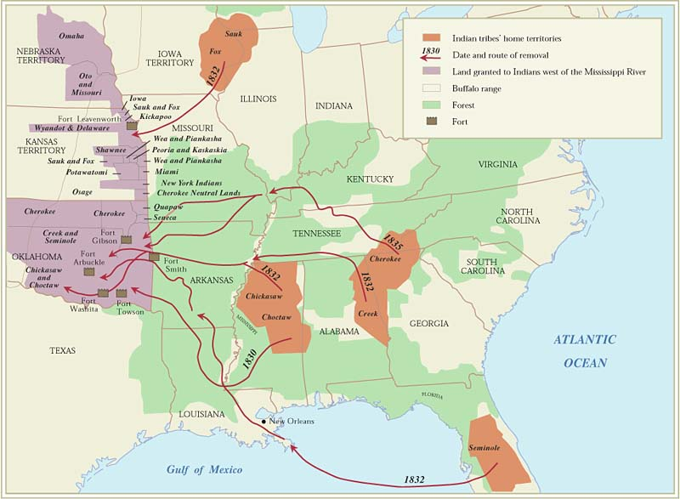
Source: Oxford Research Encyclopedia of American History, http://americanhistory.oxfordre.com/

Removal—the forced segregation of Indians away from white American society— became official federal policy after the election of President Andrew Jackson in 1828. As we have seen, the idea of removal first emerged during the presidency of Thomas Jefferson (1801-1809). Still, while Jefferson viewed removal as a potential solution to conflict between Native Americans and white American settlers, he never directly proposed removal as an official policy of the federal government. President James Monroe (1817-1825) was the first president to fully endorse removal. In his very first State of the Union Address, Monroe identified removal as the best solution to avoiding war with the Cherokee and other Native peoples of Georgia. Just before leaving office, Monroe directed Congress to pass a law that would remove the Cherokee and other tribes from the American South. Following Monroe’s directive, the Senate passed a bill in February 1825 that would have forced the Cherokee and other tribes to leave their homelands in the South, but the House of Representatives did not pass a similar bill, so removal did not become law at that time. After the election of Jackson in 1828, the Senate and House got on the same page and passed the Indian Removal Act, which Jackson signed into law on May 28, 1830.

The Indian Removal Act allowed Jackson and later presidents to pursue a variety of aggressive anti-Indian policies, including the final removal of several Indian tribes from both the South as well as Great Lakes region. In addition to the Cherokee, Chickasaw, Choctaw, Creek, and Seminole Indians—all of whom were removed from Georgia and other states in the Southern Cotton Belt—the Sauk and Fox Indians were also removed from what is today the states of Illinois, Iowa, and Wisconsin. By the time Jackson left office, his administration had secured about 100 million acres of land (mostly in the South) in exchange for about 30 million acres of land (mostly in what would later become Oklahoma and Kansas).

The forced, and sometimes violent, relocation of Indians from the East to lands west of the Mississippi River is known as the “Trail of Tears.” Thousands of Indians were forced to relocate, and hundreds died during the process. In all, Indian Removal relocated and dispossessed of their lands about 46,000 Native Americans; approximately 5000 Cherokees, 4500 Creeks, and 2000 Choctaws died during relocation, mostly due to disease, starvation, poor living conditions, exposure, and loss of individual and communal morale.

Trail of Tears by Brummett Echohawk (1957)
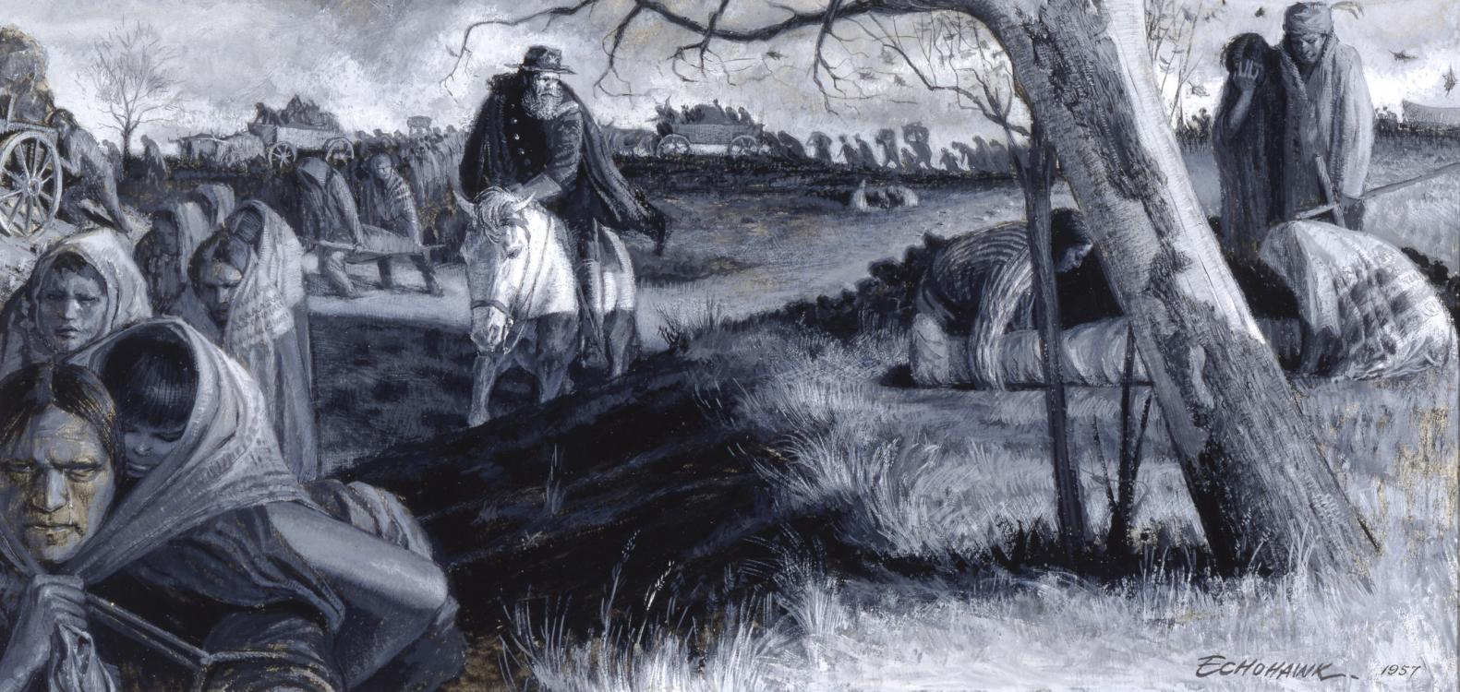
Source: Gilcrease Museum, https://collections.gilcrease.org/object/02271487
Source 5
First Annual Message (December 8, 1829)
Andrew Jackson

The text below is an excerpt from President Andrew Jackson’s First Annual Message to Congress (since the 1930s, we have called these speeches State of the Union Addresses). In this message, Jackson makes it clear that Indian Removal is the policy of his new administration. Jackson would sign the Indian Removal Act into law just six months after this speech.

The condition and ulterior destiny of the Indian tribes within the limits of some of our States have become objects of much interest and importance….  Our conduct toward these people is deeply interesting to our national character. Their present condition, contrasted with what they once were, makes a most powerful appeal to our sympathies. Our ancestors found them the uncontrolled possessors of these vast regions. By persuasion and force they have been made to retire from river to river and from mountain to mountain, until some of the tribes have become extinct and others have left but remnants to preserve for a while their once terrible names. Surrounded by the whites with their arts of civilization, which by destroying the resources of the savage doom him to weakness and decay, the fate of the Mohegan, the Narragansett, and the Delaware is fast over-taking the Choctaw, the Cherokee, and the Creek. That this fate surely awaits them if they remain within the limits of the States does not admit of a doubt. Humanity and national honor demand that every effort should be made to avert so great a calamity….A State can not be dismembered by Congress or restricted in the exercise of her constitutional power. But the people of those States [i.e. Georgia and Alabama] and of every State, actuated by feelings of justice and a regard for our national honor, submit to you the interesting question whether something can not be done, consistently with the rights of the States, to preserve this much- injured race.  As a means of effecting this end I suggest for your consideration the propriety of setting apart an ample district west of the Mississippi, and without the limits of any State or Territory now formed, to be guaranteed to the Indian tribes as long as they shall occupy it, each tribe having a distinct control over the portion designated for its use. There they may be secured in the enjoyment of governments of their own choice, subject to no other control from the United States than such as may be necessary to preserve peace on the frontier and between the several tribes. There the benevolent may endeavor to teach them the arts of civilization, and, by promoting union and harmony among them, to raise up an interesting commonwealth, destined to perpetuate the race and to attest the humanity and justice of this Government.  This emigration should be voluntary, for it would be as cruel as unjust to compel the aborigines to abandon the graves of their fathers and seek a home in a distant land. But they should be distinctly informed that if they remain within the limits of the States they must be subject to their laws…. Submitting to the laws of the States, and receiving, like other citizens, protection in their persons and property, they will ere long become merged in the mass of our population. | ulterior—future  retire—flee; move from  remnant—small remaining amount of something that used to be much larger  doom—death, destruction or some other terrible fate  Mohegan—Algonquin Indian people of Connecticut Narragansett—Algonquin Indian people of Massachusetts and greater New England  Delaware—Algonquin Indian people of New York, New Jersey, and Pennsylvania  avert—avoid  calamity—disaster  dismember—to cut off limbs off plant or animal  actuate—to cause to operate or happen  propriety—suitability; acceptability  ample—plentiful, or more than enough; large  without—outside of  emigration—act of leaving homeland to move to foreign land  aborigine—original inhabitant of a region  ere—before
Source: American Presidency Project, http://www.presidency.ucsb.edu/ws/index.php?pid=29471

Questions

19. Which people—Indians or the citizens of states like Georgia—is Jackson most concerned with helping? Explain your answer in 3-4 sentences using at least 2 pieces of evidence from the source.

20. How does Jackson frame removal—is it being done to help or harm Indians? Identify 2 key quotations that explain your answer.

21. According to Jackson, what is the fate of Choctaw, Cherokee, and Creek Indians if they are not removed to lands west of the Mississippi River? Explain your answer in 3-4 sentences using at least 2 pieces of evidence from the source.

Source 6
Indian Removal Act (May 28, 1830)
US Congress

Below is an excerpt of the Indian Removal Act, the law that authorized President Andrew Jackson to remove Native Americans to lands west of the Mississippi River. To address the problem of Indian sovereignty—part of the legal debates over Indian Removal focused on the objection of states like Georgia to having sovereign Indian nations within state borders—the law makes it very clear that all lands exchanged with Indians should be outside the boundaries of existing states.

Be it enacted by the Senate and House of Representatives of the United States of America, in Congress assembled, That it shall and may be lawful for the President of the United States to cause so much of any territory belonging to the United States, west of the river Mississippi, not included in any state or organized territory…to be divided into a suitable number of districts, for the reception of such tribes or nations of Indians as may choose to exchange the lands where they now reside, and remove there…  And be it further enacted, That it shall and may be lawful for the President to exchange any or all of such districts, so to be laid off and described, with any tribe or nation of Indians now residing within the limits of any of the states or territories, and with which the United States have existing treaties…  And be it further enacted, That in the making of any such exchange or exchanges, it shall and may be lawful for the President solemnly to assure the tribe or nation with which the exchange is made, that the United States will forever secure and guaranty to them, and their heirs or successors, the country so exchanged with them; and if they prefer it, that the United States will cause a patent or grant to be made and executed to them for the same: Provided always, That such lands shall revert to the United States, if the Indians become extinct, or abandon the same. | district—distinct area of land, territory  solemn—serious, sincere  patent—right of government to grant title, power for period of time  grant—money, land given to person, group of people by government  executed—carry out, put into effect
Source: Teaching American History, http://teachingamericanhistory.org/library/document/indian-removal-act/

Questions

22. What does the paragraph one authorize the president to do?

23. What does the paragraph two authorize the president to do?

24. What does the third paragraph three authorize the president to do?

25. Does paragraph three create a permanent new homeland for those Indians relocated under the power of the Indian Removal Act? Explain your answer in 2-3 sentences using at least 1 piece of evidence from the source.

Source 7
Map Showing the Lands assigned To Emigrant Indians West of Arkansas & Missouri (1843)
US Army Corps of Topographic Engineers

This map was produced by the US Army Corps of Topographic Engineers, an important group of federal explorers and mapmakers before the Civil War. In addition to illustrating the location of the various Indian tribes relocated west of the Mississippi River, the map also provides detailed information about each relocated tribe.

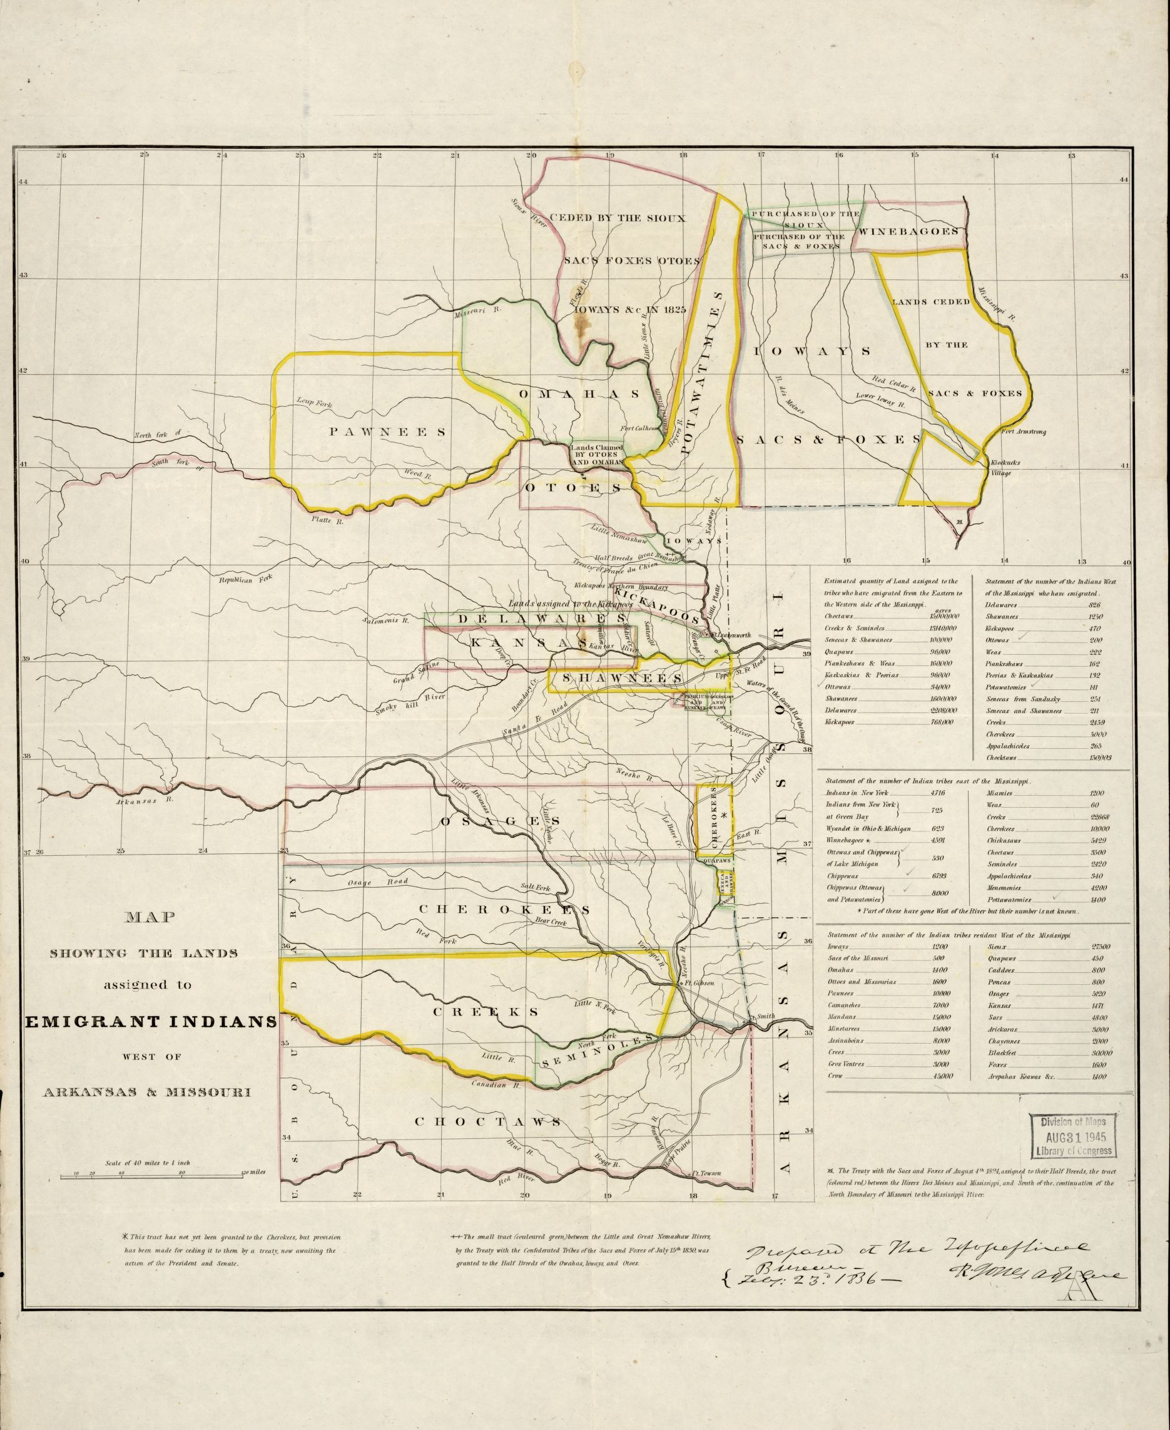
Source: Library of Congress, https://www.loc.gov/item/99446197/
Questions

26. Locate and then highlight the Mississippi River on the map.

27. How many different tribes are illustrated on the map?

28. What additional information does the map provide about the relocated peoples?

29. What words does the map used to describe the territory assigned to the relocated peoples?

Part 3. Westward Expansion and the Development of Indian Reservations before and after the Civil War
As we have seen, federal Indian policy during the nineteenth century focused on one of two aims: assimilation and segregation. Segregation dominated federal policy until the 1880s and the main idea behind Indian Removal and the creation of the first Indian reservations.

The lands set aside for the Cherokee, Chickasaw, Choctaw, Creek, Seminole and other Indian tribes during the 1830s and 1840s were not modern Indian reservations. In many ways, though, they provided a blueprint, or model, for modern reservations. Just as the policy of Indian Removal grew out of earlier ideas and policies like philanthropy, the Indian reservation system that exists in the US today grew out of problems that emerged due to removal.

Map of US Territorial Acquisitions
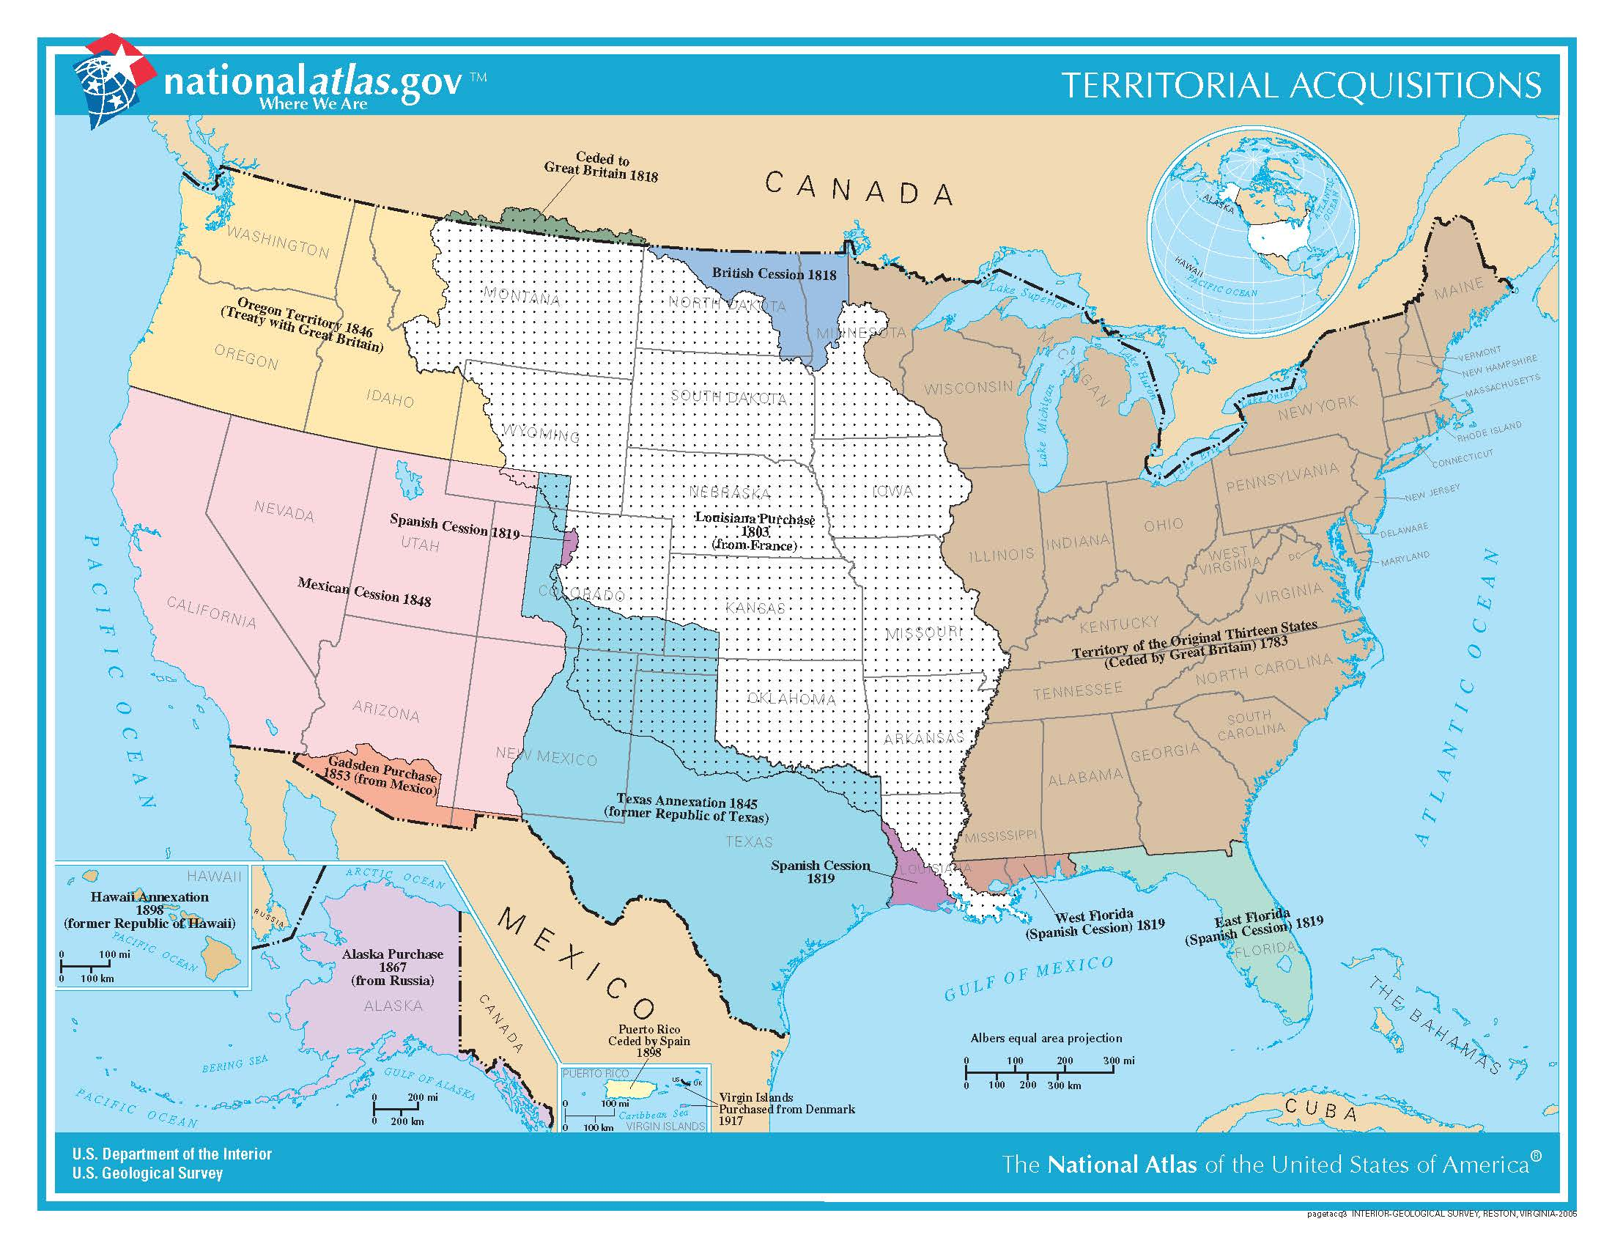
Source: US Geological Survey, https://nationalmap.gov/small_scale/printable/territorialacquisition.html#list

By the 1850s, officials in the federal government recognized that Indian removal was no longer an effective policy. In short, what worked in the 1820s, 1830s, and 1840s no longer worked in the 1850s. Why? Two words: westward expansion. During the 1840s, the United States, first, acquired large tracts of new territory due treaties with Great Britain and Mexico; and, second, during the 1840s and 1850s, large numbers of Americans from the eastern United States migrated by the tens of thousands to western territories like the Oregon, California, Kansas, Nebraska, and Colorado. More than that, Americans from the Eastern US continued to migrate to western territories and states throughout the nineteenth century. For instance, in 1850, the population of California was just 93,000 people; by 1900, it was 1.5 million. The trend in Oregon, Kansas, Nebraska, and Colorado was exactly the same: In 1850, the population of Oregon was just 12,000, but 414,00 by 1900; in 1860, the population of Kansas was 107,000, but 1.5 million by 1900; in 1860, the population of Nebraska was 29,000, but 1.1 million by 1900; and, in 1860, the population of Colorado was 34,000, but 540,000 in 1900.

Westward migration brought large numbers of whites from the East into direct contact with a variety of Native Americans in the West. One of the chief aims of Indian Removal during the 1830s and 1840s was to segregate Native Americans and white Americans—forcibly moving Indians from places in the East (where whites outnumbered Indians) to places in the West where the population of whites was relatively small (and, thus, where Indians would outnumber whites). Westward migration broke the basic reasons, or logic, of Indian Removal.

In the years both before and after the Civil War, the federal government maintained its larger goal of segregating Native Americans from the rest of American society. However, beginning in the 1850s, it found a new way to reach that goal: Indian reservations. The idea of a reservation system—of a collection of plot of land reserved for the entire tribal community—first emerged in the 1840s but did not become a concrete policy until the early 1850s. In 1851, Congress passed the Indian Appropriations Act that created the first Indian reservations in Indian Territory (the law involved additional removal of western Indians to and within Indian Territory). Further West, due to conflicts with Native peoples as a result of migration of white Americans (and others), the federal government negotiated eighteen separate treaties with Indians in California that set aside large tracts of land for California Indians. These treaties were ultimately rejected by the Senate but set a new pattern in federal Indian policy. Eventually, Congress created five “military reservations” in California in 1853. The reservation became a central feature of federal Indian policy, and continued to grow, throughout the 1860s and 1870s.

The Dawes Act of 1887, also known as the General Allotment Act and Dawes Severalty Act, ended the policy of granting large tracts of land to entire tribes. Instead, the Dawes Act sought, once again, to open more Indian lands to white settlers by “allotting” small plots of land to individual Native Americans. Unlike Indian Removal and the early reservation system, the Dawes Act was intended to be a policy of assimilation rather than segregation. Despite the major change in emphasis in the 1880s, the reservation system continued after the Dawes Act and became an important part of federal Indian policy during the twentieth century.

Source 8
“Report of the Secretary of the Interior” (November 29, 1851)
Alexander H. H. Stuart

This excerpt is from an official report written by Alexander H. H. Stuart. Stuart served as Secretary of the Interior from 1850-1853. The Secretary of the Interior is member of the presidential cabinet and oversees the Department of the Interior, a large department of the executive branch that oversees federal policy regarding federal lands and natural resources. Just as today, one of the major duties of the Secretary of the Interior is to manage federal Indian policy. In his report from 1851, Stuart calls for an end to the policy of Indian removal.

The acquisition of New Mexico and California, and the rapid expansion of our settlements in Oregon and Utah, have given increased importance to our Indian relations, and may render a change in our whole policy in regard to them necessary….  The results have been: injury to the Indians, by crowding them together in such numbers that the game is insufficient for their support; and injustice to the western States, whose security is endangered by the proximity of their savage neighbors. But since the acquisition of California and Oregon, and the establishment of large settlements on the coast of the Pacific and in Utah, a new flow of white population is advancing upon them from the west. The pressure is, therefore, increasing upon [Indians] from both sides of the continent. On the north and south they are also hemmed in by civilized communities. They are thus encompassed by an unbroken chain of civilization; and the question forces itself upon the mind of the statesman and the philanthropist, what is to become of the aboriginal race? This question must now be fairly met. A temporizing system can no longer be pursued. The policy of removal, except under peculiar circumstances, must necessarily be abandoned; and the only alternatives left are, to civilize or exterminate them. We must adopt one or the other….  It cannot be denied that most of the depredations committed by the Indians on our frontiers are the offspring of dire necessity. The advance of our population compels them to relinquish their fertile lands and seek refuge in sterile regions, which furnish neither corn nor game for their subsistence. Impelled by hunger, they seize the horses, mules, and cattle of the pioneers…[and] are immediately pursued, and, when overtaken, severely punished. This creates a feeling of revenge on their part, which seeks its gratification in outrages on the persons and property of peaceable inhabitants. The whole country then becomes excited, and a desolating war, attended with a vast sacrifice of blood and treasure, ensues. This, it is believed, is a true history of the origin of most of our Indian hostilities. | render—to make; to cause  game—animals being hunted  hemmed in—confined  encompassed—surrounded  statesman—leader; politician  philanthropist—activist sympathetic to Indians and who supports assimilationist policies  aborigine—original inhabitant of a region  temporizing—temporary  fertile—soil/land capable of growing crops  sterile—non-fertile land  pioneer—first, early settler on land  desolating—destructive
Source: US Senate, Executive Documents No. 1, 32nd Congress, 1st Session, 502-503.

Questions

30. Why does Stuart say removal is no longer a useful policy—what major changes have occurred on the frontier since the completion of Indian removal in the 1840s? Explain your answer in 3-4 sentences using at least 2 pieces of evidence from the text.

31. Is Stuart sympathetic to Native Americans? Explain your answer in 2-3 sentences using at least 1 pieces of evidence from the text.

32. Are Stuart’s comments here similar to those of Jefferson in Source 2? Explain your answer in 3-4 sentences using at least 1 piece of evidence from each text.

Source 9
Map of Mean Center of Population for the United States, 1790-1900
US Census Bureau

The map below is from the US Census Bureau. It depicts the mean center of population for the United States from 1790 (the year of the first national census) to 2010 (the year of the last national census). Each blue pyramid on the map below represents the exact middle, or balancing point, of the entire population of the United States. Another way to think of it is like this: an equal number of people live to the north, to the south, to the east, and to the west of each blue pyramid. In this way, each blue pyramid represents the exact center of population of the United States.

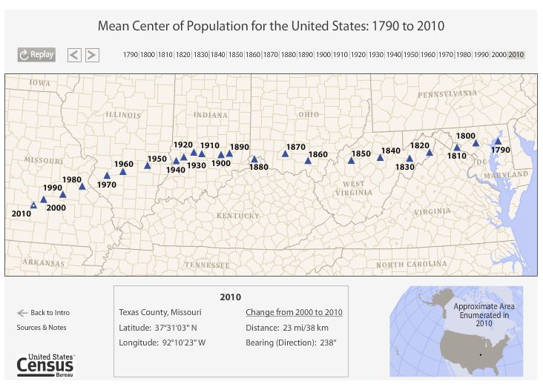

Instructions for Questions 28-31:

1. Go to the webpage below.
https://www.census.gov/geo/reference/centersofpop/animatedmean2010.html
2. Click the button that reads “View the map.”
3. Click the “Play” button above the top-left portion of the map.
4. Watch the map animation until it reaches 2010.
5. Answer the questions below.

Questions

33. Working forward from 1790 to 1900, click on each year from 1790-1900 and record the following information included in the box below the center portion of the map: 1. Location (town name) of the mean center of population; 2. change in distance between mean centers of population.

34. Which census year recorded the largest change in distance from the previous census year?

35. Which census year recorded the smallest change in distance from the previous census year?

36. How does this animated map illustrate the historical phenomenon discussed by Alexander Stuart in Source 8? Explain your answer in 3-4 sentences using 1 piece of evidence from both sources.

Source 10
The Indian Question (1874)
Francis A. Walker

This excerpt is from a book written by Francis A. Walker. Walker was an important economist, statistician, and cartographer (i.e. mapmaker) who served as superintendent of the US Census Bureau during the 1860s and 1870s, and as Commissioner of Indian Affairs from 1871-1872. Here, Walker builds on the opinions of Alexander H. H. Stuart and other federal officials by making a strong case for the importance of Indian reservations. In addition to arguing in support of Indian reservations, Walker also argues for the continued “seclusion,” or segregation, of Native Americans and white Americans.

It is doubtful whether zeal or ignorance is more responsible for the confusion which exists in the public mind in respect to this entire matter of Indian civilization. The truth will be best shown by examples.  The Cherokees, who originally owned and occupied portions of the States of Georgia, Alabama, and Tennessee, have now a reservation of nearly four million acres in the tract known as the Indian Territory….  From the statements made above, all upon the authority of official reports, it will doubtless appear to every candid reader that the Cherokees are entitled to be ranked among civilized communities. Their condition is far better than that of the agricultural classes of England; and they are not inferior in intelligence or in the ability to assert their rights….  If, then, we may assume that Indian civilization is not altogether impossible, let us inquire what should be the policy of the government towards the Indian tribes when they cease to be dangerous to our frontier population, and to oppose the progress of settlement, either by violence or by menace…  First. The reservation system should be made the general and permanent policy of the government. By this is meant something more than that the Indians should not be robbed of their lands in defiance of treaty stipulations, or that the Indian title should be respected, and the Indians maintained in possession until they can be made ready to cede their lands to the government, or to sell them, with the consent of the government, to the whites. The proposition is that the United States…should formally establish the principle of separation and seclusion, without reference to the wishes either of the Indians or of encroaching whites; should designate by law an ample and suitable reservation for each tribe and band not entitled by treaty…The principle of secluding Indians from whites for the good of both races is established by an overwhelming preponderance of authority. There are no mysterious reasons why this policy should be adopted…The first is the familiar one, that the Indian is unfortunately disposed to submit himself to the lower and baser elements of civilized society, and to acquire the vices and not the virtues of the whites….  It must be evident to every one…that the reservations…do not consist with the permanent interests of either the Indian or the government. There are too many reservations: they occupy too much territory in the aggregate; and, what is worse, some of them unnecessarily obstruct the natural access of population to portions of territory not reserved, while others, by their neighborhood, render large tracts of otherwise available land undesirable for white occupation….  It is manifest, therefore, that the next five or ten years must witness a general recasting of the scheme of Indian reservations. This is not to be accomplished by confiscating the Indian title, but by exchange, by cession, and by consolidation. Let Congress provide the necessary authority, under the proper limitations, for the executive departments, and the adjustment desired can be reached easily and amicably. | zeal—great energy, enthusiasm for topic  Indian Territory—land set aside for Cherokee and other Indians during removal, now State of Oklahoma  menace—to threaten violence or harm  stipulation—specific requirement in treaty or legal agreement  title—right, claim of ownership to land  cede—give up; transfer  proposition—statement, thesis, assertion  encroach—intrude on land, territory  ample—plentiful, or more than enough; large  disposed—inclined, willing  aggregate—whole formed by combination of several different pieces  amicable—friendly; without anger or disagreement
Source: Making of Modern America, https://quod.lib.umich.edu/m/moa/ACK1342.0001.001?rgn=main;view=fulltext.

Questions

37. What is Walker’s main thesis, or argument/proposition, in this text?

38. Does Walker argue for or against the idea that Native Americans can assimilate to American society and culture?

39. What three arguments does Walker make in favor of the reservation system?

40. Why does Walker ague that Native Americans and white Americans must remain segregated from one another?

41. In what ways are Walker’s comments here similar to those of Stuart in Source 8 and Jefferson in Source 2? Explain your answer in 4-5 sentences using at least 1 piece of evidence from all three texts.

Source 11

Map showing the location of the Indian reservations within the limits of the United States and territories (1888)

US Office of Indian Affairs

This map was produced by the Office of Indian Affairs (the previous name of the Bureau of Indian Affairs) in 1888. The map identifies the locations of all the Indian reservations in the US up to 1888.

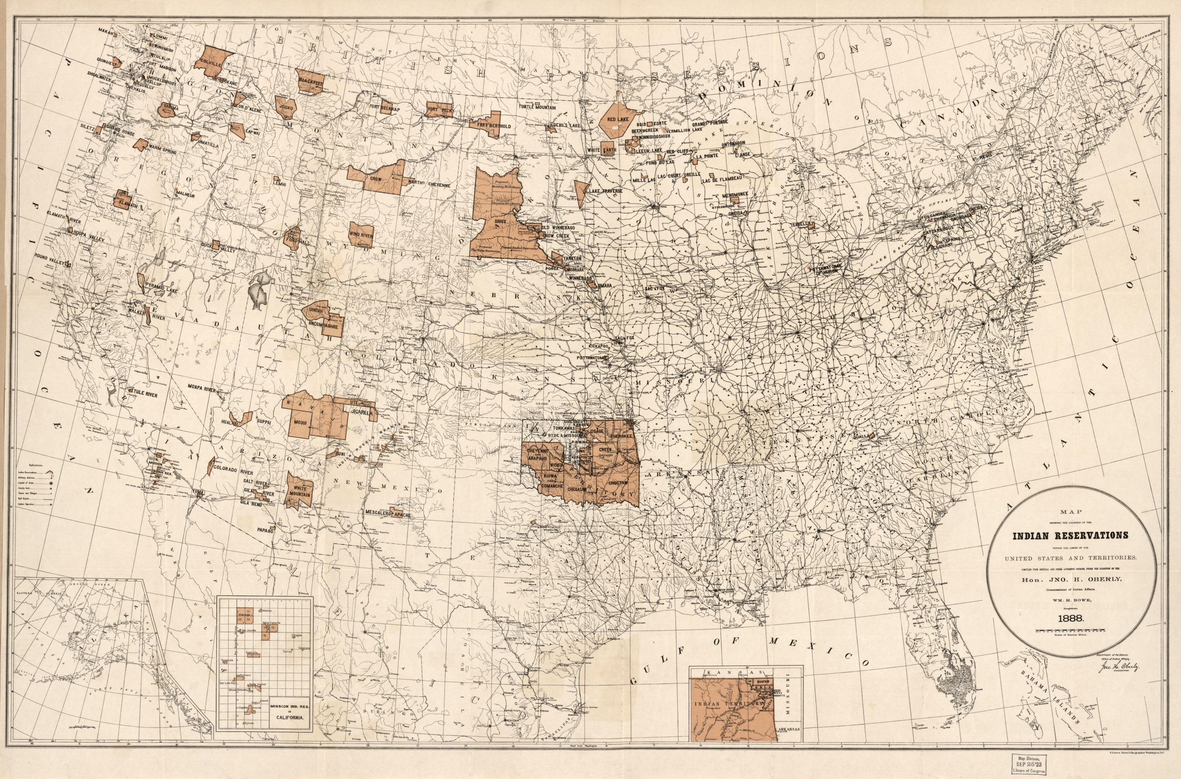
Source: Library of Congress, https://www.loc.gov/item/2009579476/
Questions

42. How many states had Indian reservations within their borders in 1888?

43. Which state has the most Indian reservations in 1888?

44. Which Southern California Indian reservations are included on this map?

45. Based on the evidence provided in this map, has the reservation system expanded or contracted since its establishment in the 1850s?

46. Now that you learned about the history of the reservation system, why is almost every Indian reservation in the US is west of the Mississippi River? In 2-3 sentences, write a brief explanation of why you think Indian reservations are found in the western rather than eastern part of the United States.

Final Activity. Why does the United States have Indian reservations?

In this lesson, you have learned about the evolution of federal Indian policy during the nineteenth century and the emergence of the modern reservation system.

The modern reservation system was not established until the 1850s, but the roots of the system go back to Indian Removal in the 1830s and 1840s, and ideas about the place of Native Americans in the United States during the 1770s and 1780s.

Your task for this final activity is to retrace the history of Indian reservations and write a short essay that answers the question: Why does the United States have Indian reservations?

I. Essay Requirements

1. Your essay should be well organized and focus on all thee historical eras covered in this source set (i.e. Early Republic; Jacksonian Era; antebellum and postbellum periods). Each period responded to the problem of colonization of Native Americans in different—but also similar—ways.

2. Your essay should be five paragraphs long. It should include the following:
- An introduction that does two things:
  - Briefly explains what Indian reservations are;
  - Provides a thesis statement regarding the historical development of Indian reservations during the nineteenth century.
- A body paragraph that analyzes one key source from the period of the Early Republic;
- A body paragraph that analyzes one key source from the Jacksonian Era;
- A body paragraph that analyzes one key source from either the antebellum or postbellum era.
- A conclusion that briefly summarizes your essay and restates your thesis regarding the historical development of Indian reservations.

III. Drafting Your Essay

As you re-read the historical evidence presented here, use the graphic organizer below to gather ideas and identify what you think are the crucial pieces of evidence that explain the historical development of Indian reservations in the US. You can also use the graphic organizer to highlight key quotations from your sources and bullet-point or brainstorm each of the paragraphs.

After you have mapped out your body paragraphs, develop a thesis statement and then write your thesis statement in the second box of the graphic organizer.

After you complete these tasks, begin drafting your essay.

Why does the United States have Indian reservations?
Thesis Statement:

#1 Piece of Evidence from Early Republic
Quotation from Source 1
Paragraph 2
Brainstorm/
Bullet Points
#2 Piece of Evidence from Jacksonian Era
Quotation from Source 2
Paragraph 3
Brainstorm/
Bullet Points
#3 Piece of Evidence from ante-postbellum era
Quotation from Source 3
Paragraph 4
Brainstorm/
Bullet Points

