Women and Gender in Native America
Source Set
Jessica Christian, UCI History Project Academic Coordinator

Lesson Inquiry Questions:
What were the gender roles in native societies in the past? How do different native people think of gender today?

California History-Social Science Standards, 1998
K.6 Students understand that history relates to events, people, and places of other times.
- Know the triumphs in American legends and historical accounts through the stories of such people as Pocahontas, George Washington, Booker T. Washington, Daniel Boone, and Benjamin Franklin.
- Understand how people lived in earlier times and how their lives would be different today (e.g., getting water from a well, growing food, making clothing, having fun, forming organizations, living by rules and laws).
1. 4 Students compare and contrast everyday life in different times and places around the world and recognize that some aspects of people, places, and things change over time while others stay the same.
- Examine the structure of schools and communities in the past.
- Recognize similarities and differences of earlier generations in such areas as work (inside and outside the home), dress, manners, stories, games, and festivals, drawing from biographies, oral histories, and folklore.
1.5 Students describe the human characteristics of familiar places and the varied backgrounds of American citizens and residents in those places.
- Recognize the ways in which they are all part of the same community, sharing principles, goals, and traditions despite their varied ancestry; the forms of diversity in their school and community; and the benefits and challenges of a diverse population.
- Understand the ways in which American Indians and immigrants have helped define Californian and American culture.
- Compare the beliefs, customs, ceremonies, traditions, and social practices of the varied cultures, drawing from folklore.
2.3 Students explain governmental institutions and practices in the United States and other countries.
- Explain how the United States and other countries make laws, carry out laws, deter mine whether laws have been violated, and punish wrongdoers.
- Describe the ways in which groups and nations interact with one another to try to resolve problems in such areas as trade, cultural contacts, treaties, diplomacy, and military force.
3.2 Students describe the American Indian nations in their local region long ago and in the recent past.
  - Describe national identities, religious beliefs, customs, and various folklore traditions.
  - Discuss the ways in which physical geography, including climate, influenced how
the local Indian nations adapted to their natural environment (e.g., how they obtained food, clothing, tools).
  - Describe the economy and systems of government, particularly those with tribal constitutions, and their relationship to federal and state governments.
  - Discuss the interaction of new settlers with the already established Indians of the region.
4.2 Students describe the social, political, cultural, and economic life and interactions among people of California from the pre-Columbian societies to the Spanish mission and Mexican rancho periods.
- Discuss the major nations of California Indians, including their geographic distribution, economic activities, legends, and religious beliefs; and describe how they depended on, adapted to, and modified the physical environment by cultivation of land and use of sea resources.
- Identify the early land and sea routes to, and European settlements in, California with a focus on the exploration of the North Pacific (e.g., by Captain James Cook, Vitus Bering, Juan Cabrillo), noting especially the importance of mountains, deserts, ocean currents, and wind patterns.
- Describe the Spanish exploration and colonization of California, including the relationships among soldiers, missionaries, and Indians (e.g., Juan Crespi, Junipero Serra, Gaspar de Portola).
- Describe the mapping of, geographic basis of, and economic factors in the placement and function of the Spanish missions; and understand how the mission system expanded the influence of Spain and Catholicism throughout New Spain and Latin America.
- Describe the daily lives of the people, native and nonnative, who occupied the presidios, missions, ranchos, and pueblos.
- Discuss the role of the Franciscans in changing the economy of California from a hunter- gatherer economy to an agricultural economy.
- Describe the effects of the Mexican War for Independence on Alta California, including its effects on the territorial boundaries of North America.
- Discuss the period of Mexican rule in California and its attributes, including land grants, secularization of the missions, and the rise of the rancho economy.
4.3 Students explain the economic, social, and political life in California from the establishment of the Bear Flag Republic through the Mexican-American War, the Gold Rush, and the granting of statehood.
- Identify the locations of Mexican settlements in California and those of other settle ments, including Fort Ross and Sutter’s Fort.
- Compare how and why people traveled to California and the routes they traveled (e.g., James Beckwourth, John Bidwell, John C. Fremont, Pio Pico).
- Analyze the effects of the Gold Rush on settlements, daily life, politics, and the physi cal environment (e.g., using biographies of John Sutter, Mariano Guadalupe Vallejo, Louise Clapp).
- Study the lives of women who helped build early California (e.g., Biddy Mason).
- Discuss how California became a state and how its new government differed from those during the Spanish and Mexican periods.
4.4 Students explain how California became an agricultural and industrial power, tracing the transformation of the California economy and its political and cultural development since the 1850s.
  - Understand the story and lasting influence of the Pony Express, Overland Mail Ser vice, Western Union, and the building of the transcontinental railroad, including the contributions of Chinese workers to its construction.
  - Explain how the Gold Rush transformed the economy of California, including the types of products produced and consumed, changes in towns (e.g., Sacramento, San Francisco), and economic conflicts between diverse groups of people.
  - Discuss immigration and migration to California between 1850 and 1900, including the diverse composition of those who came; the countries of origin and their relative locations; and conflicts and accords among the diverse groups (e.g., the 1882 Chinese Exclusion Act).
  - Describe rapid American immigration, internal migration, settlement, and the growth of towns and cities (e.g., Los Angeles).
  - Discuss the effects of the Great Depression, the Dust Bowl, and World War II on California.
  - Describe the development and locations of new industries since the turn of the century, such as the aerospace industry, electronics industry, large-scale commercial agriculture and irrigation projects, the oil and automobile industries, communications and defense industries, and important trade links with the Pacific Basin.
  - Trace the evolution of California’s water system into a network of dams, aqueducts, and reservoirs.
  - Describe the history and development of California’s public education system, including universities and community colleges.
  - Analyze the impact of twentieth-century Californians on the nation’s artistic and cultural development, including the rise of the entertainment industry (e.g., Louis B. Meyer, Walt Disney, John Steinbeck, Ansel Adams, Dorothea Lange, John Wayne).
4.5 Students understand the structures, functions, and powers of the local, state, and federal governments as described in the U.S. Constitution.
- Discuss what the U.S. Constitution is and why it is important (i.e., a written document that defines the structure and purpose of the U.S. government and describes the shared powers of federal, state, and local governments).
- Understand the purpose of the California Constitution, its key principles, and its relation ship to the U.S. Constitution.
- Describe the similarities (e.g., written documents, rule of law, consent of the governed, three separate branches) and differences (e.g., scope of jurisdiction, limits on government powers, use of the military) among federal, state, and local governments.
- Explain the structures and functions of state governments, including the roles and responsibilities of their elected officials.
- Describe the components of California’s governance structure (e.g., cities and towns, Indian rancherias and reservations, counties, school districts).
5.3 Students describe the cooperation and conflict that existed among the American Indians and between the Indian nations and the new settlers.
  - Describe the competition among the English, French, Spanish, Dutch, and Indian nations for control of North America.
  - Describe the cooperation that existed between the colonists and Indians during the 1600s and 1700s (e.g., in agriculture, the fur trade, military alliances, treaties, cultural interchanges).
  - Discuss the role of broken treaties and massacres and the factors that led to the Indians’ defeat, including the resistance of Indian nations to encroachments and assimilation (e.g., the story of the Trail of Tears).
  - Describe the internecine Indian conflicts, including the competing claims for control of lands (e.g., actions of the Iroquois, Huron, Lakota [Sioux]).
  - Explain the influence and achievements of significant leaders of the time (e.g., John Marshall, Andrew Jackson, Chief Tecumseh, Chief Logan, Chief John Ross, Sequoyah).
5.8 Students trace the colonization, immigration, and settlement patterns of the American people from 1789 to the mid-1800s, with emphasis on the role of economic incentives, effects of the physical and political geography, and transportation systems.
- Demonstrate knowledge of the explorations of the trans-Mississippi West following the Louisiana Purchase (e.g., Meriwether Lewis and William Clark, Zebulon Pike, John Fremont).
- Discuss the experiences of settlers on the overland trails to the West (e.g., location of the routes; purpose of the journeys; the influence of the terrain, rivers, vegetation, and climate; life in the territories at the end of these trails).
- Describe the continued migration of Mexican settlers into Mexican territories of the West and Southwest.
- Relate how and when California, Texas, Oregon, and other western lands became part of the United States, including the significance of the Texas War for Independence and the Mexican-American War.
6.1 Students describe what is known through archaeological studies of the early physical and cultural development of humankind from the Paleolithic era to the agricultural revolution.
- Describe the hunter-gatherer societies, including the development of tools and the use of fire.
- Identify the locations of human communities that populated the major regions of the world and describe how humans adapted to a variety of environments.
7.11 Students analyze political and economic change in the sixteenth, seventeenth, and eighteenth centuries (the Age of Exploration, the Enlightenment, and the Age of Reason).
- Know the great voyages of discovery, the locations of the routes, and the influence of cartography in the development of a new European worldview.
- Discuss the exchanges of plants, animals, technology, culture, and ideas among Europe, Africa, Asia, and the Americas in the fifteenth and sixteenth centuries and the major economic and social effects on each continent.
8.5 Students analyze U.S. foreign policy in the early Republic.
  - Outline the major treaties with American Indian nations during the administrations of the first four presidents and the varying outcomes of those treaties.
8.8 Students analyze the divergent paths of the American people in the West from 1800 to the mid-1800s and the challenges they faced.
- Discuss the election of Andrew Jackson as president in 1828, the importance of Jacksonian democracy, and his actions as president (e.g., the spoils system, veto of the National Bank, policy of Indian removal, opposition to the Supreme Court).
- Describe the purpose, challenges, and economic incentives associated with westward expansion, including the concept of Manifest Destiny (e.g., the Lewis and Clark expedition, accounts of the removal of Indians, the Cherokees’ “Trail of Tears,” settlement of the Great Plains) and the territorial acquisitions that spanned numerous decades.
8.12 Students analyze the transformation of the American economy and the changing social and political conditions in the United States in response to the Industrial Revolution.
- Identify the reasons for the development of federal Indian policy and the wars with American Indians and their relationship to agricultural development and industrialization.
11.10 Students analyze the development of federal civil rights and voting rights.
- Explain how demands of African Americans helped produce a stimulus for civil rights...
- Discuss the diffusion of the civil rights movement of African Americans from the churches of the rural South and the urban North, including the resistance to racial desegregation in Little Rock and Birmingham, and how the advances influenced the agendas, strategies, and effectiveness of the quests of American Indians, Asian Americans, and Hispanic Americans for civil rights and equal opportunities.
- Analyze the women’s rights movement from the era of Elizabeth Stanton and Susan Anthony and the passage of the Nineteenth Amendment to the movement launched in the 1960s, including differing perspectives on the roles of women.
11.11 Students analyze the major social problems and domestic policy issues in contemporary American society.
- Describe the changing roles of women in society as reflected in the entry of more women into the labor force and the changing family structure.

FAIR Education Act, 2010
In 2010, the California legislature passed the Fair, Accurate, Inclusive, and Respectful Education Act. Known informally as the FAIR Education Act, the LGBT History Bill, or simply as SB 48, the law made multiple changes to the state Education Code. While usually identified as the law that incorporated LGBT history into state curricula and classroom instruction, the law also mandated inclusion of Americans with disabilities and other cultural groups in history instruction across California.
The main crux of the law was the new language added to Education Code Section 51204.5, which reads as follows…
“…a study of the role and contributions of both men and women, Native Americans, African Americans, Mexican Americans, Asian Americans, Pacific Islanders, European Americans, lesbian, gay, bisexual, and transgender Americans, persons with disabilities, and members of other ethnic and cultural groups, to the economic, political, and social development of California and the United States of America, with particular emphasis on portraying the role of these groups in contemporary society.” [emphasis mine]
The new state History-Social Studies Framework reflects these changes to the Education Code.
Source: http://historyproject.uci.edu/teacher-resources-for-sb-48/

California History-Social Framework, 2016
Colonization involved the “displacing elements of female and two-spirit authority traditionally respected in many tribal societies. Boarding schools in the late 19th and early 20th centuries took Native children from their parents for years at a time, imposing Christianity, U.S. gender binaries and social roles, and English-only education in an attempt to make them into what school administrators viewed as proper U.S. citizens.” [emphasis mine]
Source: Eighth Grade History Framework

National Museum of the American Indian (NMAI)
Essential Understanding 4: Individual Development and Identity
American Indian individual development and identity is tied to culture and the forces that have influenced and changed culture over time. Unique social structures, such as clan systems, rites of passage, and protocols for nurturing and developing individual roles in tribal society, characterize each American Indian culture. American Indian cultures have always been dynamic and adaptive in response to interactions with others.
- Historically, well-established conventions and practices nurtured and promoted the development of individual identity. These included careful observation and nurturing of individual talents and interests by elders and family members; rites of passage; social and gender roles…
Source: http://www.nmai.si.edu/nk360/understandings.cshtml

National Museum of the American Indian (NMAI)
Essential Understanding 5: Individuals, Groups, and Institutions
American Indians have always operated and interacted within self-defined social structures that include institutions, societies, and organizations, each with specific functions. These social structures have shaped the lives and histories of American Indians through the present day.
- Native kinship systems were influential in shaping people’s roles and interactions among other individuals, groups, and institutions.
Source: http://www.nmai.si.edu/nk360/understandings.cshtml

Introduction to Historic Gender Roles
The many native nations that existed before Europeans arrived in the Americas can perhaps best be characterized as diverse. Cultural and social practices, including gender roles, varied widely. Today there are over 500 federally recognized tribes in the country, included 110 in California. And many other tribes have state and/or local recognition. Other tribes respect the sovereign status of other native nations, regardless of whether they are formally recognized by federal, state, or local governments. To help simplify this complexity anthropologists use the concept of culture areas or culture groups. The map below shows these culture groups, and includes the names of just some of the nations in each. Tribes in the same culture area share common cultural practices. For instance, most Eastern Woodlands tribes are matrilineal, meaning descent follows the mother’s line. Southwest tribes also tend to be matrilineal, but unlike in the east, men traditionally did the farming in these societies. Here are some basics on the culture areas in what is now the mainland United States:

Eastern Woodlands
- Matrilineal Descent
- Clan Structure
  - Centered around women
- Gendered Tasks
  - Women in charge of agriculture
  - Men usually in leadership roles but often elected by women (clan mothers)
  - Women often had say in warfare and other decisions

Plains
- Usually Patrilineal
- In Agricultural Groups Women Owned the Homes and Crops
- Different gender roles but mutual respect
  - Women processed hides from men’s hunts
  - Men in charge of “outside” activities

Plateau
- Bilineal Descent
- Men in charge of hunting and fishing
- Women worked gathering and foraging
  - Provided the majority of food for their families
- Elders (men and women) very respected
- Women had authority in the household
  - In some nations/tribes held elected political roles
- Spiritual quests for both genders, women could become spiritual leaders

Great Basin
- Usually Patrilineal
- Mobile societies, little agriculture
- Men hunted but less frequently than in the plains
  - They thus also helped with gathering

Southwest
- Matrilineal
  - Property held and inherited through women
- Mostly agricultural
  - Men usually the farmers
- Shared work tasks
  - Emphasis on balance and harmony
- Some gender divisions for certain tasks, like weaving and other crafts
  - Varies by nation/tribe

California (not the current state boundaries, see map below)
- Great Variety, Type Depended on Region
- Many Bilineal Descent or Flexible family Structures
- Seasonal movement, gathering and hunting
  - Fishing very important for some groups
- Living in Bands (structured by family) versus larger groups
- Some Clans or Moieties, again varied by group

Northwest Coast
- Varied by nation/tribe: bilineal, matrilineal, patrilineal
- Foraging but also trade/commerce societies
- Clans and kinship alliances very important
- Very hierarchical societies, but not in terms of gender
- Men traded, women handled negotiations and finances

Most nations/tribes did not look down on pre-marital sex. Women usually had more options in marriage matches, unlike more patriarchal Europe at the time. Some societies allowed men to marry more than one woman. Divorce was generally acceptable and not stigmatized. In matrilineal societies men often had to return to their own families/clans since women owned the property.

Native Culture Groups
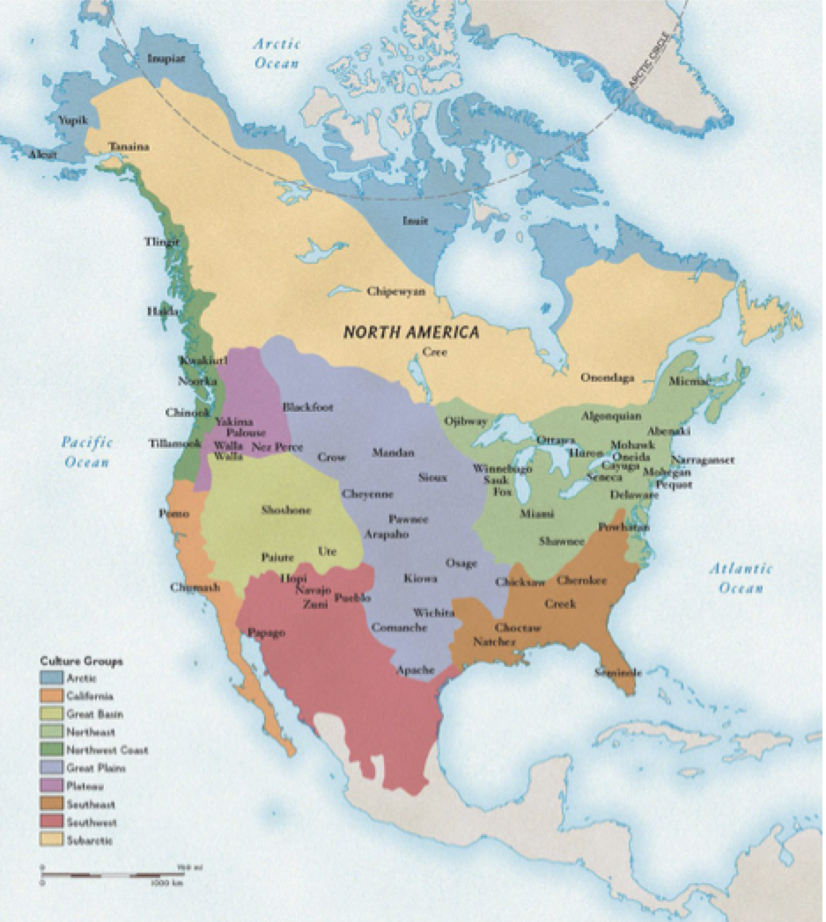

Source: https://media.nationalgeographic.org/assets/photos/000/315/31539.jpg

Questions for Students:
- Describe gender roles in each culture area/group.
- What practices did many tribes have in common?

Toypurina
In the late-1700s Spain attempted to take-over the area we now call the state of California and make it part of their empire. Three types of institutions were established: missions, pueblos, and presidios. Pueblos were towns for Spanish-speaking settlers and their families. Presidios were military forts. And missions were set up to convert native people to Catholicism. Mission San Gabriel Arcángel, in today’s Los Angeles, was founded in 1771. The Spanish speakers renamed the local Tongva (also called Kizh) people Gabrieliños, after the mission. Just 14 years after it was established, a group of these local natives planned an uprising against the mission. One of the leaders was a woman named Toypurina, an influential local native spiritual leader. She and three Tongva men were brought to trial by the Spanish after they stopped the revolt.

“Honoring Our Origins,” 2014
Mural Mile, Pacoima Neighborhood, San Fernando Valley
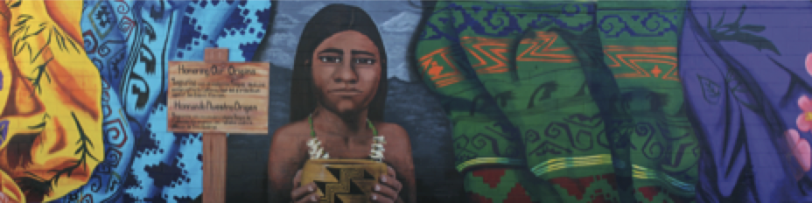

Sign Text: Toypurina was an indigenous Tongva medicine womyn
native to California that led a rebellion against San Gabriel Mission.
Source: https://hoodsisters.org/portfolio/honoring-our-origins/

A useful article on Toypurina and the revolt:
https://www.kcet.org/history-society/toypurina-a-legend-etched-in-the-landscape-of-los-angeles

Tongva (Kizh) Nation websites:
http://gabrielenoindians.org
http://www.gabrielenotongva.org
http://www.gabrielinotribe.org

Haramokngna American Indian Cultural Center:
http://www.haramokngna.org

Select Testimony from the Trial of the Leaders of the Mission San Gabriel Revolt, 1785
Testimony of Nicolás José:
He said that ‘‘most of those whom were present [at the attack on the mission] did so out of fear of the aforementioned Toypurina, who they considered very wise, and that with only a wish she could kill them.’’
Testimony of Toypurina:
[And]…according to the soldier who recorded her words, she stated succinctly that ‘‘she was angry with the Padres and with all of those of this Mission because we are living here in her land.’’ She said that ‘‘it is true that she asked the [village] captain Tomasajaquichy to come persuade the Christians not to believe in the Padres but rather only in her.’’
Source: Steven W. Hackel, “Sources of Rebellion: Indian Testimony and the Mission San Gabriel Uprising of 1785”

Toypurina’s Full Testimony, 1785
I the sergeant ordered that the gentile [non-Christian] Indian woman named Toypurina appear before me. She was accused of being the instigator of an Indian rebellion that took place the night of October 25. She was persuaded by the interpreter to reply truthfully to the questions asked.
Question 1: Previously [in 1779], when it was discovered that they (the Indians) were plotting to kill the Baja Californio [native man from Baja California] as well as the priests and soldiers, had they not been warned by the Governor, the Lieutenant from San Diego, and by the very same priests that if they tried to commit a similar act they would be severely punished?
Reply: She responded that she knew nothing about that.
Question 2: After they had been warned and advised repeatedly to keep the peace, why did they come here armed to kill the priests and the soldiers who had never harmed them?
Reply: She responded that it was true that she had ordered Chief Tomasajaquichi to come and persuade the Christians [converted native people] to trust her and not the priests. She said that she advised him to do this because she was angry with the priests and all the others at the mission, because we were living on their land.
Question 3: What prompted them to come here, knowing that it was impossible to kill the soldiers, for with one shot from the cannon many Indians would die?
Reply: She responded that the Indian Nicolás José had persuaded her by giving her some beads. She joined the others to encourage them to be brave and fight.
Question 4: Have they been harmed in any way at the hands of the soldiers, priests, or other Christians which would make them want to kill them?
Reply: She responded that the only harm that she had experienced was that we were living on their land.
Question 5: Who conspired to plan the assault and who was the leader?
Reply: She responded that Nicolás José was the first one to bring the chiefs together, and he persuaded her to influence them.
Question 6: Who was the Christian they obeyed the most and who was the first to suggest the attack?
Reply: She responded that it was Nicolás.
Question 7: Were the sheep and goats they killed at night stolen from the corral or the fields? Who committed these acts? Did the shepherds allow this or not?
Reply: She responded that Nicolás had sent the others out to steal the lambs. However, she knew nothing about the shepherds. Nicolás also ordered that three sheep be brought back, but it was not done.
Question 8: What weapons did they bring for fighting, and who provided them?
Reply: She responded she did not bring any weapons.
Question 9: How many and which rancherías [villages] banded together and where?
Reply: She responded that six rancherías came with their chiefs, as well as some other Indians from other rancherías.
Question 10: Do they understand why they are imprisoned and why the Governor, the Lieutenant, the priests, and all the soldiers are so angry with them? Are they aware of the just punishment they deserve?
Reply: She responded that she understood everything. When she was asked if she had anything else to add regarding Nicolás or the other Christians, she responded that she did not, and that everything she had said was the truth. When the inquiry was finished, I signed and dated it at the aforementioned mission, as did the assistants and the interpreter. I swear to this.
José Olivera (Sergeant)
Manuel de Vargas (Assistant)
José María Pico Verdugo (Assistant)
José María Pico (Interpreter)
Source: Lands of Promise and Despair: Chronicles of Early California, 1535-1846, 248-249.

Questions for Students:
- What do the primary sources (testimonies) reveal about the importance of Toypurina in the revolt?
- Is it possible that the accused Tongva, like Toypurina, didn’t reveal everything in their testimony? Why might they have not wanted to tell the Spanish everything?
- Compare and contrast the way Toypurina is represented in the testimony versus the mural (created in 2014).

Sacajawea
One of the best known native women in U.S. history, Sacajawea is often portrayed as someone who crossed cultures. At worst she is accused of betraying native people to aid the colonizers. She certainly served as a bridge between different societies, but much of this was not by choice. At around age twelve she was captured by another tribe and taken away from her people, the Lemhi Shoshone. Before and after European arrival many native tribes had traditions involving the capture and adoption of people from other tribes. Usually this was to replace their own family members who had been killed in wars with that other nation(s). Women and children were more likely to be adopted. Captives could become full members of their adoptive tribe. Sometimes captives were traded as well. So a tribe could negotiate an exchange of captives for those held by their enemy. Europeans and then Americans were incorporated into these captive networks. The French are one relevant example. Fur-traders, like Sacajawea’s husband French Canadian Toussaint Charbonneau, adapted to native traditions and often found it beneficial to marry into the tribes of their trading partners. Sacajawea may not have had much choice in this, some sources maintain that she was traded or sold to him. She was beneficial to him, and Lewis and Clark’s expedition, because she spoke so many languages. Those language skills were due to her status as a captive.

Agaidika Perspective on Sacajawea, by Rozina George
Sacajawea’s direct familial descendants and her people the Lemhi Shoshone know that the Lewis and Clark Journals indicate that Sacajawea remained true to her Lemhi Shoshone culture. The journals verify that Sacajawea retained the essential elements of her cultural identity including Lemhi Shoshone Language, history, and knowledge of the Lemhi medicinal/food plants, customs, and recognition of the landmarks of her homeland. She did not forget the edible plants and roots that Lemhi Shoshone women collected to eat. She used her inherited cultural knowledge to sustain her child and others. She remembered the natural medicinal remedies used by her people and how and when to collect them. These remembrances of her Lemhi Shoshone childhood played a very important part in the survival of the Lewis and Clark Expedition.
A rigorous ordeal, Sacajawea carried her infant son Jean Baptiste (Pompy) in a traditional cradleboard (the expedition members use the word “bier,” implying a wood-framed device) and that she always identified herself, even while with Lewis and Clark, as an Agaidika now known as the Lemhi Shoshone Tribe. She would have used red paint down the part of her hair, across her fore head and down onto her uppercheeks as means of identification to other tribes. These markings meant that she was Lemhi Shoshone and this identification provided the means of spiritual protection for her …Other tribes that she and the expedition came into contact with would immediately recognized these markings as Lemhi Shoshone. Sacajawea presumably told Lewis and Clark that the red paint indicated peace. On August 13, 1805, Lewis wrote: “I now painted their (Shoshone) tawny cheeks with some vermillion which with this nation is emblematic of peace.”
When Sacajawea was twelve years old she was captured by the Minnetarees or Hidatsa near present day Three Forks, Montana. She was taken from her family and her people. The following is an excerpt from Meriwether Lewis’s journal in which he documented Sacajawea’s account of her capture. Sunday July 28, 1805. “Our present camp is precisely on the spot that the Snake Indians were encamped at the time of the Minnetares of Knife R. came sight of them five years since. from hence they retreated about three miles up Jeffersons river and concealed themselves in the woods, the Minnetares pursued, attacked them, killed 4 men 4 women a number of boys and mad[e] prisoners of all the females and four boys. Sah-cah-gar-we-ah (o[u]r) Indian woman was one of the female prisoners taken at that time…” Expedition member Ordway corroborates the story. His journal entry reads, "She tells us that she was taken in middle of the River as she was crossing at a shole place to make hir ascape.” They clearly record that she had been captured by the Hidatsa…
While most of what we know about the life of Sacajawea is revealed in the journals of expedition members, there are also aspects of her life which are clarified through an understanding of our Lemhi culture and oral traditions…When Lewis and Clark met Sacajawea. Clark wrote this about the encounter: November 4th, 1804, “a french man by Name Chabonah, who speaks the Big Belly (Gros Ventre) language visit us, he wished to hire and informed us his 2 squars were snake (Shoshone) Indians, we enga(ge) him to go on with us and take one his wives to interpret the Snake language…”
…“The Indian woman recognize the point of a high plain to our right which she informed us was not very distant from the summer retreat of her nation on a river beyond the mountains which runs to the west. this hill she says her nation calls the beaver’s head from a conceived resemblance of its figure to head of that animal…:”Lewis: Thursday, August 8th, 1805. Beaverhead Rock is located near present day Dillion, Montana and the river beyond the mountains is the Salmon (Agai pah) River, Idaho.
As a Lemhi Shoshone, directly related to Sacajawea through her parents and brother Cameahwait, I (the author) have an irrefutable kinship relation to her. I can verify my relationship to her through historical documents and oral history that corroborate with expedition members’ journals. Lewis journal verifies the relationship between Sacajawea and Chief Cameahwait as brother and sister. On Saturday, August 17th, 1805, he writes, “Shortly after Capt Clark arrived with Interpreter Charbono, and Indian woman, who proved to be a sister of the Chief.” The last chief of the Lemhis Chief Tendoy, was the nephew of Sacajawea and the son of Cameahwait…
Her people understand that her knowledge of her homeland was accurate. She knew that if she followed the rivers back west, that she would eventually reach her people. In our culture, from birth on, you are taught everything about mother earth; you are taught about the Creator. Sacajawea’s people were knowledgeable about the food provided for us by So go beah (mother earth), and Sacajawea knew about the medicinal plants that help in our healing. Sacajawea knew her homeland (da veah). She knew it! Lewis and Clark both document this fact. Clark documents how excited she was to be home with her people again. August 17 Satturday 1805 “The Interpreter & Squar who were before me at Some distance danced for joyful sight, and She make signs to me that they were her nation…” “the meeting of those people was effecting, particular between Sah cah gar we ah and an Indian woman, who had been taken prisoner at the same time with her and who, had afterwards escaped from the Minnetares and rejoined her nation…”
In conclusion, we believe that Sacajawea retained her allegiance to her Lemhi Shoshone people. In spite of being captured by the Hidatsa at an early age, Sacajawea remained true to her culture and the completion of the arduous journey of the Lewis and Clark Expedition rests on this Lemhi Shoshone teen-ager’s cultural knowledge, courage and fortitude. After 200 years, the United States government should recognize and honor Sacajawea’s ancestry and acknowledge her true history and culture.
Sources: https://trailtribes.org/lemhi/agaidika-perspective-on-sacajawea.htm and http://www.lewisandclarkexhibit.org/4_0_0/4_1_0_supportingdocs/4_1_7_1/read_L5_sacagawea_source.pdf

Questions for Students:
- What does Sacajawea’s life reveal about gender roles in her original society?
- What might the quotes from Lewis and Clark’s expedition show about American expectations for women at the time?
- Why does Rozina George, a modern Lemhi Shoshone woman, think Sacajawea’s legacy is important?

Haudenosaunee (more widely known as the Iroquois)
The clan is the basic unit of these societies. These tribes are matrilineal, so members of each clan share a common female ancestor. Each clan is headed by a clan mother, often the oldest woman in the clan. Sachems (tribal chiefs) are elected by clan mothers, and can be sanctioned and removed by them. The Haudenosaunee Confederacy is a council made up of sachems from each tribe. At the time of European arrival there were five nations that made up the Confederacy: the Seneca, Cayuga, Onondaga, Oneida, and Mohawk. In 1713 the Tuscarora were at war with English settlers over their territory in North Carolina. More than half of them fled to New York and asked if they could join the Haudenosaunee. They spoke a similar language and were accepted as the sixth member. The political structure of the Haudenosaunee Confederacy inspired the structure of the United States (states with representation in a central, united government). But the founding fathers left women out of power. The 19th century feminist movement found inspiration in the power women held in these societies. The matrilineal tradition and women’s central importance continues in Haudenosaunee tribes to this day.
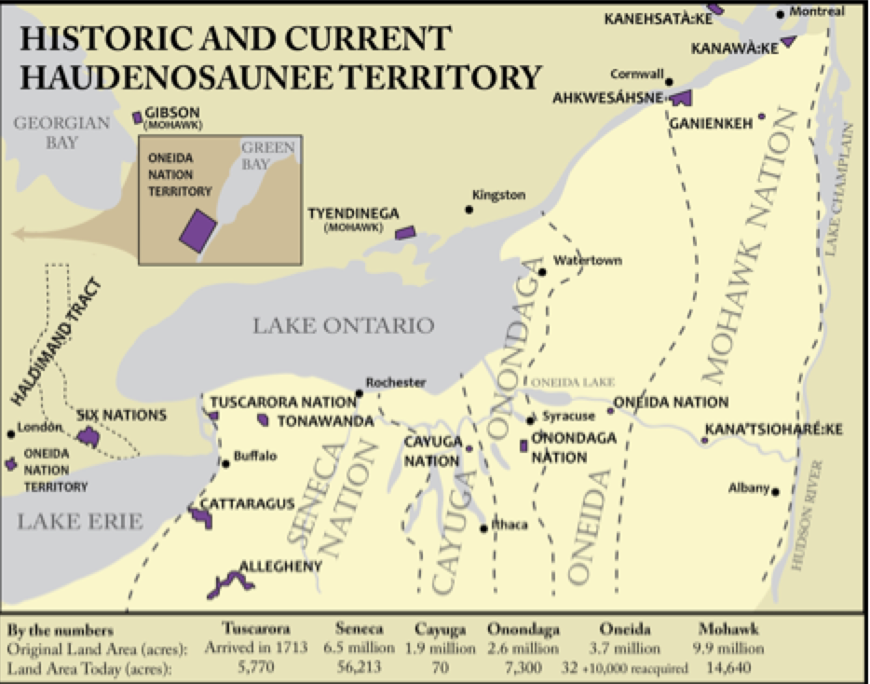

Source: http://honorthetworow.org/learn-more/haudenosaunee-territory/

Seneca Women and Chief Red Jacket Speak Women’s Words to U.S. Delegation, 1791
“‘Brother—The Great Ruler has spared us until another day to talk together; for since you came here from General Washington, you and our uncles, the sachems, have been counseling together. Moreover, your sisters, the women, have taken the same into great consideration, because you and our sachems have said so much about it. Now, that is the reason we have come to say something to you, and to tell you that the Great Ruler hath preserved you, and that you ought to hear and listen to what we women shall speak, as well as the sachems; for we are the owners of this land, AND IT IS OURS! It is we that plant it for our and their use. Hear us, therefore, for we speak things that concern us and our children; and you must not think hard of us while our men shall say more to you, for we have told them’
They then designated Red Jacket as their speaker, and he took up the speech of his clients as follows:
‘…Now, listen, brothers; you know it has been the request of our head warriors, that we are left to answer for our women, who are to conclude what ought to be done by both sachems and warriors. So hear what is their conclusion… the elder of our women have said that our sachems and warriors must help you, for the good of them and their children, and you tell us the Americans are strong for peace.
Now all that has been done for you has been done by our women; the rest will be a hard task for us…And these are the words of our women to you, and the sachems and warriors who shall go with you.’”
Source: Major Problems in American Women’s History, pages 115-116

Questions for Students:
- What do the quotes from the Seneca women and their representative show about the importance of women in Haudenosaunee culture?
- What might their pleas show about American expectations for women at the time?

Isidora Filomena
A native woman who lived through the regime change from Mexican to American control of California, Filomena was probably from the Patwin village of Churup on Cache Creek (see map below). She was born around 1784. The man who interviewed her was mostly interested in knowing more about her husband, Sem-Yeto (baptized in 1810 as Francisco Solano), a powerful Suisun (Suysun) native leader and important ally to the Mexicans in the 1830s and 1840s. But throughout the interview Filomena made clear that she, and thus other native women, held decisive and influential roles in their societies.
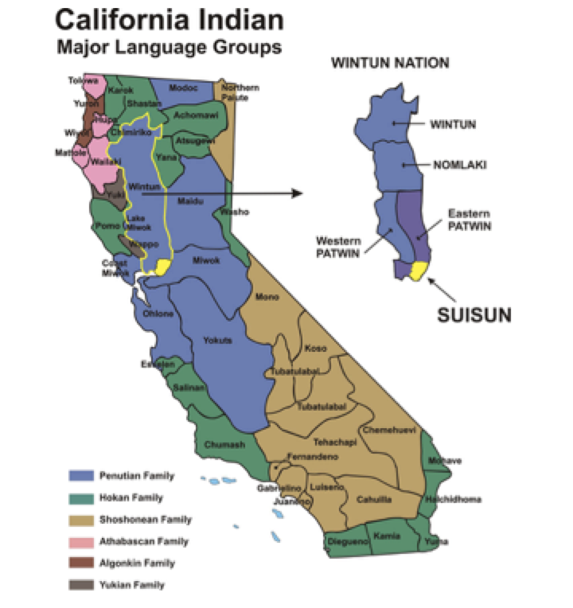

Source: http://suisunwildlife.org/CA-NAmap.htm

Henry Cerruti’s Interview of Isidora Filomena, 1874
“I married the great Solano, prince of the Suysunes, Topaytos, Yoloitos, and Chuructas. He became prince of the Topaytos after he conquered them. During his lifetime he inspired fear in everyone, white men and Indians, with the exception of his friend General Guadalupe Vallejo. Solano always refused offers of friendship from Sutter, Yount, and many other blonde men who wanted to be his friends…
I prevented my husband from killing enemy prisoners after he had conquered all of his enemies with the eight thousand men he led. Back then it was customary to tie the prisoners to trees and shoot arrows at them. I told him, ‘Leave them with Vallejo. He will make them work the land.’…
I am not Suysun like he [Solano] is. I belong to the Churucto tribe. My father’s tribe lived near Cache Creek…
…Some Suysun women had sashes with feathers. Many wore nothing more than a pelt that hung in front but did not go around their waist. Churucto Indians would paint their bodies with charcoal and red ochre. This paint was not permanent. We all had houses made of tule and we lived comfortably. We liked to bathe very much because cleanliness makes you strong. We would teach little boys how to hunt. Women did the cooking and took care of the little children.”
Source: Testimonios: Early California through the Eyes of Women, 1815-1848, page 10-11 and 13.

Questions for Students:
- How did Filomena, and thus other native women by extension, exert influence and power?
- What gender roles were girls and boys taught in her tribe?

Two Spirit People
The term two spirit is a modern phrase used to describe various traditions practiced in many Native American societies. The term references the idea, held by some tribes, that two spirits (female and male) could live within one person. The phrase two spirit came into use in the twentieth century as an umbrella term to describe these gender roles more broadly. Each tribe has their own word or words for these individuals. Tribes with these practices had more than two gender options. Sometimes the third gender combined female and male roles. Other times the individuals lived as a woman or man. So there might be four or more genders. Many thus saw gender as acquired, rather than innate. It was not about categorizing the individual based on their physical bodies but their social role and inner spirit(s). Some tribes had puberty rituals that involved presenting a teenager with tools for men’s and women’s work. The young adult would then select what role they wished to live in their society. Many tribes considered two spirits as having special religious powers or importance. Originally these multiple gender options were about the gender role performed, not sexuality. If a two spirit person married, they did so in a heterogender pairing. Having both male and female genders in a partnership was considered important in most native nations. The idea was to have partners that complimented one another. Homogender relationships were not usually accepted in most tribes. Of course, some individuals living before colonization may have been attracted to the same sex and thus chosen the other gender option to have those relationships.
In the 1970s-1990s the gay rights movement started to use two spirit traditions as evidence of historical acceptance of gay and lesbian individuals. But historically two spirit identities were not the same as contemporary understandings of gay and lesbian. Of course, these traditions have changed over time. Colonizers attempted to eradicate these practices, a legacy which continues to influence acceptance in many native communities to this day. Understandings of gender and sexuality change across time for all cultures. The gay rights movement in the U.S. has changed names over time and is now often called the lesbian, gay, bisexual, and transgender (LGBT) movement(s). But the longer format of the name includes more categories: lesbian, gay, bisexual, transgender, transsexual, queer, questioning, intersex, asexual, androgynous, two spirit, pansexual, poly, straight ally (LGBTTQQIAA2SPPSA). But even this does not include all options (such as gender non-binary, for example, which includes genderqueer, agender, and genderfluid or gender non-conforming). The term LGBT+ is a shorter form that includes recognition of many more identities through the plus sign. Two spirit individuals today identify in a variety of ways. Many define two spirit as their gender identity and sexuality as a separate category. Some see it as both gender and sexuality. The sources below will explore this diversity.

Two-Spirited Mask
By David Neel, Jr. (Kwakiutl), Contemporary Pacific Northwest Style

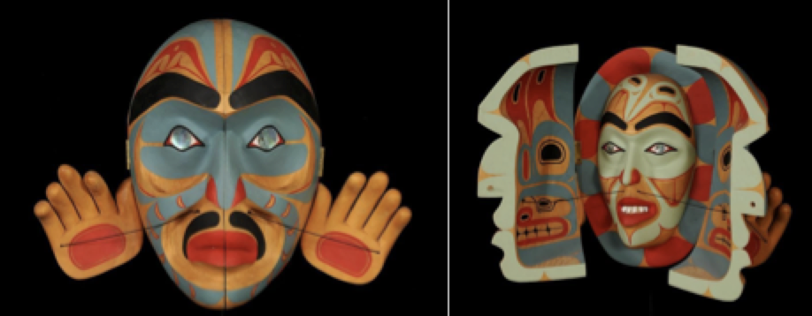

“Two-spirited people have always held a respected position within traditional Native American Society. This Transformation mask explores the link between outer and inner self; the face we show the world and the private persona that we hold within.”
Source: http://www.davidneel.com/indian-contemporary-native-spirited-mask-p-1023.html

“Decolonizing Sexuality At The Largest Two-Spirit Pow Wow In The Nation,” Project 562
Blog with photos and video exploring the impact colonization had on two spirits and contemporary attempts to decolonize these practices in tribal communities:
http://www.project562.com/blog/decolonizing-sexuality-at-the-largest-two-spirit-pow-wow-in-the-nation/

“Embracing the Spirit of Inclusion: San Francisco's Two Spirit Pow Wow,” Project 562, 2017
Video, text, and photographs from the 2017 Annual Bay Area American Indian Two Spirits (BAAITS) Pow Wow:

http://www.project562.com/blog/embracing-the-spirit-of-inclusion-san-franciscos-two-spirit-pow-wow/

Questions for Students:
- Describe historical two spirit practices.
- Why did these traditions change?
- What does the mask show about identity, not just for two spirits but for everyone?
- What are some of the ways contemporary two spirit people describe themselves?

Misconceptions and Stereotypes
There are many misunderstandings about Native Americans, including of native women, in U.S. society today. Inaccurate portrayals in the media are one reason for this. Disney’s Pocahontas serves as one example. The myth of the Indian Princess saving English colonist John Smith has been around since he published an account of the story in 1624. Smith misunderstood native customs, which used adoption of captives as a way to show the power of the adopting tribal nation. Over the years the story has been retold many times and other versions became even more inaccurate. Disney portrays it as a love story, but Pocahontas was actually just a child at the time. Her part in the adoption ritual, if it occurred, related to women’s role in native societies east of the Mississippi. Women were usually in change of making the decision if captives would be adopted or killed. But the stereotype continues, and impacts native women today.

“Growing Up with Pocahontas,” Dreaming in Indian
The following are from the book Dreaming in Indian: Contemporary Native Voices, a collection of art and writing. The first page of the section “Growing Up Pocahontas” is a reproduction of a painting called “Indian Doll” by Kelli Clifton. She is also one of three native women who shared the impact of Disney’s Pocahontas and other popular misconceptions on their lives. These are reproduced on the next two pages.

The Real Pocahontas
Short Video Clip from “Pocahontas: Beyond the Myth” (2017), a Smithsonian Channel documentary:
https://www.smithsonianchannel.com/videos/why-pocahontas-may-not-have-rescued-john-smith-after-all/56327

Questions for Students:
- What, if anything, did you know about Pocahontas before? Was it a stereotype?
- Describe Pocahontas and her story in a historically accurate way.
- What harms did stereotypes cause these three contemporary native women?

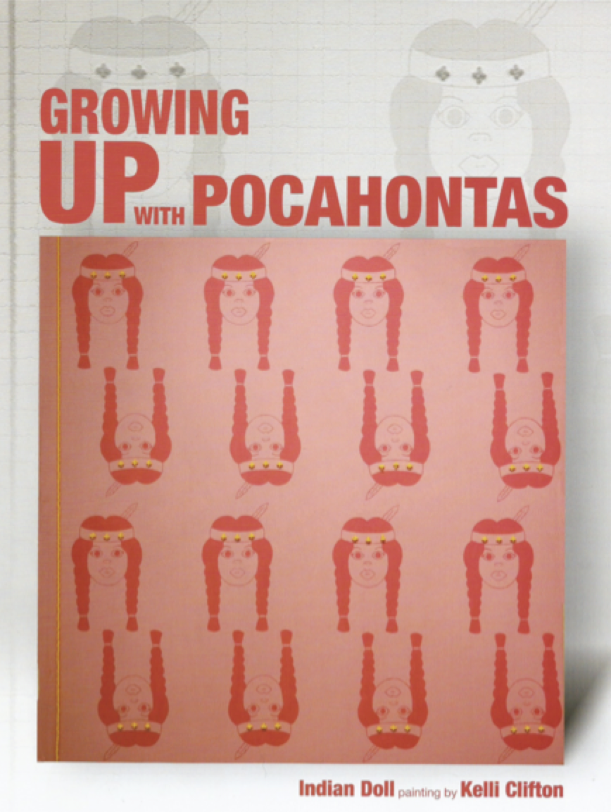

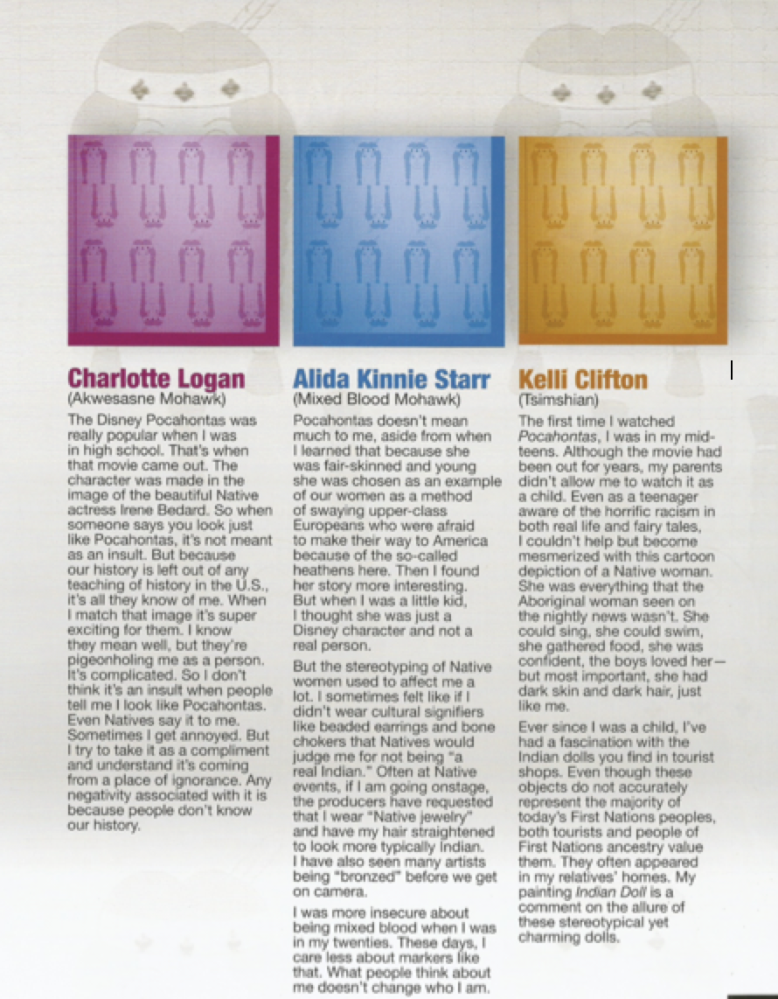

Source: Dreaming in Indian: Contemporary Native Voices, 2016

