Armenian Genocide Teaching Resources

Below the standards are recommendations for teaching the Armenian Genocide, including digital resources as well as selected primary and secondary sources.

Standard: 10.5.5. Discuss human rights violations and genocide, including the Ottoman government’s actions against Armenian citizens.

Framework Excerpt

By 1918, 16 million military personnel and civilians had died and millions more returned home wounded; this toll was enlarged by that year’s deadly pandemic of the Spanish Flu. The Ottoman, Austro-Hungarian, and Russian empires had disintegrated and in their place new, independent states emerged, including Poland, Russia, and Austria. In 1915, as the Ottoman Empire declined, the Turkish government carried out a systematic genocide against the Armenian population that had been living on its historic homeland in what is now eastern Turkey. Turkish authorities first arrested hundreds of Armenian political and intellectual leaders, sending them to their deaths; Armenian men were conscripted into work camps where they were killed outright or through exhaustion. The remaining Armenians were ordered onto death marches into the Syrian desert, during which they were subjected to rape, torture, mutilation, starvation, holocausts in desert caves, kidnapping and forced Turkification and Islamization. More than 1.5 million Armenians, more than half of the population was eliminated in this way; virtually all their personal and community properties were seized by the government, and more than 500,000 innocent people were forced into exile during the period from 1915 to 1923. When the war ended in 1918 the Armenian population was reduced by 75% and their historical lands were confiscated by the Turkish government. Students may examine the reactions of other governments, including that of the United States, and world opinion during and after the Armenian genocide. The Red Cross’s aid to Armenian Genocide survivors also demonstrates the worldwide humanitarian response to the crisis and the emerging role of the International Committee of the Red Cross as an international non-governmental humanitarian organization. They should examine the effects of the genocide on the remaining Armenian people, who were deprived of their historic homeland, and the ways in which it became a prototype of subsequent genocides. To connect these multiple effects of war, students can consider the question: What were the consequences of World War I for nations, ethnic groups, and people?

Digital Resources

IWitness Shoah Foundation
https://iwitness.usc.edu/SFI/
Testimonies of survivors and digital interactive student lessons.

Facing History and Ourselves | The Armenian Genocide Resource Collection - https://www.facinghistory.org/topics/genocide-mass-violence/armenian-genocide

Projectsave.org
Images of Armenian life before and after the genocide

Houshamadyan
Archive of Armenian life in the villages of the Ottoman Empire
https://www.houshamadyan.org/home.html

Gomidas Institute - https://www.gomidas.org/

The Armenian Genocide Museum - http://www.genocide-museum.am/eng/index.php

Teaching the Armenian Genocide with Primary Sources from the New York Times

https://learning.blogs.nytimes.com/2015/04/16/teaching-the-armenian-genocide-with-primary-sources-from-the-new-york-times/

The Genocide Education Teaching Project
Lessons to teach about genocide, particularly the Armenian Genocide
https://genocideeducation.org/

Selected Sources:

Secondary Source: Raphael Lemkin’s Definition of Genocide and the United Nations
Video that links the history of the Armenian genocide to Lemkin’s development of the term and activism on behalf of victims of genocide.
https://www.youtube.com/watch?v=XQiH_OeXpOM

Primary Source: Gedik Pasha Armenian Congregational Church, Gedik Pasha district, Constantinople, Ottoman Empire, 1896.
Taken by an unknown photographer, this photograph shows a congregation gathering in front of the camera to document the results of their all-night effort to frame their church building. Denied a building permit, church members constructed their humble church overnight, thus complying with a law that said a structure built in one night does not require a permit. Years later this building was replaced by a stone edifice, still in use today.
Courtesy of Marie Bashian Bedikian. Image provided by Project Save Armenian Photograph Archives, Inc.
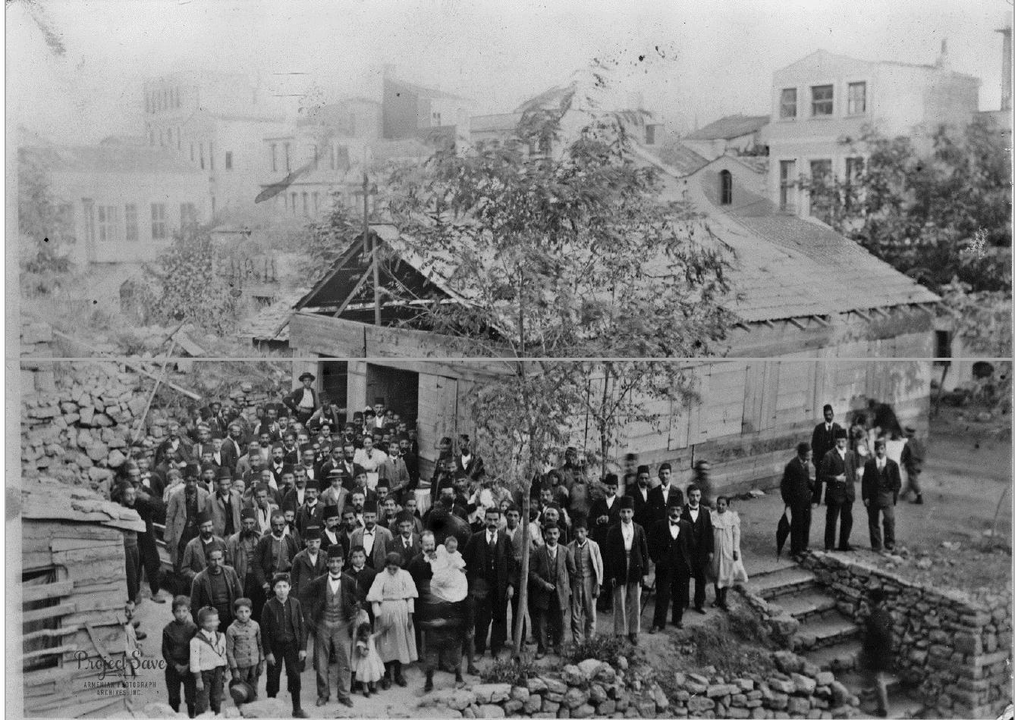

Secondary Source: Akcam, Taner. A Shameful Act: The Armenian Genocide and the Question of Turkish Responsibility, 2007. Pgs. 23-25
Under Ottoman rule the dhimmi were organized according to religion or sect, and these groups were known as millets. The autonomy of each millet was recognized through a sultanic letter of permission. Each millet administered the great majority of its own affairs, ‘not only the clerical, ritual, and charitable affairs of their flocks, but also education and the regulation of matters of personal status like marriage, divorce, guardianship, and inheritance.’ A high-ranking member of the clergy from each religious group was chosen by his community as its leader, to act as a state official, responsible to the sultan. Apart from penal matters – and even here exceptions were made – the millet leaders had the authority to adjudicate between congregants and collect taxes.
…the dhimmi were also subject to humiliating practices. They were forbidden from conducting their religious observance in a way that would disturb Muslims. The ringing of church bells and construction of churches or synagogues were forbidden…Other edicts dictated the colors to be worn. Armenian shoes and headgear, for example, were to be red, while the Greeks wore black and Jews turquoise…The dhimmi’s debasement included a prohibition on building their houses higher than those of Muslims, as a reflection of their inferiority. Their windows were not to look over Muslim quarters…Breaching these restrictions was punished by fine or imprisonment, or even, during the harsher reigns, with death.
In sum, the pluralist Islamic model rested on both humiliation and toleration. It was expected that non-Muslims would willingly accept this status; acting otherwise was violation of the dhimma agreement. The non-Muslims’ demands for equality in the nineteenth century were indeed seen as a violation of the agreement, and the Muslim communities of the Ottoman Empire had no intention of acquiescing.
Primary Source: Lieutenant Sayied Ahmed Mouktar Baas, “First-Hand Account,” 1916
Lieutenant Sayied Ahmed Moukhtar Baas, “First-Hand Account by a Turkish Army Officer on the Deportation of Armenians from Trebizond and Erzerum, December 26, 1916.” Available at Armenian National Institute http://www.armenian-genocide.org/br-12-26-16-text.html. Accessed 8/1/18.
In April 1915 I was quartered at Erzeroum. An order came from Constantinople that Armenians inhabiting the frontier towns and village be deported to the interior. […] The massacres had not begun yet. In May 1915 I was transferred to Trebizond. In July an order came to deport to the interior all the Armenians in the Vilayet of Trebizond. Being a member of the Court Martial I knew that deportations meant massacres.
The Armenian Bishop of Trebizond was ordered to proceed under escort to Erzeroum to answer for charges trumped up against him. But instead of Erzeroum he was taken to Baipurt and from there to Gumush-Khana. The Governor of the latter place was then Colonel Abdul-Kadar Aintabli of the General Staff. He is famous for his atrocities against the Armenians. He had the Bishop murdered at night. The Bishop of Erzeroum was also murdered at Gumush-Khana.
Besides the deportation order referred to above, an Imperial "Iradeh" was issued ordering that all deserters, when caught, should be shot without trial. The secret order read "Armenians" in lieu of "deserters". The Sultan's "Iradeh" was accompanied by a “fatwa" from Sheikh-ul-Islam stating that the Armenians had shed Moslem blood and their killing was lawful. Then the deportations started. […] When the first batches of Armenians arrived at Gumush-Khana all able-bodied men were sorted out with the excuse that they were going to be given work. The women and children were sent ahead under escort with the assurance by the Turkish authorities that their final destination was Mosul and that no harm will befall them. The men kept behind were taken out of town in batches of 15 and 20, lined up on the edge of ditches prepared beforehand, shot and thrown into the ditches. Hundreds of men were shot every day in a similar manner. The women and children were attacked on their way by the "Shotas," the armed bands organised by the Turkish Government who attacked them and seized a certain number. After plundering and committing the most dastardly outrages on the women and children they massacred them in cold blood. These attacks were a daily occurrence until every woman and child had been got rid of. The military escorts had strict orders not to interfere with the "Shotas".
The children that the Government had taken in charge were also deported and massacred.
The infants in the care of the American Consul of Trebizond were taken away with the pretext that they were going to be sent to Sivas where an asylum had been prepared for them. They were taken out to sea in little boats. At some distance out they were stabbed to death, put in sacks and thrown into the sea. A few days later some of their little bodies were washed up on the shore at Trebizond.
In July 1915 I was ordered to accompany a convoy of deported Armenians. It was the last batch from Trebizond. There were in the convoy 120 men, 700 children and about 400 women. From Trebizond I took them to Gumish-Khana. Here the 120 men were taken away, and, as I was informed later, they were all killed. At Gumish-Khana I was ordered to take the women and children to Erzinjian. On the way I saw thousands of bodies of Armenians unburied. Several bands of "Shotas" met us on the way and wanted me to hand over to them women and children. But I persistently refused. I did leave on the way about 300 children with Moslem families who were willing to take care of them and educate them. The "Mutessarrif" of Erzinjian ordered me to proceed with the convoy to Kamack. At the latter place the authorities refused to take charge of the women and children. I fell ill and wanted to go back, but I was told that as long as the Armenians in my charge were alive I would be sent from one place to the other. However I managed to include my batch with the deported Armenians that had come from Erzeroum. In charge of the latter was a colleague of mine Mohamed Effendi from the Gendarmerie. He told me afterwards that after leaving Kamach they came to a valley where the Euphrates ran. A band of Shotas sprang out and stopped the convoy. They ordered the escort to keep away and then shot every one of the Armenians and threw them in the river….
Primary Source: “Turks Depopulate Towns of Armenia,” New York Times, 27 August 1915. New York Times Archives.
The New York Times newspaper gave extensive coverage to the Armenian Genocide. This paper published 145 articles about anti-Armenian actions in 1915 alone.
https://www.nytimes.com/1915/08/27/archives/turks-depopulate-towns-of-armenia-traveler-reports-christians-of.html
