Lesson Author: Courtney Amaya
*Ideas for this lesson came from http://www.e4sjf.org/wp-content/uploads/2017/09/Comfort-Women-Lesson-Plan-Ideas.pdf
Grade Level: 10
Standard: 10.8 Students analyze the causes and consequences of World War II
Investigative Question: Why do we need to know about comfort women?
Framework Excerpt (p. 353):
“Comfort Women” is a euphemism that describes women who were forced into sexual service by the Japanese Army in occupied territories before and during the war. Comfort Women can be taught as an example of institutionalized sexual slavery; estimates on the total number of Comfort Women vary, but most argue that hundreds of thousands of women were forced into these situations during Japanese occupation. On December 28, 2015, the governments of Japan and the Republic of Korea entered into an agreement regarding the issues of Comfort Women. Two translations of this document can be found at http://www.mofa.go.jp/a_o/na/kr/page4e_000364.html (accessed June 29, 2017) and http://www.mofa. go.kr/ENG/press/ministrynews/20151228/1_71575.jsp?menu=m_10_10 (accessed June 29, 2017).

Map Resource to supplement lesson:
Created by Women’s Active Museum on War and Peace, in Tokyo
The locations of the “comfort stations” shown are based on official documents we have located, as well as the testimonies of survivors, former soldiers and witnesses. The yellow line shows the outer limit of the territory the Japanese military invaded.
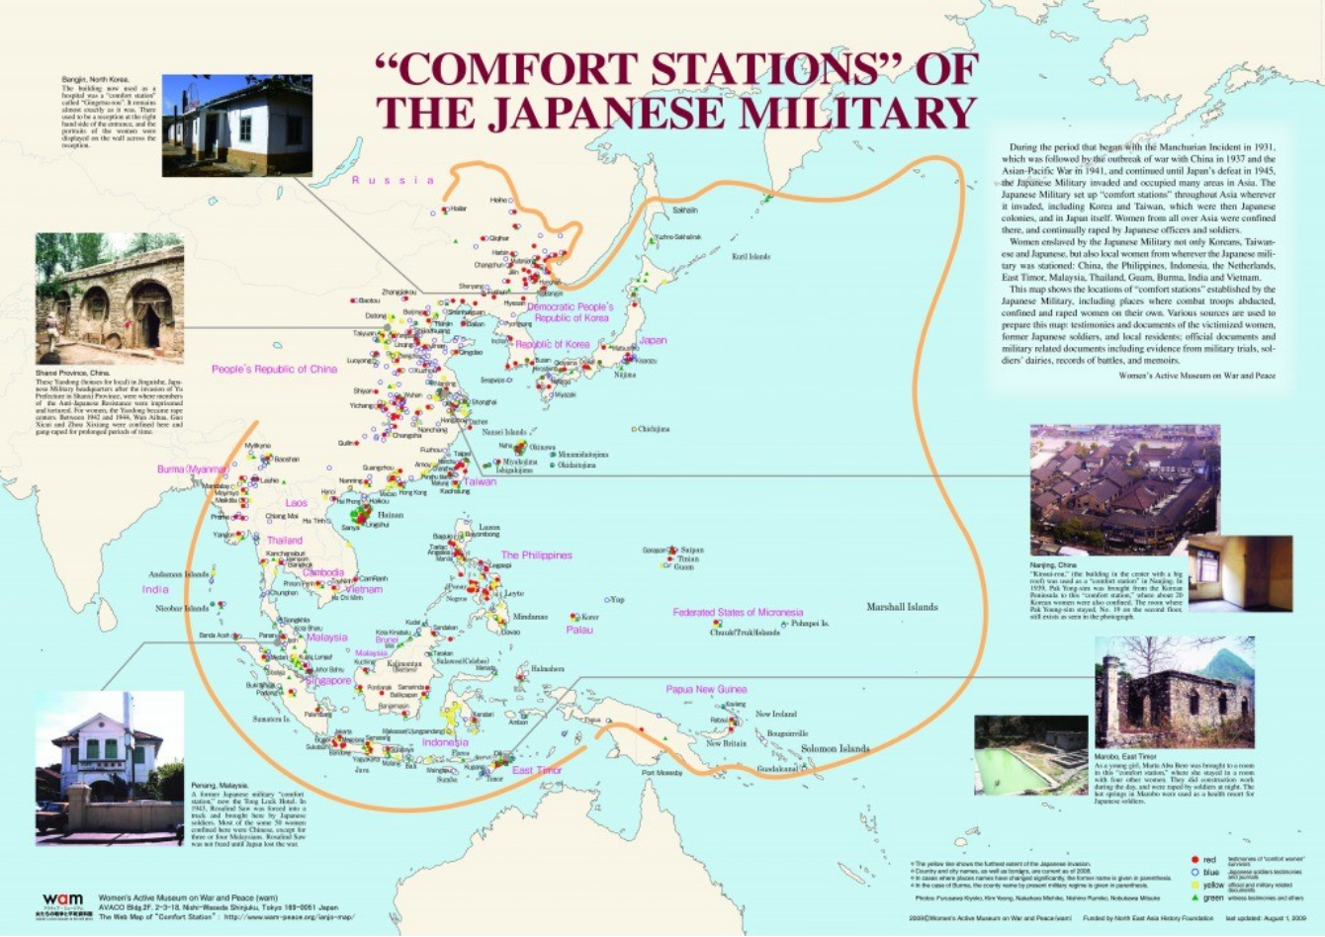

The Story of ‘Comfort Women’
“They were beaten and tortured in addition to being repeatedly raped day after day by officers and soldiers…When they were brought to the comfort stations, they were healthy in body and spirit. They left the comfort stations, diseased in body and crippled in spirit.”
-Adama Dieng, Secretary General, International Commission of Jurists, 1994.
What is a “Comfort Woman”?
“More than sixty years have passed since the end of World War II, but the wounds of Japanese colonialism and war still fester in several nations in East and Southeast Asia. In a number of countries—most notably South Korea, but to a lesser extent in China, Indonesia, and the Philippines as well—the plight of comfort women in particular has come to symbolize imperial Japan’s “war crimes.” Thanks to social movements that began in South Korea, Japan, and elsewhere in the early 1990s, comfort women survivors are now represented as “sex slaves” of wartime Imperial Japan (p1)...
The total number of wartime comfort women will never be known for sure. The estimates range widely between 20,000 and 400,000 (p23).”

How did the Japanese government justify their use of “Comfort Women”?
“It was after imperial Japan engaged in all-out war against China in July 1937 and expanded its occupied territories that the need for a great number of ianfu [military “comfort stations”] arose…The authorities believed such facilities would help prevent soldiers from committing random acts of sexual violence against women of the occupied territories—a greater concern after the infamous Nanking massacre, during which tens of thousands of Chinese women were raped…(p135)
To be sure, the intended purpose of the comfort system was to regulate military sexuality and discourage battlefield sex crimes. The comfort system, however, did not—and could not—prevent rapes, though it did help curb mass rape—especially in “pacified” areas in occupied territories (p142).”
Source: Soh, Sarah. The Comfort Women: Sexual Violence and Postcolonial Memory in Korea and Japan. Chicago: University of Chicago Press, 2008.

What methods did the Japanese use to enslave their victims?
There were three major methods of enslavement:
- Kidnapping: the Imperial Japanese forces took women and girls from their homes or communities.
- Deceived with promises of work: Imperial Japanese forces put up false job postings or had local recruiters deceive girls with promises of jobs.
- Sold by family, friends, or employers: Unfortunately it was not uncommon for victims to be sold by people they knew. It’s important to remember that these were desperate times and that many people acted out of the norm in order to save themselves and their families.
Note: There were women who were already sex workers and knew that they would be providing sexual services to soldiers. However, they did not expect to be held against their will, lose their agency over their own bodies, be abused and tortured, and be under constant threat of their lives. So they were sex slaves in the same way as the others.

What type of conditions made women vulnerable to military sexual slavery?
The following conditions are now recognized as having made women and girls in Asia during this time in history vulnerable to sexual slavery.
- Poor: women and girls from poor families were targeted because their families would have less power and resources to resist. Those in poverty were desperate for income and would therefore accept precarious employment situations with few questions.
- Uneducated: Almost all women in Asia at this time in history were uneducated and this certainly affected what options they had in life and their ability to react to situations they found themselves in.
- Illiterate: Similarly, most women were illiterate (couldn’t read or write). This reduced their ability to use print resources around them to escape their enslavement.
- Patriarchy: Cultures across Asia were deeply patriarchal was a leading factor in women’s vulnerability. The fact that women were considered men’s possessions, and that community would turn a blind eye when irresponsible men sold their daughters off as servants, laborers, etc… Such norms certainly created the context in which soldiers and recruiters could easily enslave hundreds of thousands of women and girls.
- Powerless: All of these factors leave women and girls disempowered, without agency over themselves, and therefore vulnerable.

Watch the VIDEO –https://www.youtube.com/watch?v=qsT97ax_Xb0
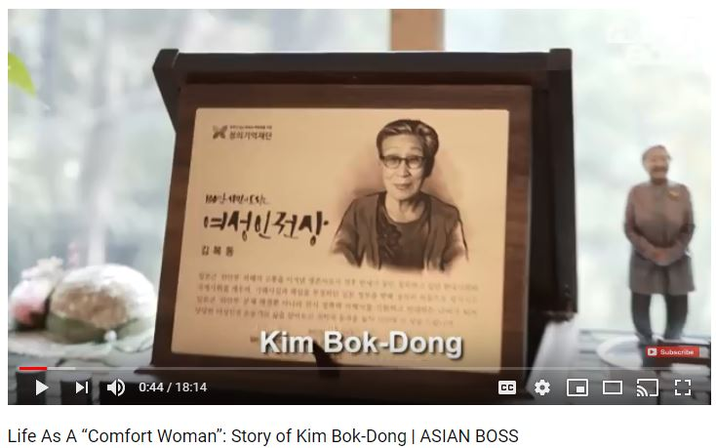

Directions: Answer the following questions while watching the video about Kim Bok-Dong’s experience as a “Comfort Woman.” [Note: there is an image which depicts nudity at 11:18 in video].
How old was Kim Bok-Dong when she was forced to become a “Comfort Woman”?
What did Kim Bok-Dong mistakenly believe she was leaving her family to do for the Japanese?
Why did Kim Bok-Dong try to kill herself with alcohol?
How many years did she serve the Japanese military as a “Comfort Woman”?

At what age did Kim Bok-Dong finally feel comfortable to tell her story publicly?

WHY did she choose to finally tell her story?
The interviewer states, “Japan claims that women like her were paid prostitutes and that they weren’t victims but went to make money.” What was Dim Bok-Dong’s response to this statement?

In 2015, the governments of Korea and the Japan agreed to a deal. How much did Japan agree to pay Korean “Comfort Women” in reparations?
(list amount in US dollars)

Kim Bok-Dong spoke about her anger over this 2015 deal. What does she want from the Japanese government?
If Kim Bok-Dong does receive reparations money from the Japanese government, what does she plan to do with it?

Why does this matter?
Unfortunately, the horrors of sexual slavery continue in the 21st century…
“The term that is usually used for this phenomenon, “sex trafficking” is a misnomer. The problem isn’t sex, nor is it prostitution as such. In many countries – China, Brazil, and most of sub-Saharan Africa –prostitution is widespread but mostly voluntary (in the sense that it is driven by economic pressure rather than physical compulsion). In those places, brothels do not lock up women, and many women work on their own without pimps or brothels. Nor is the problem exactly “trafficking,” since forced prostitution doesn’t always depend on a girl’s being transported over a great distance by a middleman. The horror of sex trafficking can more properly be labeled slavery…
It’s difficult to estimate just how many women and girls are impacted by sex trafficking, in part because you can’t easily divide sex workers into those who are working voluntarily and involuntarily. In the book, Half the Sky the authors estimate that around 3 million women and girls (and a small number of boys) worldwide are currently enslaved in the sex trade—bought, held, and forced into commercial sex work against their will. This figure may even be on the conservative side, as it doesn’t account for people who were intimidated into prostitution or the millions more under 18 who can’t consent to working in brothels.
The U. S. State Department’s tally is lower, with estimates between 600,000 and 800,000 people being trafficked across international borders each year. Eighty percent of those trafficked are women and girls, mostly for sexual exploitation. But these figures overlook the millions more victims who are trafficked annually within their own national borders.”
Source: Kristoff, Nicholas D., Sheryl Wu Dunn. Half The Sky: Turning Oppression Into Opportunity for Women Worldwide. New York: Vintage Books, 2009.
In what ways is modern day sexual slavery similar to the “Comfort Women” of the past?
- Read the excerpt (handout) about a Cambodian teenager named Srey Rath from the book, Half The Sky: Turning Oppression Into Opportunity for Women Worldwide.
https://www.npr.org/books/titles/162699796/half-the-sky-turning-oppression-into-opportunity-for-women-worldwide#excerpt
- Click on the links to watch the 3 VIDEOS
America Ferrera  (India’s sex trade) | https://www.youtube.com/watch?v=cpaPaJs3L-c&list=PLzkQfVIJun2J2BbbVr0HqbmrTJoOBiv8Y&index=10
Child sex trafficking in Southeast Asia | https://love146.org/love-story/
Prevention - #notanumber | https://love146.org/notanumber/

All three videos depict the horrors of the sex trade in the 21st century, however, each goes beyond the conflict to focus on solutions.
- Explain what the organization New Light is doing to help in India:

- What actions did the founders of Love146 do to fight against the sex trade?

- Those working to enact change with the #notanumber campaign have described the vulnerabilities of children in the 21st century that may lead to their victimization.
How are the vulnerabilities described in this video similar to the vulnerabilities of the “Comfort Women” in the 1930s and 40s?

- What specific things can we do as global citizens to show our empathy and to enact change in the world?

Supplementary Reading and Viewing Materials on Comfort Women
Prepared by Chungmoo Choi, UCI

Article
Chin Sung Chung, “The Origin and Development of the Military Sexual Slavery Problem in Imperial Japan,” in the journal positions 5:1 (1997) – Chung’s article is included in the journal positions special issue on Comfort Women titled, Colonialism, War, and Sex edited by Chungmoo Choi

Documentary Films (DVD available):
Byun Young-joo, The Murmuring (1995)
Byun Young-joo, Habitual Sadness (1997)

Feature films (rental available at IMDb):
Min Kyu-dong, Herstory (2018) – based on a true story of Korean comfort women’s legal battle and the only victory against the Japanese government.
Kim Hyeong-sok, I Can Speak (2016)

Novels
Nora Okja Keller, Comfort Woman (Penguin Books, 1998)
Mary Lynn Bracht, White Chrysanthemum (G .P. Putnum’s Sons, 2018)

Oral History
Dai Sil Kim Gibson, Silence Broken (Mid-Prairie Books, 1999)
The Korean Council for Women Drafted for Military Sexual Slavery by Japan, True Stories of Korean Comfort Women (Cassell, 1996)

Pre-Comfort Women history of Japan’s overseas brothels
Yamazaki Tomoko, <Sandakan Brothel 8>:
http://intersections.anu.edu.au/issue5/sandakan.html
(Movie based on this story: <Sandakan No. 8> - available in DVD)

